FINAL REPORT

from

Investigation of railway accident, occurred in Plovdiv locomotive depot during functional tests of locomotive № 91520043309-1 on 24.03.2022

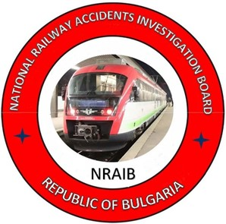

2022

OBJECTIVE OF INVESTIGATION AND EXTENT OF RESPONSIBILITY

The National Air, Maritime and Railway Transport Accidents Investigation Board (NAMRTAIB), which is an independent body performs the investigation of significant accidents and incidents. The National Board is within the Council of Ministers (CM) of the Republic of Bulgaria, and aims to find the circumstances and causes that led to the accidents and incidents occurrence in order to improve the safety and to avoid such in future.
The investigation, which the NAMRTAIB performs is an independent from any judicial investigation, and does not include the determination of fault and responsibility in no circumstances.
The investigation is performed in accordance with the requirements of DIRECTIVE (EU) 2016/798 of the European Parliament and of the Council of 11 May 2016 on railway transport safety, the Railway Transport Act (RTA), Ordinance No59 dated 5.12.2006 on the rail transport safety management, and Ordinance No Н-32 dated 19.09.2007 on the coordination of the activities and information exchange during the railway accidents and incidents investigation, as well as per Agreement dated 17.04.2018 on the interaction during investigation of accidents and incidents in the air, maritime and railway transport between the Prosecutor's Office of the Republic of Bulgaria, Ministry of Interior, and the Ministry of Transport, Information Technology and Communications.
The Investigation reports follow the requirements of REGULATION (EU) 2020/572 of the Commission dated 24 April 2020 on the reporting structure for railway accident and incident investigation reports.

TABLE OF CONTENTS

№ | Title of section | Pg.
1. | Summary | 5
2. | Investigation | 7
3. | Description of the event | 10
4. | Analysis of the event | 17
5. | Conclusions | 32
6. | Safety recommendations | 34

ABBREVIATIONS, USED IN THE REPORT

BDZ PS Ltd. – ,,BDZ-Passenger Services“ Ltd. – state carrier for passenger services
BDZ Cargo Ltd. – ,,BDZ-Cargo“ Ltd. – state carrier for freight services
SE NRIC – State enterprise „National railway Infrastructure Company “(railway infrastructure manager)
RTA – Railway Transport Act
SWCA – Safe Working Conditions Act
RAEA – Railway Administration Executive Agency
RQIA – Repairs Quality Inspector Acceptor
OCL – Overhead contact line (catenary)
ECM – Entity in Charge of Maintenance
DDoI – District Directorate of Interior
MPTH – Multi-profile Transport Hospital
NAMRTAIB – National Air, Maritime, and Railway Transport Accidents Investigation Board (Independent Specialized National Investigation Body)
NSSI – National Social Security Institute
GLI – General Labour Inspectorate
TF – Task Force
DPO – District Prosecutor's Office – Plovdiv
DID – District Investigation Department – Plovdiv
RRS – Rail Rolling Stock
RN – Repair as Needed
EMC – Emergency Medical Care
SMS – Safety Management System
OHS – Occupational Health Service
TRRS – Traction Rolling Stock
NVR – National Vehicle Register
PLD – Prescription of Locomotive Depot

- Summary
  - Brief Description of the Event.
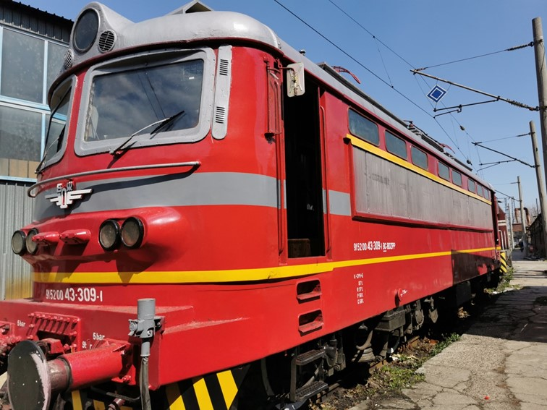
On 18.03.2022, locomotive No. 91520043309-1, registered in the NVR, property of the BDZ PS Ltd. railway undertaking, certified ECM, entered in Plovdiv Locomotive Depot for RN. The Locomotive depot is part of the BDZ PS Ltd. railway undertaking for passenger transport. In the period 21.03.÷24.03.2022, the locomotive is being repaired for the detected damages. During the downtime for repairs, due to occurred operational necessity, the contactor for train heating was dismantled from the locomotive, and installed on another locomotive in operation. After the repairs carried out in the repair shop, the locomotive was handed over for operation as around 15:20 p.m. on 24.03.2022 was taken out of the repair shop by a diesel shunting locomotive and positioned on the 5th track in the depot under a catenary, where functional tests were carried out before commissioning (Fig. 1.1).
Fig. 1.1.
In the course of the tests, which qualified experts performed, they found that the train heating of the locomotive did not work. The head of the workshop ordered the Organizer of production and repair of RRS, master, to eliminate the identified malfunction in the locomotive. The master got down, took the necessary tool and went back to the locomotive in order to eliminate it. During the elimination of the detected malfunctions, violations of the normative and inter-departmental acts (ordinances and instructions) regulating the safe working conditions when working with electrical devices in locomotives were committed.
As a result of non-compliance with regulations and lack of coordination in the actions between the experts performing the functional tests and the employee connecting the operating circuits for the train heating of the locomotive, the pantograph was lifted without warning, which resulted in an electrocution with a fatal outcome (fatal accident).

  - Location and time of the event occurrence.
On the fifth passage track in Locomotive Depot Plovdiv, the track was electrified, around 15:45 p.m. on 24.03.2022, to carry out locomotive tests (fig. 3.2).
  - Factors determining and contributing the event.
A determining factor for the occurrence of the event is non-compliance with the requirements of the regulatory safety framework when working with electrical devices during the additionally performed repair work in the locomotive.
A contributing factor to the occurrence of the event is the lack of coordination between the experts performing the functional tests and the master-technician performing the repair in the locomotive.
  - Direct causes and consequences of the event.
The immediate cause of the fatal accident was electrocution of the employee (during troubleshooting in the engine compartment of the locomotive) by an electric shock with an alternating current of voltage 1500 V, 50 Hz, which flowed through the power circuit of the train heating as a result of uncoordinated actions of those involved experts in locomotive testing (lifting the locomotive pantograph and turning on 25 kV voltage, without disclosure).
  - Safety recommendations and addressees to which they are addressed.
In order to prevent other similar accidents that could have other serious consequences, the Investigation Commission proposes to the National Safety Authority Railway Administration Executive Agency safety recommendations related to “BDZ-Passenger Services” Ltd. and “BDZ-Cargo” Ltd.
- Recommendation 1 proposes BDZ PS Ltd. and BDZ Cargo Ltd. to conduct an extraordinary briefing for the personnel in the repair and operation of RRS and to be acquainted with the Final Report of the NAMRTAIB on the occurred accident.
- Recommendation 2 proposes BDZ PS Ltd. and BDZ Cargo Ltd. to conduct an updated training for the personnel in the repair and operation of RRS on the safety measures as per Ordinance No7 and Ordinance No13.
- Recommendation 3 proposes BDZ PS Ltd. and BDZ Cargo Ltd. to make amendments and additions to the normative documents regulating the types of repairs of TRS (Regulations for the organization of repair activities in locomotive depots, Instructions for safe work when servicing electric locomotives and motor trains in locomotive depots, Regulations for depot repairs and maintenance of electric locomotives of BDZ and Samples by which TRS is accepted and handed over for repair as necessary).
- Recommendation 4 proposes BDZ PS Ltd. and BDZ Cargo Ltd. to change the work instructions and PLD, which will guarantee increased control by the officials during the performance and acceptance of the repair works, checking of the protective locks of the locomotives, ensuring traceability and personal responsibility.
- Recommendation 5 proposes BDZ PS Ltd. and BDZ Cargo Ltd. to create order and organization after coming out of repair and during operation, upon acceptance of the locomotive, the locomotive crews to check and enter in the logbook the state of all the protective locks of the locomotives.

2. Investigation
  - Decision for starting the investigation.
The decision to initiate the investigation was taken by the member of the Management Board of the NAMRTAIB in the Republic of Bulgaria, leading the investigation of railway accidents and incidents given the severity of the accident and its impact on railway transport safety. The investigation is focused on the analysis and organization of the human factor and legal acts that regulate the safe working conditions, which aims to prevent other similar accidents.
  - Motives for the decision to initiate the investigation.
The member of the Management Board of the NAMRATIB took the Decision to initiate the investigation based on art. 20, paragraph 1 of Directive (EU) 2016/798, art. 115к, paragraph 1, item 1 of RTA, and art. 76, par. 1, item 1 of Ordinance No 59 dated 5.12.2006.
  - Scope and restrictions of the investigation.
The scope defines the parameters of the investigation, there are examined and analysed the human factor (the practices of the employees carrying out the acceptance of locomotives from repair and the employees who carried out the repair operations), the violations of the normative acts related to the safety, and training of the personnel responsible for the locomotives repair and operation.
Given the fatal accident that occurred, the investigation is focused on the circumstances that led to the causes of its occurrence.
  - Competences of the persons, involved in the investigation.
The member of the Management Board of the NAMRATIB, head of railway transport field headed the Investigation Commission. The composition of the commission includes external independent experts - habilitated persons from the scientific circles and experts with free profession with qualification and professional orientation in fields of activity – safe working conditions in the repair and operation of the traction rolling stock.
2.5. Communication and consultations with the persons and entities, involved in the event.
The Investigation Commission coordinated its actions with the Task Force, which includes representatives from the entity BDZ PS Ltd. The Task Force collected all the necessary documents, samples, materials and written witnesses of the entity’s personnel. They were handed over to the Chairperson of the Investigation Commission in the NAMRATIB. The Chairperson of the Investigation Commission conducted an interview with the officials directly involved in the accident. The entity was requested and provided information on the maintenance of the locomotives, and the order of their acceptance and handing over after repair. Interviews were conducted with the transport safety authorities, safety and health at work and with the management of the railway undertaking BDZ PS Ltd. In addition, interviews were conducted with the personnel involved in the repair and acceptance of the locomotive from repair at the Plovdiv Locomotive Depot and the entity's management team.
2.6. Degree of cooperation from the participating entities.
During the investigation, the managers of the railway undertaking BDZ PS Ltd. provided full assistance and access to the Investigative Commission at NAMRATIB to all materials and documents, several inspections of the locomotive were carried out at Locomotive Depot Plovdiv. Full access to the rolling stock and infrastructure elements at the depot was provided.
  - Methods and techniques of investigation and analysis.
On 24/03/2022 at 17:30 p.m., the member of the MB of NAMRATIB with the competence to investigate railway accidents received a verbal notification on the mobile phone from the shift dispatcher on duty at BDZ PS Ltd. about a realized accident (fatal accident) at 15:45 p.m. in locomotive depot Plovdiv. The member of the MB of NAMRATIB with the competence to investigate railway accidents analysed the information received, ordered the railway undertaking BDZ PS Ltd. to take no further action until arriving on the spot.
On 25/03/2022 at 09:00 a.m., the member of the MB of NAMRATIB with an expert from the Investigation Commission arrived at the Plovdiv Locomotive Depot. The first meetings were held on the spot and written statements of the employees directly involved in the accident were taken - the head of the locomotive repair shop, the RQIA, the locomotive driver instructor and the shift depot master in the presence of the director of PSD - Plovdiv and the deputy head of the depot operation.
Around 10:00 a.m., the authorities of the pre-trial proceedings from DID - Plovdiv to the DPO - Plovdiv, the Ministry of Interior - Plovdiv, representatives of the GLI - Plovdiv and NSSI - Plovdiv also arrived on the spot.
A coordination plan for joint actions with the authorities of the pre-trial proceedings has been drawn up. The first inspections of locomotive No. 91520043309-1, located on the 5th track, were carried out. An inspection was also carried out of the engine compartment, where the train heating contactor (the place of the accident) was positioned with the affected employee.
All primary documents related to the repair and delivery of the locomotive and the regulations related to safe and healthy working conditions were requested.
The briefing books were requested to establish that daily briefing was carried out for the personnel involved in the accident.
Certified copies of Regulations for depot repair of electric locomotives, Instructions regarding safe operation, repair and maintenance of locomotives - part of the Quality Management System and Orders issued by the employer regarding various activities related to the repair and operation of locomotives were provided in Locomotive Depot Plovdiv, Safety Risk Assessment Methodology at BDZ PS Ltd., Register of Hazards in the Operation and Repair of RRS at BDZ PS Ltd., Safety Management of Passenger Transportation, Monitoring and Exchange of Information, etc.
On 25.03.2022, the authorities of the RD MI - Plovdiv provided the Chairperson of the Investigation Commission in the NAMRATIB with the recordings taken from the security cameras, which recorded the actions of the personnel involved in carrying out the tests and repairs in locomotive No. 91520043309-1, positioned on 5th track in Locomotive depot Plovdiv, as well as to the employees who were present near the locomotive on 24.03.2022.
The Investigation Commission at the NAMRATIB analysed the camera recordings of the actions of the employees who were present on board of the locomotive and around it in the interval 15:15÷16:30 p.m. on 24.03.2022 during and after the occurrence of the event.
On 07/04/2022, after analysing the recordings from the cameras, the Investigative Commission at the NAMRATIB requested and held at the Plovdiv Locomotive Depot a re-interview of the employees who participated in the event, who made additions to the primary written statements, (those who were present at the tests in the locomotive and outside the locomotive at occurrence of the accident).
An interview with RQIA was not conducted due to his absence from work for health reasons. The same was not found by the Investigation Commission for further interview until the preparation of the final report.
The Commission analysed the regulations related to the implementation of the repair and handover of the locomotives from repair as necessary, as well as the instructions for safe work related to the activity at BDZ PS Ltd. and found inaccuracy and incompleteness in the samples and instructions.
The Investigation Commission requested and received from the SE NRIC a Report on the consumed electrical energy, taken from the electricity meter of locomotive No. 91520043309-1, during the time of the tests in the interval from 00:00 a.m. on 24.03.2022 to 00:00 a.m. on 25.03. 2022. In the specified time interval, electricity consumption from the overhead contact line/catenary was recorded as follows:
• on 24.03.2022 from 15:15 p.m. until 15:30 p.m. – 7 kW;
• on 24.03.2022 from 15:30 p.m. until 15:45 p.m. – 2 kW.
These data confirm that in the time interval from 15:15 p.m. to 15:45 p.m. on 24.03.2022, the pantograph was lifted and the locomotive was under a voltage of 25 kV.
  - Difficulties faced during the investigation.
During the investigation, the Investigation Commission at the NAMRATIB did not encounter any difficulties. The representatives of the Task force and the safety authorities of the BDZ PS Ltd. railway undertaking provided full assistance to the Investigation Commission. Locomotive No. 91520043309-1 has been exempted from supervision by the authorities of DID - Plovdiv and the Investigation Commission at the NAMRATIB.
  - Interaction with the judicial authorities.
In accordance with the Agreement on Interaction between the bodies of the pre-trial proceedings and the Investigation Commission of the NAMRATIB in force from 17.04.2018, information, documents and materials were exchanged.
  - Other important information for the investigation context.
The DID - Plovdiv provided a copy of the Expert report No. 10/28.03.2022 of the UMHAC, “St. George” - the city of Plovdiv to establish the causes of the death of an organizer of production and repair of RRS, master. The death was due to "acute cardiovascular and respiratory failure due to the action of electric current (electro trauma)" during the time when he was troubleshooting the locomotive.

- Description of the event
  - Information on the event and the context.
    - Description of the event type.
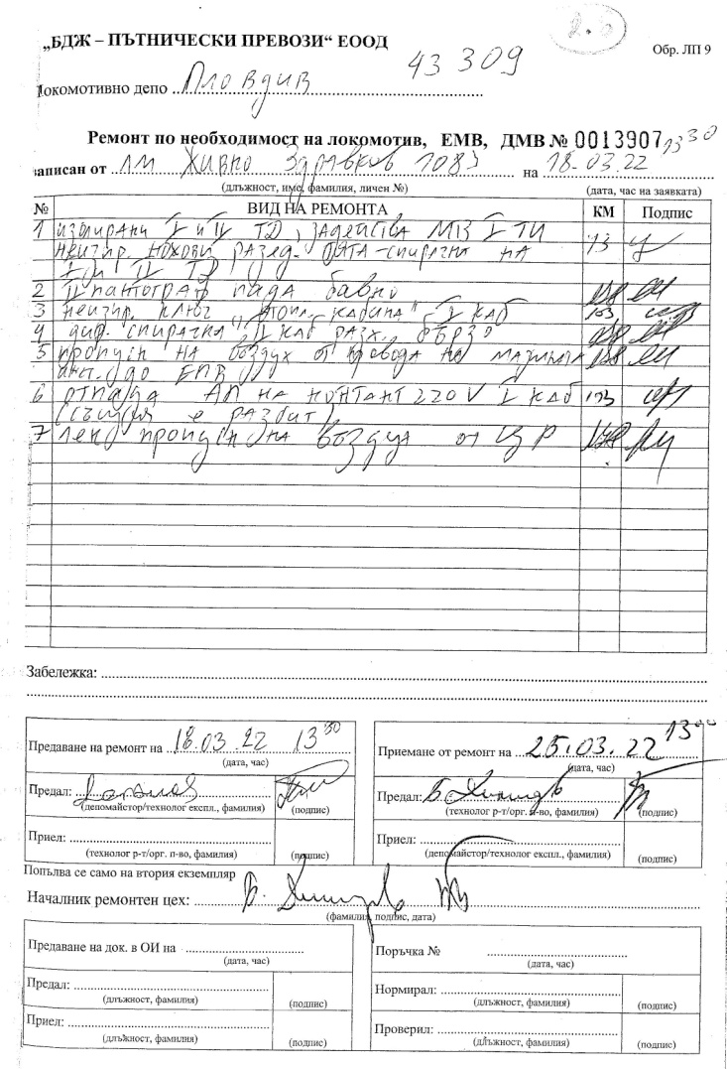
On 18.03.2022 at 13:30 p.m. locomotive № 91520043309-1 was handed over for repair under necessity by the locomotive driver who was the last handled the locomotive with seven malfunctions, found and described in Sample LP-9, under № 0013907, (fig.3.1):
Fig. 3.1
Described malfunctions:
- Insulated first (І) and second (ІІ) traction engine (TE), activated maximum current protection (MCP) of І (first) traction rectifier (TR). Faulty blade disconnectors - traction-brake of І (first) and ІІ (second) traction engine (TE);
- ІІ (second) pantograph got down slowly;
- Faulty heating switch І (first) cabin;
- Direct brake ІІ (second cabin) fast loosening;
- Air leakage from the drive of the lubrication system to the electro-pneumatic valves (EPV);
- Automatic fuse (AF) got down of contact 220 V І (first) cabin. The same was broken;
- Slight air leakage from the centrifugal regulator (CR).
On 21.03.2022, locomotive No. 91520043309-1 was received in the repair shop of Locomotive Depot Plovdiv for eliminating the indicated malfunctions.
On 24.03.2022 at 14:40 p.m., the master of the shop notified the depot master on duty that the locomotive No. 91520043309-1 was ready for repair and could be moved to the 5th track under tension for functional tests to be carried out by the officials before commissioning.
On 24/03/2022 at 3:15 p.m. shunting diesel locomotive No. 98520052003-1 took out locomotive No. 91520043309-1 of the repair shop and then it was placed on the 5th track under catenary to carry out functional tests.
The officials who performed the functional tests of locomotive № 91520043309-1, are:
- Instructor, locomotive driver;
- Repairs Quality Inspector Acceptor (RQIA);
During the performance of the functional tests in the locomotive cabin, participated also:
- Organizer production and repair of RRS – master (affected);
- Deputy Head of operation in Plovdiv locomotive depot.
After 15:38 p.m., RQIA manipulated the locomotive control panel
    - Date, punctual time and location of the event.
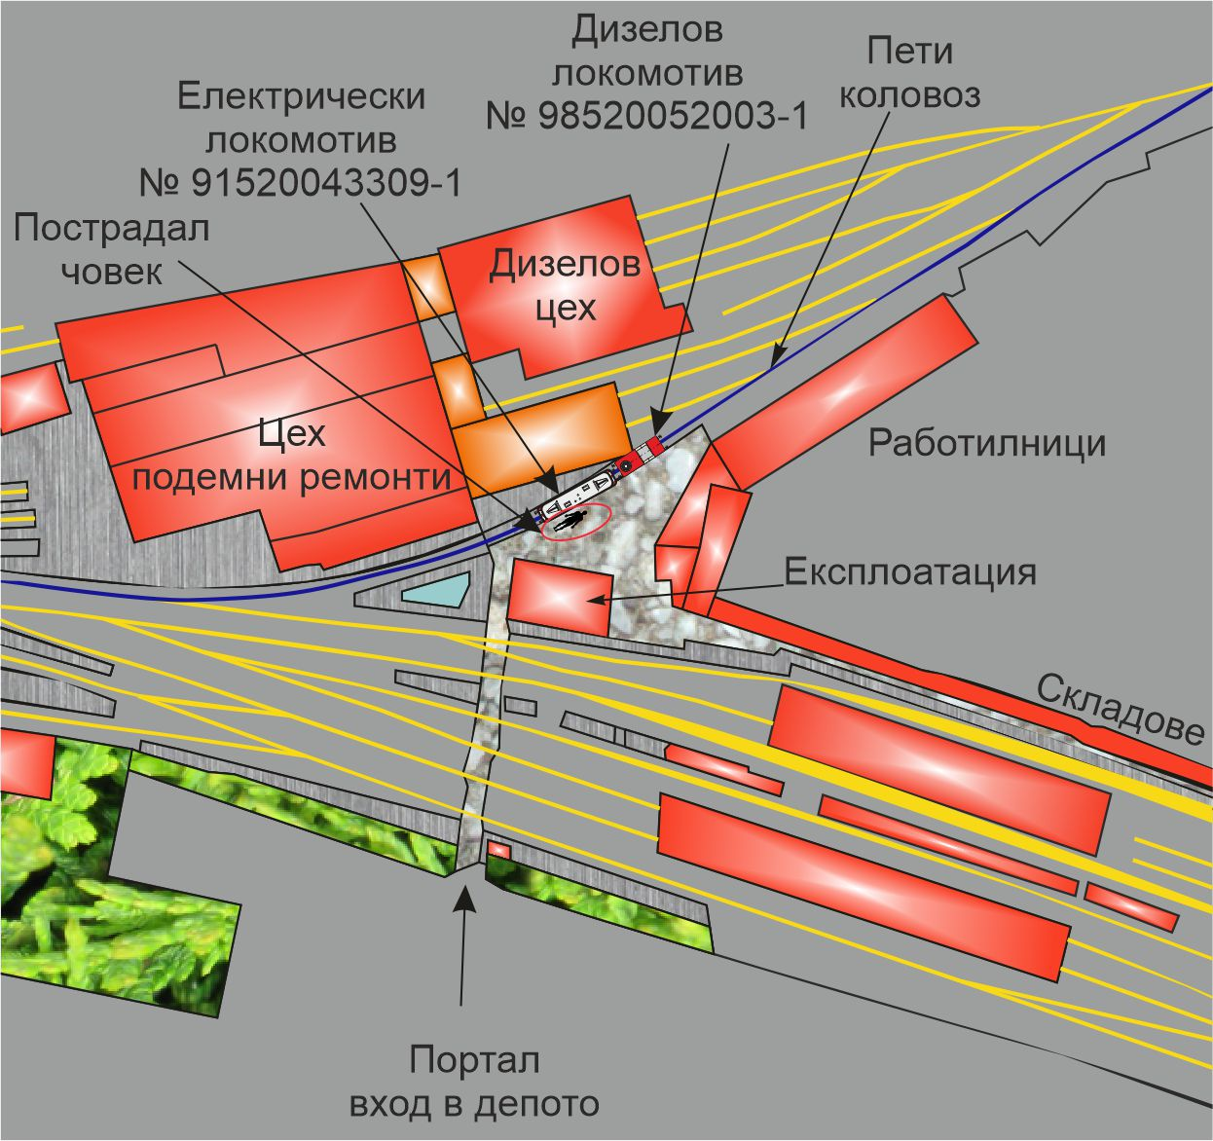
The event occurred on 24.03.2022 at 15:45 p.m. on the fifth track in the area of Plovdiv locomotive depot, which is within the structure of BDZ PS Ltd. (fig. 3.2).
Fig. 3.2. Scheme of Plovdiv locomotive depot with the layout of the two locomotives, the affected one and the main buildings around.
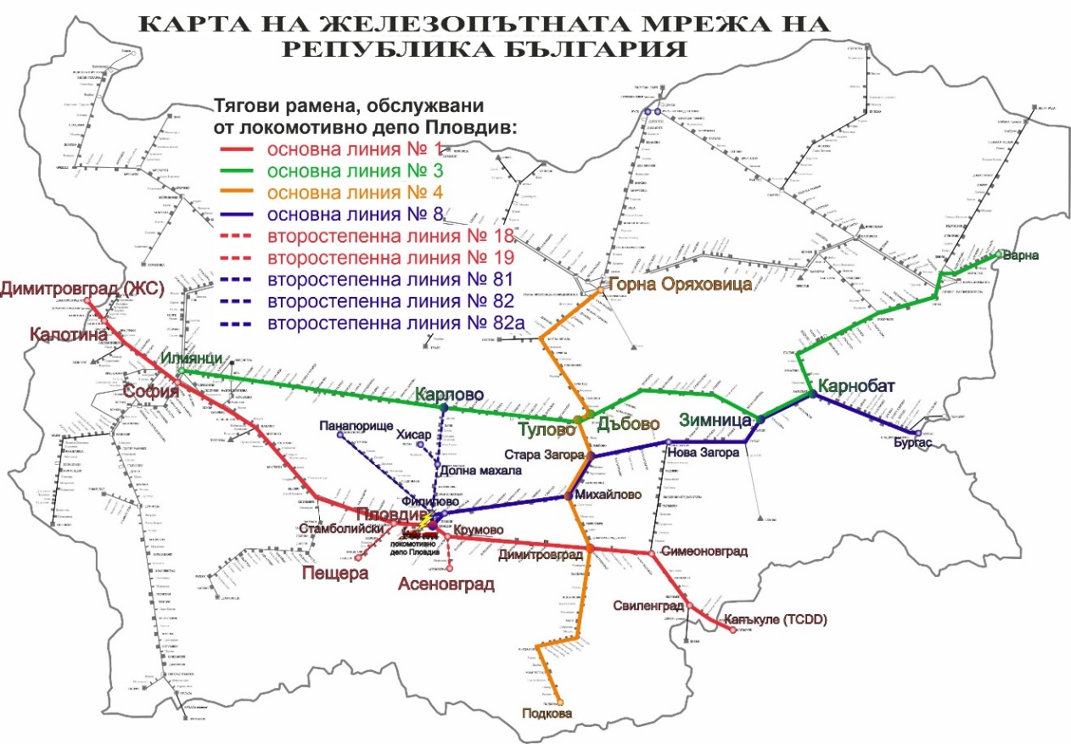
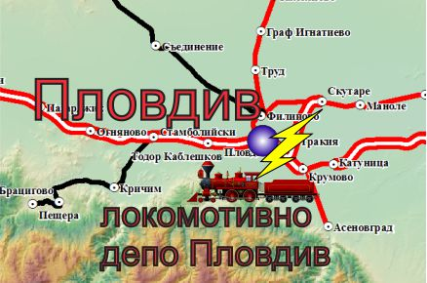
Plovdiv locomotive depot is situated next to Plovdiv station (fig. 3.3), which also services the traction frames along main lines №№ 1, 3, 4, 8 and secondary lines №№ 18, 19, 81, 82 and 82а (fig. 3.4).
Fig.3.4. Traction frames that Plovdiv locomotive depot services.
Fig. 3.3. Map with the location of Plovdiv locomotive depot.

    - Description of the event location:
      - Meteorological and geographical condition at the time of the event.
• The event occurred in the light part of the day, around 15:45 p.m.
• Air temperature: 21°С.
• Wind speed and direction: North-West, 5 km/h.
• Weather – clear, sunny;
      - Performance of construction activities on the site or in vicinity.
Not applicable.
    - Fatalities, injuries and material damages:
      - Employees of the railway undertaking.
Organizer production and repair of RRS, master – fatality.
      - Other persons officially connected with the location of the event.
None.
      - Passengers.
None.
      - External persons.
None.
      - Cargo, luggage or other property.
None.
      - Rolling stock, infrastructure and environment.
None.
    - Description of other consequences, including the event impact on the usual activity of the participants.
None.
    - Identity of the participants and their functions.
Railway infrastructure:
Not applicable.
Railway undertaking:
,,BDZ-Passenger Services“ Ltd. has:
▪ License for performing railway transport services № 151, valid until 30.11.2022;
▪ Safety Certificate Part А BG, valid until 30.12.2022;
▪ Safety Certificate Part B BG, valid until 30.12.2022;
▪ Certificate for ECM BG, valid until 18.04.2026.
Personnel of ,,BDZ-Passenger Services“ Ltd. involved in the accident:
• Inspector of repair quality, acceptor – Plovdiv locomotive depot;
• Locomotive driver, instructor – Plovdiv locomotive depot;
• Head of repair workshop – Plovdiv locomotive depot;
• Deputy Head of operation – Plovdiv locomotive depot;
• Organizer of production and repair of RRS, master – Plovdiv locomotive depot.
    - Description of the respective parts of the railway infrastructure and signalling system:
      - Type of the track, railway switch, rail crossing etc.
The fifth track is a passage track, in curve with radius R=190 m, inclination 0 ‰, with length L=264м. The track connects the Eastern and Western part of Plovdiv locomotive depot with Plovdiv station.
      - Interstation block system, station installation, type of signalling.
Not applicable.
      - Train protection systems.
Not applicable.
    - Other information referring the event.
Not applicable.

  - Factual description of the occurred:
    - Immediate sequence of events that led to the accident, including:
      - Actions that the involved in the event persons undertook
In order to objectify the investigation, the Investigation Commission used the video recordings from a security camera ("nvr_Ploshtad_main_20220324151510_162300") provided by the Ministry of Interior - Plovdiv. The time recorded by the camera differs from the astronomical time, being ahead of it by 2.5 minutes according to the data provided by the security company "TRAFFIC SOT" OOD, which maintains the video surveillance at the Locomotive Depot Plovdiv.
The following chronology of the event was established:
- At 15:20:06 p.m. locomotive № 91520043309-1 was towed by a diesel locomotive № 98520052003-1 and it was established on the 5th track, between the building Operation and repair workshop of Plovdiv locomotive depot (fig. 3.5);
- At 15:20:28 p.m. instructor, locomotive driver with a folder in hand got up in the first cabin of the locomotive (the nearest to the camera). At that time the two pantographs of the locomotive were dropped (fig. 3.6);
- At 15:21:03 p.m. the locomotive instructor from the cabin entered in the engine compartment of the locomotive from the reversing cabinet side, impassable corridor (fig. 3.7).
- At 15:27:13 p.m. the organizer production and repair of RRS, master got up in the locomotive (the affected) (fig.3.8);
- At 15:28:17 p.m. with a cup of coffee in his mouth got up in the locomotive the Deputy head of operation (fig. 3.9);
- At 15:30:13 p.m. in the locomotive got up inspector repair quality, acceptor (fig.3.10);
- At 15:38:15 p.m. on the locomotive driver place sat inspector repair quality, acceptor (fig.3.11);
- At 15:41:02 p.m. organizer production and repair of RRS, master (the affected) got down from the locomotive from the assistant locomotive driver side (fig.3.12);
- At 15:42:28 p.m. organizer production and repair of RRS, master (the affected) got up in the locomotive again from the assistant locomotive driver side with a screw driver in hand and directed straight to the engine compartment in the impassable corridor for eliminating the fault in the contactor for the train heating (fig.3.13);
- At 15:44:32 p.m. the Deputy head of operation with a cup of coffee in his mouth got down from the locomotive (fig. 3.14);
- At 15:45:06 p.m. inspector repair quality, acceptor extended his left hand forward to the console, and then the second pantograph of the locomotive was raised (fig.3.15).
- At 15:45:22 p.m. second pantograph was dropped (fig.3.16).
- At 15:58:45 p.m. arrived an EMC vehicle (fig.3.17).
- At 16:05:00 p.m. the EMC team established the hour of the death (fig.3.18).

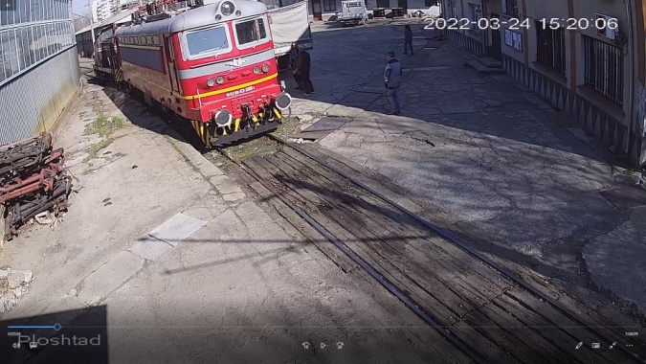 | 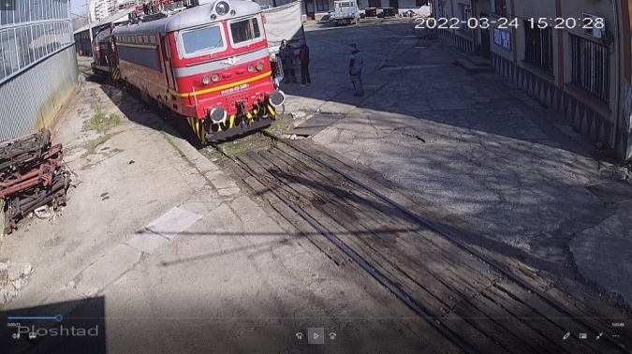
fig. 3.5 | fig. 3.6

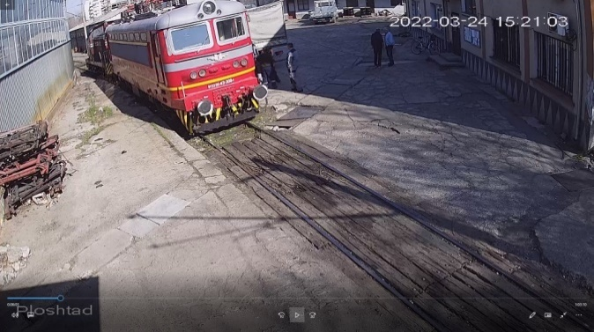 | 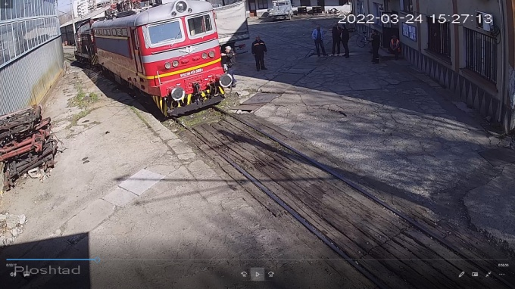
fig. 3.7 | fig. 3.8

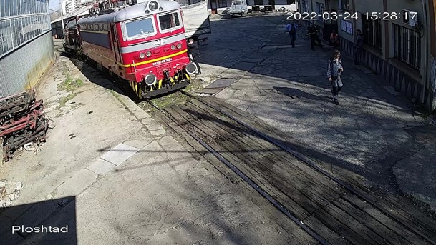 | 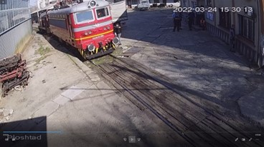
fig. 3.9 | fig. 3.10
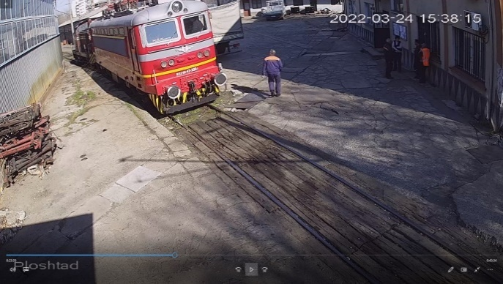 | 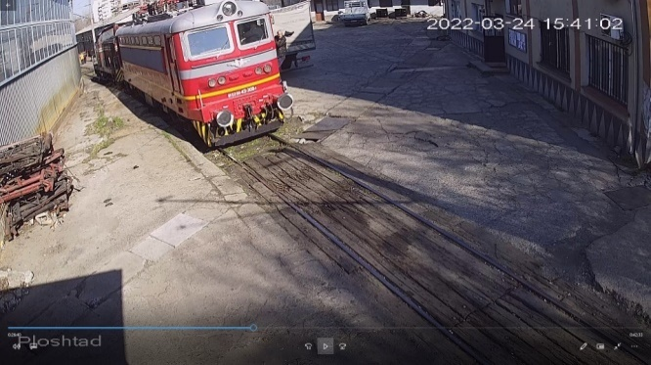
fig. 3.11 | fig. 3.12

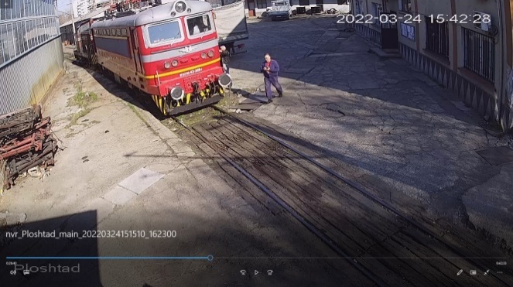 | 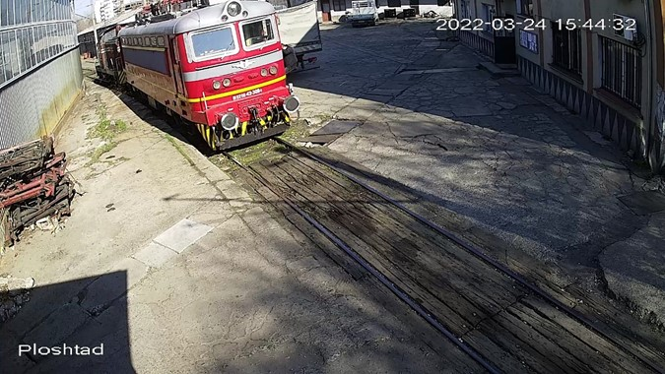
fig. 3.13 | fig. 3.14

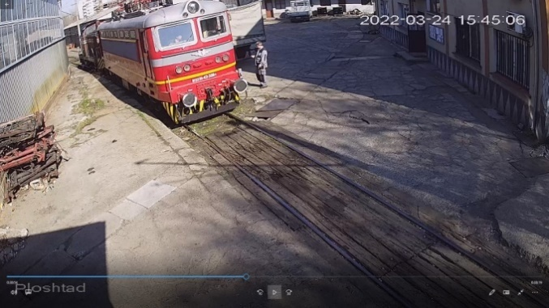 | 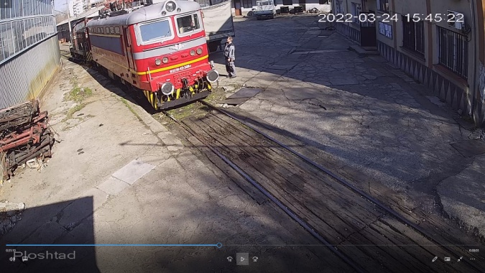
fig. 3.15 | fig. 3.16

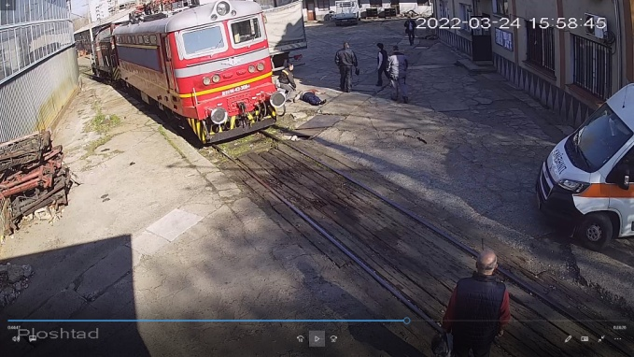 | 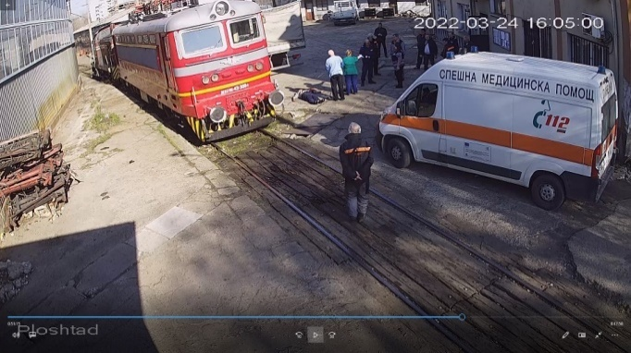
fig. 3.17 | fig. 3.18

      - Rolling stock and technical facilities functioning.
At the moment of the accident, locomotive № 91520043309-1 was positioned on 5th track in the depot for performance of functional tests before commissioning.
3.2.1.3. Operational system functioning.
Not applicable.
    - Sequence of events from the beginning of the accident to the end of the rescue services actions:
      - Undertaken measures for protecting and guarding the event location.
At 16:00 p.m., the authorities of the MI-Plovdiv arrived in Plovdiv Locomotive Depot and, after clarifying the circumstances of the accident, the access of the present employees from the depot was not restricted.
The authorities of the pre-trial proceedings from DID - Plovdiv also arrived on the spot to carry out procedural and investigative actions and inspections under the control of a supervising prosecutor from DPO - Plovdiv.

      - Actions of the emergency rescue services.
After discovering the accident, at 15:46 p.m. an employee from the locomotive depot reported to the national emergency number 112. At 15:55 p.m., another employee called 112 a second time.
From 15:47 p.m. to 15:56 p.m. employees of the locomotive depot, incl. the "Safety and Health at Work" employee tried to provide first aid to the victim - without result;
At 15:58 p.m., a specialized EMC vehicle arrived at the locomotive depot;
In the interval 16:00 ÷ 16:05 p.m. the EMC team made several attempts with various manipulations to help the victim - without result;
At 16:05 p.m., the EMC team determined the hour of the death;

      - Actions of the emergency rehabilitation services.
Not applicable.
- Analysis of the event
  - Participation and responsibilities of the entities, involved in the event:
    - Railway undertaking.
The Investigation Commission got acquainted on the spot with the circumstances that led to the accident (fatal accident), carried out several inspections of the locomotive, and conducted several interviews with employees related to the accident, with the management team of the undertaking and the authorities on safe working conditions. Analysed the regulations related to the repair and operation for the safe work of the personnel.
Main sources of information about the accident are the testimony of the employees and the video recordings taken from the security camera installed at the entrance of the lifting repair workshop, directed to the 5th track. By coincidence, locomotive No. 915243309-1 was positioned on the fifth track between the platform in front of the Operation building and the repair hall in front of the lifting repair workshop. The locomotive was shunted using diesel locomotive No. 98520052003-1 to perform functional tests under pressure.
The events are presented chronologically, with the times indicated in the analysis corresponding to the recording captured by the security camera.
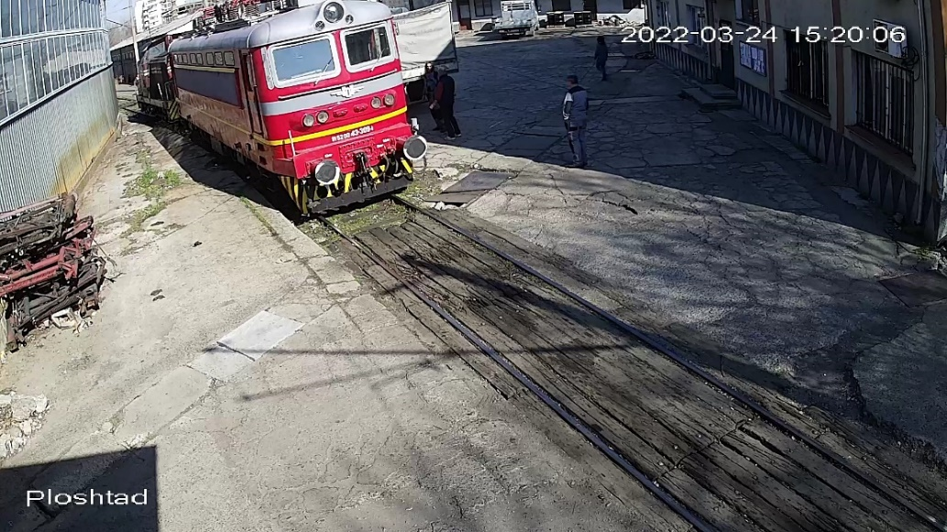
Locomotive № 91520043309-1 was positioned for performance of the tests at 15:20:06 p.m. by diesel locomotive № 98520052003-1 (fig. 4.1).
Fig. 4.1.
At 15:20:28 p.m., an instructor, a locomotive driver, got into the first cabin of the locomotive (close to the camera) (Fig. 4.2). The two pantographs on the locomotive were dropped. Once he was already in the locomotive, he began to perform preliminary checks of the systems: he entered the impassable corridor on the side of the assistant locomotive driver, where the reversing cabinet was located; raised the first pantograph (the one close to the camera), visually checking that it was up, then returned to the control panel, from where he conversed with the head of the repair shop, who was next to the locomotive, and other repair personnel. From the conversation between the instructor, locomotive driver and the head of the repair shop, it became clear that the contactor of the train heating did not turn on (described in the explanations of the instructor, locomotive driver) - a finding that the instructor, locomotive driver established during the inspections, which was made immediately after boarding the locomotive. The head of the workshop ordered the organizer of production and repair of RRS, a master to fix the malfunction in the locomotive.
At 15:27:13 p.m., an organizer of production and repair of RRS, master, dressed in dark blue jump suit, and a black jacket with a yellow horizontal stripe, got into the first cabin of the locomotive on the side of the assistant locomotive driver (Fig. 4.3). After he got into the locomotive, entered immediately in the engine compartment, and headed to the reversing cabinet.
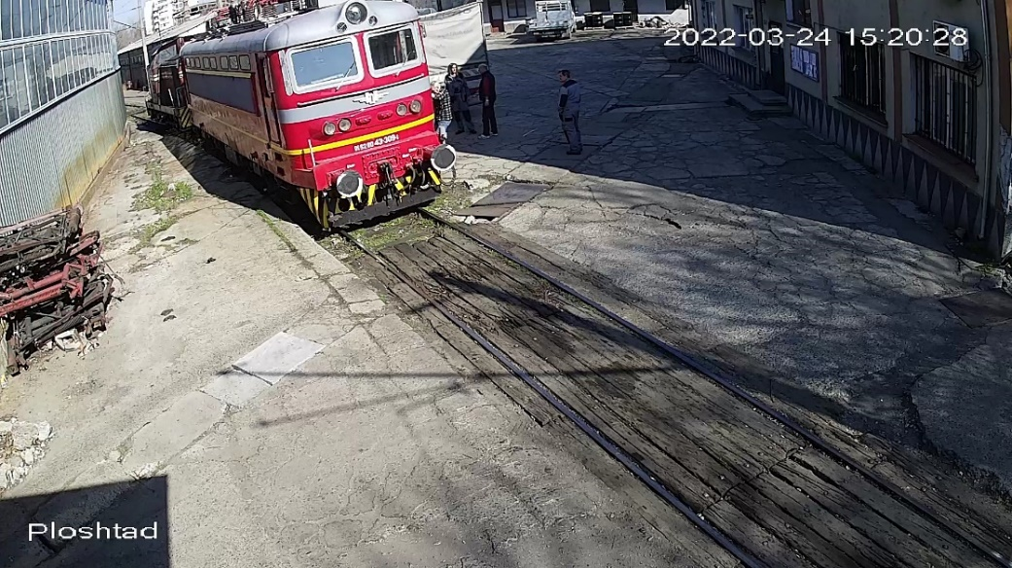
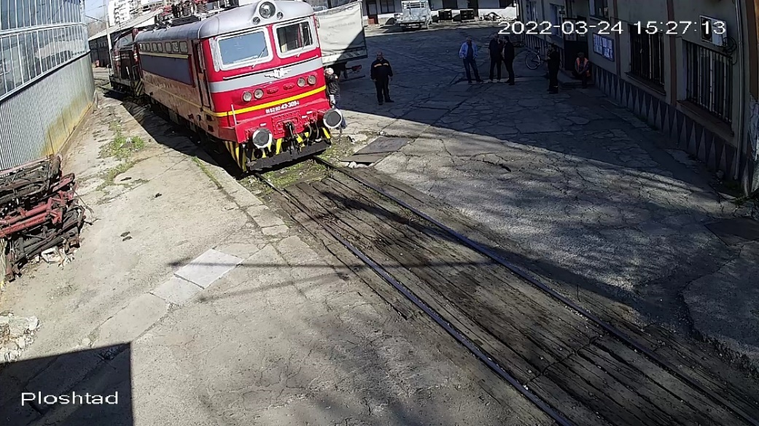
At 15:28:11 p.m. organizer production and repair of RRS, master went out from the engine compartment and had a talk with the instructor, locomotive driver.
Fig. 4.2.
Fig. 4.3.
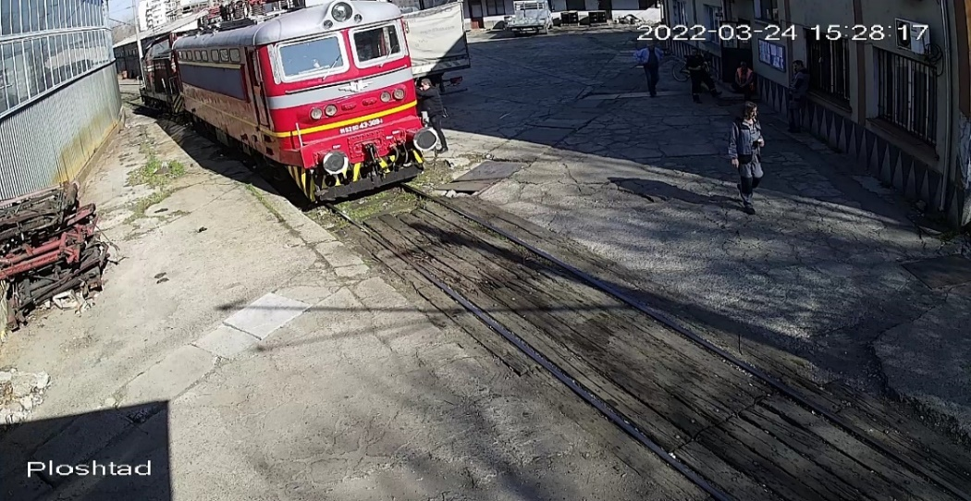
At 15:28:17 p.m. got up also the deputy head of operation in Plovdiv locomotive depot (fig. 4.4).
Fig. 4.4
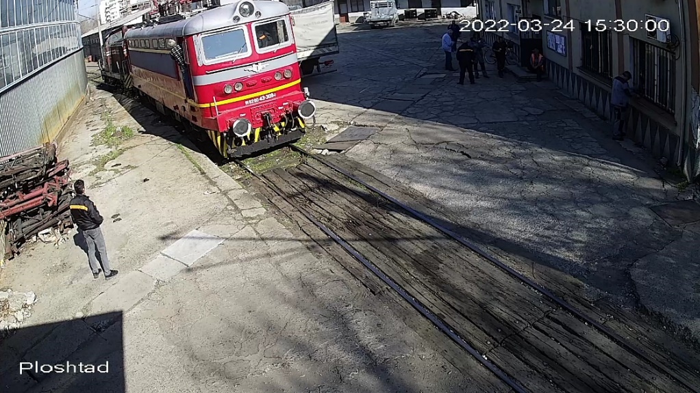
This was followed by repeated lifting and lowering of the two pantographs. At 15:29:51 p.m. and at 15:30:00 p.m., an instructor, a locomotive driver appeared from the driver's seat, apparently to control the operation of the pantographs (fig. 4.5, item 1). At that time, the repair quality inspector - acceptor stood on the platform next to the locomotive and observed the actions of the instructor, the locomotive driver and the operation of the pantographs (fig. 4.5, item 2)
Fig. 4.5.
1
2
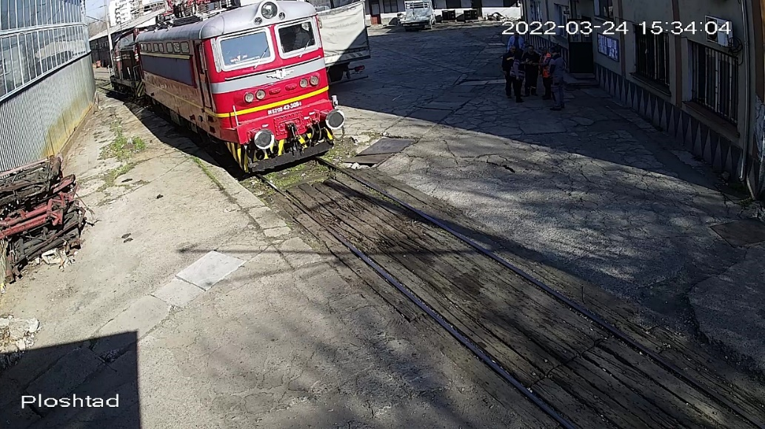
At 15:30:13 p.m., the repair quality inspector, acceptor, got on the locomotive (Fig. 3.9) and headed to the nearby impassable corridor, most likely to check the condition of the apparatus. For 3 minutes and 51 seconds he was in the engine compartment and the camera showed moving figures who were apparently talking and discussing something.
Fig. 4.6.
At 15:34:04 p.m., a repair quality inspector, acceptor, sat in the seat of the locomotive driver, and from that moment on, through the locomotive control panel, he manipulated the operating keys and devices (Fig. 4.6, the yellow arrow).
Actions to carry out the planned functional tests of the locomotive followed, and at that time there were four people in the control cabin.
At 15:41:02 p.m., the organizer of the production and repair of RRS, master got off the locomotive (Fig. 4.7) and went to the electricians' department to bring a screwdriver (according to the testimony of the other employees).
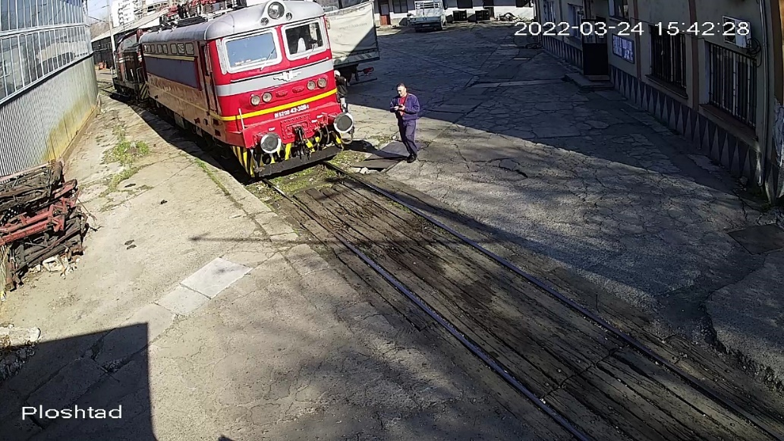
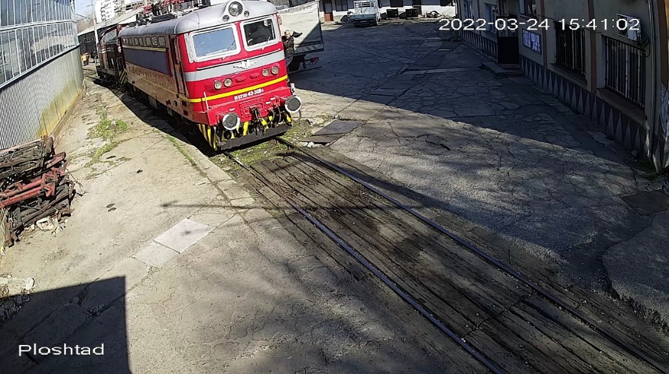
At 15:42:28 p.m. he got on the locomotive again, carrying a screwdriver in his right hand (Fig. 4.8). Entering in the locomotive, he went directly to the engine compartment. The video from the camera does not show him talking to anyone.
Fig. 4.8.
Fig. 4.7.

At 15:42:32 p.m., the deputy head of operation got off the locomotive (fig. 4.9).
During the functional tests carried out by the RQIA, the instructor, the locomotive driver and the repairer of the identified damage to the train heating system - the organizer of production and repair of RRS, master, the presence of the deputy head of the operation of Plovdiv Locomotive Depot in the cabin of the locomotive for 15 minutes is inexplicable, given the compliance with the safety regulations listed in Ordinance No. 13 dated 30.12.2005 for ensuring healthy and safe working conditions in the railway transport.
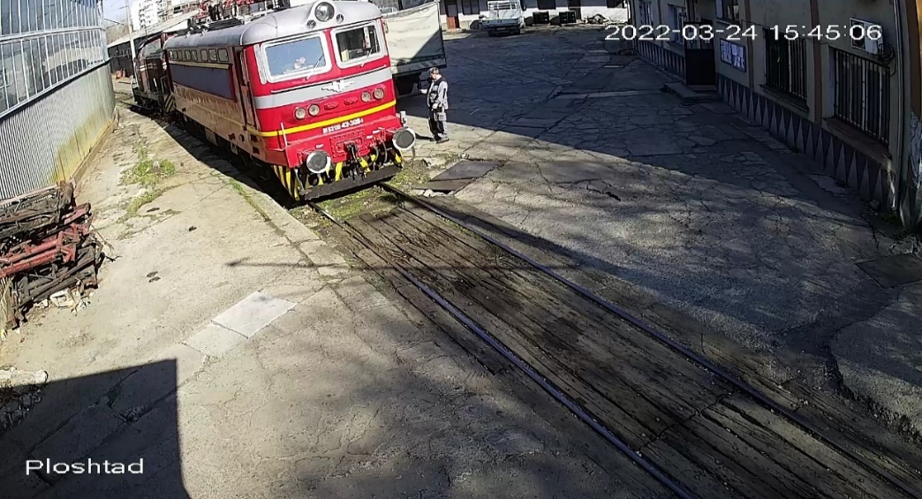
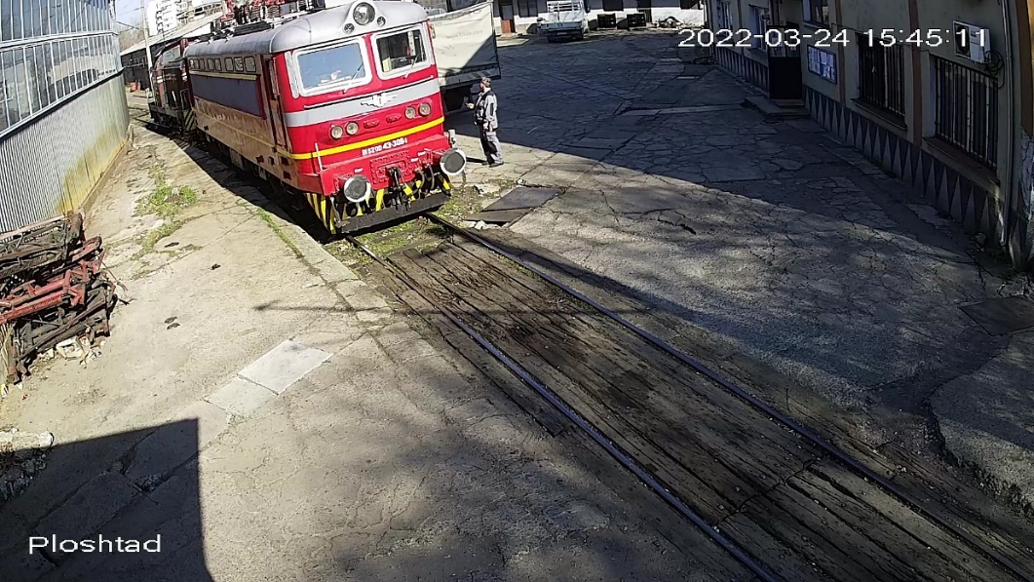
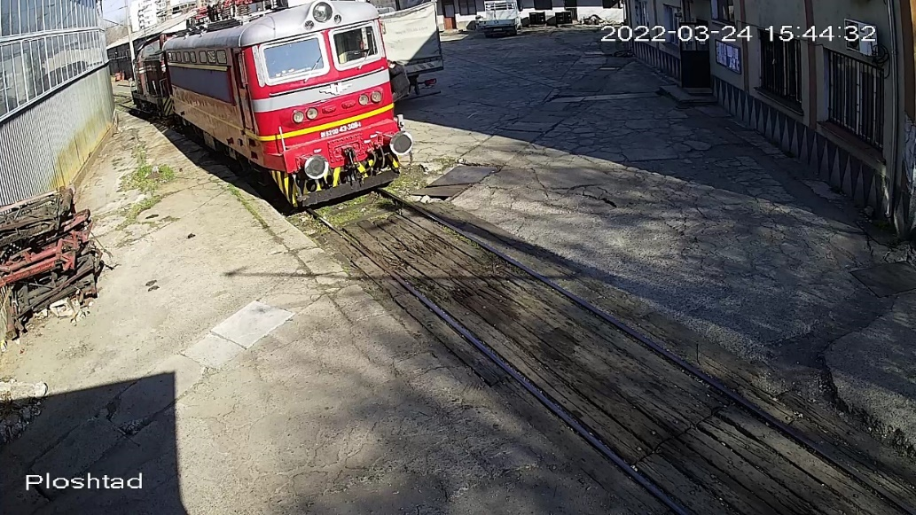
At 15:45:06 p.m. the repair quality inspector – acceptor bended ahead (fig. 4.10, pos. 1) and it is evident that the second pantograph was lifted (fig. 4.10, pos. 2).
Fig. 4.10.
1
3
2
Fig. 4.11.
Fig. 4.9.
The head of repair, who at that time was standing on the platform opposite the the opened door of the locomotive cabin and was looking at something on his phone (Fig. 4.10, pos. 3), turned his head to the right and up in the direction of the second pantograph, apparently noticing its lifting (Fig. 4.11).
At 15:45:22 p.m. the second pantograph was dropped, most likely by tripping the battery fuse.
At 15:45:29 p.m., the head of repair got on the locomotive.
At 15:47:25 p.m., the body of the organizer of the production and repair of RRS was taken down to the platform next to the locomotive.
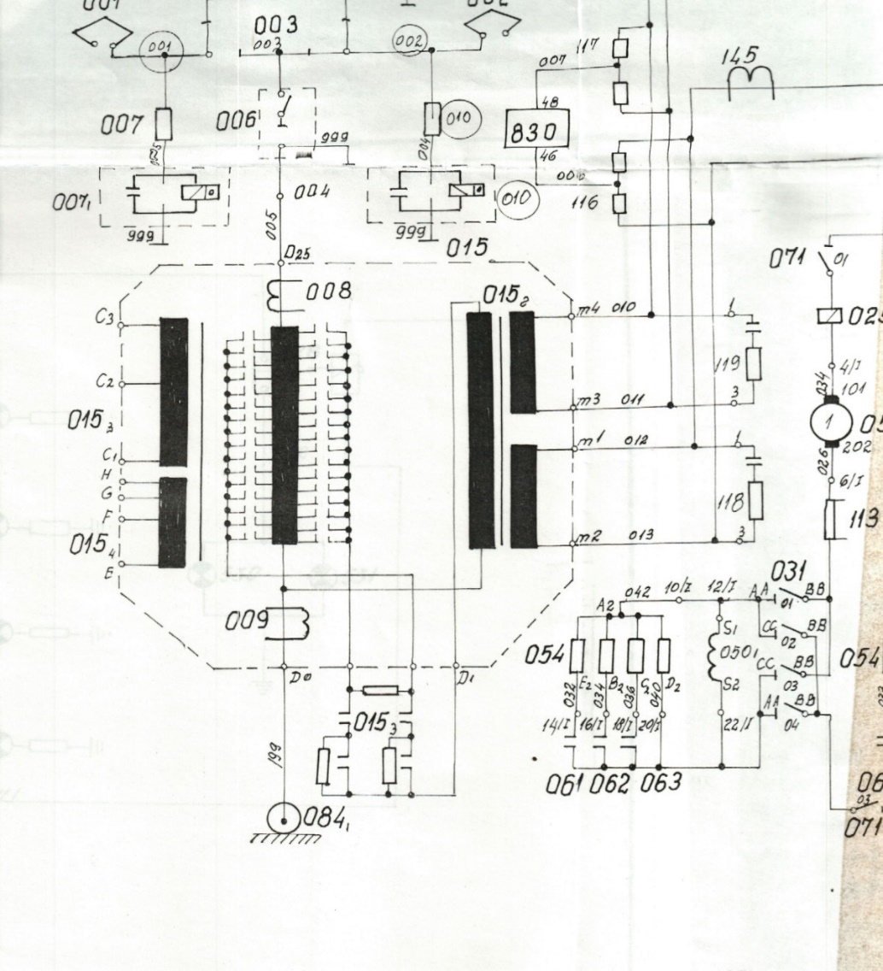
The train heating contactor closed the train heating power circuits, which supply 1500 V alternating current to the heaters in the passenger car compartments.
Fig. 4.12. Part of the power schemes of locomotive 43 with the outputs of the traction transformer for train heating.
They include:
- the coil for train heating 015₃ of the traction transformer;
- the board 700 for switching the terminals of the coil 015₃, the electropneumatic contactor 710;
- the cables with 720 terminals;
- sockets 721 and the current transformers 701 and 702 (fig. 4.12).

The train heating circuit receives voltage from coil 015₃, the voltage between terminals C1 - C2 being 1000 V, and between terminals C1 - C3 - 1500 V. The heaters of the cars are supplied with a voltage of 1500 V, 50 Нz on the circuit: terminal C3 of the coil 015₃, Wire 702, Panel Contact 700, Wire 703, Contactor Power Contact 710, Wire 704, Plug 720, Wagon Socket, Wagon Heaters, Rails, Locomotive Bus Earth 084₁, Wire 199, CT Primary Windings 701 and 702, terminal C1 of coil 015₃.
Fig. 4.13. Part of the train heating control circuits of locomotives series 43 and 44.
1
2
3
4
5
6

The switching on and off the power circuit of the train heating is carried out using the electro-pneumatic contactor 710. In fig. 4.14 is shown the appearance of the electro-pneumatic contactor 710 for the train heating.
The train heating control circuits (operational circuits for the train heating) serve to supply the coil of the EPK 710 and the signalling circuits with a voltage of 48 V. The train heating on and off switches 451 and 452 participate with their contacts in the control circuits (fig. 4.13, pos. 1), the automatic fuses 472 (fig. 4.13, pos. 2, fig. 4.15), the electro pneumatic valve (EPV) 710₁ (fig. 4.13, pos. 3, fig. 4.16), the lock 710₃ (fig. 4.13, pos. 4), the signal lamp 725 (fig. 4.13, pos. 5) and the magnetic pointers 475 and 476 (fig. 4.13, pos. 6, fig. 4.17, pos. 2).

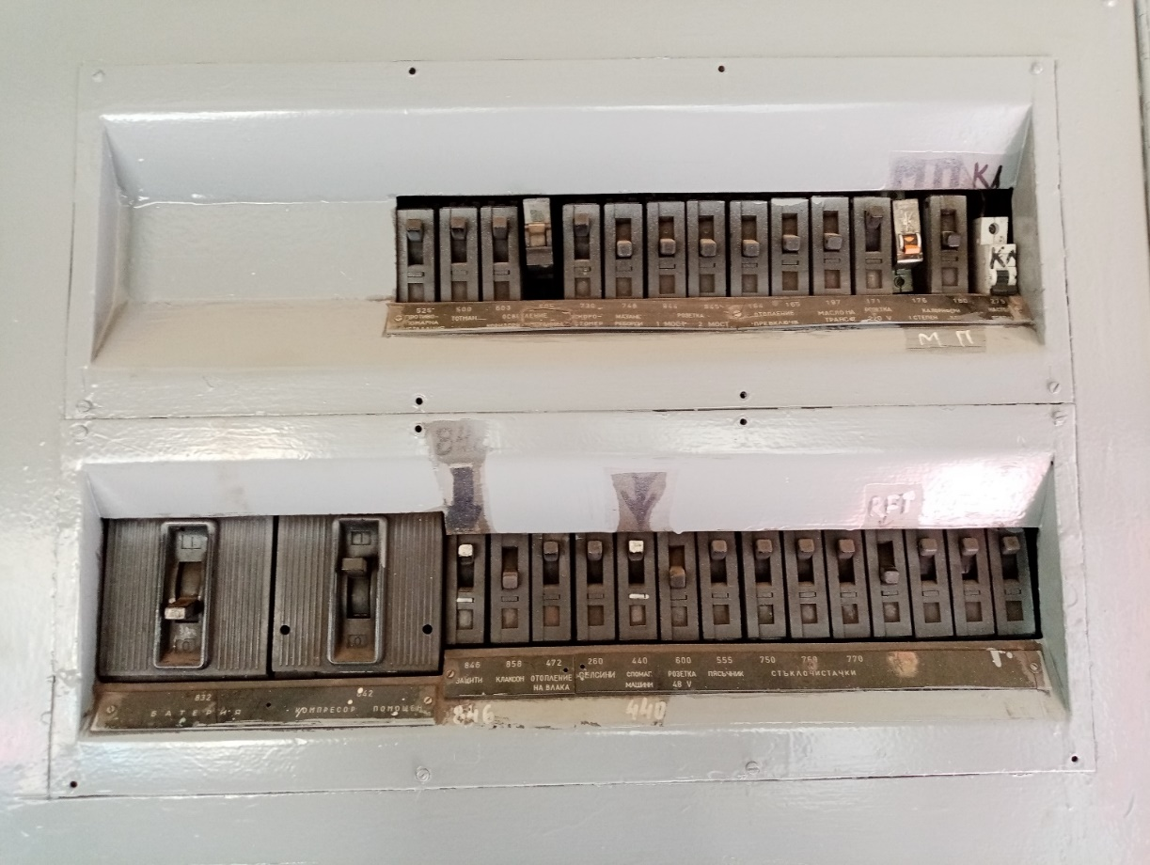
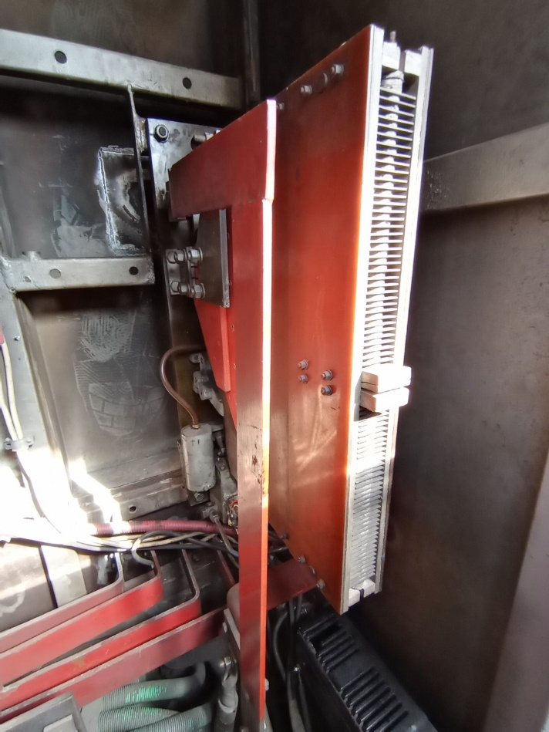
The switches 451 and 452 are turned on and off with a removable handle (fig. 4.17, item 1). It can only be removed when the switch is off. With the same handle, the blind cable head is unlocked, with which the cable is locked with the terminal or the closing cap of the plug socket.
Fig. 4.15. Fuse panel in command cabin 1. Position 1 – automatic fuse for the train heating; position 2 – battery main switch.
1
2
Fig. 4.14. Electrical pneumatic contactor 710 for the train heating.
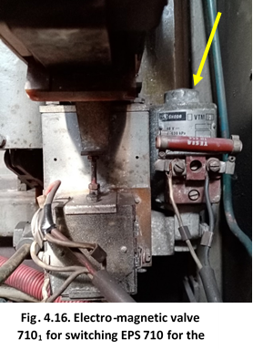

    - Infrastructure manager.
Fig. 4.17.
1
2
Not applicable.
    - Entities in charge of the technical maintenance.
Not applicable.
    - Manufacturers or providers of rolling stock and railway products.
Not applicable.
    - National Safety Authority.
Railway Administration Executive Agency is the National Safety Authority for railway transport in the Republic of Bulgaria.
    - Notified bodies or Risk assessment bodies.
Not applicable.
    - Certifying bodies of the entities in charge of the technical maintenance.
The Railway Administration Executive Agency as the National Safety Authority for railway transport performs certification of the entities in charge of the vehicles maintenance (ECM) in accordance with Directive 2004/49/EC and Regulation (EU) 445/2011, as per Ordinance No 59 on the railway transport safety management and on the maintenance functions in accordance with Directive 2004/49/EC and Regulation (EU) 445/2011.
From June 16, 2020 the RAEA performs certification of the ECM as per the Commission Implementing Regulation (EU) 2019/779 of 16 May 2019 laying down detailed provisions on a system of certification of entities in charge of maintenance of vehicles pursuant to Directive (EU) 2016/798 of the European Parliament and of the Council and repealing Commission Regulation (EU) No 445/2011.

    - Persons or entities involved in the event, documented or not in the respective safety management systems or indicated in register.
BDZ PS Ltd. - Quality Procedure PK-2-15 "Safety Management of Passenger Transportation. Monitoring and information" from 13.12.2018. Methodology for assessing the safety risk in BDZ PS Ltd. from 23.02.2012.
  - Rolling stock and technical facilities:
    - Factors, deriving from the design of the rolling stock, railway infrastructure or technical facilities.
Not applicable.
    - Factors deriving from the installation and placing into service of the rolling stock, railway infrastructure and technical facilities.
Not applicable.
    - Factors deriving from manufacturers or other supplier of railway products..
Not applicable.
    - Factors deriving from the technical maintenance and/or modification of the rolling stock or the technical facilities.
Not applicable.
    - Factors due to the entity in charge of the technical maintenance, workshops for technical maintenance and other technical maintenance service providers.
Not applicable.
    - Other factors or consequences considered as involved within the investigation objectives.
  - Human factor:
    - Individual human characteristics:
      - Training and development, including skills and experience.
  - Deputy head, operation - 22 years of work experience:
    - Diploma reg. No. 0709/11.05.2010, field "Transportation Technique", acquired qualification "Master Engineer", training conducted 2007 - 2010, issued by VTU "Todor Kableshkov" - Sofia;
    - Locomotive driving license BG 71 2016 0550;
    - Certificate No. 288 for the position of "deputy head of operation at PSD Plovdiv, locomotive depot Plovdiv" dated 02.15.2022;
    - Certificate for locomotive driving BG 71 2016 0550;
  - Head of workshop - 23 years of experience:
    - Diploma Reg. No. 75092/07.12.1999, field"General Mechanical Engineering and Instrumentation", acquired qualification "Mechanical Engineer", specialization "Control and Measurement Technology", training conducted 1994-1999, issued by TU Sofia, Plovdiv branch;
• Repair quality inspector, acceptor - 35 years of experience:
    - Diploma No. 23180/19.08.1989, field "Railway technology - electric locomotives", acquired qualification "Engineer-operator in transport - locomotive driver of electric locomotives", training conducted in the period 1986 - 1989, issued by VNVTU " Todor Kableshkov" - Sofia;
  - Locomotive driver - instructor, locomotive - work experience 44 years:
    - Diploma No. 16740/14.07.1978, field "Operation and repair of diesel locomotives", acquired qualification "Technician - locomotive driver of diesel locomotives", training conducted in the period 1975 - 1978, issued by RI "Todor Kableshkov" - Sofia;
    - Locomotive driving Certificate BG 71 2018 1403;
    - Protocol № 304-271-365/16.06.2004 – 30.06.2004 for the position „Locomotive instructor and depot master“, training conducted in the period 16.06.2004 – 30.06.2004;
    - Professional training certificate reg. № 3620-826/10/07/2007, acquired qualification „Locomotive driver of electrical locomotives series 43, 44, 45.000“, training performed in the period 23/04/2007 – 05/06/2007, issued by BDZ Professional Training Center;
  - Organizer production and repair of RRS, master – work experience 36 years:
    - Diploma No. 3553/30.06.1984, field "Electrical equipment of industrial enterprises", acquired qualification "electrician", issued by TET "V. I. Lenin" - Plovdiv.
      - Medical and personal circumstances, which influence the event, including the presence of physical and psychological stress.
- Deputy head of operation:
  - Card for preventive medical examination from 01.04.2021, issued by MTH Plovdiv – conclusion: suitable for deputy head of operation;
- Head of workshop:
  - Card for preventive medical examination from 22.04.2019, issued by MTH Plovdiv – conclusion: suitable for head of workshop;
- Repair quality inspector, acceptor:
- Locomotive driver – instructor, locomotive:
  - Single Health Information Dossier № 543/23.03.2021, issued by NMTH Sofia, conclusion: suitable for locomotive instructor;
- Organizer production and repair of RRS, master:
  - Card for preventive medical examination from 25.06.2020, issued by MTH Plovdiv – conclusion: suitable for electrician;
      - Fatigue.
The personnel involved in the subject's accident worked a full-time, eight-hour day, a 40-hour work week. The requirements for breaks between shifts, according to the normative acts, have been met.
      - Motivation and attitudes related to the human factor.
Not applicable.
    - Work related factors:
      - Tasks planning.
"BDZ-Passenger Services" Ltd. is a licensed railway undertaking for the transportation of passengers according to an approved Plan for composing the trains laid down in the train operation schedule. In addition to transport, the railway undertaking is certified ECM for carrying out types of repairs of its own TRRS and ST in its own locomotive depots, including repairs as necessary, which are carried out in accordance with the requirements of the regulations and instructions for the relevant type of repair.
      - Constructive particularities of the facilities that influence the connection human-machine.
Not applicable.
      - Communication means.
Not applicable.
      - Practices and processes.
Not applicable.
      - Operation rules, local instructions, staff requirements, prescriptions for technical maintenance and applicable standards.
BDZ PS Ltd. implements national and departmental normative acts:
- Ordinance No. 13/30.12.2005 on ensuring healthy and safe working conditions during operational and repair activities in railway transport;
- Ordinance No. RD-07-2/16.12.2009 for the terms and conditions for periodic training and instruction of employees on the rules providing SHWC;
- Quality management system "Repair and maintenance of TPS PK 2-8, Version No. 1" effective from 13.12.2018;
- Regulations for depot repair and maintenance of BDZ electric locomotives;
- Regulations for the organization of repair activities at the Plovdiv Locomotive Depot;
- Instructions for safe work when servicing electric locomotives and locomotives at Locomotive Depot Plovdiv;
- Safety instructions for working with hand-held electric tools, portable lamps and transformers in Locomotive Depot Plovdiv;
- Safety instructions for assembly and disassembly operations in the repair of diesel and electric locomotives and ST;
- Program plan for conducting a weekly briefing at the Plovdiv Locomotive Depot;
- Book for workplace instruction, periodical, extraordinary on safety and health at work.
      - Working time of the involved personnel.
The working hours of the staff are carried out in accordance with the provisions of the Labour Code and Ordinance No. 50 of 28.12.2001. The personnel involved in the entity's accident worked a full-time, eight-hour day, a 40-hour work week. The working hours in accordance with the requirements of the regulatory acts for the management and executive staff, who are engaged in ensuring the transportation of passengers and cargo in railway transport, are observed.
      - Risk treatment practices.
Railway undertaking
“BDZ-Passenger Services” Ltd. implements the following procedures:
- Safety risk assessment methodology in BDZ PS Ltd.;
- Quality procedure PK-2-15 “Management of the safety of passenger transport. Monitoring and exchange of information”;
- Register of hazards in the operation, repair and maintenance of RRS in BDZ PS Ltd.
Railway infrastructure
Not applicable
      - Context, machinery, equipment and indications for shaping the working practices
Not applicable
    - Organizational factors and tasks:
      - Planning of the working force and the working load.
The planning of the work of the personnel directly related to the repair and operation of the RRS and the safety of railway transport is planned in accordance with the requirements of the European and national normative acts, rules, methodologies, instructions and good European practices.
      - Communications, information and teamwork.
Not applicable.
      - Recruitment, staffing requirements, resources.
In BDZ PS Ltd., the selection of personnel is carried out according to an approved "Human Resources Management System", which includes:
- Rules for recruitment and selection of personnel;
- Rules for appointment and changes in employment relationships;
- Rules for staff training and development;
- Rules for ensuring HSWC, Ecology, and organization of the activity of STM. The entity's personnel is selected and appointed with the relevant legal capacity, professional qualifications and skills for working in the management and executive staff.
      - Implementation management and supervision.
Not applicable.
      - Compensation (remuneration).
The entity's personnel, in accordance with the requirements of the national regulations, are on open-ended employment contracts, in which the relevant remuneration and compensations are defined and regulated, individually for each position.
      - Leadership, powers related issues.
Not applicable.
      - Organizational culture.
Not applicable.
      - Legal issues (including the respective European and national rules and provisions)..
Not applicable.
      - Regulatory framework conditions and safety management system application
Railway undertaking.
- Directive (EU) 2016/798 of the European Parliament and of the Council of 11 May 2016 on railway safety;
- Commission Delegated Regulation (EU) 2018/762 of 8 March 2018 establishing common safety methods on safety management system requirements pursuant to Directive (EU) 2016/798 of the European Parliament and of the Council and repealing Commission Regulations (EU) No 1158/2010 and (EU) No 1169/2010;
- COMMISSION IMPLEMENTING REGULATION (EU) 2019/779 of 16 May 2019 laying down detailed provisions on a system of certification of entities in charge of maintenance of vehicles pursuant to Directive (EU) 2016/798 of the European Parliament and of the Council and repealing Commission Regulation (EU) No 445/2011;
- COMMISSION IMPLEMENTING REGULATION (EU) No 402/2013 of 30 April 2013 on the common safety method for risk evaluation and assessment and repealing Regulation (EC) No 352/2009;
- Railway Transport Act;
- ORDINANCE No 59 dated 5.12.2006 on the railway transport safety management.
Railway infrastructure.
- Directive (EU) 2016/798 of the European Parliament and of the Council of 11 May 2016 on railway safety;
- Commission Delegated Regulation (EU) 2018/762 of 8 March 2018 establishing common safety methods on safety management system requirements pursuant to Directive (EU) 2016/798 of the European Parliament and of the Council and repealing Commission Regulations (EU) No 1158/2010 and (EU) No 1169/2010;
- COMMISSION IMPLEMENTING REGULATION (EU) 2019/779 of 16 May 2019 laying down detailed provisions on a system of certification of entities in charge of maintenance of vehicles pursuant to Directive (EU) 2016/798 of the European Parliament and of the Council and repealing Commission Regulation (EU) No 445/2011;
- COMMISSION IMPLEMENTING REGULATION (EU) No 402/2013 of 30 April 2013 on the common safety method for risk evaluation and assessment and repealing Regulation (EC) No 352/2009;
- Railway Transport Act;
- ORDINANCE No 59 dated 5.12.2006 on the railway transport safety management.
- Ordinance No. 7/23.09.1999 on the minimum requirements for health and safety working conditions at workplaces and when using work equipment/SG, no. 88 of 1999;
- Ordinance No. 13/30.12.2005 on ensuring healthy and safe working conditions during operational and repair activities in railway transport.

Railway infrastructure
Not applicable.
    - Environmental factors:
      - Labour conditions (noise, illumination, vibrations).
Not applicable.
      - Meteorological and geographic conditions.
• In the light part of the day – 15:45 p.m.;
• Air temperature 21ºС;
• Wind speed and direction around 5 km/h North-West;
• Weather – clear, sunny;
• Locomotive depot Plovdiv is geographically located in the south-central part of the railway network of the Republic of Bulgaria.
      - Construction works, performed on the spot or in very proximity.
Not applicable.
    - Any other significant factor for the investigation objectives.
Not applicable.
  - Feedback and control mechanisms, including risk and safety management, as well as monitoring processes.
    - Regulatory framework conditions.
Commission Delegated Regulation (EU) 2018/761 of 16 February 2018 establishing common safety methods for supervision by national safety authorities after the issue of a single safety certificate or a safety authorisation pursuant to Directive (EU) 2016/798 of the European Parliament and of the Council and repealing Commission Regulation (EU) No 1077/2012
Commission Delegated Regulation (EU) 2018/762 of 8 March 2018 establishing common safety methods on safety management system requirements pursuant to Directive (EU) 2016/798 of the European Parliament and of the Council and repealing Commission Regulations (EU) No 1158/2010 and (EU) No 1169/2010
ORDINANCE No 59 dated 5.12.2006 on the railway transport safety management.
Ordinance No. 7/23.09.1999 on the minimum requirements for health and safety working conditions at workplaces and when using work equipment/SG, no. 88 of 1999;
Ordinance No. 13/30.12.2005 on ensuring healthy and safe working conditions during operational and repair activities in railway transport.
    - Processes, methods and results from the activities on the risk assessment and monitoring that the involved entities performed:
Railway undertakings.
"BDZ-Passenger Services" Ltd. implements:
- Quality management system PK 2-15 "Safety management of passenger transport. Monitoring and exchange of information." In section 6.7. "SMS implementation control, item 6.7.2. "Periodic control of the implementation of the SMS is carried out through internal audits: monthly and complex. Complex audits are conducted once a year on all safety-related structures."
- In accordance with the requirements of the "Methodology for safety risk analysis and assessment in force from 23.02.2012", the railway undertaking BDZ PS Ltd. has not prepared and submitted monthly reports for the current year, as well as a complex (annual) audit previous year's risk monitoring report.
Railway Infrastructure.
Not applicable.
      - Entities in charge of the technical maintenance.
„BDZ-Passenger Services” Ltd. is a certified ECM.
      - Manufacturers and all other participants.
Not applicable.
      - Reports for independent risk assessment.
No assessment has been made by an Independent Assessor (AsBo) of any changes in operating conditions or factors relevant to the occurred accident.
    - Safety management system of the involved:
      - Railway undertakings.
"BDZ-Passenger Services" Ltd. implements "Methodology for safety risk analysis and assessment", which is an integral part of the Safety Management System.
Railway Infrastructure.
Not applicable.
    - Safety Management System of the entities in charge of the technical maintenance.
Not applicable.
    - Results from the supervision, performed by the National Safety Authority.
The results from the performed audits and inspections referring the functionality of the Safety Management System of “BDZ-Passenger Services” Ltd. as per the requirements of Regulation (EU) 2018/761, Ordinance No 56 and Ordinance No 59 on respect of the specific requirements of the European legislation and national rules for design, maintenance and operation of the managed railway infrastructure demonstrate that the entities maintain SMS and are able to respect the requirements, envisaged in the respective normative documents.

    - Permits, certificates and assessment reports, provided by the National Safety Authority or other Conformity Assessment Bodies:
      - Safety certificates of the involved railway infrastructure managers.
Not applicable.
      - Safety certificates of the involved railway undertakings.
Railway infrastructure
Not applicable.
Railway undertaking
"BDZ-Passenger Services" Ltd. has a Part A Safety Certificate with No. BG 11 2017 0009, valid until 30/12/2022;
"BDZ-Passenger Services" Ltd. has a Part B Safety Certificate with No. BG 12 2017 0009, valid until 30.12.2022;
      - Permits for placing in service of permanently fixed equipment and permits for placing vehicles on the market
Not applicable.
      - Entities in charge of the technical maintenance.
"BDZ-Passenger Services" Ltd. holds a Certificate of ECM with EIN No. BG/31/00 21/ 0001, valid until 18.04.2026 and is responsible for the technical maintenance of the TRRS it operates;
    - Other system factors.
Not applicable.
  - Previous similar cases.
The NAMRTAIB has not investigated accidents of similar nature so far.

- Conclusions
  - Summary of the analysis for the event causes.
Based on the presented facts and the analysis of the events that led to the occurrence of the accident (fatality), the Investigation Commission considers:
The locomotive engineer instructor got into the locomotive cabin alone and performed preliminary functional tests to ensure that the locomotive faults have indeed been eliminated. After running a few tests, he found that the train heating contactor was not turning on and shared this with the head of repair. The latter called the organizer of the production and repair of RRS, a master, ordered him to get in the locomotive and to fix the malfunction. The organizer of the production and repair of RRS, the master got into the locomotive and found that the contactor for the train heating did not turn on. Meanwhile, the Deputy Head of operation and the Quality and Repair Inspector, acceptor, got on the board of the locomotive. According to the testimony of the employees who were in the cabin of the locomotive at that time, the organizer of the production and repair of RRS, a master found the malfunction of the contactor for the train heating and therefore went to the electrician's department to get the necessary tool to remove it - a screwdriver. When re-boarding the locomotive, the organizer of production and repair of RRS, master went to the place of the contactor in the impassable corridor of the locomotive and, kneeling, took actions to restore it to working order (according to his words, quoted by the employees in the cabin, the operational contactor power supply – 48 V was not connected). At the same time, the officials performing the functional tests did not pay attention to the fact that it was located in close proximity to the contactor for the train heating in order to eliminate the fault. At that point, the quality and repair inspector, acceptor lifted the pantograph, which supplies voltage (1500 V, 50 Nz AC) to the train heating contactor. The organizer of production and repair of RRS, master who had not yet finished connecting the operational power supply, found himself under pressure and this led to his death.
The cause for the accident was a series of violations of the regulations on health and safety at work when working with electrical equipment and electrical networks in RRS.
Infringed legal acts:
• ORDINANCE No. 7 dated 23.09.1999 on the minimum requirements for health and safety working conditions at workplaces and when using work equipment:
"Art. 202. par. 2 When carrying out repair work related to risk for workers, organizational and technical measures for safety are implemented:
…
"it. 2. turning off the power supply";
…
"it. 4. implementation of measures against re-inclusion";
• ORDINANCE No. 13 dated December 30, 2005 on ensuring health and safety working conditions in railway transport, Appendix No. 13 to Art. 428, par. 1 "Specific requirements for safety and health in the service of electric locomotives and motor trains for voltage 25 kV and frequency 50 Hz"
item 3. In order to put the electric locomotive or electric motor train under voltage, the following rules are observed:
3.1. there are no persons or objects in the corridors of the locomotive, on the roof and under the locomotive (motor train);
3.2. the doors of the cabin in which the crew is located are closed, but not locked; the doors of the other cabins are locked and the windows are closed'; the outer engine compartment doors of the locomotives are locked;
,,3.3. the cabins and passage corridors are free of extraneous objects';
3.4. all safety doors, girds, cabinet lids are closed;
3.7. the locomotive driver announces loudly "Attention, I am raising the pantograph";
3.8. the locomotive driver performs the command operation to raise the pantograph"
Item 6. When removing a failure or accidental repair in the engine compartment or in an apparatus cabinet (chest) in or under the body-shell, when the electric rolling stock is not under voltage, but the battery is connected, all measures designed by design for the given series are implemented to secure against placing of the composition under tension.
6.1. After the command to turn off the main switch and drop the pantograph, the driver personally checks that the pantograph is dropped.
Item 7. It is forbidden to touch and work on devices, machines, wires when the battery is on.
• ORDINANCE No. 13 of December 30, 2005 on ensuring health and safety working conditions in railway transport, art. 587, para. 2 "Safety requirements for the repair of locomotives and motor trains and wagons are specified in Appendix No. 19 RRS"
"item 36. After the repair of the electric locomotive is completed, the pantograph is raised and the test under high voltage is carried out by persons having the right to drive. The repairman or master is present to check for malfunctions and danger to workers and service personnel. After this preparation, the pantograph lifter loudly announces "I am lifting the pantograph".
"item 38. Pull tests are performed only by the designated officials. The presence in the locomotives or motor trains of persons unrelated to the tests is prohibited.'
  - Undertaken measures after the event occurrence.
BDZ PS Ltd. has issued an alarm bulletin with ex. No. 03-09-323/23.05.2022 regarding the implementation of measures to comply with the normative acts for safe work.
On the basis of Order No. 01-16-253/30.05.2022 of the manager of BDZ PS Ltd., an audit was carried out on the topic "Inspection of the circumstances related to an occupational accident in locomotive No. 91520043309-1 on 24.03.2022 and were undertaken actions by "BDZ-Passenger Service" Ltd. to prevent other accidents with electric current in locomotives". The audit was carried out in the period from 30.05. until 22.06.2022
  - Additional findings.
The state structure of "BDZ Holding" EAD includes two railway undertakings "BDZ Passenger Services" Ltd., and "BDZ-Cargo" Ltd., which own, operate and maintain the same series of locomotives: 43, 44 and 45,000.
BDZ-Cargo Ltd. is a licensed carrier for freight transport, with a valid safety certificate and a valid ECM certificate. Given the investigation carried out, the Investigation Commission considers that the proposed safety recommendations for BDZ PS Ltd. are also applicable to BDZ-Cargo Ltd.
- Safety recommendations
In order to improve the safety in the rail transport, the chairperson of the Investigation Commission at NAMRATIB proposes to the Railway Administration Executive Agency the following safety recommendations adapted to BDZ PS Ltd. and BDZ-Cargo Ltd.
- Recommendation 1 proposes BDZ PS Ltd. and BDZ Cargo Ltd. to conduct an extraordinary briefing for the personnel in the repair and operation of RRS and to be acquainted with the Final Report of the NAMRTAIB on the occurred accident.
- Recommendation 2 proposes BDZ PS Ltd. and BDZ Cargo Ltd. to conduct an updated training for the personnel in the repair and operation of RRS on the safety measures as per Ordinance No7 and Ordinance No13.
- Recommendation 3 proposes BDZ PS Ltd. and BDZ Cargo Ltd. to make amendments and additions to the normative documents regulating the types of repairs of TRS (Regulations for the organization of repair activities in locomotive depots, Instructions for safe work when servicing electric locomotives and motor trains in locomotive depots, Regulations for depot repairs and maintenance of electric locomotives of BDZ and Samples by which TRS is accepted and handed over for repair as necessary).
- Recommendation 4 proposes BDZ PS Ltd. and BDZ Cargo Ltd. to change the work instructions and PLD, which will guarantee increased control by the officials during the performance and acceptance of the repair works, checking of the protective locks of the locomotives, ensuring traceability and personal responsibility.
- Recommendation 5 proposes BDZ PS Ltd. and BDZ Cargo Ltd. to create order and organization after coming out of repair and during operation, upon acceptance of the locomotive, the locomotive crews to check and enter in the logbook the state of all the protective locks of the locomotives.

In accordance with the requirements of Art. 24 (2) of Directive (EU) 798/2016 and Art. 91, para. 3 of Ordinance № 59 of 5.12.2006, the Chairperson of the Investigation Commission in NAMRATIB, provides on 25.07.2022 to the RAEA and to all interested parties a final report containing information on the circumstances and causes that led to the fatal accident with formulated safety recommendations for improving the safety in the rail transport, and avoiding other similar accidents.
The Commission at NAMRTAIB, proposes a final report with safety recommendations on 25.07.2022.

Chairperson:
Dr. Eng. Boycho Skrobanski
Deputy President of the NAMRTAIB AB

