FINAL REPORT

from

investigation of railway accident – derailment of wagons from DFT № 30592 between the stations Yana and Kremikovtsi on 26.07.2022

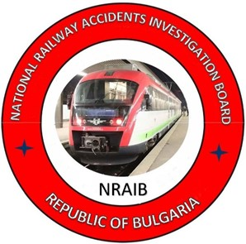

2022

OBJECTIVE OF INVESTIGATION AND EXTENT OF RESPONSIBILITY

The National Air, Maritime and Railway Transport Accidents Investigation Board (NAMRTAIB), which is an independent body performs the investigation of significant accidents, accidents and incidents. The National Board is within the Council of Ministers (CM) of the Republic of Bulgaria, and aims to find the circumstances and causes that led to the accidents and incidents occurrence in order to improve the safety and to avoid such in future.
The investigation, which the NAMRTAIB performed is independent from any judicial investigation, and does not include the determination of fault or responsibility.
The investigation is performed in accordance with the requirements of DIRECTIVE (EU) 2016/798 of the European Parliament and of the Council of 11 May 2016 on railway transport safety, the Railway Transport Act (RTA), Ordinance No59 dated 5.12.2006 on the rail transport safety management, as well as per Agreement dated 17.04.2018 on the interaction during investigation of accidents and incidents in the air, maritime and railway transport between the Prosecutor's Office of the Republic of Bulgaria, Ministry of Interior, and the Ministry of Transport, Information Technology and Communications.
The Investigation reports follow the requirements of REGULATION (EU) 2020/572 of the Commission dated 24 April 2020 on the reporting structure for railway accident and incident investigation reports.

TABLE OF CONTENTS

№ | Title of section | Стр.
 | Summary | 5
 | Investigation | 9
 | Description of the event | 12
 | Analysis of the event | 24
 | Conclusions | 45
 | Safety recommendations | 47

ABBREVIATIONS, USED IN THE REPORT

IFT – International fast train
IDFT – International Direct Freight Train
DFT – Direct freight train
SE NRIC – State enterprise „National railway Infrastructure Company “(railway infrastructure manager)
„Rail Cargo Carrier-Bulgaria” EOOD – Railway undertaking for freight transport
RS – Railway section
SHWC – Safe and healthy working conditions
RTA – Railway Transport Act
TOU – Traffic organization unit
IPT – Intercity Passenger Train
km – Kilometre along the rail track
OCL – Overhead contact line (catenary)
ECM – Entity in Charge of Maintenance
Ordinance № 59 – Ordinance on the rail transport safety management
Ordinance № 58 – Ordinance on the rules of technical operation, train movement and signalling in the rail transport
NAMRTAIB – National Air, Maritime, and Railway Transport Accidents Investigation Board (Independent Specialized National Investigation Body
RAEA/NSA – Railway Administration Executive Agency, National Safety Authority
TF – Task Force
SE – Signalling equipment
ABS – Automatic Block System
RRS – Rail Rolling Stock
TOMR – Train operation management and reporting
MoI – Ministry of Interior
SDoI – Sofia Directorate of Interior
MUS – “Multi units” System
SMS – Safety Management System
TMWI – Technician-mechanic wagon inspector
TOSAMD – Train operation and station activity management Division
DCCM – Device for communications, connections and messages in stations
WRD – Wagon repair depot
- Summary
  - Brief Description of the Event.
On 26.07.2022 at 12:30 p.m., DFT No 30592, assigned by telegram/timetable No.131/26.07.2022 of SE NRIC, departed from Plovdiv marshalling yard with a route from Plovdiv marshalling yard to Iliyantsi station at the request of the railway company "Rail Cargo Carrier - Bulgaria" EOOD. The train was operated by the railway undertaking "Rail Cargo Carrier - Bulgaria" EOOD, with a route Svilengrad - Plovdiv - Karlovo - Iliantsi, consisting of 20 loaded wagons, types R and S, 80 axles, 1566 tons, 387 meters, with a train locomotive No. 918111161116 and auxiliary locomotive in head No. 918111162593. The two locomotives operated on a multi-unit (MUS) system and the control was from the first locomotive with a locomotive crew, first-person locomotive driver and second-person locomotive driver. DFT No. 30592 arrived at Karlovo station at 14:20 p.m. and at 14:37 p.m., after reversing the direction of travel, the train departed. It arrived at Pirdop station at 15:36 p.m. to meet PT No 30113, operating under schedule. DFT No. 30592 departed from Pirdop station at 15:54 p.m. The train passed Stolnik station without stopping at 16:50 p.m., it passed Yana station without stopping at 16:56 p.m., and at the Yana - Kremikovtsi interstation at km 19+041 at 17:01:13 p.m., five wagons of the train composition derailed, causing a break and the train stopped at 17:01:43 p.m. After the performed inspection, the locomotive crew found that the train was separated in two places (the wagons were in three parts) and five wagons at the end of the train had derailed, they informed the traffic manager on duty in Yana station and the train dispatcher of the railway line (Fig. 1.1).
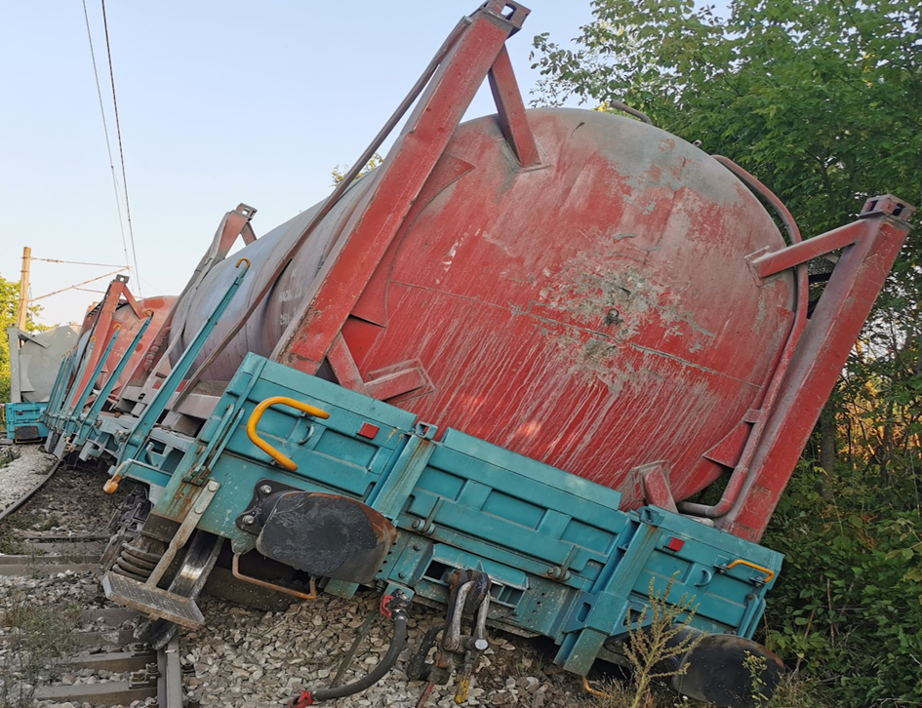
The wagons of the train are flat, loaded with container/tanks full of cement. Because of the derailment, about 100 m of the rail track were destroyed (fig. 1.2), the derailed wagons were also damaged (fig. 1.3).
Fig. 1.1. Five wagons derailed of DFT № 30592.
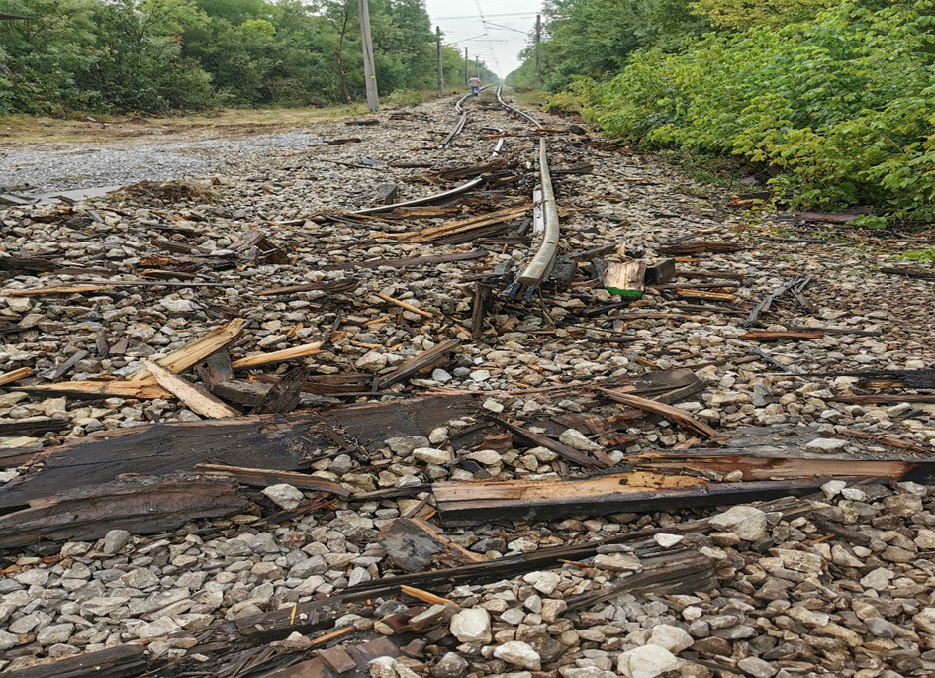
On 26.07. and 27.07.2022 the derailed five wagons in Yana-Kremikovtsi interstation were lifted and transported in the stations Yana and Kremikovtsi.
Fig. 1.2. Damages caused to the rail track because of the derailed train.

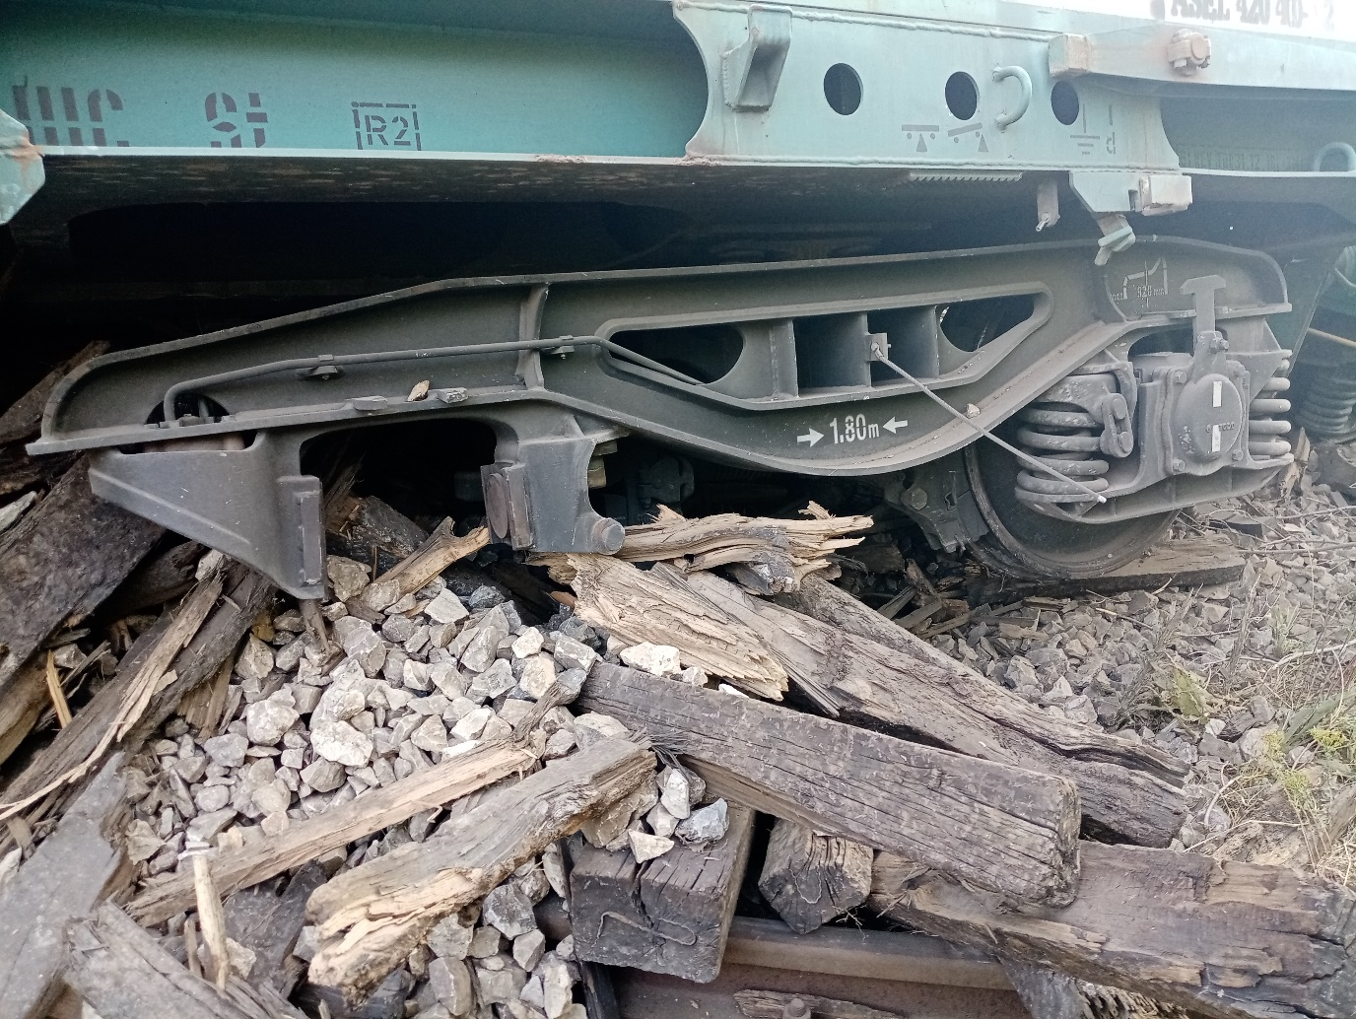
Fig. 1.3. Damages caused to the wagons as a result from the derailment.
Fig. 1.4. Scheme of the derailment of DFT № 30592 in Yana-Kremikovtsi interstation
at km км 19+041, drawn by SE NRIC.

Train operation
Direction
Yana station
Kremikovtsi station
Direction of the mileage
The train operation between Yana and Kremikovtsi stations was interrupted from 17:20 p.m. on 26.07.2022 until 15:00 p.m. on 29.07.2022, it was restored at a speed of 25 km/h on 30.09.2022, the movement of trains was restored at a speed of 40 km/h according to the Tables with technical parameters and regulations (appendix to book timetables) of SE NRIC.
  - Location and time of the event occurrence.
The event occurred on a straight-line section between Yana and Kremikovtsi stations at km 19+041 at 17:01 p.m. on 26.07.2022 (Fig. 1.4).
Yana and Kremikovtsi stations are located on the third main conventional railway line Iliantsi – Karlovo – Tulovo – Dabovo – Karnobat – Sindel – Varna ferry, single-track line, electrified, with speeds up to 130 km/h (Fig. 3.1).
  - Factors determining and contributing the event.
The determining factor for the occurrence of the accident was the operation of the rail track with detected malfunctions in the superstructure in the derailment area.
A contributing factor to the occurrence of the accident was the high daytime temperatures, which caused longitudinal displacements (sliding) of the rails of the continuously welded track and complete "closing" of the thermal gaps in the continuously welded track, which is on a wooden sleeper grid.
A system factor for the occurrence of the accident was overdue repairs over time, which were not carried out in accordance with the norms of maintenance and repair of the rail track, which contributed to the deterioration of its technical condition. The implementation of the repairs on the rail track has been delayed in accordance with the requirements of the "Instruction for Fixed Tangible Assets", a part of the SMS of SE NRIC.
  - Direct causes and consequences of the event.
The accident occurred because of a combination of factors. The high temperatures in the rails caused their longitudinal displacement, combined with the dynamic forces induced by the passing freight train, which resulted in the track distortion under the train in the zone of the transition from continuously welded track to jointed track. The lower resistance of the rail track on wooden sleepers compared to that on concrete sleepers has resulted in rail distortion in the derailment area.
  - Safety recommendations and addressees to which they are addressed.
In order to prevent other similar accidents, the Investigation Commission proposes to the National Safety Authority RAEA safety recommendations related to “Rail Cargo Carrier Bulgaria” EOOD and SE NRIC.
- Recommendation 1 proposes that SE NRIC and "Rail Cargo Carrier - Bulgaria" EOOD shall acquaint the interested personnel with the contents of this report.
- Recommendation 2 suggests that the Railway Administration EA analyses and evaluates the functioning of the Safety Management System of the SE NRIC in terms of operation, maintenance and repair of the rail track, and the transitions between the continuously welded and jointed track.
- Recommendation 3, suggests that the SE NRIC restore the whitewashing of the continuously welded rail track during the summer season in order to limit the increase in temperatures in the rails due to the solar heating.
- Recommendation 4, suggests that SE NRIC plan and carry out repairs of the rail track in the interstation Kremikovtsi - Yana, guaranteeing the traffic safety.

- Investigation
  - Decision for starting the investigation.
The decision to initiate the investigation was taken by the member of the Management Board of the NAMRTAIB in the Republic of Bulgaria, leading the investigation of railway accidents and incidents given the severity of the accident and its impact on railway transport safety. The investigation is mainly focused on the analysis and organization, which aims to prevent serious accidents.
  - Motives for the decision to initiate the investigation.
The member of the Management Board of the NAMRTAIB, leading the railway unit takes the decision to initiate the investigation based on art. 20, paragraph 2 of Directive (EU) 2016/798, art. 115к, paragraph 1, item 2 of RTA, and art. 76, par. 1, item 2 of Ordinance No 59 dated 5.12.2006.
  - Scope and restrictions of the investigation.
The scope of the investigation examined and analysed the human factor, the railway system related to the safety of rail freight transport and the repair and maintenance of the railway infrastructure and the safety management system (SMS).
The investigation is undertaken taking into account the circumstances and causes that led to the occurrence of the accident - derailment of five wagons from DFT No. 30592, which resulted in significant material damage to the rail track and RRS.
  - Competences of the persons, involved in the investigation.
The member of the Management Board of the NAMRATIB, head of railway transport field headed the Investigation Commission. The composition of the commission includes external independent experts - habilitated persons from the scientific circles and experts with qualification and professional orientation in fields of activity – human factor, railway infrastructure, and rail rolling stock.
  - Communication and consultations with the persons and entities, involved in the event.
The Commission determined the parameters of the investigation and coordinated its actions with the Task Force, which includes representatives of the two entities ("Rail Cargo Carrier - Bulgaria" EOOD and SE NRIC). The Task Force collected all the documents and samples, written statements of the personnel of the entities, the records from the recording devices of the train locomotive No. 918111161116 and auxiliary locomotive in the head No. 918111162593, hauling DFT No. 30592. The materials and documents were handed over to the Chairman of the Investigation Commission at the NAMRATIB. The Chairperson of the Investigation Commission conducted an on-site interview with the locomotive staff, the traffic managers on-duty in Yana and Kremikovtsi stations, the head of the railway section responsible for the repair and maintenance of the rail track involved in the accident. Additional information regarding the repair and maintenance of the rail track at the mentioned interstation was requested and provided by SE NRIC. "Rail Cargo Carrier - Bulgaria" EOOD was requested and provided information on the repair and maintenance of the locomotives and wagons of the train. Interviews were conducted with the safety authorities of the two entities and with the management of the railway undertaking "Rail Cargo Carrier - Bulgaria" EOOD and the SE NRIC.
  - Degree of cooperation from the participating entities.
During the investigation, the managers of the railway undertaking "Rail Cargo Carrier - Bulgaria" EOOD and the representatives of the SE NRIC provided full assistance and a complete set of all the necessary materials and documents to the Commission in the NAMRATIB. Full access was provided during the measurements of the derailed rolling stock and to the elements of the rail track during the measurement of its parameters.
  - Methods and techniques of investigation and analysis.
On 26.07.2022 at 17:30 p.m., the member of the Management Board of the NAMRATIB with the competence to investigate railway accidents received a verbal notification on the mobile phone from the Chief Safety Inspector of the SE NRIC. At 17:50 p.m., there was an SMS notification from the officials on duty of the railway infrastructure manager SE NRIC about an accident that had occurred - the derailment of DFT No. 30592. The member of the Management Board of NAMRATIB analysed the information received and immediately left for the place of the accident. He ordered to the two entities (SE NRIC and "Rail Cargo Carrier - Bulgaria" EOOD) to take no other actions and to maintain the situation of the accident until arriving at the place.
At 19:00 p.m., the member of the Management Board of NAMRATIB arrived at the place of the accident between Yana and Kremikovtsi stations with three external experts. Primary surveys and preparation of photographic material of DFT No. 30592 and the rail track were undertaken. When inspecting the train, it was found that it was broken in two places, the first group with the two locomotives and 12 wagons did not derail, stopped at km 18+477, after breaking the screw coupling between the 12th and 13th wagon (stopped at km 18+823), did not derail and after breaking the screw coupling between the 14th and 15th wagons (derailed with all the wheel-sets, and laid to the left, stopped at km 18+938), the 16th wagon derailed with all the wheel-sets, the 17th wagon derailed with all the wheel-sets and laid to the right, 18th wagon derailed with all the wheel-sets, 19th wagon derailed with the first wheel-set, and 20th wagon (not derailed, stopped at km 19+055). The wagons have visible severe deformations on the undercarriage and some with deformed frames; the damages are described in detail in the protocol of findings for each wagon.
In the train's direction of travel, the derailment occurred 9 m after the transition from continuously welded track S 49 type on concrete sleeper gird to jointed track on wooden sleeper gird. In the area of the derailed five wagons, for about 110 m of the track of S 49 rail type on wooden sleeper grid was completely destroyed, and the right rail in the direction of movement was severely deformed and bent with a radius of 6 meters from the axis of the rail track.
Inspections were carried out of the overhead contact line - unaffected by the accident.
Inspections were carried out of the signalling equipment - unaffected by the accident.
Due to non-compliance with the Safety Procedures of the two entities, the notification to the Ministry of Internal Affairs authorities on the national telephone number 112 was made at 20:40 p.m., which delayed the overall organization of the inspection of the accident in the daylight by the authorities of the pre-trial proceedings and the restoration of the railway infrastructure.
Around 22:15 p.m., authorities from the Internal Security Service of the Ministry of Internal Affairs, an investigating police officer and security police arrived at the place of the accident. At the place of the accident, new joint inspections were organized and conducted with the representatives of the pre-trial proceedings from the SDoI. On the spot, the investigating police officers from the SDoI took statements from the personnel of the two entities, tests of the locomotive crew for alcohol and narcotic substances, which were negative. After the performed procedural-investigative actions with a protocol for inspection of the place of the accident from 26.07.2022, a pre-trial proceeding was initiated under the inventory of the "Investigation of transport crimes" sector - "Investigation" department at the Ministry of Internal Affairs. The established proceedings were under the supervision of the Sofia District Prosecutor's Office. An organization has been created for follow-up actions and exchange of information between the bodies of the pre-trial proceedings from the SDoI and the chairperson of the Investigation Commission from the NAMRATIB.
At 23:05 p.m., after the on-site inspections were completed, the member of the Management Board of NAMRATIB (Chairperson of the Investigation Commission) gave written permission to the head of the Task Force to carry out emergency recovery activities by SE NRIC and Rail Cargo Carrier - Bulgaria" EOOD.
At 23:25 p.m., after the completion of the procedural-investigative actions by the pre-trial proceedings bodies from the SDoI, written permission was given to the SE NRIC to carry out emergency restoration activities.
After the permissions were given, SE NRIC and "Rail Cargo Carrier - Bulgaria" EOOD created an organization to lift the wagons on the rails and one part of them was taken to Yana station and the others to Kremikovtsi station.
On 27.07.2022, the Investigation Commission went to the place of the accident, where new inspections of the technical condition of the rail track before the point of derailment were carried out and established the point of derailment of the first derailed wagon (15th wagon of DFT No. 30592), which dragged four more wagons behind it, which also derailed. The complete destruction of the rail track under the composition of the derailed wagons caused the train to break in two places.
On 27.07.2022, two of the wagons with the most severe damage, the container/tanks were reloaded onto a motor vehicle and taken to the Iliantsi cargo receiving station.
On 08.08.2022, written permissions were given by the Chairperson of the Investigation Commission and by the authorities of the pre-trial proceedings from the SDoI to the Ministry of Interior for the removal of three of the derailed wagons from the Yana and Kremikovtsi stations to the Poduyane Wagon Repair Depot.
On 10.08.2022, inspections and measurements of the parameters of the wagons were carried out at the Poduyane Wagon Repair Depot, and protocols of findings were prepared for their technical condition.
On 31.08.2022, at the site of "RVP Sofia" EOOD, two of the most severely derailed wagons were inspected, the parameters of the wagons were measured, and protocols of findings were drawn up for their technical condition.
On 01.09.2022, the chairperson of the Investigation Commission in the NAMRATIB received from the head of the Task Force in the Regional Inspectorate "Safety of Transportation" - Sofia the collected materials, documents and material evidence (including photographic material) regarding the railway accident - derailment of DFT No. 30592 at the Yana - Kremikovtsi interstation on 26.07.2022.
On 05.09.2022, written permissions were given to the railway undertaking "Rail Cargo Carrier - Bulgaria" EOOD and to the SE NRIC by the Chairperson of the Investigation Commission, and the authorities of the pre-trial proceedings from the SDoI to the Ministry of Interior for the release of the wagons from supervision and their provision to the Turkish Railways Administration TCDD (wagon owner).
  - Difficulties faced during the investigation.
During the investigation, the Investigation Commission of the NAMRATIB did not encounter any difficulties. The representatives of the Task Force and the safety authorities of the Railway Infrastructure Manager and the Railway Undertaking provided full cooperation to the Investigation Commission.
  - Interaction with the judicial authorities.
In accordance with the Agreement on Interaction between the bodies of the pre-trial proceedings and the Investigation Commission of the NAMRATIB in force from 17.04.2018, information, documents and materials were exchanged between the parties during the investigation. The pre-trial authorities from SDoI assigned the preparation of expertise that refer the accident.
  - Other important information for the investigation context.
In the course of the investigation, the recordings were taken from the recording devices of the two locomotives No. 918111161116, and auxiliary locomotive No. 918111162593, serving DFT No30592, and decoding was made in graphical and tabular form, which are identical to both locomotives. The transcripts were handed over by the head of the "Security" department of the railway undertaking to the chairperson of the Investigation Commission at the NAMRATIB in the presence of the head of the Task Force. The permissible speed for the Yana - Kremikovtsi interstation is 40 km/h.
- Description of the event
  - Information on the event and the context.
    - Description of the event type.
On 26.07.2022 at 01:20 a.m., IDFT No. 48190 departed from Kapikule station, Republic of Türkiye to Dimitrovgrad station, Republic of Bulgaria. The train was appointed for movement by telegram of the SE NRIC at the request of the railway undertaking "Rail Cargo Carrier Bulgaria" EOOD, consisting of 20 wagons types R and S, loaded, 80 axles, 1566 tons, 387 meters, served by locomotive No. 915210800636 of "Rail Cargo Carrier - Bulgaria" EOOD to Svilengrad station. At 01:41 a.m. IDFT No. 48190 arrived at Svilengrad station. At Svilengrad station, locomotive No 915210800636 was disconnected from the train and locomotive No. 918111162593 was attached in its place, and at 02:19 a.m. the train left for Dimitrovgrad station. From Kapikule station, the service of IDFT No. 48190 was carried out by the railway undertaking "Rail Cargo Carrier Bulgaria" EOOD. IDFT No. 48190 arrived at Dimitrovgrad station at 03:14 a.m. Locomotive No. 918111162593 was disconnected from the train and locomotive No. 918111161116 was attached to the train, and locomotive No. 918111162593 was attached to the head (Fig. 3.1.)
Fig. 3.1. Schedule of IDFT № 48190.
The train departed from Dimitrovgrad station at 07:50 a.m. with changed number DFT No. 10596 in the same composition (fig. 3.2). The two locomotives operated in a multi-unit (MUS) system and were serviced by the first locomotive with a locomotive crew, a first-person locomotive driver and a second-person locomotive driver. At 08:20 a.m. DFT No 10596 stopped at Parvomai station for a meeting with IPT No. 10241, stopping according to the schedule at Parvomai station at 08:19 a.m., and after the meeting, at 08:27 a.m. departed for Plovdiv marshalling yard. At 08:55 a.m. DFT No 10596 arrived at Katunitsa station and stayed until 11:17 a.m. +187 minutes due to a malfunction with IFT No 13141 in the Plovdiv marshalling yard/east - Krumovo section. DFT No. 10596 departed from Katunitsa station at 11:17 a.m., arrived at Krumovo station at 11:23 a.m. to meet IPT No. 10252, and left behind FT No1614. The train departed from Krumovo station at 12:13 a.m. and arrived at Plovdiv marshalling yard at 12:24 p.m.
From Plovdiv marshalling yard at 12:43 p.m. the train departed with a changed number DFT No30592, assigned with a telegram of SE NRIC for movement along the section from Plovdiv marshalling yard to Iliantsi station at the request of the railway undertaking "Rail Cargo Carrier - Bulgaria" EOOD in 20 wagons loaded, 80 axles, 1566 tons, 387 meters, served by train locomotive No. 918111161116 and head locomotive No. 918111162593 (Fig. 3.3). Both locomotives were operated by the same locomotive same. At 12:49:17 p.m. DFT No. 30592 arrived at Plovdiv station to meet IPT No18205 and departed at 12:49:26 p.m. At 13:49 p.m. DFT No. 30592 arrived at Banya station, stopped for a meeting with IPT No. 82207 and departed for Karlovo station at 14:02 p.m. DFT No. 30592 arrived at Karlovo station at 14:20 p.m.
Fig. 3.3. Schedule of DFT № 30592.
Fig. 3.2. Schedule of DFT 10596

From Karlovo station DFT No. 30592 departed at 14:37 p.m. after reversing the travel direction, it passed Sopot station without stopping at 14:45 p.m. At 14:53 p.m. DFT No. 30592 passed Hristo Danovo station without stopping, at 15:04 p.m. it passed Klisura station without stopping, at 15:12 p.m. it passed Stryama station without stopping, at 15:18 p.m. it passed Koprivshtitsa station without stopping, at 15 :27 p.m., it passed Anton station without stopping and arrived at Pirdop station at 15:36:31 p.m., it stayed for 17 minutes and 48 seconds to meet PT No. 30113 moving on schedule. From Pirdop station DFT No. 30592 departed at 15:54:19 p.m., it passed Zlatitsa station, it passed Mirkovo station without stopping at 16:13 p.m., it passed Dolno Kamartsi station without stopping at 16:24 p.m., it passed Makotsevo station without stopping at 16: 31 p.m., it passed Sarantsi station without stopping at 16:34 p.m., it passed Stolnik station without stopping at 16:50 p.m., it passed Yana station without stopping at 16:56:31 p.m. and in the Yana - Kremikovtsi interstation at km 19+041 at 17 :01:13 p.m. from DFT No. 30592 derailed five wagons at the end of the train with Nos. 31753816722-0, 31754540057-2, 31753816645-3, 31753216300-5 and 31754562315-1.
    - Date, punctual time and location of the event.
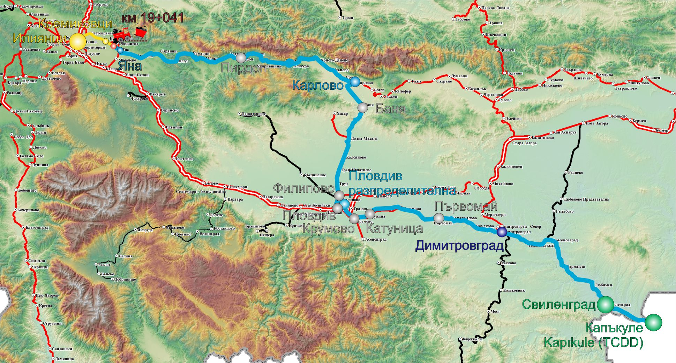
On 26.07.2022 at 17:01 p.m. during the movement of DFT No 30592 in the Yana - Kremikovtsi interstation at km 19+041, five wagons derailed at the end of the train. The place of the event is on a straight-line section of the rail track in an uphill 10 ‰ in the direction of increasing mileage of the main railway line No. 3 (Fig. 3.4), i.e. downhill in the train movement direction. At the time of the derailment, the train was moving at a speed of 41 km/h.
Fig. 3.4. Route of the train movement with the place of the accident.
- Origin station of the train;
- Major stations along the train alignment;
- Station from which the new crew takes the management;
- Stations, where the train had a change;
- Final destination station for the movement of DFT № 30592 – Iliantsi;
- Place of the accident – Yana – Kremikovtsi;
- Track, which DFT № 30592 passed;
- Track, which DFT № 30592 was about to pass;

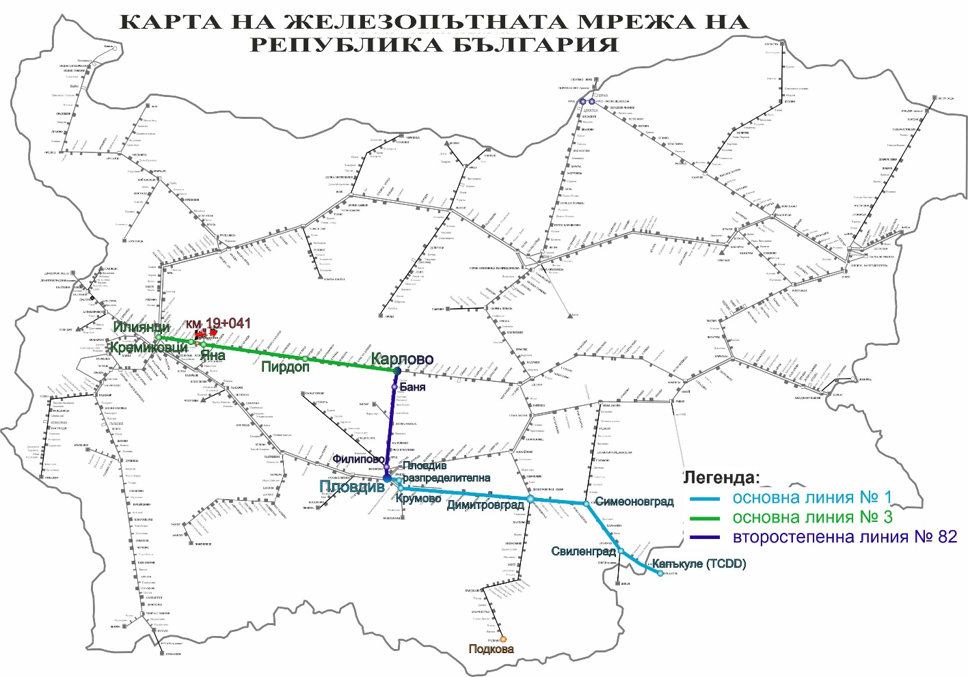
DFT No. 30592 moved in the direction of Kapikule – Plovdiv – Karlovo – Iliyantsi, crossing the main line No. 1, secondary line No. 82 and main line No. 3 (Fig. 3.5)
Fig. 3.5. Map of the train movement route.
    - Description of the event location:
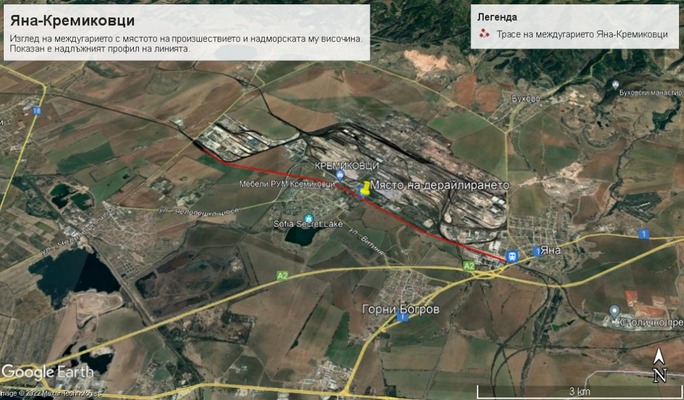
      - Location of the place of the accident.
Fig. 3.6. GPS location of the place of the accident at km 19+041 along Yana-Kremikovtsi interstation.
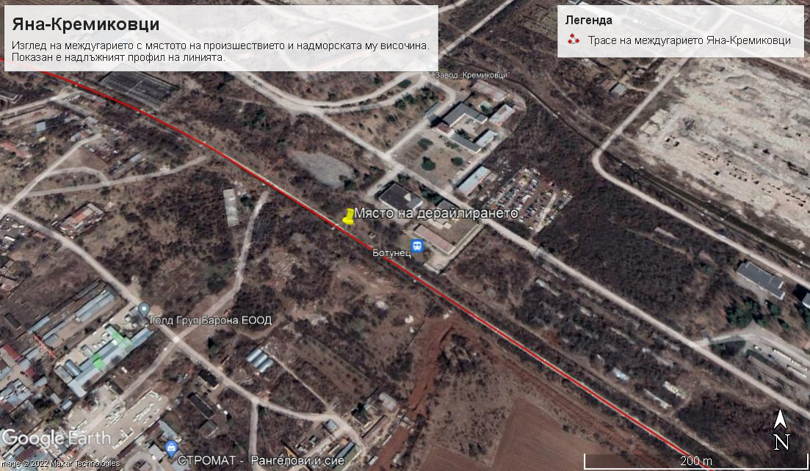
Geographic width: 42°44'23.83"С;
Fig. 3.7. GPS location of the place of the accident at km 19+041along Yana-Kremikovtsi interstation.
Geographic length: 23°31'17.12"I (fig. 3.6 and 3.7).

      - Meteorological and geographical condition at the time of the event.
- In the light part of the day – 17:01 p.m. (under locomotive recording device data);
- Air temperature: +35ºС;
- Wind speed and direction: 12 m/s, from North-west;
- Weather – sunny, hot and clear with normal visibility of the signals;
- The stations Yana and Kremikovtsi geographically are located in the western part of the rail network.
3.1.3.3. Performance of construction activities on the site or in vicinity.
At the date of the accident construction works have not been performed on the site or in vicinity.
    - Fatalities, injuries and material damages:
      - Employees of the railway infrastructure manager or railway undertaking.
None
      - Other persons officially connected with the location of the event.
None.
      - Passengers.
None
      - External persons.
None
      - Cargo, luggage or other property.
None.
      - Rolling stock, infrastructure and environment.
• Material damage of freight wagon, type R with № 31753816722-0 – derailed with four wheel-sets, suffered damages to the running gear amounting to 3 482,50 BGN.;
• Material damage of freight wagon, type S with № 31754540057-2 – derailed with four wheel-sets, suffered damages to the running gear amounting to 56 495,59 BGN.;
• Material damage of freight wagon, type R with № 31753816645-3 – derailed with four wheel-sets, suffered damages to the running gear amounting to 224 766,35 BGN.;
• Material damage of freight wagon, type R with № 31753216300-5 – derailed with four wheel-sets, suffered damages to the running gear amounting to 3 487,85 BGN.;
• Material damage of freight wagon, type S with № 31754562315-1– derailed with one wheel-set amounting to 1 165,45 BGN..;
- Costs for emergency activities at RVP Sofia EOOD – 23 808,00 BGN..
- Total damages caused to the rolling stock - 314 832,86 BGN..
• Total damages caused to the rail track with amortization charges at 26.07.2022 in the area of the accident from km 18+937 to km 19+041 = 104 meters amounting to 4233,53 BGN.;
• Total damages: 319 066,39 BGN..
    - Description of other consequences, including the event impact on the usual activity of the participants.
In the period 26.07÷29.07.2022, the railway infrastructure manager and the railway undertakings have generated additional costs for changing the train schedule along the section.
• Deviated trains of the railway undertakings – 230,97 BGN..;
• Cancelled trains of the railway undertakings – 2 594,80 BGN..;
• Appointed trains of the railway undertakings – none;
• Delayed trains of the railway undertakings in neighbouring stations – 10;
• Costs for rehabilitation means of Sofia RS – 2 245,00 BGN..;
• Costs for rehabilitation means of Vratsa RS – 3 519,91 BGN..;
• Total other costs: 8 590,68 BGN.
    - Identity of the participants and their functions.
Railway infrastructure:
- SE National railway infrastructure company has Safety Authorization № BG 21/2018/0001 valid from 01.07.2018 until 30.06.2023.
SE NRIC personnel, involved in the accident:
- Traffic manager on-duty in Yana station on shift;
- Traffic manager on-duty in Kremikovtsi station on shift;
- Head of Iliantsi railway section;
- Head of Transport group on RRS;
- Trackman railway line.
Railway undertaking:
“Rail Cargo Carrier-Bulgaria” EOOD has:
    - License for railway transport services № 211, valid until 17.06.2025;
    - Single Safety Certificate BG 10 2020 0045, valid until 06.08.2025;
Personnel of “Rail Cargo Carrier-Bulgaria” EOOD involved in the accident:
• Locomotive driver first person of locomotive № 918111162593 of DFT № 30592;
• Locomotive driver second person of locomotive № 918111162593 of DFT № 30592;
    - Description of the respective parts of the railway infrastructure and signalling system:
      - Type of the track, railway switch, rail crossing etc..
The railway line between Yana and Kremikovtsi stations is 6,178 meters long, single-track line. The rail track is combined: continuously welded track on reinforced concrete sleepers ST-4 with PAK 68I fastening and jointed rail track on wooden sleepers with type K fastening, both with S 49 type rails. In the two areas where the rail track is on wooden sleepers, in the past, there was a Botunets station at km 18+700 with three tracks, the activity of which was subsequently closed over time and the railway switches in both throats were dismantled and replaced with a jointed track on wooden sleepers with a length of 105 meters.
In the derailment area, it was found that the thermal gaps of the jointed track on a wooden gird were closed (Fig. 3.8)
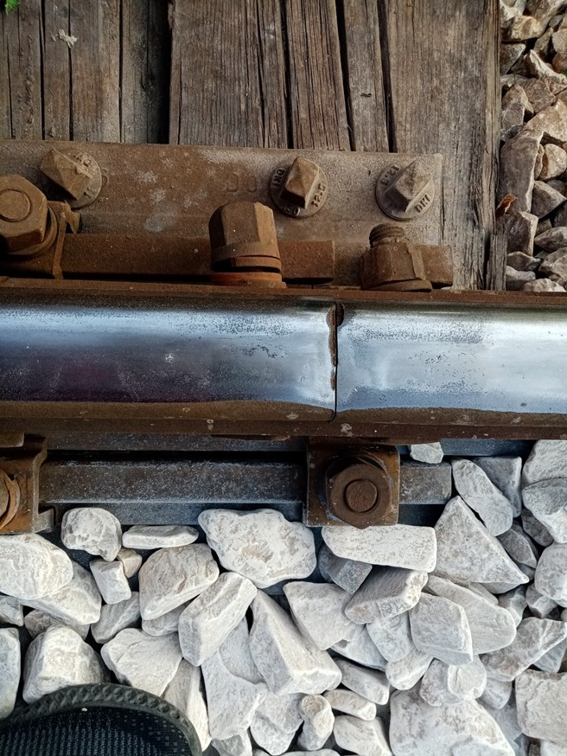
The rails of the continuously welded track on the concrete sleeper gird slide in longitudinal position up to 130 mm in the train movement direction (to the jointed rail track on a wooden gird) (fig. 4.10).
Фиг. 3.8. Състояние на наставите: топлинните междини са „затворени“.
Fig. 3.8. Condition of the joints: the heat gaps are “closed”

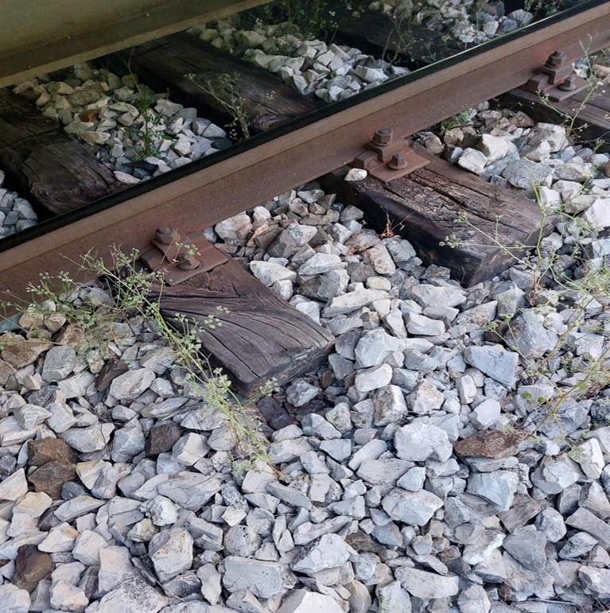
Fig. 3.8а. A displacement in the transition from continuously welded track to jointed track on wooden sleepers is evident in the non-destroyed part of the jointed track on wooden sleepers.

      - Interstation block system, station installation, type of signalling
The Yana – Kremikovtsi interstation is equipped with automatic block system (AB) with axle counters, without traffic signals – well functioning;
Yana Station is equipped with RRI - "Russian Unified" - well functioning;
The Kremikovtsi station is equipped with RRI - "Russian for small stations" - well functioning;
Type of signalling:
At Yana and Kremikovtsi stations the entrance and exit semaphores are under speed signalling – well functioning;
      - Train protection systems.
The Yana and Kremikovtsi stations do not have train protection system.
The locomotives № 918111162593 and № 918111161116 are equipped with warning device active type and digital registering device type DAREC ETCS_V 4.7.2.
    - Other information referring the event.
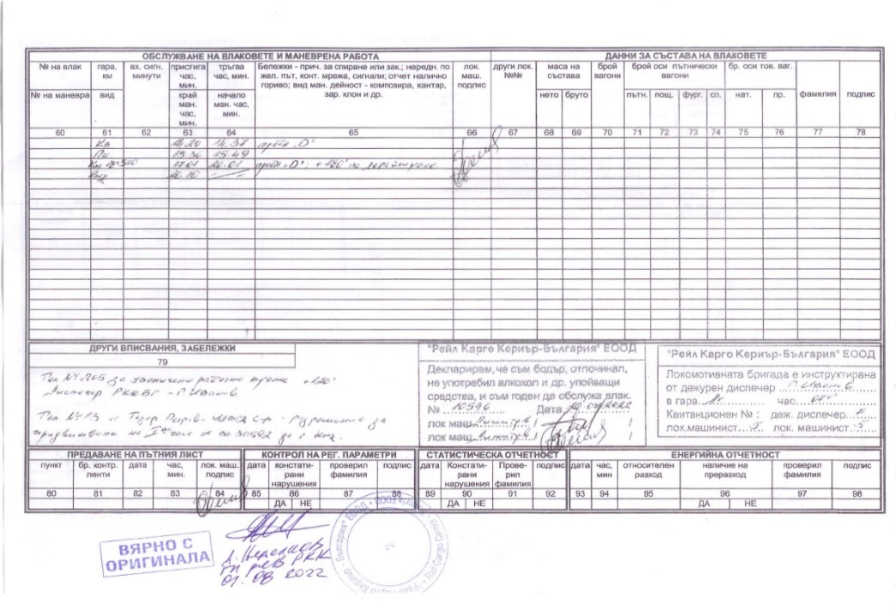
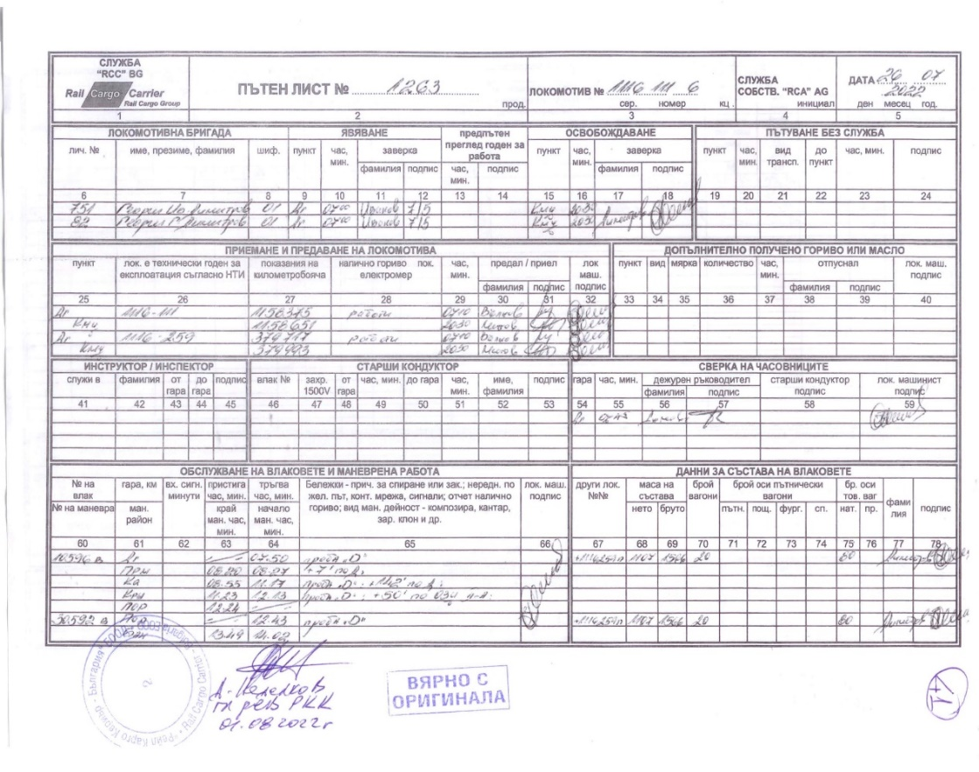
The train documents „Way-bill“, „Brake mass certificate and „Nature sheet“ (fig. 3.9 ÷ 3.12) correspond to the hours of the actual movement of the train under the presented data of the TOMR and the locomotives encryption.
Fig. 3.10. Way-bill of locomotives №№ 918111161116 and 918111162593 – rear part.
Fig. 3.9. Way-bill of locomotives №№ 918111161116 and 918111162593 – front part.

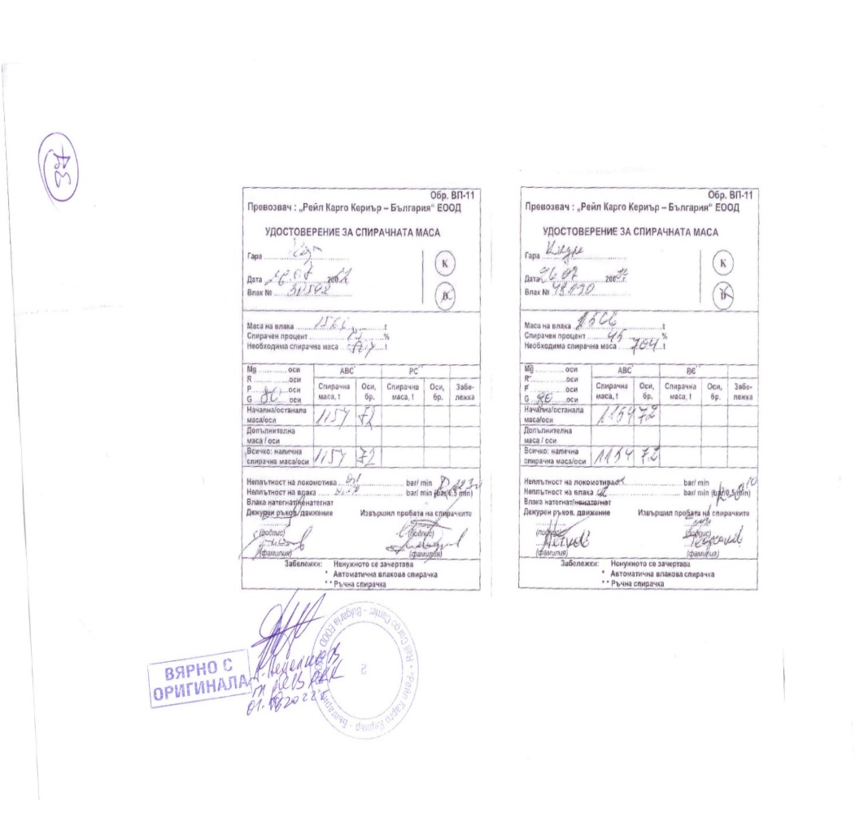
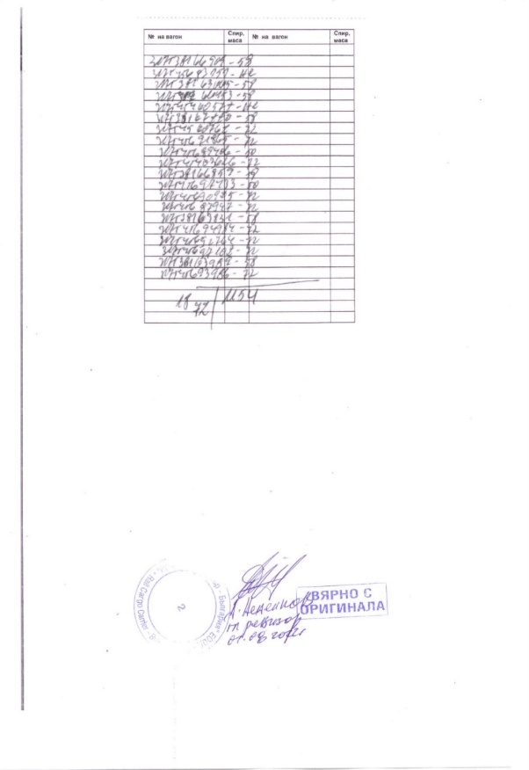
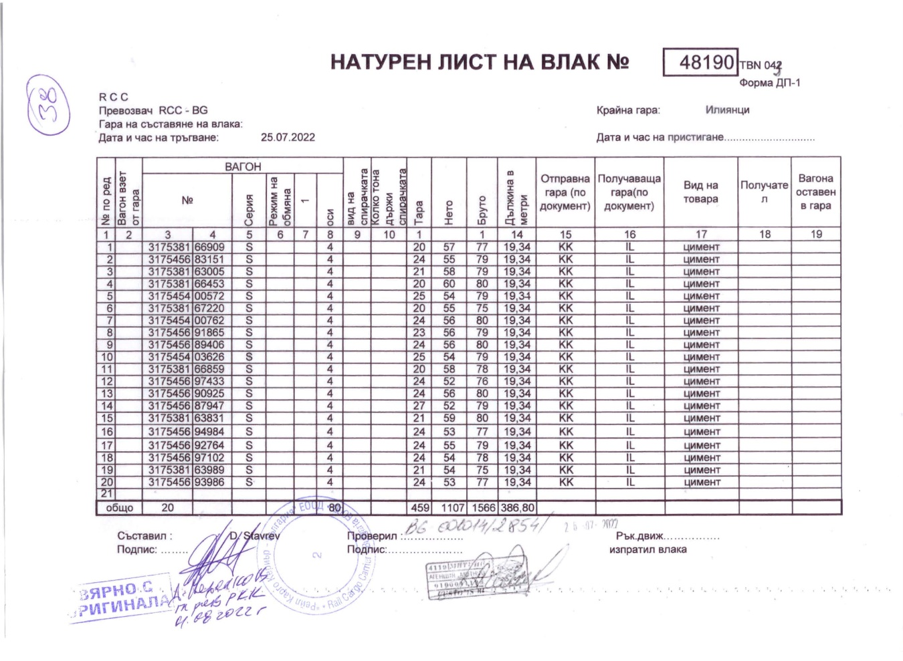
Factual description of the occurred.
Fig. 3.12 Brake mass certificate of DFT
No 30592, issued in Kapikule station and Plovdiv stationразпределителна – лице.
Fig. 3.13. Brake mass certificate of DFT № 30592 – rear part.
Fig. 3.11. Way-bill of DFT № 30592.
    - Immediate sequence of events that led to the accident, including:
      - Actions that the involved in the event persons undertook.
In the written testimony of the traffic manager on- duty in Yana station, it is reflected that DFT No. 30592 passed without stopping at the station at 16:58 p.m., he did not see anything wrong with the passage of the train. At 17:20 p.m., the locomotive driver of the train notified the traffic manager on duty in Yana station by mobile phone that the train had derailed in the intermediate station.
From the written testimony of the locomotive driver of DFT No. 30592, it is clear that along Yana - Kremikovtsi interstation, he felt two pulls of the train and the pressure in the main air duct began to decrease gradually. He stopped the train, and after the inspection he found that five wagons at the end of the train had derailed, about which he duly informed the interested parties.
From the written testimony of the trackman, performing a technical inspection of the rail track in the Yana - Kremikovtsi interstation, it is clear that during the two rounds carried out between 08:00 a.m. and 13:00 p.m., he did not find any technical malfunctions on the rail track.
      - Rolling stock and technical facilities functioning.
Until the time of the accident, the rolling stock of DFT No. 30592 (the two locomotives and the twenty wagons) were technically sound. From the deciphering of the movement of DFT No. 30592, a strong pulling of the train was found along the Yana - Kremikovtsi interstation, the pressure in the main air duct began to decrease rapidly (due to the train breaking) and it stopped at km 18+477.
      - Operational system functioning.
The operational system for managing the train traffic between Yana and Kremikovtsi stations and along the section at the time of the accident was regular and functioning normally.
    - Sequence of the events from the beginning of the occurrence until the end of the rescue services actions:
      - Undertaken measures for protecting and guarding the event location.
After the arrival of the authorities from SDoI to the Ministry of Interior at around 22:15 p.m., and clarification of the situation, access to the area was not restricted due to its uninhabited nature. Procedural-investigative actions were carried out on the spot by the authorities of the pre-trial proceedings at the SDoI and inspections by the Investigation Commission at the NAMRATIB and the interested officials of the entities. Media access was restricted.
      - Actions of the emergency rescue services.
Not applicable.
      - Actions of the emergency rehabilitation services
The Sofia Rehabilitation Service was notified at 17:37 p.m. by a senior train dispatcher and after the departure of UNIMOG recovery vehicle from Sofia station; it arrived at the place of the accident at 18:15 p.m.
The Vratsa Rehabilitation Service sent specialized rehabilitation vehicle UNIMOG to the place of derailment.
At 20:10 p.m., the first part of the 14 non-derailed wagons from DFT No. 30592 was pulled into Kremikovtsi station.
At 23:05 p.m. after completion of the inspections, written permission was given by the head of the investigation from the NAMRATIB to carry out emergency recovery activities.
At 23:25 p.m., the authorities of the pre-trial proceedings from the SDoI to the Ministry of Interior, after completing the inspections, then was given a written permission for starting emergency rehabilitation activities.
The 19th wagon with No. 31754562315-1 was lifted at 00:10 a.m. on 27.07.2022 and attached with the 20th wagon No. 31753816690-9 non-derailed of DFT train No. 30592 and they were pulled into Yana station;
Wagon 15 with No. 31753816722-0, the first derailed from DFT No. 30592, was lifted at 02:50 a.m. on 27.07.2022 and at 05:00 a.m. it was pulled into Kremikovtsi station;
Wagon 16 with No. 31754540057-2 from DFT No. 30592 was lifted at 14:00 p.m. on 27/07/2022 and pulled into Yana station;
Wagon 18 with No. 31753216300-5 from DFT No. 30592 was lifted at 18:00 p.m. on 27/07/2022 and pulled into Kremikovtsi station;
Wagon 17 with No. 31753816645-3 from DFT No. 30592 was lifted at 20:10 p.m. on 27/07/2022 and pulled into Yana station.
In the interval from 10:00 a.m. to 12:00 p.m. on 27/07/2022, the contact wire was lifted to the catenary cable carrier with a frontage of 200 m for the operation of a mobile crane to reload the containers from the 17th and 18th wagons of cars.
On 27.07.2022, in the interval 10:00 a.m. ÷ 12:00 p.m., approaches were built for the operation of the truck crane, and in the interval 14:00 ÷ 17:00 p.m., the containers were reloaded from wagon No. 31753216300-5 to cars and taken to the receiving station Iliantsi - recipient company "Tsemko" EOOD.
On 28.07.2022, from 10:00 a.m. to 13:00 p.m., the containers were reloaded from wagon No. 31753816645-3 to cars and taken to the final recipient company "Tsemko" Ltd. in the industrial railway branch of "Toplivo" JSC.
On 27.07.2022 at 21:00 p.m., the Yana - Kremikovtsi interstation was cleared of the derailed wagons.
On 28.07.2022, preparatory works were carried out on the alignment for laying the rail track.
On 29.07.2022, restoration works were carried out, renewal of 137.5 meters with a second-hand rail track on a reinforced concrete sleeper grid. The catenary network was adjusted, 9 earthing cables were restored. The movement of trains was restored at 15:00 p.m., the speed in the place of derailment was limited to 25 km/h, and along the rest of the Yana - Kremikovtsi interstation, the movement was carried out according to the schedule. From 30.09.2022, the traffic along the entire interstation has been restored for a speed according to the schedule up to 40 km/h.
- Analysis of the event
  - Participation and responsibilities of the entities, involved in the event
    - Railway undertaking.
Analysis of the traffic of DFT № 30592.
The data on the movement of DFT No. 30592 were downloaded from the recording devices of locomotives No. 918111161116 and 918111162593.
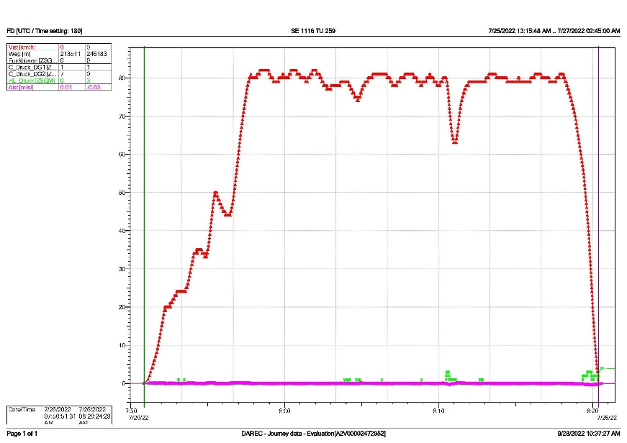
During the movement from Dimitrovgrad station to Plovdiv marshalling yard, the train ran as DFT No. 10596. It departed from Dimitrovgrad station at 07:50:51 a.m. (fig. 4.1) and arrived at Plovdiv marshalling yard at 12:24:46 p.m. (fig. 4.2). During its journey from Dimitrovgrad station to Plovdiv marshalling yard, the train ran according to the schedule.
Fig. 4.1. Movement of DFT № 10596 from Dimitrovgrad to Parvomay station.
At Plovdiv marshalling yard, the train number has been changed and then as DFT No. 30592 it departed at 12:43:46 p.m., arrived at Plovdiv station at 12:49:17 p.m., staid for 9 seconds and left Plovdiv station at 12:49:26 p.m.
DFT No. 30592 arrived at Banya station at 13:49:00 p.m., where it stayed for 13 minutes and 44 seconds. It departed from Banya station at 14:02:44 p.m., and arrived at Karlovo station at 14:20:44 p.m. At Karlovo station, the two locomotives performed a shunting by attaching to the other side of the train in order to reverse the movement direction (Fig. 4.3). When moving from the Plovdiv marshalling yard to the Karlovo station, the train ran according to the schedule.

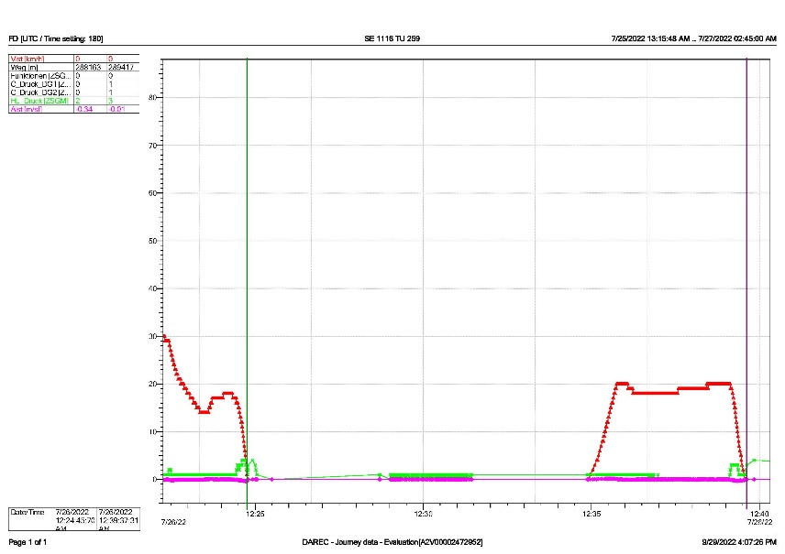
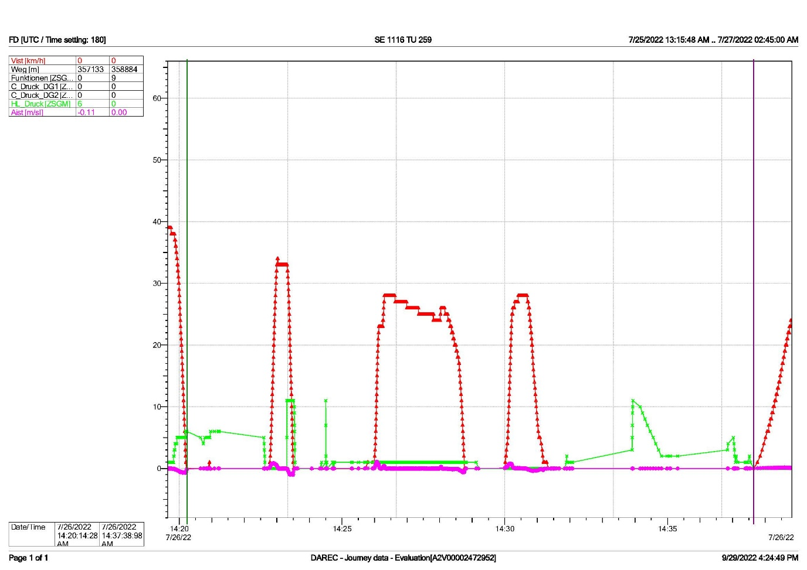
Fig. 4.2. Movement and stay of DFT № 10596 in Plovdiv marshalling yard.
Fig. 4.3. Movement and stay of the locomotives in Karlovo station.
DFT № 30592 departed from Karlovo station at 14:37:38 p.m. (fig. 4.3).
The train arrived in Pirdop station at 15:36:31 p.m. It stayed in the station for 17 minutes and 49 seconds and departed at 15:54:19 p.m. (fig. 4.4).
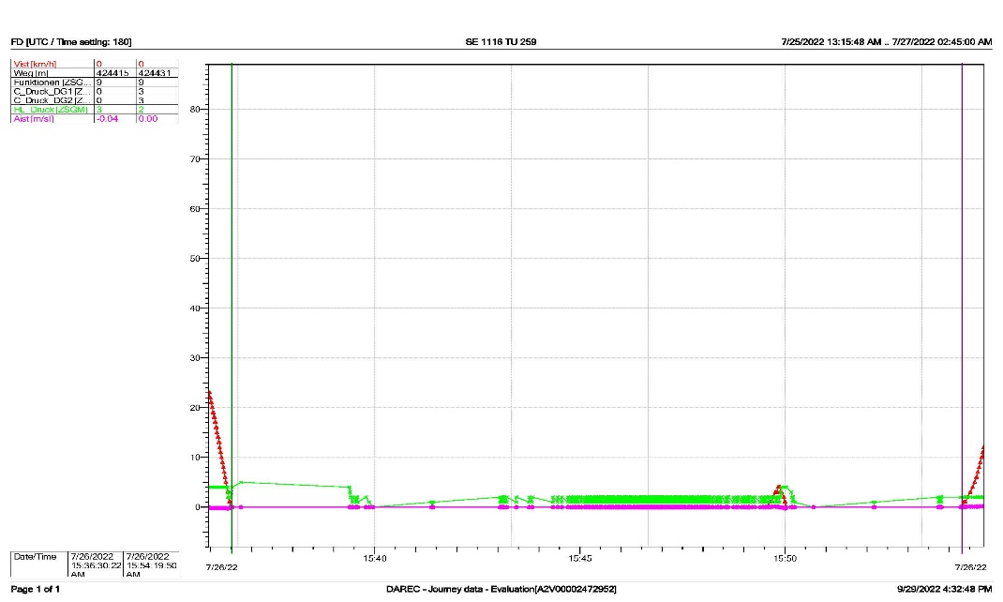
DFT № 30592 ran without stopping from Pirdop station to the place of derailment under schedule.
Fig. 4.4. Stay of DFT № 30592 in Pirdop station.
DFT № 30592 passed without stopping Yana station at 16:56:31 p.m. with a speed of 38 km/h, and directed along the Yana - Kremikovtsi interstation (Fig. 4.5, pos. 1), and then the speed increased to 41 km/h (Fig. 4.5, pos. 2) and thus it moved until 16:57:16 p.m. when the speed decreased to 40 km/h and for 1 minute and 27 seconds and travelled 970 meters until 16:58:43 p.m. (Fig. 4.5, pos. 3). At that point the speed increased to 41 km/h, travelling 322 meters from 16:58:44 p.m. to 16:59:12 p.m. for 28 seconds (Fig. 4.5, pos. 4). That was followed by a reduction in speed to 40 km/h from 16:59:12 p.m. to 16:59:31 p.m. for 19 seconds, covering 215 meters (Fig. 4.5, pos. 5), and then a further reduction to 39 km /h from 16:59:32 p.m. to 17:00:13 p.m. for 41 seconds, the train travelled 443 meters (Fig. 4.5, pos. 6). That was followed by an increase in speed to 40 km/h from 17:00:13 p.m. to 17:00:55 p.m. for 42 seconds, covering 477 meters (Fig. 4.5, pos. 7) and a further increase to 41 km/h from 17:00:55 p.m. to 17:01:25 p.m. for 29 seconds, the train travelled 337 meters (Fig. 4.5, pos. 8).
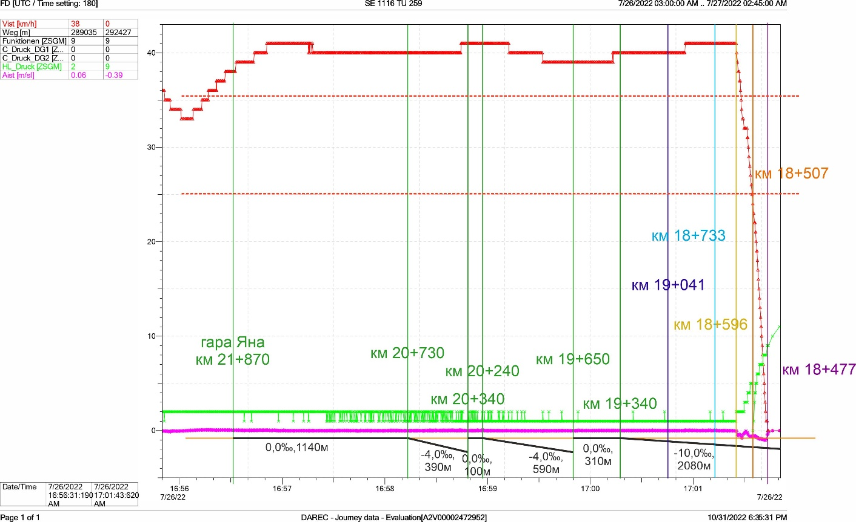
The leading locomotive was located at km 19+041 at 17:00:45 p.m., and the movement speed was 40 km/h (Fig. 5, pos. 9). The 2 locomotives and 14 wagons passed through the place without any problems. After travelling 108 meters, the speed increased to 41 km/h (Fig. 5, pos. 8). When the leading locomotive was located at km 18+733 (fig. 5, pos. 10), the 15th wagon of the train derailed and after it another 4 wagons derailed successively. In that condition, the train travelled another 137 meters. When the leading locomotive was located at km 18+596 at 17:01:25 p.m., i.e. 445 meters and 20 seconds after the derailment, the speed began to decrease, due to a reduction in pressure in the main air conduct, as the engine driver performed several stages of service holding with the automatic train brake. An impact loosening followed and immediately after it a rapid arrest, which was a consequence of the splitting (breaking) of the train between the 14th and 15th wagons (fig. 5, pos. 11). The train split at one more place – between the 12th and 13th wagons. The break between the 14th and 15th wagons was caused by contact of the running gear of the 15th wagon with the ballast prism. The train was also broken in a third place - between the 17th and 18th wagons due to the tilting of the 17th wagon in relation to its longitudinal axis and deviation of its rear part to the left of the rail track. After traveling 89 meters from the moment of holding the automatic train brake at km 18+507 at 17:01:34 p.m., an impact release of the automatic train brake was registered by increasing the pressure in the main air conduct above 5 bars (Fig. 5, pos. 12, Fig. 6, pos. 1), which did not reflect the change in speed and it continued to decrease until the final stop of the train composition. At that moment, the front buffers of the leading locomotive were located at km 18+477 (fig. 5, pos. 13). From the time the automatic train brake was applied to the final stop, the train travelled 119 meters.
Fig. 4.5. Final meters from the movement of DFT № 30592 with the indicated longitudinal inclinations of the rail track.
Place of derailment
10. Location of the locomotive at the moment of derailment (V=41 km/h)
11. Place of train breaking (25 km/h)
13. Place of the train establishing
1
2
3
4
5
6
7
8
9
12. Place of the hit loosening (25 km/h)
The results from the registration are presented in a tabular form on Fig. 4.7.
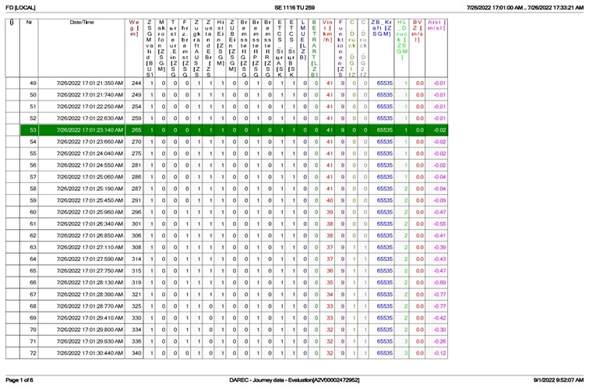
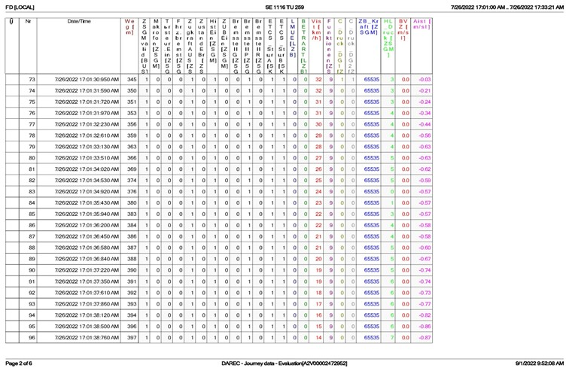
Fig. 4.7а. Data on the movement of DFT № 30592 from the breaking moment to the final stopping.
Fig. 4.7b. Data on the movement of DFT № 30592 from the breaking moment until the final stop.
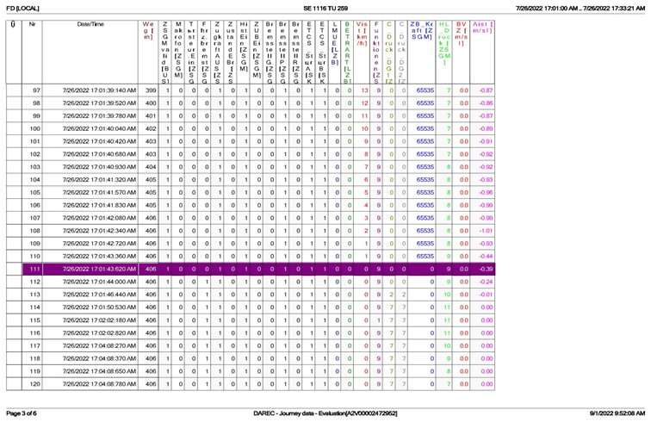
Fig. 4.7c. Data on the movement of DFT № 30592 from the breaking moment until the final stop.
Since DFT No. 30592 was served by two locomotives (double traction), an analysis was also made of the recordings from the recording device of the second (train) locomotive, which worked synchronously with the first under the "multi-unit" system (MUS). The analysis of the movement of the two locomotives shows that they worked in complete synchronization, and the events recorded by one and the other locomotive differ by a few seconds, on the one hand due to a small difference in the readings of the on-board clocks, on the other - due to the inertia of certain processes, for example, a change in pressure in the main air duct when controlling the automatic train brake (Fig. 4.8). The pressure differences in the main air duct of the two locomotives (Fig. 4.8) are due precisely to the inertia of the air pressure, as the pressure in the main air duct in the first locomotive increased to 5 bar as a result of the command given by the crane driver (Fig. 4.8, item 1 ). Almost immediately after that, the pressure in the main air duct was reduced due to its disconnection and the brake was applied in a fast hold mode. In the case of the second locomotive, this change was not observed, but the opposite was seen: the pressure in the main air duct decreased, then increased, and then again, a trend of its decrease was observed due to the disconnection of the train (Fig. 4.8, pos. 2). The difference was due to the inertia of the air movement in the duct, which was because the major changes in the first locomotive could not be realized in the second. In all cases, a decrease in pressure in the main air duct and the transition of the brake to the fast hold mode were observed.

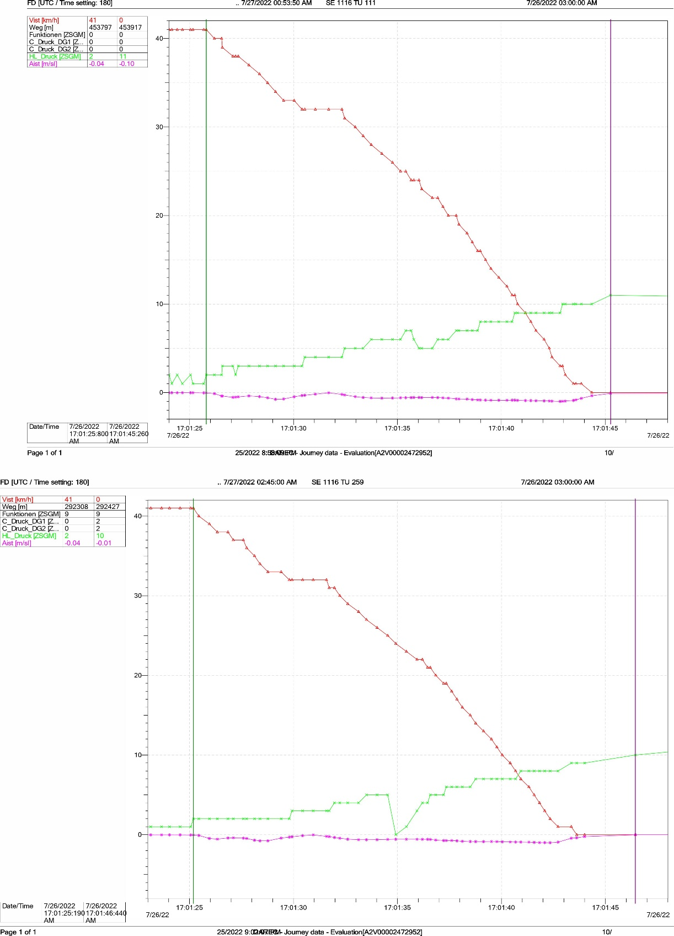
Fig. 4.8. Comparison of the registered data of the two locomotives of DFT № 30592.
1
2
During the analysis of the movement of the train from Svilengrad station to the place of derailment, it was found that in many places the current speed of movement exceeded the permissible speed of movement for the specific section by up to 3 km/h. That was due to the inertia of the system for controlling and maintaining a constant speed of movement of this type of locomotives (the so-called "tempomat/speed control"), which allows easier, more convenient and economical control of the movement of the train and is often used by the locomotive drivers. Due to the peculiarities of the locomotive control system, it could not be set more precisely (step 10 km/h) to prevent small deviations. The registered small excesses of the permissible traffic speed were not fatal and cannot be considered as the cause of the accident, on the one hand due to the insignificant influence of the excess (in that case an excess of 1 km/h, representing 2.5% of the permissible speed ), and on the other hand due to the fact that the permissible speed of movement on the strength of the rail track in a given section was higher by a minimum of 25% of the specified permissible speed of movement of trains in the same section.
    - Infrastructure manager.
Analysis of the rail track condition.
In the railway network, the continuously welded track reinforced type has gained the greatest distribution. The track from rails with a length of more than 90 m, works as continuously welded track reinforced type, after the various types of fastenings are tightened very well, and their "breathing" ends are 45-50 m long. In the fixed middle part of the rails, maximum longitudinal forces appear. The size of these forces depends on the type of rails and on the size of the temperature difference compared to the neutral temperature. The magnitude of the longitudinal forces does not depend on the length of the free section that is why it can be of unlimited length. In the winter, tension forces appear in the rails of the non-maintained track, which can cause the welds to break and the rails to break, because of the low negative temperatures. In the summer, significant compressive forces appear in the rails, which tend to break the stability of the rail track and cause it to sway. There is a difference between horizontal transverse and vertical sweeping of the rail track in the high summer temperatures. The longitudinal displacement of the rails, because of the temperature forces, is manifested by sliding of the rails on the rib pads. This is characteristic when the connection of the rails with the sleepers is insufficiently reliable. The track temperature is always taken into account for the continuously welded track, which can be significantly different from the air temperature at the same place and time. The rail temperature is assumed to be about 20º C higher than the maximum air temperature. It is assumed that the minimum temperature of the rails is the same as the minimum air temperature in winter conditions. The laying temperature of the continuously welded track is that measured when the fasteners are tightened. The neutral temperature of the rails is that at which there is no stress from the action of temperature changes. The section from Iliyantsi station to Karlovo station is in the second climate zone with a maximum rail temperature of up to 63º C, and minimum temperature of -23.2º C and a temperature amplitude of 86.2º C. Protective (buffer) units are placed at the ends of the continuously welded track, such as in front of a section with jointed track, as is the case, one unit of normal length is placed. Specifically in the case, the derailment occurred at an air temperature of around 35º C and a rail temperature of around 55º C. This is far from the allowable temperature of 63º C for the second zone. In this section, the rail temperature is not measured due to the reduced speed of the trains. The derailment in this case happened under the moving train. Before the accident, there was no work on the rail track.
Particularities of the rail track along the Kremikovtsi-Yana interstation from the place of derailment at km 19 + 041.
The derailment occurred at 9.30 a.m. from the end of the continuously welded track in the area of the jointed track, which is on a wooden sleeper grid. The rail track from the entrance switch of Yana station, Kremikovtsi station to km 19 + 050, is continuously welded track in a straight-line section. The rails are type S49 and are laid on reinforced concrete sleepers ST-4 and fastenings PAK-68I. Welds have joined the continuously welded track since 1984 at a temperature of 25º C and at a temperature interval of 26 to 36º C. It is interrupted by glued joints at the signal points of the warning and entrance signal at the Yana side of Kremikovtsi station. There is a buffer protective unit from km 19+050 to 19+075 (the joints at both ends of the unit are connected by normal iron connections/joints).
The inspection carried out on 28.07.2022 revealed the following:
The rail track is well ballasted. No hardened ballast prism. There are no sharp deviations in axis and level. This is also confirmed by the measurement of the rail track in a dynamic state on 09.05.2022 with the EM-120 track-measuring laboratory. No defective rails were found during the defectoscopy performed on 29.06.2022. Until the time of the accident, no measurement of the rail track during the summer season at high temperatures was documented, and no breakage of welds was found during the winter season under the action of tensile forces in the rail threads at low temperatures.
The following condition of the rail track from km 20+257 to km 19+050 before the derailment area was found:
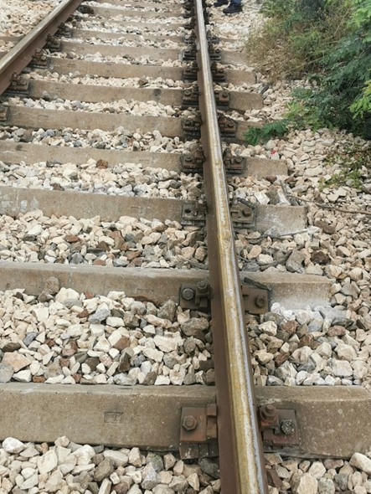
- Great number and a couple consecutive half-inverted sleepers SТ-4 (fig. 4.9).
Fig. 4.9. Half-inverted reinforced concrete sleepers ST-4 before the derailment area derderailmentreaareaдерайлиране.
- Broken contact of the heel of the rails with the rib pads. This contributes to an uneven load on the sleepers from the passing RRS, respectively on the ballast prism and the ground platform.
- Big percentage of made and dropped rubber pads from the rib ones.
- Big percentage of loosen clamping sets (bolts, clamping tiles and spring rings).
- Damaged anchor bolts connecting the rib pads to the ST-4 reinforced concrete sleepers.
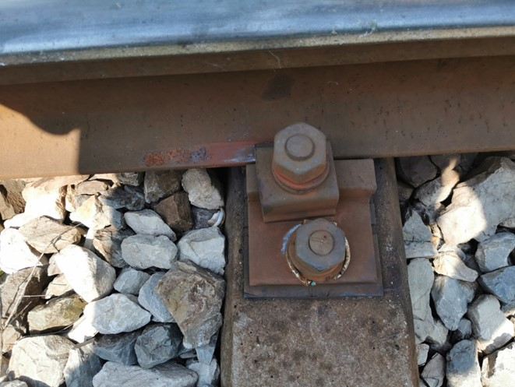
Untightened fastenings (rails with sleepers) were found, which at high temperatures and the direct exposure of the rails from the sun, caused a longitudinal slip of the rails up to 130 mm in the direction of the border of the continuously welded track with the jointed track (Fig. 4.10)
Fig. 4.10. Longitudinal displacement of the rails.
After the continuously welded track, there is a 104 m long jointed track a wooden sleeper gird in the direction of Kremikovtsi station with a "K" fastening.
Around 19:00 p.m., the thermal gaps in the jointed track were apparently completely closed (Fig. 4.11). At 9.30 a.m. from the border between the continuously welded track and the jointed track at km 19+050, i.e. at km 19+041 at the point of derailment, there is a sweep of the rail track up to 150 mm, to the left in the train movement direction, starting immediately after the beginning of the jointed track. In the next 94.70 m, the wooden sleepers and rails were completely destroyed.
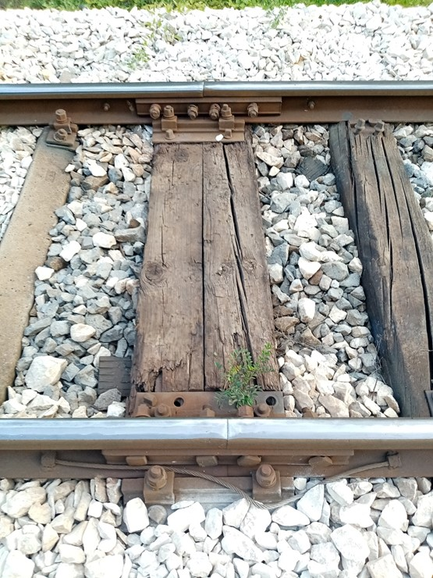
From the inspections carried out and the findings made, gaps are identified in the SMS regarding the repair and maintenance of the continuously welded track along Yana - Kremikovtsi interstation.
Fig. 4.11. The thermal gaps are „closed“.
    - Entities in charge of the technical maintenance.
SE NRIC is a railway infrastructure manager.
SE NRIC is a certified ECM and is responsible for the repair and maintenance of the railway network and facilities.
"Rail Cargo Carrier - Bulgaria" EOOD is a licensed rail undertaking that does not have an ECM Certificate.
For the used locomotives, Certificate of the organization responsible for maintenance No. DE /31/0122/0031 with a validity period of 06.05.2027 was issued by TUV SUD Rail GmbH – Deutschland.
    - Manufacturers or providers of rolling stock and railway products.
Not applicable.
    - National Safety Authority.
Railway Administration Executive Agency is the National Safety Authority of the Republic of Bulgaria.
    - Notified bodies or Risk assessment authorities.
Not applicable.
    - Certifying bodies of the entities in charge of maintenance.

The Railway Administration Executive Agency as the National Safety Authority for railway transport performs certification of the entities in charge of the vehicles maintenance (ECM) in accordance with Directive 2004/49/EC and Regulation (EU) 445/2011, as per Ordinance No 59 on the railway transport safety management and on the maintenance functions in accordance with Directive 2004/49/EC and Regulation (EU) 445/2011.
From June 16, 2020 the RAEA performs certification of the ECM as per the Commission Implementing Regulation (EU) 2019/779 of 16 May 2019 laying down detailed provisions on a system of certification of entities in charge of maintenance of vehicles pursuant to Directive (EU) 2016/798 of the European Parliament and of the Council and repealing Commission Regulation (EU) No 445/2011.
    - Persons or entities involved in the event, documented or not in the respective safety management systems or indicated in register.
• SE NRIC implements Safety Procedure PB 2.09 "Methodology for determining, assessing and managing of the risk" version 06 effective from 01.09.2021, part of the SMS.
• "Rail Cargo Carrier - Bulgaria" EOOD implements SMS procedures - Process "P15 Risk Management", procedure "P-RMS 50 Risk Management Manual" and instruction "DNA-RMS 51 Prescription for conducting risk analysis"
Rolling stock and technical facilities
    - Factors, deriving from the design of the rolling stock, railway infrastructure or technical facilities.
Not applicable.
    - Factors deriving from the installation and placing into service of the rolling stock, railway infrastructure and technical facilities.
Not applicable.
    - Factors deriving from manufacturers or other supplier of railway products.
Not applicable.
    - Factors, deriving from the technical maintenance and/or modification of the rolling stock or the technical facilities.
Not applicable.
    - Factors due to the entity in charge of the technical maintenance, workshops for technical maintenance and other technical maintenance service providers.
Not applicable.
    - Other factors or consequences considered as involved within the investigation objectives.
Not applicable.
  - Human factor:
    - Individual human characteristics:
      - Training and development, including skills and experience.
Railway undertaking:
• Locomotive driver first person of locomotive No. 918111162593:
- Certificate of qualification No. 000575 acquired qualification "Locomotive driver of electric locomotives", conducted training in the period 1993÷1996, educational institution VVTU "Todor Kableshkov" - Sofia;
- Locomotive driving license BG 71 2017 0781 issued by RAEA;
- Certificate No. 80 for holding the position of "Locomotive driver" in "Rail Cargo Carrier - Bulgaria" EOOD from 05.01.2021.
- Additional certificate No. 528120210781 from "Rail Cargo Carrier - Bulgaria" EOOD for rolling stock for which the driver is allowed to drive - series EA3000, ES64U2 r X4-E Lok from 23.03.2021 to 23.03.2024 on the national railway infrastructure of the Republic of Bulgaria until 12.05.2025.
• Locomotive driver second person of locomotive № 918111162593:
- Diploma № 000586 of „Railway transport/machinery – electrical locomotives“, conducted training in the period 1993÷1996, educational institution VVTU "Todor Kableshkov" - Sofia;
- Locomotive driving license BG 71 2016 0082 issued by RAEA;
- Certificate № 74 for holding the position of "Locomotive driver-instructor" in "Rail Cargo Carrier - Bulgaria" EOOD from 05.08.2021.
- Additional certificate № 528120210082 from "Rail Cargo Carrier - Bulgaria" EOOD for rolling stock, for which is permitted the locomotive driver to driver – type ES64U2 E X4-E Lok E from 23.02.2021 to 23.02.2024 along the national railway network of the Republic of Bulgaria.
Railway infrastructure:
• Traffic manager in Yana station:
- Diploma № 20774, acquired qualification ,,Traffic manager and commercial operation“, training performed in the period 1981 ÷ 1984, issued by HRTI ,,Todor Kableshkov – Sofia;
- Certificate № 5220 for holding the position Traffic manager at TOSAD – Sofia dated 09.11.2020.
• Traffic manager in Kremikovtsi station:
- Diploma № 16297 recognized qualification "Traffic and Commercial Operation Manager", conducted training in the period 1974÷1977, training institution HRTS,,Todor Kableshkov - Sofia;
- Certificate № 5134 for holding the position Traffic manager at TOSAD – Sofia dated 08.06.2020.
• Head of railway section:
- Diploma № 000307, „Transport construction“, training conducted in the period 1992÷1995, issued by VVTU ,,Todor Kableshkov – Sofia;
- Certificate № 40 for holding the position Head of section on RRS in RS – Sofia dated 15.02.2021
• Head of Transport group on RRS:
- License for qualification № 10537 acquired qualification for „Construction technician on maintenance and repair of railway lines and facilities“, training conducted in the period 20.10.2008÷18.02.2009, training institution PQC at SE NRIC;
- Certificate № 1092 for holding the position Head of Transport group, RRS at RS – Sofia dated 01.06.2022.
• Trackman on railway line:
- Certificate for qualification № 7145 acquired qualification for „Railway trackman“, training conducted in the period 11.06.2007÷06.07.2007, training institution PQC at SE NRIC;
- Certificate № 409 for holding the position Trackman railway line in RS – Sofia dated 22.08.2011.
      - Medical and personal circumstances, which influence the event, including the presence of physical and psychological stress.
Railway undertaking:
• Locomotive driver first person of locomotive № 918111162593:
- Single health dossier № 1567 dated 13.06.2022, issued by National multi-profile transport hospital – Sofia.
Conclusion: suitable for locomotive driver.
- Psychological certificate № 490/13.04.2022, issued by Psychological laboratory at National multi-profile transport hospital Sofia for locomotive driver.
Conclusion: accepted for 5 year-period.
• Locomotive driver second person of locomotive № 918111162593:
- Single health dossier № 1367 dated 01.06.2022, issued by National multi-profile transport hospital – Sofia.
Conclusion: suitable for locomotive driver.
- Psychological certificate № 854/28.09.2018, issued by Psychological laboratory at National multi-profile transport hospital Sofia for locomotive driver.
Conclusion: accepted for 5 year-period.
Railway infrastructure:
• Traffic manager at Yana station:
- Single health dossier № 2100 dated 12.07.2022, issued by National multi-profile transport hospital – Sofia.
Conclusion: suitable for traffic manager.
- Psychological certificate № 272/24.02.2022, issued by Psychological laboratory at National multi-profile transport hospital Sofia for traffic manager
Conclusion: accepted for 3 year-period.
• Traffic manager at Kremikovtsi station:
- Single health dossier with conclusion dated 27.05.2020 issued by Labor Medicine Service at SE NRIC.
- Conclusion: suitable for traffic manager.
- Psychological certificate № 433/30.03.2021, issued by Psychological laboratory at National multi-profile transport hospital Sofia for traffic manager
Conclusion: accepted for 3 year-period.
• Head of railway section:
Medical card dated 23.05.1995, issued by National multi-profile transport hospital – Sofia.
Conclusion – suitable for Head of railway section.
• Head of Transport group on RRS:
- Single health dossier with conclusion dated 30.01.2012, issued by Labor Medicine Service at SE NRIC.
Conclusion: suitable for Head of Transport group on RRS.
• Trackman railway line:
Single health dossier – conclusion dated 20.02.2019, issued by Labor Medicine Service at SE NRIC.
Conclusion – suitable for Trackman railway line.
      - Fatigue.
Railway undertaking:
• Locomotive driver I-st person of locomotive № 918111162593:
Break/rest: from 25.07.2022 hour 19 minutes 00 until 26.07.2022 hour 07 minutes 00
Started work: 26.07.2022 hour 07 minutes 00 – (12 hours and 00 min.)
• Locomotive driver second person of locomotive № 918111162593:
Break/rest: from 23.07.2022 hour 21 minutes 00 until 26.07.2022 hour 07 minutes 00
Started work: 26.07.2022 hour 07 minutes 00 – (69 h. and 00 min.)
Railway infrastructure:
• Traffic manager Yana station:
Break/rest: from 24.07.2022 hour 07 minutes 00 until 26.07.2022 hour 07 minutes 00
Started work: 26.07.2022 hour 07 minutes 00 – ( 48 hours and 00 min.)
• Traffic manager Kremikovtsi station:
Break/rest: from 22.07.2022 hour 19 minutes 00 until 26.07.2022 hour 06 minutes 00
Started work: 26.07.2022 hour 06 minutes 00 (23 hours and 00 min.)
• Head of railway section:
Break/rest: from 25.07.2022 hour 17 minutes 00 until 26.07.2022 hour 08 minutes 00
Started work: 26.07.2022 hour 08 minutes 00 – (15 h. and 00 min.)
• Head of Transport group on RRS:
Break/rest: from 25.07.2022 hour 17 minutes 00 until 26.07.2022 hour 08 minutes 00
Started work: 26.07.2022 hour 08 minutes 00 – (15 h. and 00 min.)
• Trackman railway line:
Break/rest: from 25.07.2022 hour and 18 minutes 00 until 26.07.2022 hour 09 minutes 00
Started work: 26.07.2022 hour 09 minutes 00 – (15 h. and 00 min.)
      - Motivation and attitudes related to the human factor
Not applicable.
    - Work related factors:
      - Tasks planning.
• SE NRIC carries out maintenance, repair and operation of the railway infrastructure. Prepares schedules and timetables based on requests submitted by the railway undertakings for the movement of trains and vehicles on all the main and secondary railway lines.
• "Rail Cargo Carrier - Bulgaria" EOOD carries out rail transportation of freights according to the approved Plan for composing the trains and according to the additionally requested and assigned trains in the traffic schedule.
      - Constructive particularities of the facilities that influence the connection human-machine.
Not applicable.
      - Communication means.
The communication connections at Yana and Kremikovtsi station along the interstation and with the train dispatcher of the section are carried out with DCCM - 6, as well as at the station with the corresponding switch posts.
The traffic manager on- duty on shift at the railway stations at the SE NRIC and the "Rail Cargo Carrier - Bulgaria" EOOD is provided with official mobile phones.
      - Practices and processes.
Not applicable.
      - Operation rules, local instructions, staff requirements, prescriptions for technical maintenance and applicable standards.
Application of national and internal normative acts and standards.
      - Working time of the involved personnel.
The staff involved in the accident of both entities works in shifts regime of 12-hour working shift. In accordance with the requirements of the normative acts - Labour Code and Ordinance № 50 of 28.12.2001 for the working hours of the managerial and executive staff, engaged in providing the transportation of passengers and freights in the railway transport.
      - Risk treatment practices.
• SE NRIC applies safety procedure SP 2.09 „Methods of evaluation, assessment and management of the risk „version 06 dated 01.09.2021, which is part of the SMS.
• "Rail Cargo Carrier - Bulgaria" EOOD implements the following procedures:
- Implementation of COMMISSION IMPLEMENTING REGULATION (EU) No. 402/2013 of April 30, 2013 on the common safety method for risk evaluation and assessment and repealing Regulation (EC) No. 352/2009;
- Procedures from SMS: Process "P15_Risk Management", procedure "P-RMS 50 Risk Management Manual" and instruction "DNA-RMS 51: Prescription for risk analysis";
      - Context, machinery, equipment and indications for shaping the working practices
Not applicable.
    - Organizational factors and tasks:
      - Planning of the working force and the working load.
In the two entities SE NRIC, and "Rail Cargo Carrier - Bulgaria" EOOD, in accordance with the requirements of national regulations, developed methodologies and good European practices, the work and workload of personnel directly related to the safety of rail transport is planned.
      - Communications, information and teamwork.
Not applicable.
      - Recruitment, staffing requirements, resources.
• In "Rail Cargo Carrier - Bulgaria" EOOD, the selection of personnel is carried out in accordance with the IMS 01 Manual for integrated management, in which there is a section related to the selection of personnel. "Rail Cargo Carrier - Bulgaria" EOOD has a certified quality management system according to the ISO 9001:2015 standard;
• SE NRIC has approved the "Strategy for the management of human resources 2021÷2025".
The selection of the personnel at SE NRIC is carried out according to the established "Rules for recruitment, selection and appointment of personnel in the central administration of the SE NRIC" in force from 01.12.2020.
The recruitment, selection and appointment of personnel is carried out by the "Human Resources Management" department, which is responsible for:
- Recruitment;
- Maintaining a personnel database;
- Creating a system of selection techniques;
- Carrying out the selection together with the head of the unit;
- Documenting the process and communicating with staff;
- Appointment.
      - Implementation management and supervision
Not applicable
      - Compensation (remuneration).
• In "Rail Cargo Carrier - Bulgaria" EOOD, the locomotive drivers have a permanent main (and only) employment contract. Their remuneration is according to the terms of the employment contracts.
• "Internal rules for working salary" have been approved in the SE NRIC, effective from 01.09.2014, which regulate issues related to the salaries of the staff in the company:
- General provisions for the organization of the salary in the enterprise;
- Determining and distributing the funds for salaries - sources, order and way of forming the remuneration;
- Determination and amendment of salaries and additional remuneration;
- Regulation, order and method of payment of the working salaries.
      - Leadership, powers related issues.
Not applicable.
      - Organizational culture.
Not applicable.
      - Legal issues (including the respective European and national rules and provisions).
Not applicable.
      - Regulatory framework conditions and safety management system application.
Railway undertaking.
- Directive (EU) 2016/798 of the European Parliament and of the Council of 11 May 2016 on railway safety;
- Commission Delegated Regulation (EU) 2018/762 of 8 March 2018 establishing common safety methods on safety management system requirements pursuant to Directive (EU) 2016/798 of the European Parliament and of the Council and repealing Commission Regulations (EU) No 1158/2010 and (EU) No 1169/2010;
- COMMISSION IMPLEMENTING REGULATION (EU) 2019/779 of 16 May 2019 laying down detailed provisions on a system of certification of entities in charge of maintenance of vehicles pursuant to Directive (EU) 2016/798 of the European Parliament and of the Council and repealing Commission Regulation (EU) No 445/2011;
- COMMISSION IMPLEMENTING REGULATION (EU) No 402/2013 of 30 April 2013 on the common safety method for risk evaluation and assessment and repealing Regulation (EC) No 352/2009;
- Railway Transport Act;
- ORDINANCE No 59 dated 5.12.2006 on the railway transport safety management.
Railway infrastructure.
- Directive (EU) 2016/798 of the European Parliament and of the Council of 11 May 2016 on railway safety;
- Commission Delegated Regulation (EU) 2018/762 of 8 March 2018 establishing common safety methods on safety management system requirements pursuant to Directive (EU) 2016/798 of the European Parliament and of the Council and repealing Commission Regulations (EU) No 1158/2010 and (EU) No 1169/2010;
- COMMISSION IMPLEMENTING REGULATION (EU) 2019/779 of 16 May 2019 laying down detailed provisions on a system of certification of entities in charge of maintenance of vehicles pursuant to Directive (EU) 2016/798 of the European Parliament and of the Council and repealing Commission Regulation (EU) No 445/2011;
- COMMISSION IMPLEMENTING REGULATION (EU) No 402/2013 of 30 April 2013 on the common safety method for risk evaluation and assessment and repealing Regulation (EC) No 352/2009;
- Railway Transport Act;
- ORDINANCE No 59 dated 5.12.2006 on the railway transport safety management.
    - Environmental factors:
Not applicable.
      - Labour conditions (noise, illumination, vibrations).
Not applicable.
      - Meteorological and geographic conditions.
• In the light part of the day – 17:01 p.m.;
• Air temperature +35ºС;
• Wind speed and direction: 12 m/s, northwest;
• Weather – clear, sunny and hot with normal visibility of the signals;
• The stations Yana and Kremikovtsi are located in the western part of the rail network;
      - Construction works, performed on the spot or in very proximity.
On 26.07.2022, along the Yana - Kremikovtsi interstation, construction works on the railway infrastructure at the place and near the accident were not carried out.
    - Any other factors for the investigation objective.
Not applicable.
  - Feedback and control mechanisms, including risk and safety management, as well as monitoring processes:
    - Regulatory framework conditions.
Commission Delegated Regulation (EU) 2018/761 of 16 February 2018 establishing common safety methods for supervision by national safety authorities after the issue of a single safety certificate or a safety authorisation pursuant to Directive (EU) 2016/798 of the European Parliament and of the Council and repealing Commission Regulation (EU) No 1077/2012
Commission Delegated Regulation (EU) 2018/762 of 8 March 2018 establishing common safety methods on safety management system requirements pursuant to Directive (EU) 2016/798 of the European Parliament and of the Council and repealing Commission Regulations (EU) No 1158/2010 and (EU) No 1169/2010
ORDINANCE No 59 dated 5.12.2006 on the railway transport safety management
    - Processes, methods and results from the activities on the risk assessment and monitoring that the involved entities performed:
      - Railway undertakings.
- "Rail Cargo Carrier - Bulgaria" EOOD implements IMPLEMENTING REGULATION (EU) No. 402/2013 OF THE COMMISSION dated April 30, 2013 regarding the general safety method for determining and assessing risk and repealing Regulation (EC) No. 352/2009 and SMS procedures: Process "P15_Risk Management", procedure "P-RMS 50 Risk Management Manual" and instruction "DNA-RMS 51: Prescription for performing risk analysis";
- Changes in the activity of "Rail Cargo Carrier Bulgaria" EOOD have not yet been carried out, which were related to the accident and which fell under the definition of "substantial" in the sense of IMPLEMENTING REGULATION (EU) No. 402/2013.
Infrastructure Manager.
- SE NRIC implements safety procedure PB 2.09 "Methodology for determining, assessing and managing risk" version 06 effective from 01.09.2021, which is part of the SMS.
      - Entities in charge of the technical maintenance.
Railway undertaking
- "Rail Cargo Carrier - Bulgaria" EOOD does not have an ECM certificate;
- For locomotives Certificate of the organization responsible for maintenance No. DE /31/0122/0031 with a validity period of 06.05.2027.
- For wagons Certificate of the organization responsible for maintenance No. TR /31/0021/0001 with a validity period until 31.12.2022 in accordance with Annex G to COTIF and Annex A to ATMF.
Infrastructure Manager
- SE NRIC is a certified ECM with Certificate No. BG/31/0020/0003 valid until 30.06.2025;
      - Manufacturers and all other participants.
Not applicable.
      - Reports for independent risk assessment.
No assessment has been made by an Independent Assessor (AsBo) of any changes in operating conditions or factors relevant to the occurred accident.
    - Safety management system of the involved:
      - Railway undertakings.
"Rail Cargo Carrier - Bulgaria" EOOD implements the "Safety Management System Manual" effective from 01.02.2020.
      - Railway Infrastructure.
SE NRIC implements safety procedure PB 2.09 "Methodology for determining, evaluating and managing risk version 06" effective from 01.09.2021, which is part of the SMS.
    - Safety Management System of the entities in charge of the technical maintenance.
"Rail Cargo Carrier Bulgaria" EOOD:
• For locomotive No. 91811116259-3 ÖBB Technische Services GmbH, additional permit No. BG 5120130018 dated 31.07.2013 issued by RAEA and for locomotive No. 91811116111-6 ÖBB Technische Services GmbH, additional permit No. BG 5120160020 dated 25.07. 2016 issued by RAEA;
• For wagons Certificate of the organization responsible for maintenance No. TR /31/0021/0001 with a validity period until 31.12.2022 in accordance with Annex G to COTIF and Annex A to ATMF.
SE NRIC implements Safety Procedure PB 7.01 "Regulations for maintaining the signalling system (Safety equipment)", which is part of the SMS;
SE NRIC implements approved "Rules for current maintenance of rail track" effective from 2021.
    - Results from the supervision, performed by the National Safety Authority
The results of the performed audits and inspections regarding the functioning of the Safety Management System of SE NRIC and "Rail Cargo Carrier - Bulgaria" EOOD in accordance with the requirements of Regulation (EU) 2018/761, Regulation (EU) No. 1169/2010, Regulation No. 56 and Ordinance No. 59 to respect the specific requirements of European legislation and national rules for the design, maintenance and operation of the managed railway infrastructure, show that the companies maintain the SMS and can fulfil the requirements provided for in the relevant legal acts.
In the period from 19.10.2020 to 30.10.2020, the National Safety Authority (NSA) carried out an annual planned supervision of the SMS of SE NRIC.
In the period from 03.06.2020 to 09.07.2020, the National Safety Authority (NSA) conducted an audit within the framework of the procedure for issuing a Single Safety Certificate. No discrepancies were found during the audit.
    - Permits, certificates and assessment reports, provided by the National Safety Authority or other Conformity Assessment Bodies:
      - Safety certificates of the involved railway infrastructure manager
SE NRIC holds Safety Authorization No BG 21/2018/0001 valid from 01.07.2018 to 30.06.2023.
      - Safety certificates of the involved railway undertaking.
"Rail Cargo Carrier - Bulgaria" EOOD has a Single Safety Certificate BG 10 2020 0045, valid until 06/08/2025;
      - Authorizations for placing in service of permanently fixed facilities and authorizations for placing vehicles on the market.
Not applicable.
      - Entities in charge of the technical maintenance.
•"Rail Cargo Carrier - Bulgaria" EOOD does not hold an ECM Certificate;
• For locomotives, Certificate of the organization responsible for maintenance No. DE /31/0122/0031 with a validity period of 06.05.2027, issued by TUV SUD Rail GmbH – Deutschland;
• For wagons Certificate of the organization responsible for maintenance No. TR /31/0021/0001 valid until 31.12.2022 in accordance with Annex G to COTIF and Annex A to ATMF, issued by the Ministry of Transport and Infrastructure, Ankara - Turkey;
• SE NRIC has a Certificate of a structure responsible for maintenance No. BG /31/0020/0003, valid until 30.06.2025;
• SE NRIC holds the Certificate of ECM of railway vehicles No. LGRA/2020/0004, valid until 16.06.2023 with the scope of activity - Passenger wagons, specialized vehicles for railway maintenance and other specialized vehicles.
    - Other system factors.
Not applicable.
  - Previous similar cases.
The Railway transport accidents field at the NAMRTAIB investigated accidents of similar nature.
On 31.07.2021 at 15:25 p.m. IT No. 50890 left Blagoevgrad station, consisting of 16 tank cars empty of light fuels, 64 axles, 329 tons, hauled by locomotive No. 98520055155-6 and electric locomotive No. 97520061003- 1 with locomotive crews of BDZ Cargo EOOD. In locomotive No. 97520061003-1, the transport crew travelled to Dupnitsa station - shunter operator and shunting switchman employees of BDZ Cargo EOOD, who composed the train at Blagoevgrad station. The train route is in the direction Blagoevgrad – Kocherinovo – Boboshevo – Dupnitsa. At 15:37 p. m. the train departs from Kocherinovo station with a regular departure signal. During the movement of the train in the Kocherinovo - Boboshevo interstation, around kilometre 107+545, the locomotive drivers of the two locomotives felt a shaking of the locomotives, and the locomotive driver of the leading locomotive No. 97520061003-1 started to stop the train with the train brake and the train stopped at km 107+500. The shunting crew and locomotive drivers inspected the train and found that the last 5 wagons of the train with Nos. 81527852130-8, 337965338-0, 31527852254-7, 31527851994-9, 82527851614-1 had derailed to the right in the direction of movement and the track was highly deformed.
The most likely cause of the accident is the horizontal sweep of the rail track, across the axis of the track under the passing rolling stock, due to an increase in the temperature of the air, respectively the temperature of the rails.
- Conclusions
  - Summary of the analysis for the event causes.
The Investigation Commission visited the site of the accident several times, got acquainted with the documentation collected and provided by the SE NRIC on the maintenance and operation of the railway infrastructure.
The Investigation Commission was acquainted with the provided documentation on the technical condition of the locomotives of "Rail Cargo Carrier Bulgaria" EOOD, which served the train, as well as with the provided documentation from the Turkish Railway Administration (TCDD) on the maintenance and repair of the derailed wagons.
The Investigation Commission carried out several detailed inspections of the approaches from both sides from jointed to continuously welded track in the area of the accident. He carried out inspections of the rolling stock (locomotives and derailed wagons), conducted an interview with the station staff on shift at the time of the accident. Analysed all the circumstances related to the rail track derailment, which led to the derailment of five wagons of DFT No. 30592.
It was found that the derailed rolling stock was upright and normal, the signalling systems in both stations were functional and working normally, the railway track on wooden sleepers was swept horizontally and vertically under the passing train (1566 t). The train was running on schedule.
The accident was caused by horizontal and vertical swaying of the rail track, due to the high temperature stresses in the tracks because of the high air temperatures recorded during the day (+35°C). The place of derailment of DFT No. 30592 at km 19+041 in the Yana - Kremikovtsi interstation is in the open air; the section of the transition from continuously welded track to jointed track on wooden sleepers is exposed to direct solar radiation, which led to the "closing" of all thermal gaps. During the passing of DFT No. 30592, the railway track washed out horizontally under it, and five wagons at the end of the train derailed.
The speed of the trains between Kremikovtsi and Yana stations according to the schedule is 40 km/h - fully justified, due to the deteriorated technical condition of the rail track. This is expressed in the following:
• Many consecutive semi-inverted reinforced concrete sleepers ST-4;
• Broken contact between the heels of the rails and the rib pads;
• A large percentage of worked and dropped rubber pads;
• High percentage of untightened clamping sets;
• Compromised/damaged anchor bolts connecting the rib pads with the ST-4 reinforced concrete sleepers;
• Cracked and unfastened wooden sleepers in the intact part of the section in the area of the railway track.
That led to sleeper sweep after km 19+050 and a sharp change in the axis of the rail track, as a result of which the right and left wheels of the track axles of the 15th wagon to the left simultaneously derailed in the direction of the movement of the train that dragged the 16th, 17th, 18th and 19th wagons – also derailed. The sweeping of the rail track began immediately after the end of the continuously welded track in the transition from reinforced concrete sleeper grid to the wooden one on the jointed track.
From the presented vehicle documents, it can be claimed that before the accident DFT No. 30592 was technically upright, provided with the necessary brake mass. DFT No. 30592, with a required braking mass of 704.7 tons, had an available brake mass of 1154 tons. The second and fifth wagons of the train were equipped with an insulated brake.
The Protocol of findings on the technical condition of the 15th wagon with No. 317538167220 (the first derailed from the DFT composition No. 30592) was presented to the TF Report. It was established that "All controlled parameters are normal", and the Protocol of findings on the technical condition of the 16th wagon with No. 317545400572 from the composition of DFT No. 30592 (the second derailed from the composition of DFT No. 30592) was also presented, in which also „The control dimensions of the wheel-sets are within the permissible norms”.
  - Undertaken measures after the event occurrence.
The head of the investigation from the NAMRTAIB, after coordinating the actions with the pre-trial proceedings bodies SDoI to the Ministry of the Interior, gave permission to restore the rail track, lift and move the derailed five wagons to WRF Poduyane and "RVP Sofia" OOD for measuring the technical parameters.
The railway infrastructure manager has undertaken the rehabilitation of the destroyed section of 130 meters of railway track.
After clearing the place of the event from the derailed wagons, in the presence of the Investigation Commission from the NAMRTAIB, control measurements were made of the approaches of the rail track in the zones from continuously welded track to jointed track.

  - Additional findings.
1. On 28.07.2022, the Investigation Commission established a longitudinal displacement of the rails up to 130 mm in the area of the continuously welded track on reinforced concrete sleepers in the direction of train movement towards the jointed rail track on wooden sleepers.
2. On 31.08.2022, the Investigation Commission inspected two of the most severely damaged wagons from the derailment at "RVP Sofia" Ltd. and found cracks and broken welds on bearing elements of the frame of wagons Nos. 31753816645-3 and 31754540057 -2, respectively the 17th and 16th of the train composition.

- Safety recommendations
In order to improve the safety in the rail transport, the Chairperson of the Investigation Commission at the NAMRTAIB proposes the following safety recommendations to the National Safety Authority (RAEA), related to SE NRIC and "Rail Cargo Carrier - Bulgaria" EOOD.

- Recommendation 1 proposes that SE NRIC and "Rail Cargo Carrier - Bulgaria" EOOD shall acquaint the interested personnel with the contents of this report.
- Recommendation 2 suggests that the Railway Administration EA analyses and evaluates the functioning of the Safety Management System of the SE NRIC in terms of operation, maintenance and repair of the rail track, and the transitions between the continuously welded and jointed track.
- Recommendation 3, suggests that the SE NRIC restore the whitewashing of the continuously welded rail track during the summer season in order to limit the increase in temperatures in the rails due to the solar heating.
- Recommendation 4, suggests that SE NRIC plan and carry out repairs of the rail track in the interstation Kremikovtsi - Yana, guaranteeing the traffic safety.

In accordance with the requirements of Art. 24 (2) of Directive (EU) 798/2016 and Art. 91, para. 3 of Ordinance № 59 of 5.12.2006, the Chairperson of the Investigation Commission in NAMRATIB, provides a final report containing information on the circumstances and causes that led to the accident with formulated safety recommendations.

The Member of the Managing Board at NAMRTAIB, presents a final report with safety recommendations on 28.11.2022.

Chairperson:
Dr Eng. Boycho Skrobanski
Deputy President of the NAMRTAIB AB

