FINAL REPORT

from

Investigation of railway accident – fire in locomotive № 91520044169-8, servicing fast train
№ 2610 in Mezdra South station on 06.01.2023

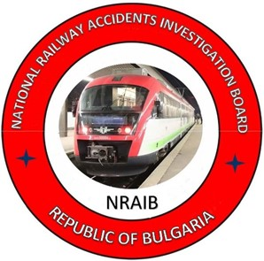

2023

OBJECTIVE OF INVESTIGATION AND EXTENT OF RESPONSIBILITY
The National Air, Maritime and Railway Transport Accidents Investigation Board (NAMRTAIB), which is an independent body performs the investigation of significant accidents, accidents and incidents. The National Board is within the Council of Ministers (CM) of the Republic of Bulgaria, and aims to find the circumstances and causes that led to the accidents and incidents occurrence in order to improve the safety and to avoid such in future.
The investigation, which the NAMRTAIB performed is independent from any judicial investigation, and does not include the determination of fault or responsibility.
The investigation is performed in accordance with the requirements of DIRECTIVE (EU) 2016/798 of the European Parliament and of the Council of 11 May 2016 on railway transport safety, the Railway Transport Act (RTA), Ordinance No59 dated 5.12.2006 on the rail transport safety management, as well as per Agreement dated 17.04.2018 on the interaction during investigation of accidents and incidents in the air, maritime and railway transport between the Prosecutor's Office of the Republic of Bulgaria, Ministry of Interior, and the Ministry of Transport, Information Technology and Communications.
The Investigation reports follow the requirements of REGULATION (EU) 2020/572 of the Commission dated 24 April 2020 on the reporting structure for railway accident and incident investigation reports.

TABLE OF CONTENTS

№ | Title of section | Pg.
 | Summary | 5
 | Investigation | 10
 | Description of the event | 13
 | Analysis of the event | 23
 | Conclusions | 52
 | Safety recommendations | 53

ABBREVIATIONS, USED IN THE REPORT

FT – Fast train
BDZ PS EOOD –,,BDZ-Passenger Services“ EOOD – state railway undertaking for passengers
SE NRIC – State enterprise „National railway Infrastructure Company “(railway infrastructure manager)
RS – Railway section
RTA – Railway Transport Act
TOU – Traffic organization unit
km – Kilometre along the rail track
OCL – Overhead contact line (catenary)
ECM – Entity in Charge of Maintenance
SPR – Small planned repair
Ordinance № 59 – Ordinance on the rail transport safety management
NAMRTAIB – National Air, Maritime, and Railway Transport Accidents Investigation Board (Independent Specialized National Investigation Body)
RAEA/NSA – Railway Administration Executive Agency, National Safety Authority
TF – Task Force
SE – Signalling equipment
SABS – Semi-automatic Block System
RRS – Rail Rolling Stock
FEI – Fire extinguishing installation
TOMR – Train operation management and reporting
RD MoI – Regional department within the Ministry of Interior
RD FSaCP – Regional department Fire Safety and Civil Protection
SMS – Safety Management System
TI – Technical inspection
TOSAMD – Train operation and station activity management Division
DCCM – Device for communications, connections and messages
HST – Higher School of Transportation “Todor Kableshkov” – Sofia
PTC – Professional Training Center at BDZ
CRP- Center for retraining of personnel at SE NRIC
TDRC – Train-dispatching radio connection
EPV – Electrical pneumatic valve

- Summary
  - Brief Description of the Event.
On 06.01.2023, FT No. 2610 departed according to the train schedule from Varna station at 05:00 a.m. (fig. 1.2 and 1.3) in a composition of 4 coaches, 170 tons, hauled by locomotive No. 91520044169-8, served by locomotive driver and assistant locomotive driver and transport crew of the train with train master and conductor. The personnel servicing the train and the rolling stock is partof the railway undertaking "BDZ-Passenger Services" EOOD. Diesel locomotive No. 92520007126-2 is attached to the train for path use between the train locomotive and the first coach. The diesel locomotive was uncoupled from the train at Gorna Oryahovitsa station and FT No. 2610 continued its movement in its original composition. The train on the route run daily in the direction Varna - Gorna Oryahovitsa - Sofia.
FT No. 2610 departed from Mezdra station at 10:44 a.m. The train passed on the second main track at Mezdra South Station at 10:47 a.m. without stopping, the traffic manager on duty at Mezdra South Station noticed that smoke was coming from the draft gear of the locomotive. The locomotive driver, looking to the right at the traffic manager on duty, noticed that the engine department was filled with black smoke and initiated a "quick stop" of the train by activating the automatic train brake. The train came to an emergency stop at 10:50 a.m. and a rapid ignition of the locomotive followed (Fig. 1.1). The traffic manager on-duty returned to the office and saw on the "control board" that the train has stopped at a "distance section" in the station area. He sent the post switchman to the halted train to ascertain the cause of the halt. After about five minutes, the switchman reported that thick smoke was coming from the locomotive, and the passengers were evacuated from the train. The locomotive driver provided information about the fire that occurred in the locomotive on phone 112. At 10:57 a.m., the voltage in the catenary at Mezdra South station and at the Mezdra South - Zverino interstation on Track No. 1 and Track No. 2 was turned off. At 11:05 a.m. a fire truck from RD FSaCP Mezdra arrived and began to extinguish the burning locomotive. At 12:15 p.m., the fire in the locomotive was extinguished and it was moved to the Mezdra South station. At 12:31 p.m., after permission from the authorities of RD FSaCP Mezdra, the voltage was applied to the catenary. At 13:02 p.m. FT No. 2610 with locomotive No. 91520044162-3 departed from Mezdra South Station to Sofia Station.
Fig. 1.1. Locomotive № 91520044169-8 of FT № 2610 in Mezdra South station.
The personnel, serviced the train, and the passengers in the train were not injured. There were no material damages along the railway infrastructure, only the fired locomotive № 91520044169-8, serviced FT № 2610 suffered material damages.
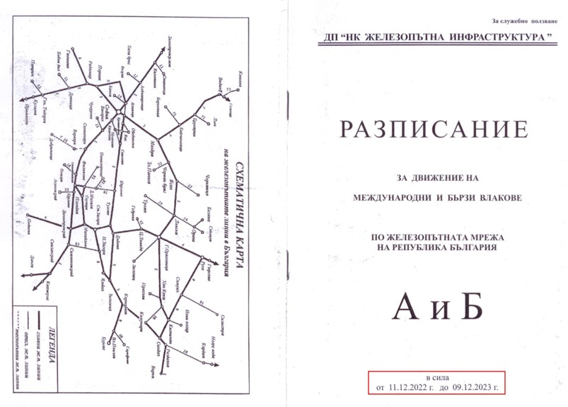
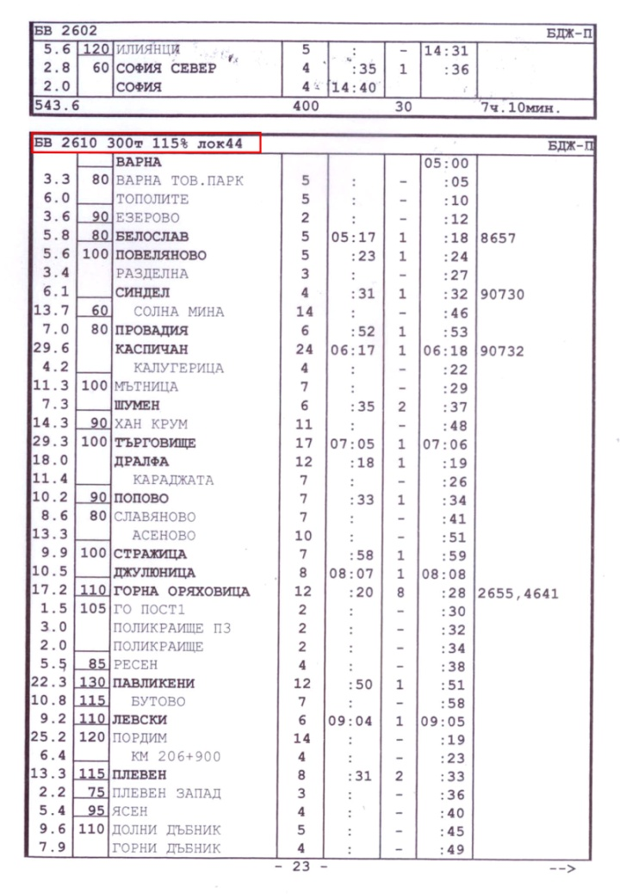
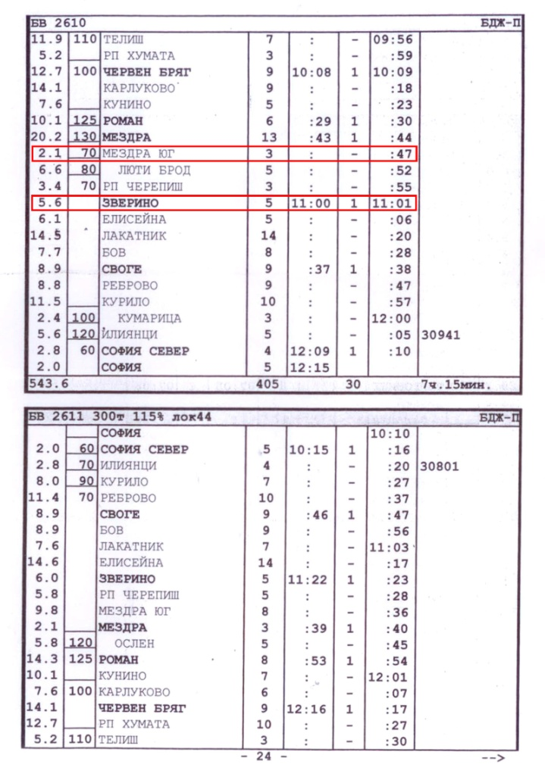
The train traffic between the Mezdra South and Zverino stations was interrupted in the period 11:00 ÷ 12:30 on 06.01.2023 and was restored under schedule.
Fig. 1.2. Schedule of FT № 2610.

  - Location and time of the event occurrence.
Fig. 1.3. Amended schedule under telegram № 84/5.12.2022 of FT № 2610.
The fire in locomotive № 91520044169-8 occurred during movement of FT № 2610 between the stations Mezdra and Mezdra South at 10:48 a.m., as it stopped after the station building of Mezdra South station at km 85+090 (fig. 1.4). At 10:50 a.m. significant fire was growing in the engine compartment of the locomotive, which subsequently comprised the whole locomotive (fig. 1.1).
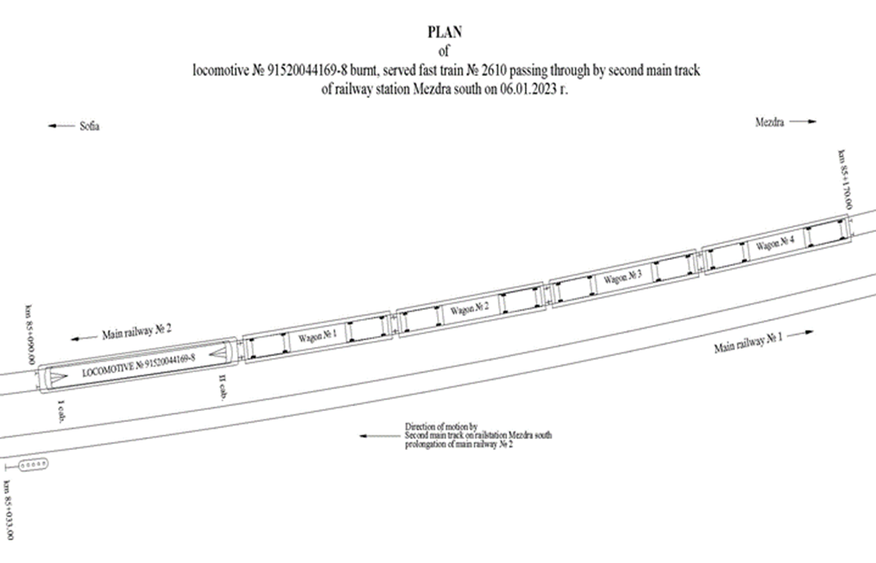
Fig. 1.4. Scheme of the spot of fire occurrence in locomotive № 91520044169-8.
  - Factors determining and contributing the event.
A determining factor for the occurrence of the accident, established by a protocol of findings dated 25.01.2023 for measuring the capacitors of the engine-pumps of locomotive No. 91520044169-8, is that the BOAON 3-06/88 capacitors are of reduced capacity and do not meet the nominal values. That resulted in a lack of starting torque on the first circuit engine-pump, possibly resulting in compromised traction transformer oil cooling. The operating temperature of the oil increased unacceptably and led to its ignition.
A contributing factor to the accident was that the traction transformer oil pressure control was inoperative because the baroscopes were malfunctioning, thus no indication of the operation of the reduced flow first circuit engine- pump was activated. For that reason, the drivers did not take the necessary actions timely.
  - Direct causes and consequences of the event.
The accident occurred as a result of breaking the integrity of the flexible rubber joint of the first cooling circuit, which led to the leakage of transformer oil. The high-temperature leaked oil exceeds the flash point, causing it ignition. When the FEI was activated by the driver, it did not work. That allowed the fire to spread and caused great material damages. Due to heavy smoke in the engine compartment, extinguishing with manual fire extinguishers was not possible.
The consequences of the event were complete ignition of the locomotive and considerable burning of part of its equipment. Power and operating cables connected to the traction motors, engine-pumps, rectifier blocks, motor-fans for cooling the rectifier blocks, etc. were burnt.
  - Safety recommendations and addressees to which they are addressed.
In order to prevent other similar accidents, the Investigation Commission proposes to the National Safety Authority RAEA safety recommendations related to the railway undertaking “BDZ-Passenger Services” EOOD and SE NRIC.
- Recommendation 1, proposes that SE NRIC and "BDZ-Passenger Services" EOOD familiarize the interested personnel with the contents of the report;
- Recommendation 2, proposes that BDZ PS EOOD restores the performance of monthly talks and trainings for the operation and repair personnel in the locomotive depots;
- Recommendation 3, proposes that BDZ PS EOOD replace all the elastic joints in the cooling circuits of the transformer oil of locomotives series 44 and 45 with metal elastic joints;
- Recommendation 4, proposes that BDZ PS EOOD within TI to carry out checks on the serviceability of the baroscopes to control the operation of the engine-pumps, as well as the condition of their starting capacitors;
- Recommendation 5, proposes that BDZ PS EOOD design, develop and install a new FEI on the locomotive series 44 and 45;
- Recommendation 6, proposes that BDZ PS EOOD create an organization for amending and supplementing the departmental regulation PLS 100/2018 for the restoration of capital repairs and the inter-repair runs of locomotive series 43, 44 and 45;
- Recommendation 7, proposes that BDZ PS EOOD take actions to limit the access of the locomotive crew to the apparatus and electrical hard connections for control in apparatus cabinets M1 and M2 in the first and second cabins of locomotives series 44 and 45;
- Recommendation 8, proposes that BDZ PS EOOD install video recorders on the two front walls of the locomotives with visibility to the railway infrastructure and in the two command cabins of the locomotives.
- Investigation
  - Decision for starting the investigation.
The decision to initiate the safety investigation was taken by the member of the Management Board of the NAMRTAIB in the Republic of Bulgaria, leading the investigation of railway accidents and incidents in accordance with the requirements of art. 22, paragraph 3 of Directive (EU) 2016/798 of EPC. Given the severity of the accident and its impact on railway transport safety, the investigation is mainly focused on the analysis and organization, which aims to prevent other serious accidents of similar nature.
  - Motives for the decision to initiate the investigation.
The member of the Management Board of the NAMRTAIB, took the decision to initiate the investigation based on art. 20, paragraph 2 (a) of Directive (EU) 2016/798, art. 115к, paragraph 1, item 2 of RTA, and art. 76, par. 1, item 2 of Ordinance No 59 dated 5.12.2006.
The investigation was undertaken considering the circumstances that led to the fire in locomotive No 91520044169-8 servicing FT No 2610 during train movement, which resulted in heavy material damage to the locomotive.
  - Scope and restrictions of the investigation.
The scope of the investigation included and analyzed the organizational and human factor, the Safety Management System related to the repair and maintenance, including the risk assessment with registered hazards of the traction rolling stock in the railway undertaking "BDZ-Passenger Services" EOOD and the normative acts to it.
The investigation of the accident started after the notification received and the timely movement of the head of the investigation to the NAMRTAIB. Restrictions and delays during the investigation were not allowed.
  - Competences of the persons, involved in the investigation.
In accordance with the requirements of art. 22, paragraph 1 of Directive 2016/798, the Investigation Commission was headed by the member of the Management Board of the NAMRTAIB, head of the railway transport unit. The members of the Commission are independent external experts - qualified persons from higher transport educational institutions, scientific circles, experts in the field of human and organizational factors with qualifications in railway infrastructure, rolling stock and management and operation of train traffic.
  - Communication and consultations with the persons and entities, involved in the event.
The Commission determined the parameters of the investigation and coordinated its actions with the Task Force, which includes experts and transport safety authorities of the two entities (BDZ PS EOOD and SE NRIC). The Task Force collected all the documents and samples, written statements of the personnel of the subjects, the records from the recording devices of locomotive No. 91520044169-8, hauling FT No 2610 on 06.01.2023. The materials and documents were provided to the head of the safety investigation at NAMRTAIB. The Investigation Commission conducted an interview with the train staff (locomotive driver, assistant locomotive driver and train master) and got acquainted with the testimony of the persons involved in the accident. BDZ PS EOOD additionally were requested and provided information on the repair and maintenance of the locomotive. Interviews were conducted with the safety authorities of the two entities, with the management of the railway undertaking BDZ PS EOOD and the SE NRIC. A printout of the actual movement of FT No 2610 from Varna station to Mezdra South station on 06.01.2023 has been requested and provided by SE NRIC.
  - Degree of cooperation from the participating entities.
During the investigation by the Commission at the NAMRATIB, the managers of the railway undertaking BDZ PS EOOD and the representatives of SE NRIC provided full assistance and a complete set of all the necessary materials and documents. Full access to the fired locomotive No 91520044169-8 in Gorna Oryahovitsa locomotive depot was provided for carrying out inspections, measurements and expertise.

  - Methods and techniques of investigation and analysis.
On 06.01.2023 at 11:00 a.m., the member of the Management Board of NAMRATIB with competence to investigate railway accidents received a verbal notification on the mobile phone from the dispatcher on duty of BDZ PS EOOD. At 11:05 a.m. there was also a written SMS notification from the dispatcher on duty of the manager of the railway infrastructure (SE NRIC) about an accident that had occurred - the ignition of locomotive No. 91520044169-8, servicing FT No. 2610.
At the place of the accident, joint inspections were organized and conducted with representatives of the pre-trial proceedings from the Mezdra RD Ministry of Interior and the railway company BDZ PS EOOD. A protocol has been drawn up for the performed inspections.
At 13:30 p.m. after the completion of the procedural and investigative actions, written permission was given by the authorities of the Mezdra RD Ministry of Interior to carry out emergency recovery activities and release the burnt locomotive from supervision.
By an order of the head of the safety investigation at the NAMRATIB, locomotive No91520044169-8 was moved to the Gorna Oryahovitsa Locomotive Depot (location of the locomotive stay) and placed under supervision due to the initiation of a safety investigation by a commission appointed at the NAMRATIB.
After a written permission from the authorities of the Mezdra RD Ministry of Interior at 14:47 p.m. on 06.01.2023, locomotive No. 91520044169-8 was moved from the Mezdra South station to the Mezdra Locomotive Depot.
At 23:12 p.m. on 09.01.2023, the burnt-out locomotive No 91520044169-8, hauled by locomotive No 91520044121-9, at a speed of up to 60 km/h departed from Mezdra station and arrived at Gorna Oryahovitsa station at 03:36 a.m. on 10.01 .2023. The locomotive was moved from the Gorna Oryahovitsa station to the Gorna Oryahovitsa locomotive depot at 03:40 a.m. on 10.01.2023.
In the period 11.01.÷13.01.2023, the Investigation Commission at the NAMRATIB went to the Gorna Oryahovitsa Locomotive Depot, where, together with the managers of BDZ PS EOOD for the operation and maintenance of railway transport and for safety, a safety investigation was started to establish the circumstances and reasons, causing the locomotive ignition. The Commission carried out comprehensive inspections from the outside and in the engine compartment of the burned locomotive No. 91520044169-8. The burnt machines and aggregates were dismantled from the engine compartment, which were subjected to additional inspections and measurements in order to establish their technical condition, for which protocols were drawn up:
- For measuring the capacity and the capacitors of both motor-pumps;
- For the condition of the II-nd circulation pump of the cooling system;
- For measuring the weights of 4 (four) pcs. tanks of fire-extinguishing powder and 2 (two) CO2 fire extinguishers connected to the fire-extinguishing installation in the locomotive which was found to have been activated by the locomotive driver but failed to operate;
- For chemical analysis and technical tests of the oil in the locomotive transformer;
On 18.01.2023, the Investigation Commission at the NAMRATIB conducted an interview with the locomotive crew, which operated locomotive No 91520044169-8, servicing FT No 2610. It got acquainted with their written statements given on the day of the accident. The speedometer tape of locomotive No 91520044169-8 was handed over to the Chairman of the Safety Commission for the purpose of using the information for the needs of the investigation. An external expert from the Investigation Commission deciphered the removed speedometer tape for the movement of the locomotive.
On 18.01.2023, the head of the safety investigation at NAMRATIB received from the head of the Task force at TOSAMD - Sofia the collected materials and documents (including photographic material) regarding the railway accident - a fire occurred in locomotive No. 91520044169-8, servicing FT No 2610 on 06.01.2023.
In the period 25.01.÷27.01.2023, the Investigative Commission at the NAMRATIB continued with the inspections and measurements of other machines and units affected by the fire in the locomotive, for which protocols were drawn up on their technical condition.
  - Difficulties faced during the investigation.
During the investigation, the Investigation Commission of the NAMRATIB did not encounter any difficulties. The representatives of the Task Force and the safety authorities of the Railway Infrastructure Manager and the Railway Undertaking provided full cooperation to the safety Investigation Commission.
  - Interaction with the judicial authorities.
In accordance with the Agreement on Interaction between the bodies of the pre-trial proceedings and the NAMRATIB in force from 17.04.2018, the investigating authorities from the Mezdra RD Ministry of Interior and the Safety Investigation Commission conducted parallel inspections at the place of the accident.
  - Other important information for the investigation context.
In connection with the provisions of the Agreement on the interaction between the pre-trial proceedings authorities and the head of the safety investigation by the NAMRATIB, in accordance with the requirement of Art. 9 of the Agreement, the Mezdra District Prosecutor's Office did not initiate pre-trial proceedings.

- Description of the event
  - Information on the event and the context.
    - Description of the event type.
On 06.01.2023, fast train (FT) No 2610 of BDZ PS EOOD consisting of 4 coaches, 170 tons, served by locomotive No. 91520044169-8, by a locomotive driver and an assistant locomotive driver from the Sofia Locomotive Depot and a transport crew of a train master and conductor from Transport Service Gorna Oryahovitsa run according to schedule in the direction Varna - Gorna Oryahovitsa - Sofia. Diesel locomotive No. 92520007126-2 was attached to the train for path use at Varna station between the train locomotive and the first coach for path use. The diesel locomotive was detached from the train at Gorna Oryahovitsa station. The service personnel of the locomotive, the train and the rolling stock are part of the railway undertaking "BDZ-Passenger Services" EOOD, a national carrier for passenger transport in the Republic of Bulgaria. During the movement of FT No 2610 from Varna station to Mezdra station, the staff on shift along the route in the railway stations did not notice any irregularities when the train passed.
The train departed from Mezdra station at 10:44 a.m. At 10:47 a.m., when crossing the second track at the Mezdra South station without stopping, the traffic manager on duty at the station noticed that smoke was coming from the draft gear of the locomotive, as the train approached the station building, the smoke intensified. The engine driver, seeing the traffic manager on-duty, looked to the right in the engine compartment and noticed the presence of black smoke, after which he made a "quick stop" with the automatic train brake and the train stopped at 10:50 a.m. on the second track after the station building at km 85 +090. At that moment, the locomotive ignited. The traffic manager on-duty returned to the office, saw on the control board that the train has stopped in a "distance section" in the station area, which he notified to the train dispatcher of the section. The traffic manager on-duty sent the post switchman to the stopped train to report what was happening. The station switchman reported from the place that the last coach of the train was after switch No. 6, and the locomotive was in front of the "Station Boundary" sign on the second track and thick black smoke was coming out of it. The engine driver and the assistant engine driver undertook fire extinguishing from the outside in the area of the locomotive draft gear with the portable fire extinguishers in the engine. Subsequently, the conductor brought more fire extinguishers from the passenger coaches, which were also used. The locomotive driver promptly reported the fire to the national emergency number 112.
At 10:57 a.m., the energy dispatcher on-duty ordered the traffic manager on-duty at the Mezdra South station to turn off the voltage in the catenary at the station and at the Mezdra South - Zverino interstation on track No. 1 and track No. 2 in order to extinguish the fire that occurred in the locomotive.
Around 11:05 a.m., a specialized fire-extinguishing vehicle from RD FSaCP Mezdra arrived on the spot and began to extinguish the fire in the locomotive.
At 11:18 a.m., locomotive No 98520052034-6 of BDZ PS EOOD was sent from Mezdra station, which returned the coaches of FT No 2610 to Mezdra South station on the first track. After performing the shunting activities, the locomotive returned to the Mezdra station.
At 11:39 a.m., locomotive No 91520044162-3 of BDZ PS EOOD was sent from Mezdra station to transport FT No 2610 from Mezdra South station to Sofia station.
At 11:50 a.m., a second fire-extinguishing vehicle from RD FSaCP Vratsa arrived with a reserve of water, without participating in the fire extinguishing of the locomotive.
At 12:27 p.m., a specialized machine DM No 99529436805-6 of the Sofia Energy Department was sent from Mezdra station to inspect the catenary in Mezdra South station and in the Mezdra South - Zverino interstation on track No. 2.
At 12:30 p.m., locomotive No 98520052034-6 was again sent from Mezdra station to move the burnt locomotive along the second track in front of the station building of Mezdra South station.
At 12:31 p.m., after permission from the authorities of RD FSaCP Mezdra, voltage was applied to the catenary at Mezdra South station and in the Mezdra South-Zverino interstation on track No 1 and track No 2.
At 13:02 p.m., with 135 minutes delay, FT No. 2610 departed in the direction from Mezdra South Station to Sofia Station on track No. 1.
At 13:05 p.m., the burnt locomotive No 91520044169-8 on the second track at the Mezdra South station ignited again. At the stated request of the authorities from RD FSaCP Mezdra, the voltage in the catenary has been switched off at the Mezdra South station on the first and second track and in the Mezdra South - Zverino interstation on track No. 2, for re-extinguishing the locomotive.
At 13:20 p.m., the inspection of the catenary at the Mezdra South station and on track No 2 Mezdra South - Zverino was completed.
At 13:58 p.m., the fire in the locomotive was extinguished. In the catenary of the first and second tracks at the Mezdra South station and in the Mezdra South - Zverino track No. 2 interstation, voltage is applied.
From the time of the emergency stop of the train, the train master and the conductor promptly arranged to get all eighty passengers out of the coaches.
At 14:47 p.m., the burnt locomotive No 91520044169-8 was attached to locomotive No91520044121-9 and was moved from Mezdra South Station to Mezdra Locomotive Depot.
On 09.01.2023 at 23:12 p.m., working train No. 29999, consisting of locomotive No91520044121-9 with the burnt locomotive No. 91520044169-8 attached to it, departed from Mezdra station to Gorna Oryahovitsa station. The speed of movement of the working train is up to 60 km/h.
On 10.01.2023 at 03:36 a.m. the train arrived at Gorna Oryahovitsa station and locomotive No91520044169-8 was handed over to the Gorna Oryahovitsa Locomotive Depot (locomotive housing).
    - Date, punctual time and location of the event.
On 06.01.2023 at 10:47 a.m., a fire broke out in the locomotive of the train during the passage of FT No. 2610 along the second track of the Mezdra South station without stopping. At 10:50 a.m., the locomotive driver made an emergency stop of the train in the station area. The second track at the Mezdra South station in the direction of the movement of FT No. 2610 is a main track, a continuation of the current track No. 2. In plan, the track is in a right curve with a radius R=910 meters, super elevation H=60 mm and a profile with inclination of 4 .23 ‰ in ascent. (Fig. 3.1).
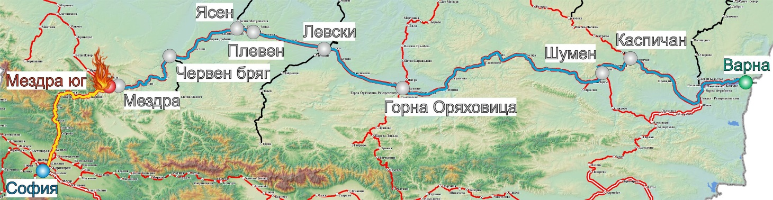
FT № 2610 run along main line № 2 in direction Varna-Gorna Oryahovitsa-Sofia (fig. 3.2).
Fig. 3.1. Route of FT № 2610 and the place of the accident.
- Origin station of FT № 2610;
- Main stations along the train alignment;
- Final destination station of FT № 2610;
- Place of the accident;
- Track, which FT № 2610 passed;
- Track, which FT № 2610 was about to pass;
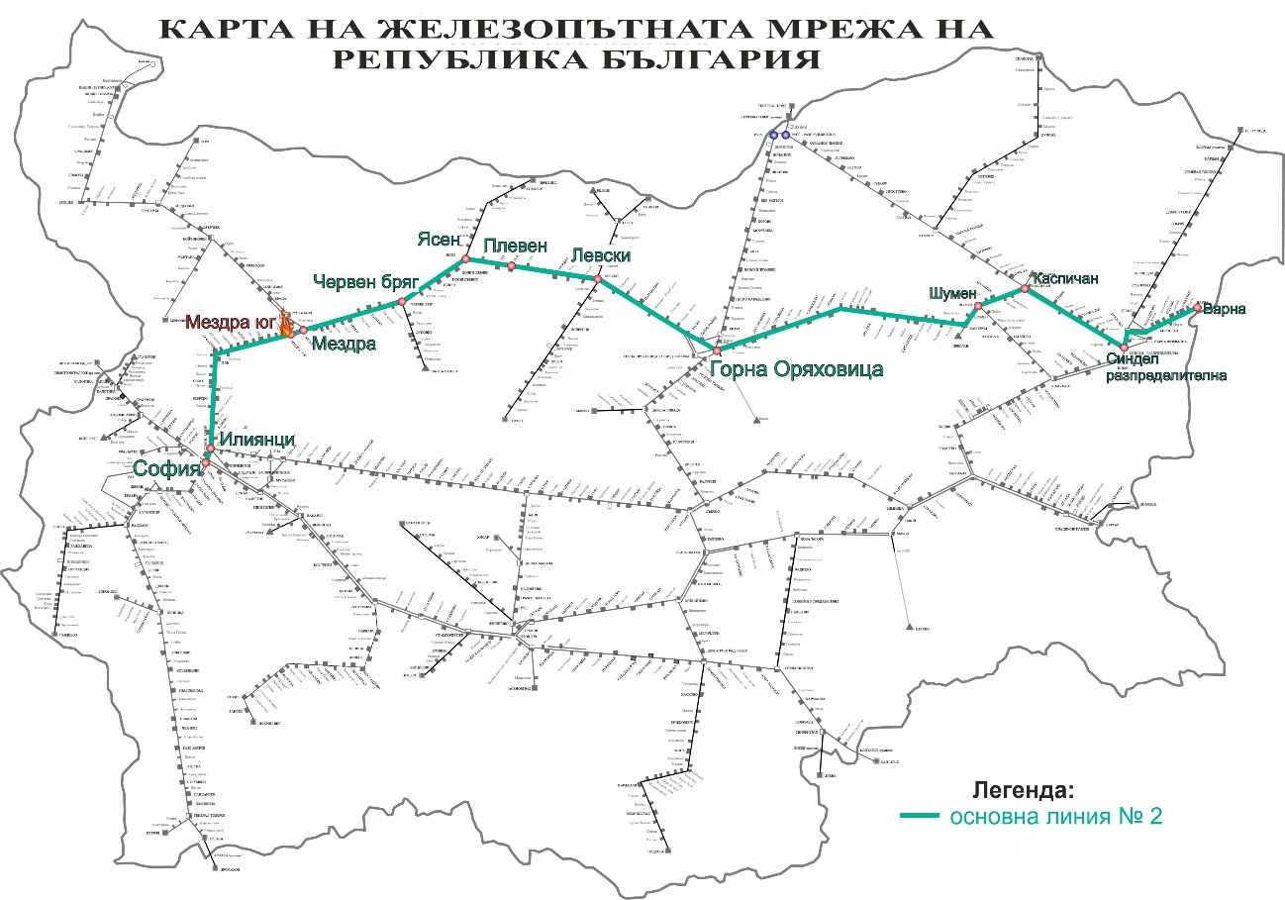
    - Description of the event location:
Fig. 3.2. Map of the route of movement of FT № 2610.
      - Location of the place of the accident (fig. 3.3).
Geographic width: 43° 7'31.93"N
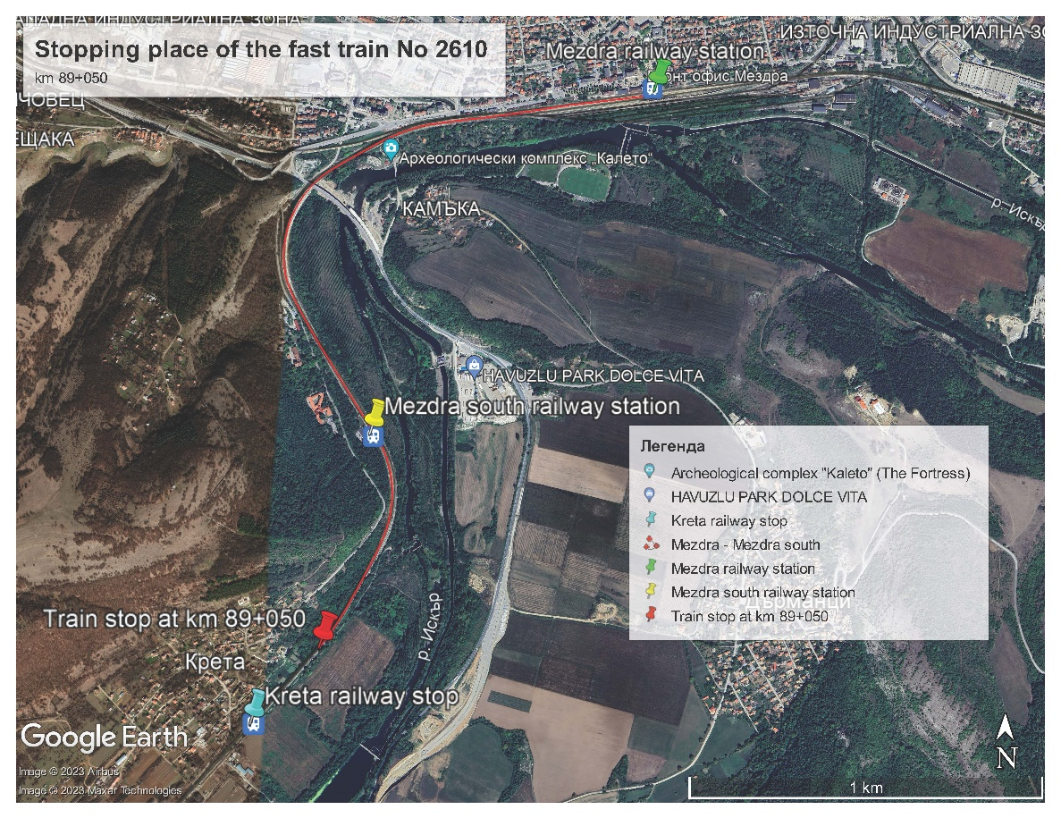
Geographic length: 23°42'9.07"E
Fig. 3.3. GPS location of the accident – km 85+090.

      - Meteorological and geographical condition at the time of the event on 06.01.2023
- In the light part of the day – 10:50 часа (under locomotive recording device data);
- Air temperature: +13ºС;
- Wind speed and direction approximately 12 m/s, West;
- Weather – clear with insignificant cloudiness;
- Average humidity 52 %;
- There was no registered reduced visibility and rains.
      - Performance of construction activities on the site or in vicinity.
In the area of the Mezdra South station, no construction works on the railway infrastructure (railway and facilities, catenary and signalling equipment) have been carried out by the manager of the railway infrastructure.
    - Fatalities, injuries and material damages:
      - Employees of the railway infrastructure manager or railway undertaking.
None.
      - Other persons officially connected with the location of the event.
None.
      - Passengers.
None
      - External persons.
None
      - Cargo, luggage or other property.
None.
      - Rolling stock, infrastructure and environment.
• Material damage of the locomotive № 91520044169-8 – burnt engine compartment;
• Material damage of passenger coaches – None;
• Protocol account – damage that BDZ PS EOOD presented for locomotive № 91520044169-8 amounting to 12 740,48 BGN.;
• Damage caused to the track – None;
• Damage caused to the catenary – None;
• Damage caused to the signalling equipment – None;
• Damage caused to the environment– None;
• Total costs for damages: 12 740,48 BGN.
    - Description of other consequences, including the event impact on the usual activity of the participants.
In the period 10:50÷12:30 on 06.01.2023, the railway infrastructure manager and the railway undertakings have not generated additional costs for changing the train schedule and capacity along the section.
• Deviated trains of the railway undertakings – none;
• Cancelled trains of the railway undertakings – none;
• Assigned trains of the railway undertakings – none;
• Delayed trains of the railway undertakings – none;
• Costs for rehabilitation means – none;
• Total other costs: none.
    - Identity of the participants and their functions.
Railway infrastructure:

- SE National railway Infrastructure Company has a Safety Authorization which guarantees safe operation and maintenance of the railway infrastructure and the adjacent facilities. Ensures equal and non-discriminatory access to all the licensed and certified railway undertakings for the transport of passengers and goods to the railway infrastructure of the Republic of Bulgaria
SE NRIC personnel, involved in the accident:
- Traffic manager on-duty in Mezdra South station;
- Post switchman in Mezdra South station;
Railway undertaking:
• BDZ PS EOOD holds a License and a Single Safety Certificate, which guarantees the provision of safe railway services for the transport of passengers on the railway network of the Republic of Bulgaria. BDZ PS EOOD is a national carrier, under contract with the state for passenger transportation.
Personnel of BDZ PS EOOD involved in the accident:
• Locomotive driver of locomotive № 91520044169-8 of FT № 2610;
• Assistant locomotive driver of locomotive № 91520044169-8 of FT № 2610;
• Train master of FT № 2610.
    - Description of the respective parts of the railway infrastructure and signalling system:
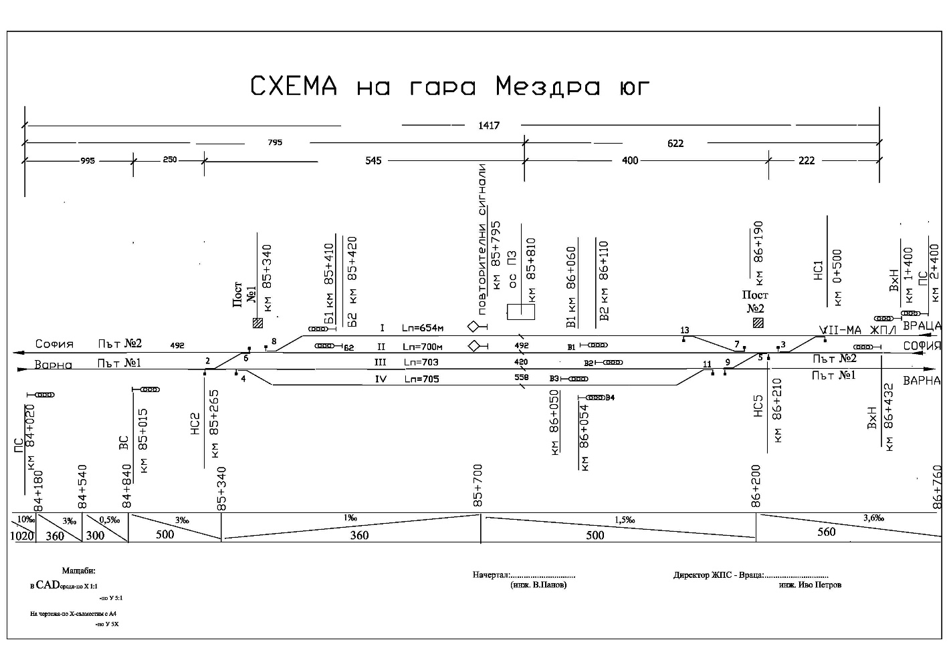
      - Type of the track, railway switch, rail crossing etc.
Fig. 3.4. Scheme of Mezdra South station.
Mezdra South station has four tracks. The second and third main tracks are a continuation of the current track No. 1 and No. 2. The first track is a receiving-departure track, a continuation of the main railway line No. 7 from and to Vidin station. The fourth track is a receiving-departure track to Mezdra station. The tracks of the station in the direction of increasing mileage are in a left curve with super elevation and cants depending on the direction of movement. Mezdra South Station is a junction station in the railway network with directions for main railway line No. 2 and main railway line No. 7 (Fig. 3.4).
The second track at the Mezdra South station in the direction of the movement of FT No. 2610 is a main track, a continuation of the current track No. 2 to the Zverino station. In plan, the track is in a right curve with radius R=910 m, super elevation H=60 mm and a profile with an inclination of 4.23 ‰ in ascent.
      - Interstation block system, station installation, type of signalling.
The Mezdra south - Zverino interstation is equipped with Automatic block system without traffic signals and axle counters - serviceable;
Station interlocking:
Mezdra station is equipped with RRI type Н-68 У – serviceable;
Type of signalling:
In Mezdra South station – entrance and exit semaphores are along the speed signalling – serviceable;
      - Train protection systems.
Mezdra South station does not have a train protection system. The stations and interstation are equipped with a train dispatcher radio connection (TDRC), with the help of which a radio connection is established between the locomotive driver and the traffic manager on-duty, the train dispatcher, individual stations and with the trains in the relevant railway section - serviceable.
Locomotive No 91520044169-8 is equipped with an active type alert device and a "Hasler RT9" type recorder - working.
    - Other information referring the event.
      - Train documents of FT № 2610 in „BDZ-Passenger services“ EOOD.
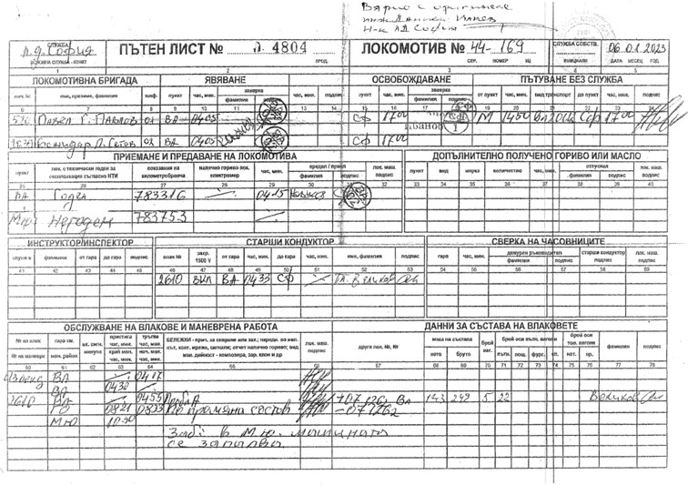
The train documents „Way-bill“ and „Brake mass certificate“ (fig. 3.5 ÷ 3.8) correspond to the hours of the actual movement of the train under the presented data of the TDRC system and the locomotives encryption.
Fig. 3.5. Way-bill of locomotive № 91520044169-8 – front part.
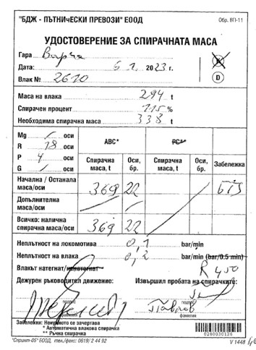
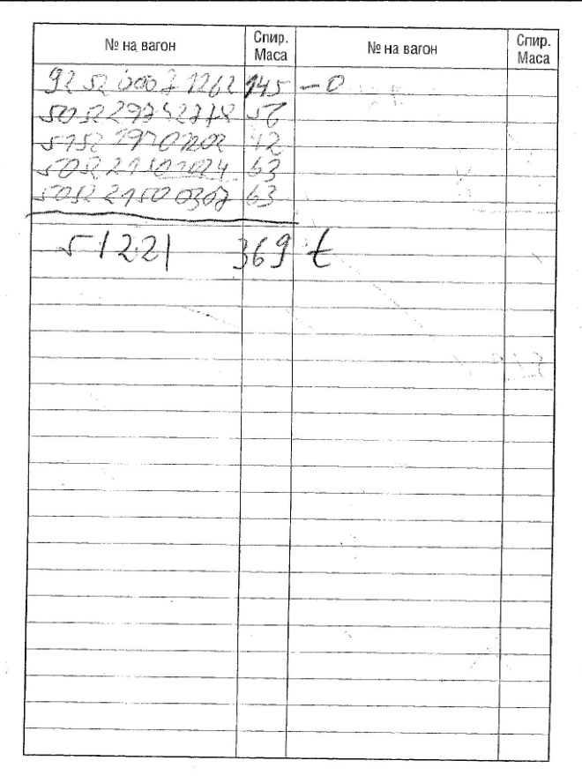
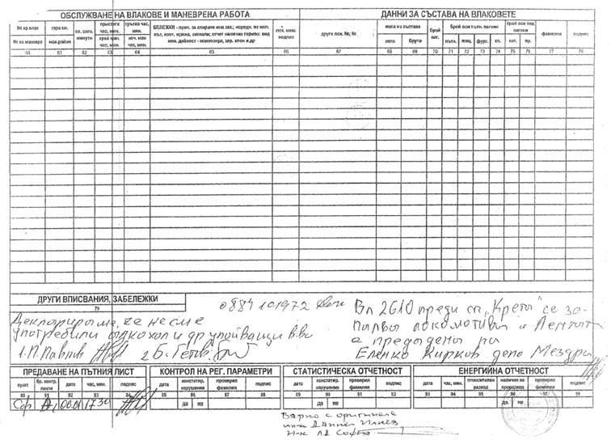
Fig. 3.7. Brake mass certificate of FT № 2610, issued in Varna station – front and rear part. On the rear part with „О“ is indicated the detachment from the composition of the diesel locomotive № 92520007126-2 in Gorna Oryahovitsa station.

Fig. 3.6. Way-bill of locomotive № 91520044169-8 – rear part.
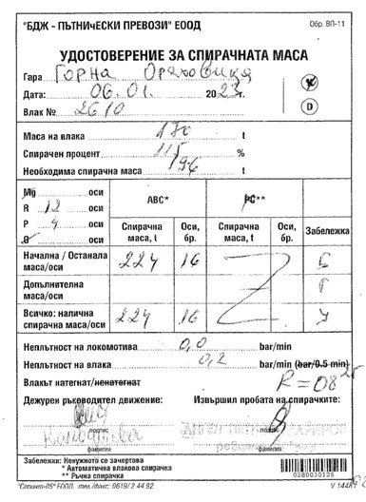
  - Factual description of the occurred.
Fig. 3.8. Brake mass certificate of FT № 2610, issued in Gorna Oryahovitsa station – front part after detachment of diesel locomotive № 92520007126-2.
    - Immediate sequence of events that led to the accident, including:
      - Actions that the involved in the event persons undertook.
At 10:47 a.m., when FT No. 2610 was passing without stopping along the second track of the Mezdra South station, the traffic manager on duty saw that smoke was coming from the draft gear of the locomotive and tried to attract the attention of the locomotive driver with hand movements. At that moment, the locomotive driver noticed thick black smoke in the engine compartment and made a quick stop of the train at 10:50 a.m. on the second track at km 85+090 after the station building. The locomotive crew switched off the voltage of the locomotive and with the available fire extinguishers began extinguishing the locomotive from the outside. They also activated the fire-extinguishing system (the Investigation Commission later found that it did not work). The conductor and the assistant locomotive driver brought more fire extinguishers from the coaches, which were used, but the fire grew quickly. The locomotive driver informed the national telephone number 112 about the fire that has occurred.
The transport crew: train master and conductor, promptly organized the evacuation of all the passengers from the coaches with their luggage at a safe distance.
The switchman on duty at Mezdra South station was sent on the spot by the traffic manager on duty and reported, and then the traffic manager on-duty reported to the train dispatcher on duty of the section. A rapid disconnection of the voltage in the catenary was organized to start extinguishing the locomotive by the authorities of RD FSaCP.
At 11:05 a.m., a specialized fire-extinguishing vehicle of RD FSaCP Mezdra arrived and began extinguishing the locomotive. At 12:30 p.m., the fire was brought under control and extinguished.
At 13:05 p.m., the locomotive moved onto a second track with a shunting locomotive and ignites again. Again the voltage in the catenary was switched off and extinguishing started again. At 13:58 p.m. the fire was located and extinguished.
At 14:47 p.m., the burnt locomotive No 91520044169-8 was moved from the Mezdra South station to the Mezdra Locomotive Depot, where measures were taken to equip it and move it to the Gorna Oryahovitsa Locomotive Depot.
      - Rolling stock and technical facilities functioning.
Until the time of the accident, the rolling stock of FT No 2610 (the locomotive and the four coaches) were technically sound.
During the service of FT No. 2610, the locomotive crew of locomotive No 91520044169-8 did not find any failures and damages that were prerequisites for a fire in the locomotive. The locomotive is regularly registered in the European Vehicle Register (ERV).
Coaches with No 505229742778, 515219401202, 5052221501024, 505221500307 of FT No2610 are serviceable and regularly registered in the European Vehicle Register (ERV).
In Mezdra South station, the station interlocking is RRI type H-68У. Before the accident, the traffic manager on duty ordered a route for FT No. 2610 without stopping at the station along the second main track, a continuation of the current track No. 2 to Zverino station.
      - Operational system functioning.
The operational train traffic control system on the main railway line No. 2 and between Mezdra and Mezdra South stations and Zverino before the accident was serviceable and functioning normally. The train traffic in the Mezdra - Sofia section is carried out on a double-track railway line. The two lines are specialized in the directions of the trains in the odd direction on track No. 1 and in the even direction on track No. 2.
During the time of the accident, the operational system between the Mezdra and Mezdra South stations on track No. 2 was not functioning from 10:50 a.m. to 12:30 p.m. on 06.01.2023.
    - Sequence of the events from the beginning of the occurrence until the end of the rescue services actions:
      - Undertaken measures for protecting and guarding the event location.
At 11:05 a.m., the authorities of the RD Mezdra Ministry of Interior arrived at the place of the accident, after clarifying the situation, the area was restricted to outsiders. The authorities of RD FSaCP and the interested officials of the entities were allowed to access the site. Media access was restricted.
      - Actions of the emergency rescue services.
At around 11:05 a.m., the authorities of RD FSaCP Mezdra arrived at the place of the accident and started extinguishing the fire in the locomotive. The fire in the locomotive was extinguished at 12:30 p.m.
At 11:50 a.m., under the orders of RD FSaCP Mezdra, a second fire extinguishing vehicle arrived from the Vratsa Railway Station for a water reserve, without having participated in extinguishing the locomotive.
At 12:31 p.m., after permission from the authorities of RD FSaCP Mezdra, voltage was applied to the catenary at the Zverino - Mezdra South interstation on track No 1 and track No 2.
At 13:05 p.m., locomotive No 91520044169-8 at the Mezdra South station ignited again. At the request of the authorities from RD FSaCP Mezdra, the voltage in the catenary at Mezdra South station on the first and second tracks and the Mezdra South - Zverino interstation on track No. 2 has been turned off again, for extinguishing the locomotive and inspecting the catenary.
At 13:20 p.m., the inspection of the catenary at the Mezdra South station and the Mezdra South - Zverino track No. 2 interstation was completed.
At 13:58 p.m., the repeated fire in the locomotive was extinguished and the voltage was applied to the catenary at the Mezdra South station and the Mezdra South - Zverino track No. 2 interstation.
      - Actions of the emergency rehabilitation services
Non applicable.
      - Actions that SE NRIC and “BDZ-Passenger Services” EOOD undertook for restoring the schedule and capacity along the railway line
On 06.01.2023 at 12:30 p.m., after completion of the procedural-investigative actions, written permission was given by the RD Mezdra of the Ministry of Interior to carry out emergency restoration activities.
At 11:18 a.m., shunting locomotive No. 91520052034-6 departed from Mezdra station to Mezdra South station. The locomotive arrived at 11:25 a.m., was attached to the coaches of FT No. 2610 and returned to the first track. The locomotive returned to Mezdra station.
At 11:39 a.m., mainline locomotive No. 91520044162-3 departed from Mezdra station to Mezdra South station to serve train No 2610 to Sofia station.
At 12:27 p.m., a specialized machine of the Sofia Energy Department, DM 99529436805-6, departed from Mezdra station to inspect the catenary at Mezdra South station and the Mezdra South - Zverino interstation.
At 12:30 p.m., shunting locomotive No. 91520052034-6 departed from Mezdra station again to return the burnt locomotive No. 91520044169-8 in front of the station building of Mezdra South station.
At 13:02 p.m. FT No. 2610 with locomotive No. 91520044162-3 departed from Mezdra South Station to Sofia Station with 135 minutes delay.
At 13:20 p.m., the inspection of the catenary at the Mezdra South station and the Mezdra South - Zverino interstation was completed. After the inspections of the rail track and the catenary, no damages from the fire were found.
At 14:47 p.m. on 06.01.2023, the burnt locomotive No. 91520044169-8 was moved from the Mezdra South station to the Mezdra Locomotive Depot, where it was equipped for moving to the Gorna Oryahovitsa Locomotive Depot.
At 23:12 p.m. on 09. 01.2023, the burnt locomotive No. 91520044169-8, towed by locomotive No 91520044121-9 at a speed of up to 60 km/h, departed for the Gorna Oryahovitsa Locomotive Depot.
On 10.01.2023 at 03:36 a.m. the two locomotives arrived at the Gorna Oryahovitsa station and at 03:40 a.m. the burnt locomotive No. 91520044169-8 was handed over to the Gorna Oryahovitsa locomotive depot.
- Analysis of the event
  - Participation and responsibilities of the entities, involved in the event
    - Railway undertaking.
Analysis of the movement of FT № 2610.
The records were removed from the recording device (speedometer tape) of locomotive No91520044169-8, at the head of FT No. 2610 on 01.06.2023.
The registration of the main and most important parameters of the movement of the locomotive, respectively of the train, in speedometer installations "Hasler" system is done by recording on the speedometer control tape:
- Instant value of the speed (V-S);
- Astronomic time via the schedule and seal on the tape, as well as the travelling time and stop (diagram Т);
- Travelled time for the separate track sections (via perforations on the tape – 2,5 mm = 0,5 km);
On the speedometer tape within apparatuses type RT (as of locomotive № 91520044169-8) could be also registered the following additional parameters:
- Pressure in the main air conduct;
- Movement direction;
- Activation of the rheostat brake;
- Activation of the automatic brake (pneumatic registering);
The speedometer tape is verified for finding:
- Whether the maximum speed of movement is kept;
- Whether the speed is restricted to the prescribed while passing a section, which requires a speed restriction;
- Whether the duration of reduced speed movement is respected, i.e. to travel a distance equal to the length of the reduction plus the length of the entire train;
- Are there any unplanned stops along the interstation;
- Are there any slips noted on the locomotive;
- Is there a decrease in the pressure of the main air conduct of the air brake when performing the various tests;
- How the automatic train air brake was used and how the rheostat brake was used;
- Availability of additional registrations in accordance with those provided for each series of TPRRS (traction power rolling stock);
- Availability of all the records for the relevant TPRRS.
The speedometer control tapes can also be used for other clarifications in the movement of trains, namely:
- Delays in departure and arrival;
- Stopping at closed signals in the stations;
- Within calculating the energy cost etc.
The speedometer control tapes are considered a valuable objective document in the investigation of safety accidents.
Any falsification of the speedometer tape, wilful destruction or tampering with the clock or recording mechanism shall be considered as safety violations.
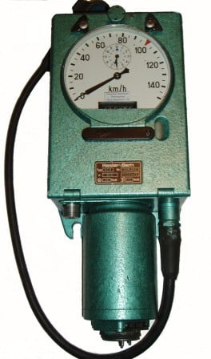
Locomotive No. 91520044169-8 is equipped with a "Hasler" type speedometer installation consisting of a three-phase alternating current collector converter (Geber) driven by one of the locomotive's track wheelset. The resulting three-phase voltage with a variable frequency depending on the set speed drives the mechanical speedometer synchronous electric motors mounted to it (Fig. 4.12). One speed measuring device is installed in the locomotive cabins: the recording device (tape tachograph) RT9 in cabin No. 1 (fig. 4.1) and the non-recording device (tachometer) A16 in cabin No. 2 (fig. 4.2). The two speedometers have a range of 0÷150 km/h
Fig. 4.1. Tape tachograph RT9
Fig. 4.2. Tachometer A16
The tape tachograph measures and shows on a comprehensible dial the following data during the locomotive movement:
- Track speed in km/h;
- Time in hours and minutes;
- All the passed section in km (kilometre counter);
The tachometer measures and displays on a clear dial the same data that the tape tachograph displays, without the distance travelled and without recording the information. It is electrically connected to the tachograph, and if the power cable is interrupted, the two devices stop recording the speed of movement.
The recording equipment of the RT9 tachograph records the following basic parameters:
- Track speed in km/h;
- Astronomic time, as well as the travelling and staying time;
- The passed track for the separate track sections;
- Other parameters of movement of the locomotive.
Registering (speedometer) tape is made of waxed paper. It has lined fields for recording the information transmitted by the tape tachograph (Fig. 4.3). The speedometer tape is a valuable objective data source for accurately determining the beginning, course and end of movement-related processes.
On the speedometer tape are registered:
- Instant value of the speed in km/h;
- Astronomic time;
- Travelling time;
- Stopping time;
- The passed track for individual track sections;
- The air pressure in the main air conduct (MAC);
Other data (optional, due to which it is not always respected).
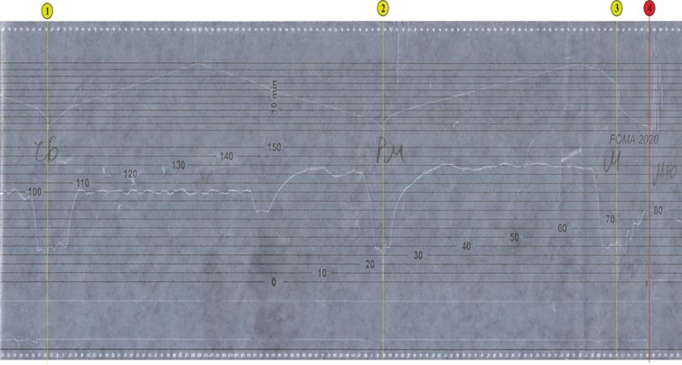
In Fig. 4.3 graphical images V(S), t(S) and PL(S) are shown for locomotive No. 91520044169-8, taken from the scanned speedometer tape of the locomotive during the movement of FT No. 2610 after passing with a stop through the Cherven Bryag stations (marker ), Roman (marker ) and Mezdra (marker ). The locomotive speedometer installation did not register a numerical reading of the astronomical time in the top field of the tape.
Fig. 4.3. Speedometer tape of locomotive № 91520044169-8.
As can be seen from the data of the decoding of speedometer tape, presented by BDZ PS EOOD, the train departed from Mezdra station at 10:46 a.m. After the departure, locomotive No. 91520044169-8 accelerated to 80 km/h, after which a rapid stop (hold) followed, ending at the point marked with marker).
In the next Fig. 4.4 is shown an enlarged graphic image of the parameters of locomotive No91520044169-8, from the speedometer tape of the locomotive during the movement of FT No2610 immediately before the accident.
The start of stopping is at the point marked * at a driving speed of about 80 km/h, and reaching zero speed is at the point marked . According to the additionally added distance scale in red colour, the stopping distance of the train is 250 meters.
From the above graphs, no over speeding by the locomotive is found, therefore it is not relevant to the accident that occurred.

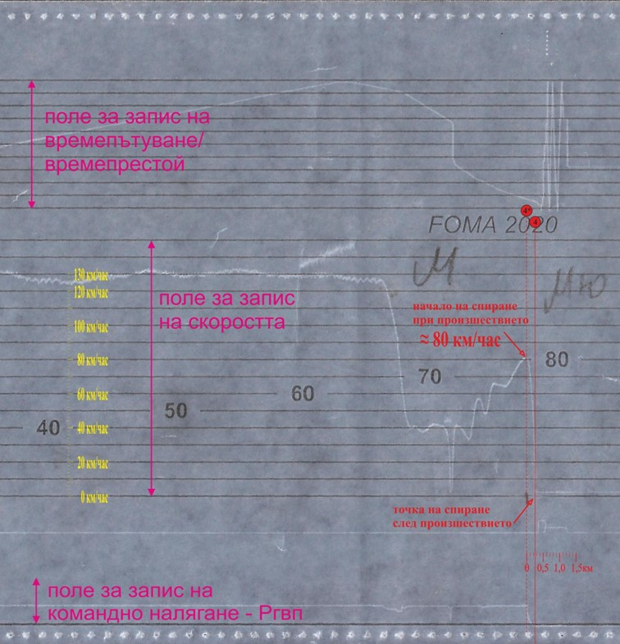
FT No. 2610 departed from Varna station at 05:02 a.m. consisting of four coaches and diesel locomotive No. 92520007126-2, attached between the train locomotive and the first coach of the train. Locomotive No. 92520007126-2 has a maximum design speed of 100 km/h. In the section from Varna station to Dzhulyunitsa station, the train run at the permitted speed according to the schedule, which is 100 km/h.
Fig. 4.4. Speedometer tape of locomotive № 91520044169-8.
The train arrived at Dzhulyunitsa station at 08:08 a.m. and, after a one-minute delay, it departed at 08:09 a.m. (Fig. 4.5). Along Dzhuliunitsa - Gorna Oryahovitsa interstation FT No 2610 moved with a maximum speed of 110 km/h, which is permissible for this train in the indicated interstation (fig. 4.5, item 1). At the same time, the maximum permissible speed of diesel locomotive No 92520007126-2 attached to the train is 100 km/h, i.e. in the interstation Djulyunitsa - Gorna Oryahovitsa FT No. 2610 exceeded the speed of movement by up to 10 km/h (fig. 4.5, pos. 2) and travelled 9500 meters at a speed higher than the permissible speed for the coupled diesel locomotive (fig. 4.5, item 3).
After uncoupling the diesel locomotive at the Gorna Oryahovitsa station, the train continued its journey with four passenger coaches. When moving to the Mezdra South station, the locomotive driver observed the permissible speeds according to the schedule and no irregularities were observed during the train movement.
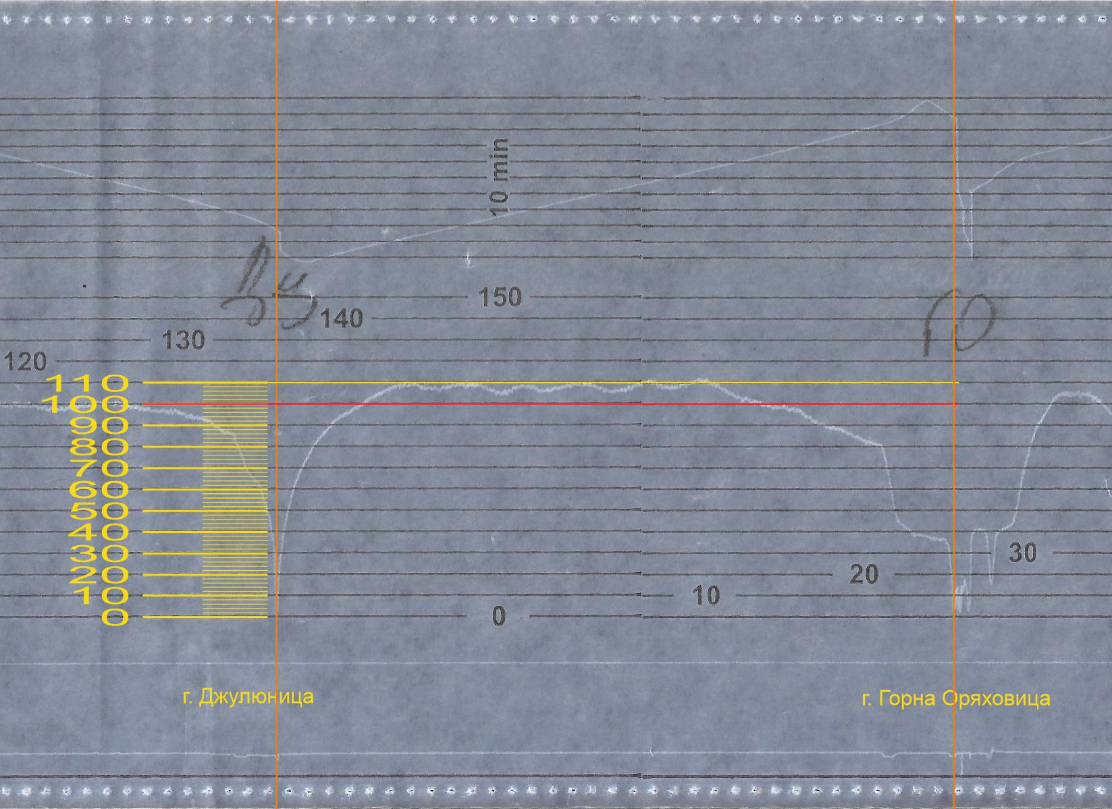
FT No. 2610 departed from Mezdra station at 10:46 a.m. after a stay of 3 minutes and 40 seconds. The train accelerated, reaching a speed of 42 km/h in about 45 seconds and traveling about 200 meters (Fig. 4.6, item 1). That was followed by a decrease in speed to about 33 km/h for about 30 seconds, and the distance covered was 300 meters (Fig. 4.6, item 2). The train again increased its speed to 57 km/h in 35 seconds, it travelled 350 meters (Fig. 4.6, pos. 3) and again followed a decrease to 48 km/h in 150 meters for 15 seconds (Fig. 4.6, pos. 4). The third time, the train increased its speed to 66 km/h in 20 seconds, traveling about 280 meters (Fig. 4.6, item 5). Then the speed decreased to 64 km/h in 20 seconds, traveling 320 meters (Fig. 4.6, pos. 6). After the last decrease, the speed started to increase again, reaching 80 km/h, and the train travelled 400 meters in 30 seconds (Fig. 4.6, item 8). That was the maximum speed that the train reached after leaving Mezdra station. The train passed through the Mezdra South station in traction mode at a speed of 76 km/h, during which the speed continued to increase to 80 km/h (Fig. 4.6, item 7). This is also confirmed by the reading of the selsin (the sensor) reading the position of the controller, whose arrow remained at position 26 (Fig. 4.7). 100 meters after reaching the maximum speed, the pressure in the main air conduct decreased from 5.0 to 0.0 bar, i.e., a quick stop with the automatic train brake was made (Fig. 4.6, item 9). About 90 meters after the stop, the speed started to decrease and after another 200 meters it reached 0 km/h and the train stopped (Fig. 4.6, item 10).
Fig. 4.5. Diagram of the movement of FT № 2610 along Dzhuliunitsa - Gorna Oryahovitsa interstation.
1
2
3
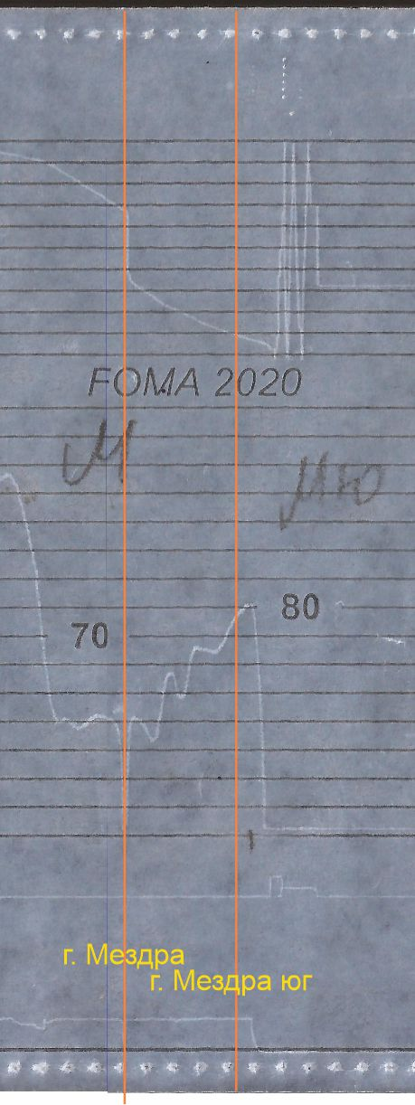
Fig. 4.6. Diagram of movement of FT № 2610 along Mezdra-Mezdra South interstation.
1
2
3
5
8
10
6
9
4
7

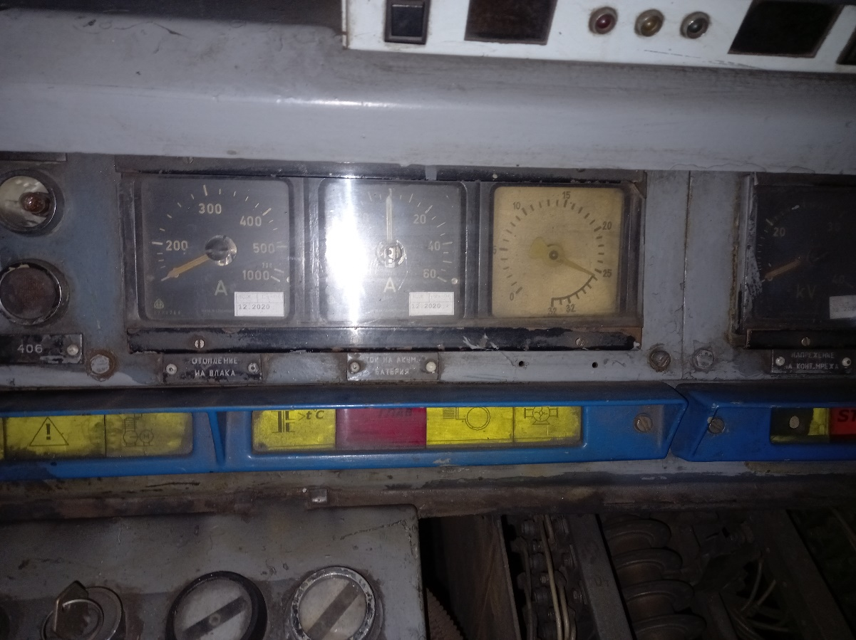
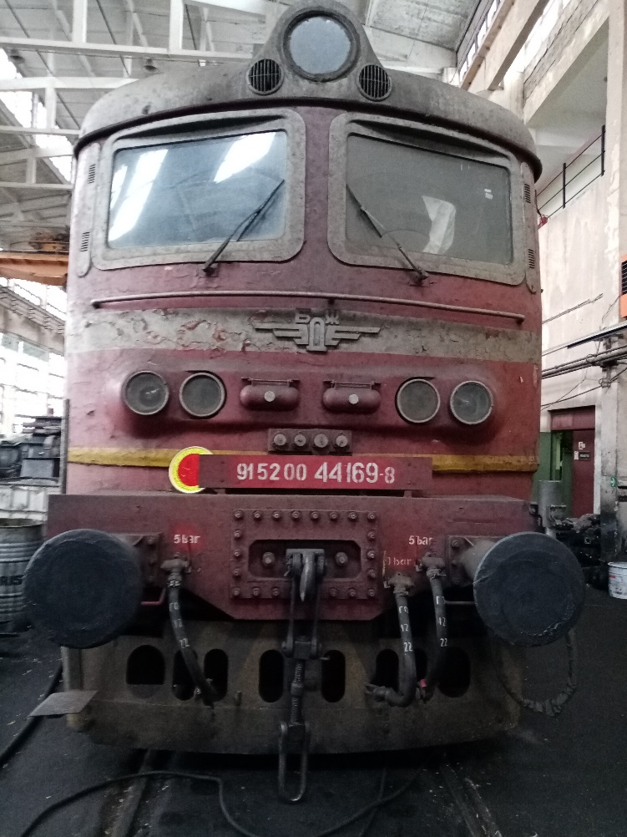
Fig. 4.7.
Fig. 4.8.
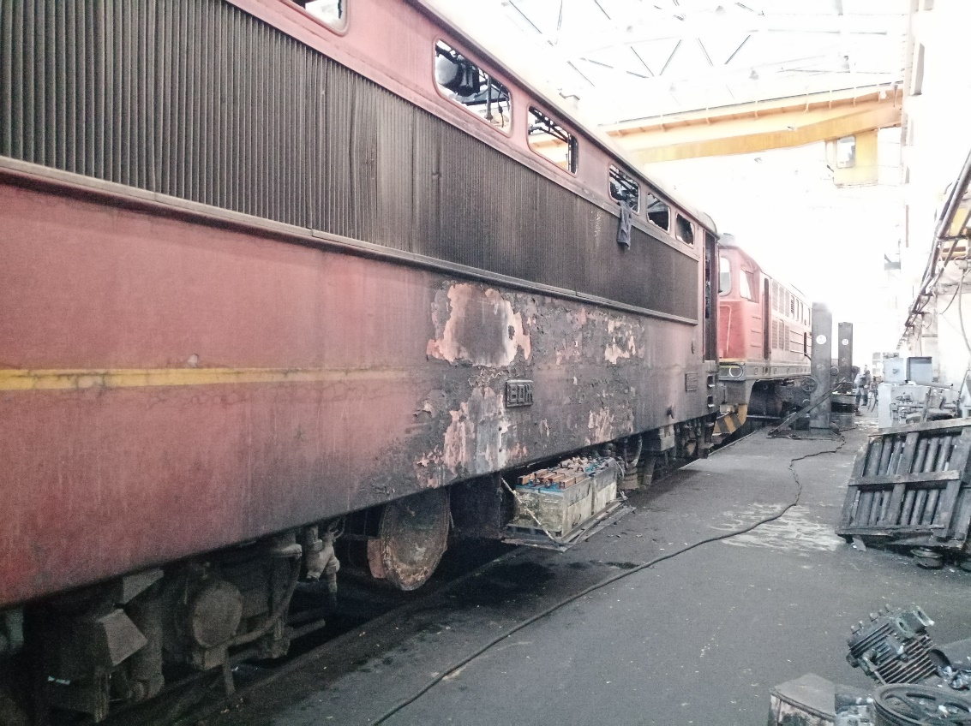
The Commission performed several inspections of locomotive № 91520044169-8, located in Gorna Oryahovitsa locomotive depot (fig. 4.8).
Fig. 4.9.
From the inspection of the external part of the locomotive, it was found that there were traces of burning in the middle of the body shell around the storage batteries on the left side in the direction of the train movement (Fig. 4.9). On the other side of the body shell, no traces of burning were found (Fig. 4.10). By order of the Investigation Commission, the locomotive was jacked up and the bogies separated. That enabled an inspection of the underside of the body shell as well as the bogies with the traction motors and power cables. The Commission found traces of burning on the underside of the body shell on the frame beams and sheet metal separating the engine compartment from the underframe of the locomotive (Fig. 4.11). It was also found that the insulation of the power cables feeding the traction motors was burnt (Fig. 4.12). The traces proved that in that part the combustion was external, caused by a lateral source, and the power cables of the traction motors could not be considered as the source of the ignition. An inspection was also carried out of the bogies together with the traction motor power supply terminal boxes, and it was also ruled out that the ignition could not be traced to that part of the locomotive (Fig. 4.11). The rectifier blocks were removed from the locomotive for a better and comprehensive inspection, as they are often the source of ignitions in these locomotives. The Commission inspected these facilities and found that there were damages in their lower part, which were caused by external sources, and for the most part the rectifiers were in good condition (Figs. 4.13 and 4.14).
After carrying out the inspections on the outside of the locomotive, as well as the dismantled assemblies, the Commission proceeded to inspections in the engine compartment. First of all, it was established that the fire-extinguishing installation of the locomotive was activated by the locomotive crew (Fig. 4.15, item 1 and item 2), but it did not actually work, because no traces of fire-extinguishing powder were found in the engine compartment, with which it was loaded (Fig. 4.16).
The Investigation Commission focused on the most charred part of the engine compartment, namely the engine-pump, as all traces of combustion indicated that was the place from which the fire originated and spread (Fig. 4.17).
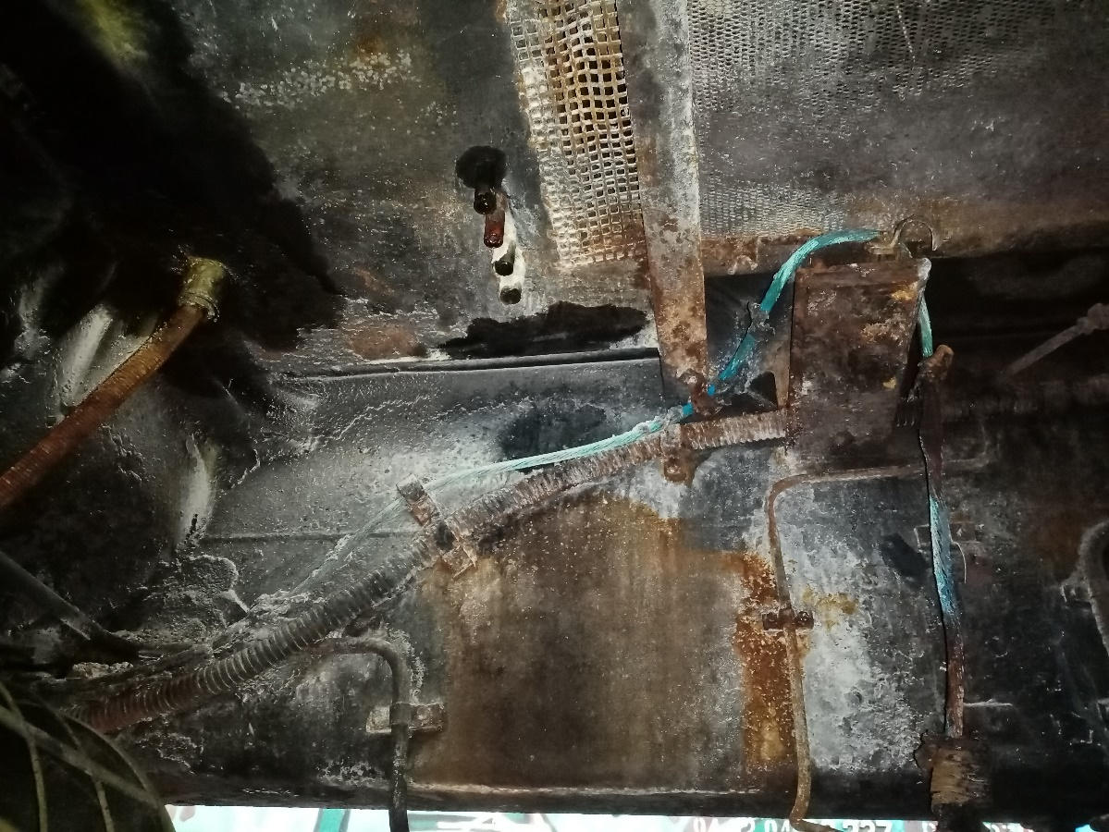
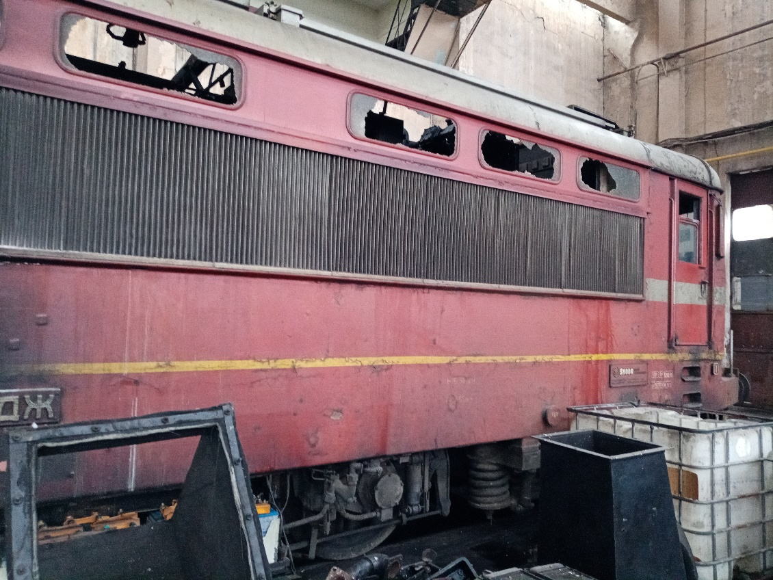
Spots of high-temperature burning were found on the metal parts (Fig. 4.17, item 1), as well as burnt insulation. It was also found that the flexible connection of the engine-pump with the traction transformer - a rubber joint - was burnt and completely missing (Fig. 4.17, pos. 2), and the taps leading from and to the transformer were partially melted (Fig. 4.17, item 3)
Fig. 4.11.
Fig. 4.10.
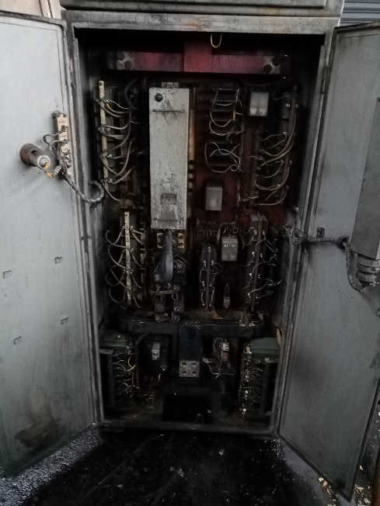
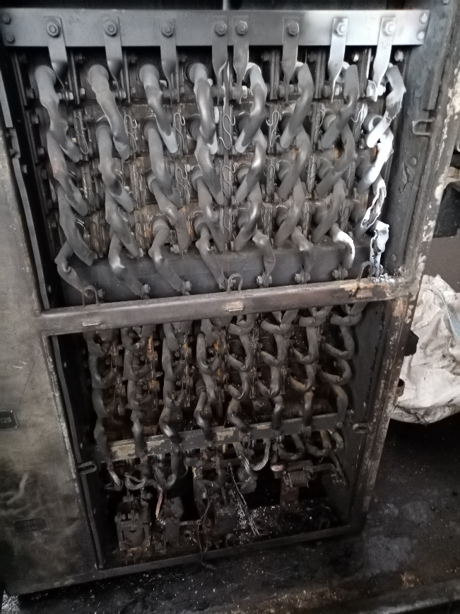
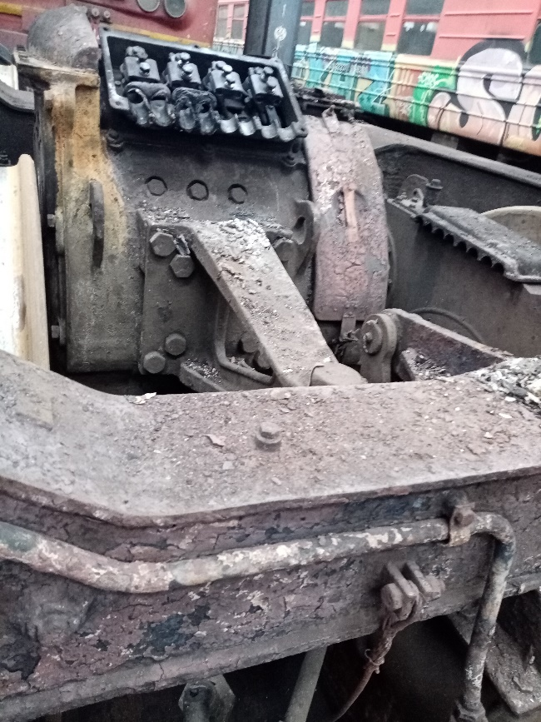
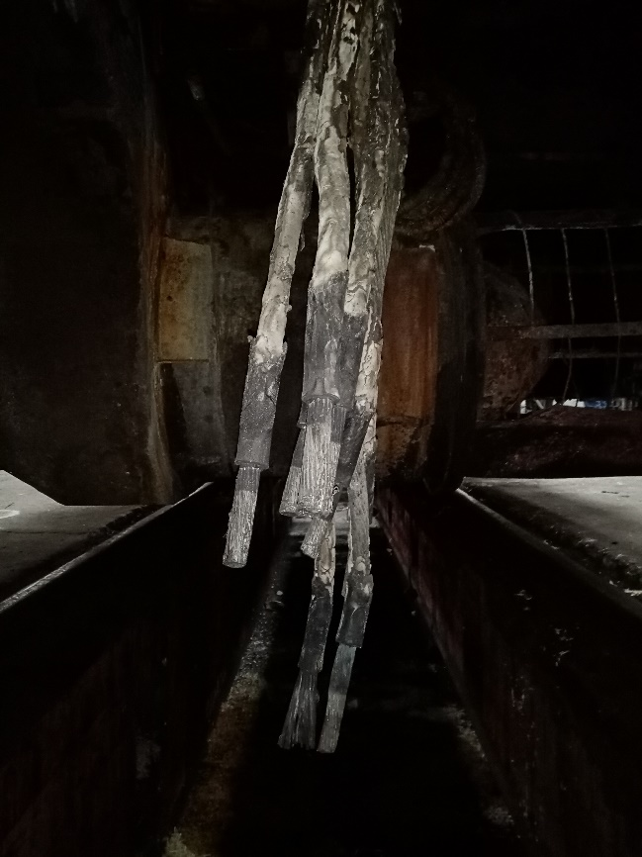
Fig. 4.14.
Fig 4.13.
Fig. 4.12.

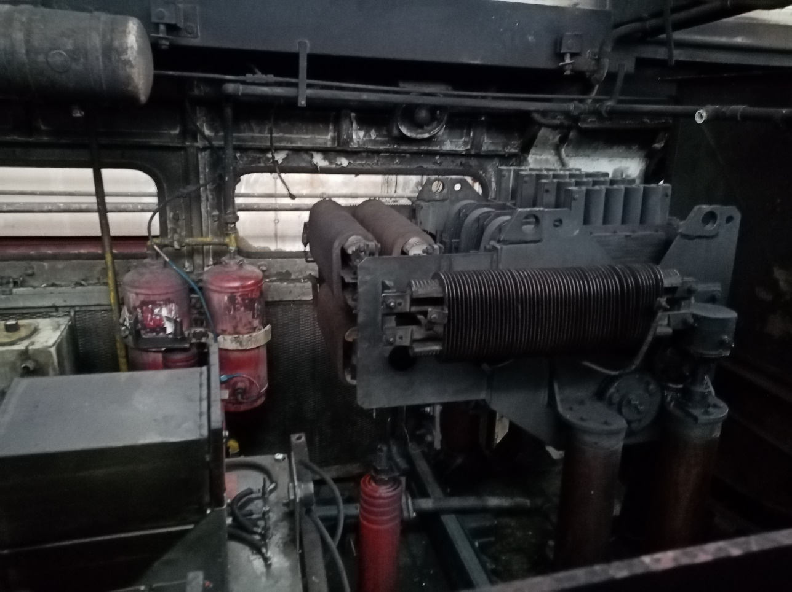
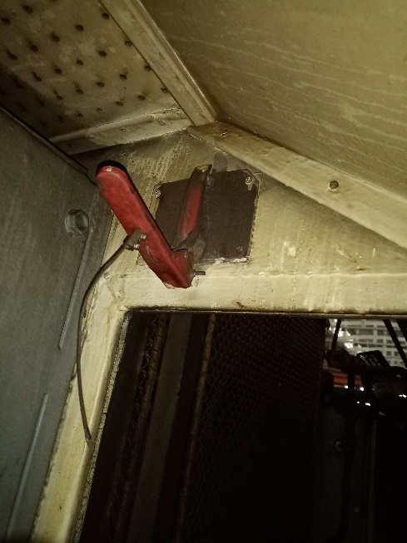
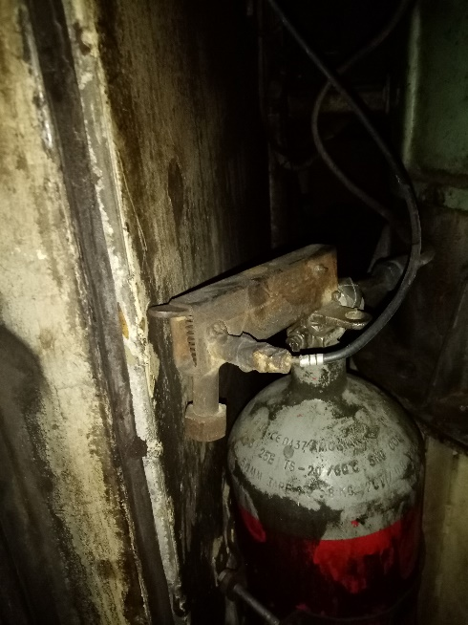
Fig. 4.16.
Fig. 4.15.

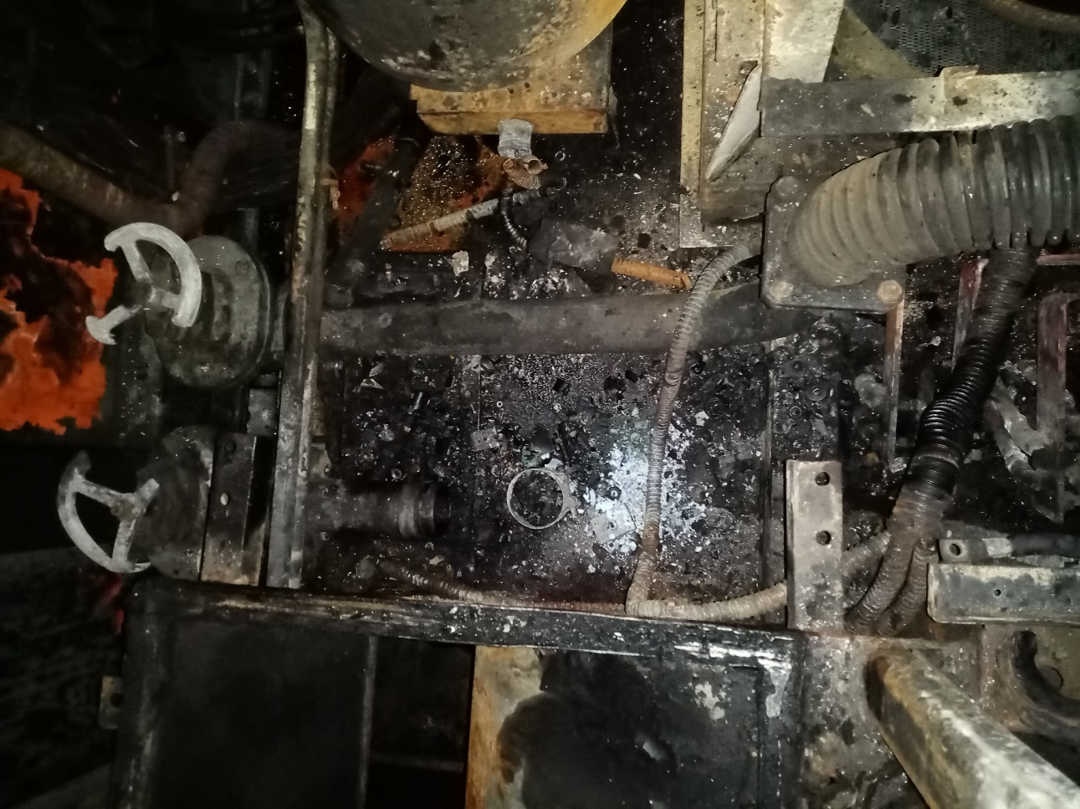
From the analysis, it can be concluded that the focus of the ignition was located in the area of the engine-pump on the side of the second traction group.
Fig. 4.17.
1
2
3
The Investigation Commission thoroughly inspected the removed motor-pump and demanded the measurement of the capacitors of both motor-pumps. From the inspection, it was established that the motor-pump was functional and there were no visible damages on it (fig. 4.18). During the measurement of the capacitors, it was found that their parameters did not correspond to their nominal values laid down in the technical documentation. The thickness of the copper membrane of the baroscopes was also measured and found to be 0.8 mm (Fig. 4.19). From the observations and measurements carried out, it can be concluded that the engine-pumps, and in particular the one on the side of the second traction group, did not work in normal mode with their nominal parameters and the oil flow rate was reduced. That caused the temperature of the transformer oil to rise, which at one point ignited and ignited the remaining combustibles in that area. Eventually, the rubber joint connecting the motor-pump to the traction transformer ignited, spilling and igniting the remaining transformer oil, which in turn helped fuel the fire. The traction transformer oil low pressure protection in the face of the baroscopes with (thickened copper diaphragms) also did not activate to signal that the motor-pumps were running at reduced flow.
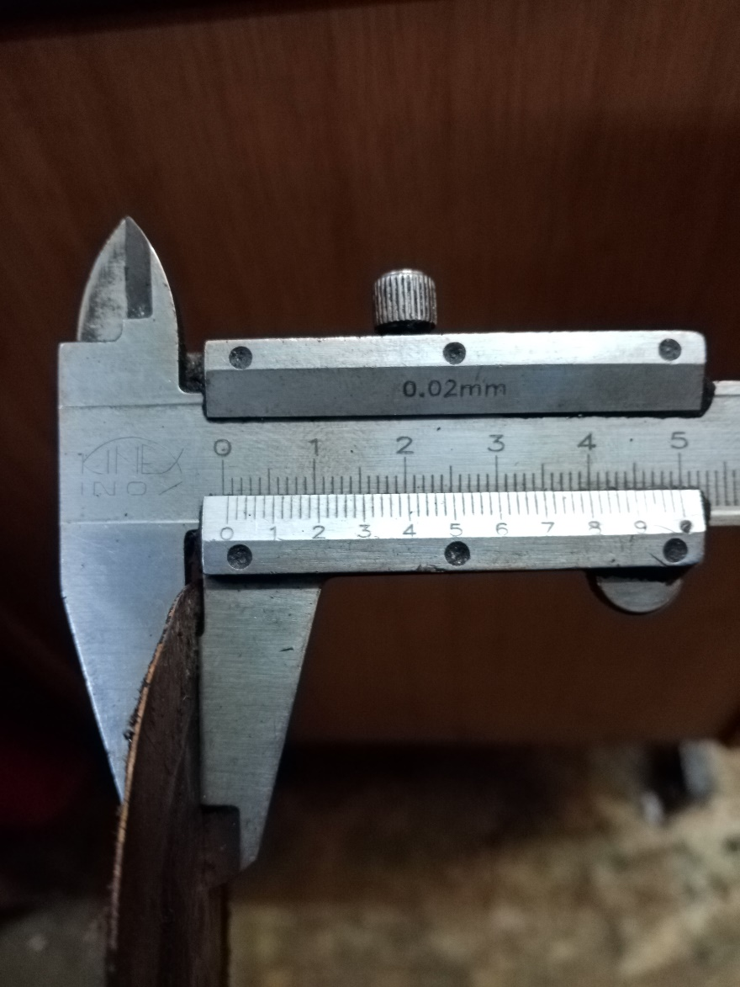
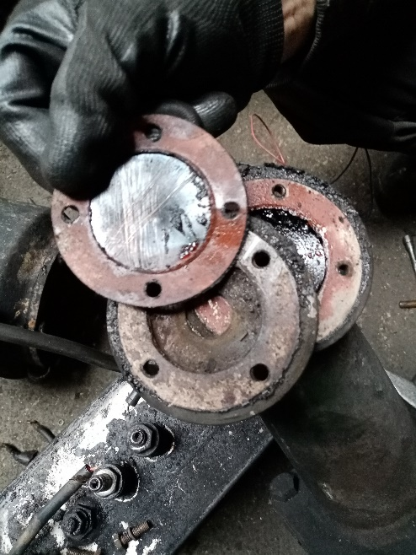
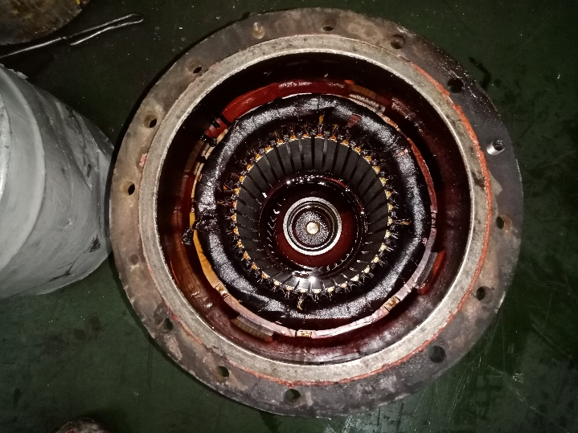
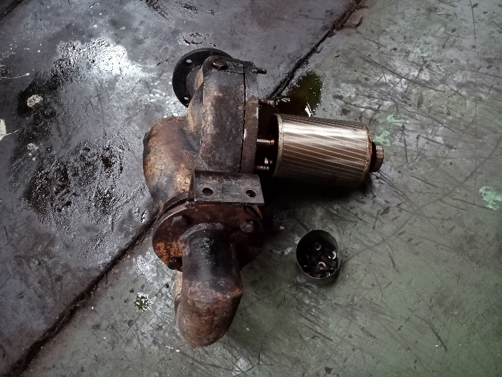
All the listed facts eventually led to the ignition of the insulation of the cables feeding the motor-pump on the side of the second traction group, as a result, other elements in that part of the engine compartment ignited and that led to the ignition of the transformer oil and that spread the fire.
Fig. 4.19.
0,8 mm
Fig. 4.18.

In the circumstances, the probability of the fire occurring while the locomotive was in motion was the malfunction of the second circuit of the cooling system of the traction transformer, which disrupted the cooling of the oil in the traction transformer.

The Commission found that in the accident, after the fire extinguishing installation (FEI) of locomotive No 91520044169-8 was activated, the structurally intended effect of extinguishing the fire in the locomotive did not follow (fig. 4.16).

Under an order of the Investigation Commission, additional measurements were made of:
- Protocol of inspection of the oil pump of the locomotive on 12.01.2023. (see Fig. 4.20);
- Protocol of chemical analysis and technical tests of the oil in the contour on 12.01.2023. (see Fig. 4.21);
- Protocol of findings from the measurement of capacity of the capacitors in the oil pumps dated 12.01.2023. (see Fig. 4.22);
- Protocol of weighing the elements of the FEI dated 12.01.2023. (Tanks with fire-extinguishing powder – 4 pcs. And gas bottles СО₂ – 2 pcs.) – see Fig.4.23.

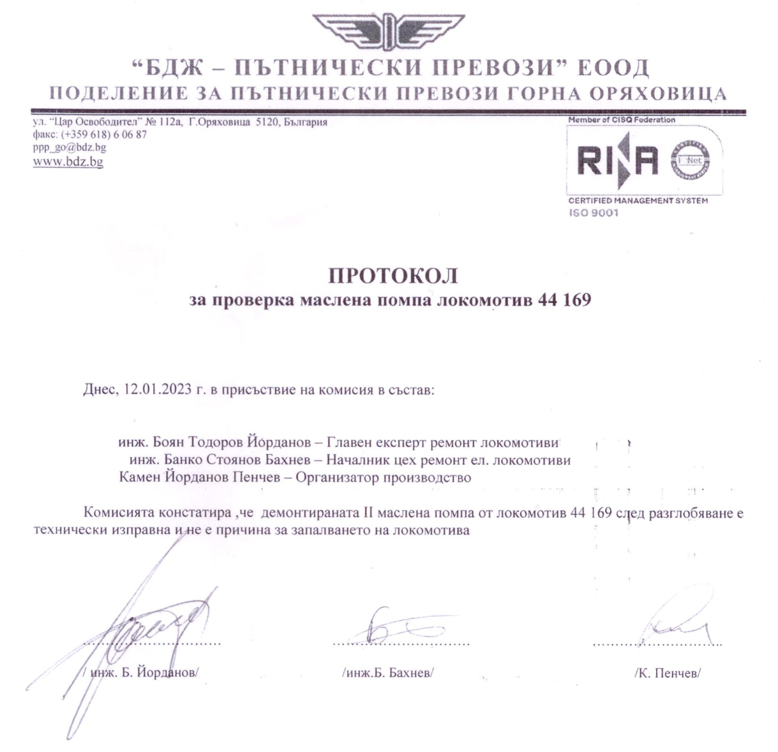
Fig. 4.20.

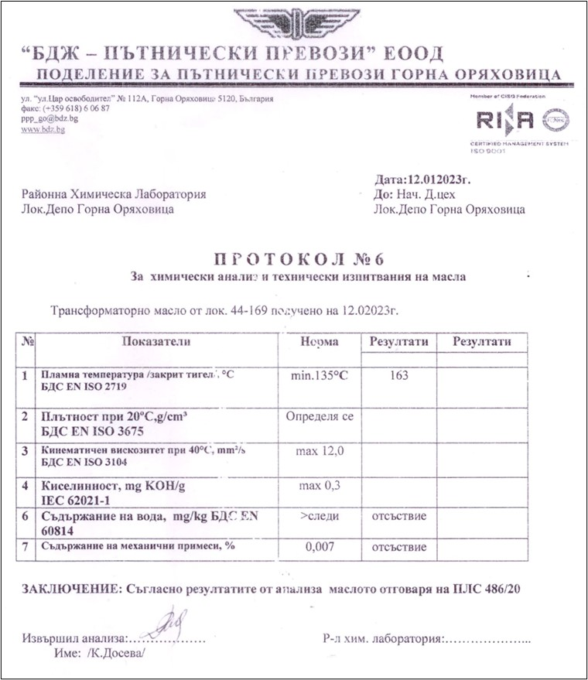
Fig. 4.21.

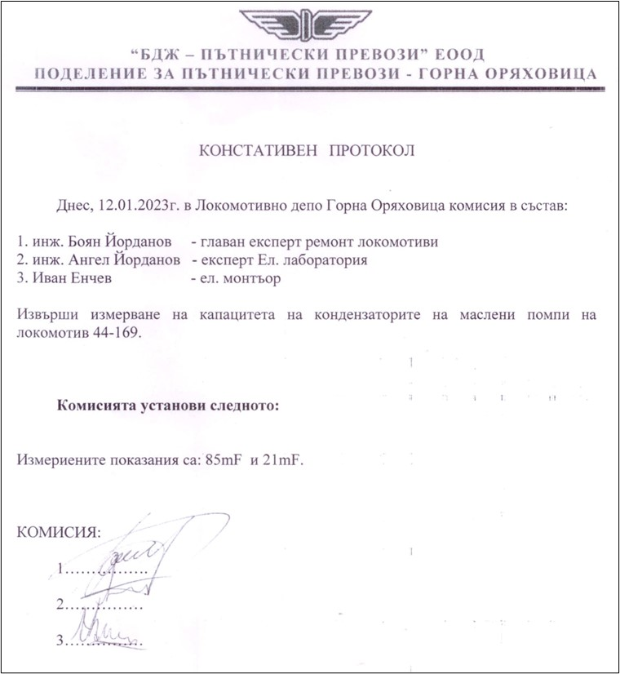
The Commission from Gorna Oryahovitsa locomotive depot found that:
Fig. 4.22.

- The dismantled engine-pump II of locomotive № 91520044169-8, after dismantling was technically regular;
- As per the results of the analysis, the oil corresponds to PLS 486/20”. It was established a flame temperature 163ºС, within minimum required 135ºС. In the oil structure were not found content of water and other machinery mixtures;
- The measured values of the capacity of starting capacitors of the oil pumps are respectively 85 μF (of pump 1) and 21 μF (of pump 2) within nominal values 88 μF;
- Net weight of the fire-extinguishers of FEI of locomotive № 91520044169-8:
- 1. Tank with fire-extinguishing powder – 8,460 kg.
- 2. Tank with fire-extinguishing powder – 9,040 kg.
- 3. Tank with fire-extinguishing powder – 10,000 kg.
- 4. Tank with fire-extinguishing powder – 9,720 kg.
- 5. Fire-extinguisher СО₂ - 5,000 kg.
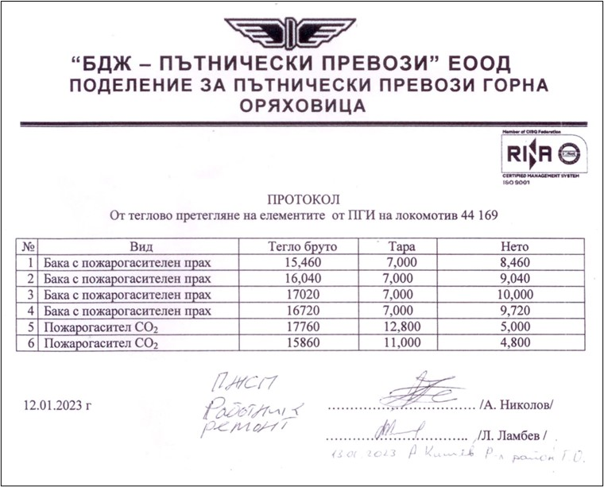
- 6. Fire-extinguisher СО₂ - 4,800 kg.
Fig. 4.23.

Given the fact that before the fire occurred, locomotive No. 91520044169-8 was working in high positions (before Mezdra station it was continuously moving at a speed of 130 km/h, with a high tractive force, or current load - fig. 4.7), it could be assumed that insufficient cooling of the rectifier cabinets or the oil circuit was also a probable cause of the fire.
However, based on the findings, a significant number of ignitions of locomotives series 44 occurred after the so-called "upgrading" consisting in the installation of a new electronic electricity meter and given the area where the fire occurred, it could be assumed that the ignition may have occurred in the area of the measuring voltage transformer of the electricity meter. In fig. 4.24 is shown the basic circuit diagram of the electricity meter.
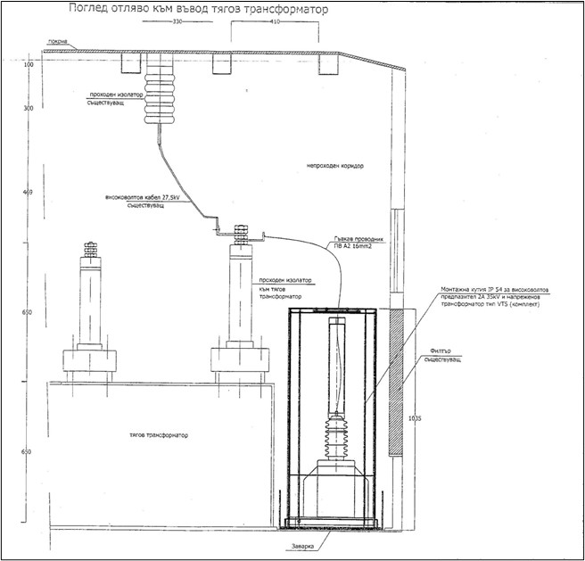
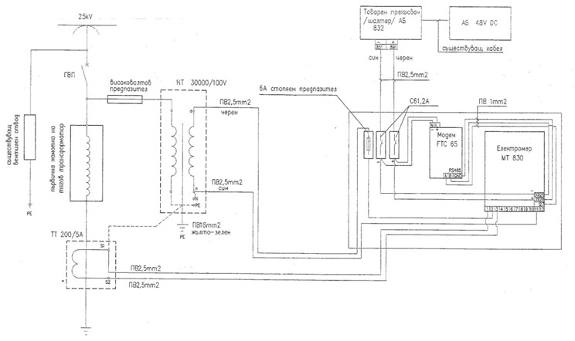
Fig. 4.25. Location and connection of the measuring voltage transformer of electrical meter.
Fig. 4.24. Principal scheme of electronic electrical meter.
On fig. 4.25 is shown the topology (location and connection) of the measuring voltage transformer of the electrical meter.
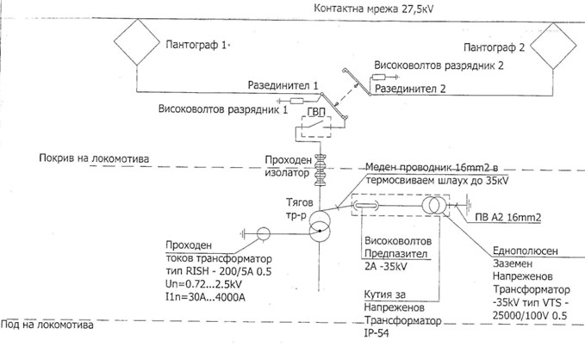
On fig. 4.26 is displayed the s.c. „single linear scheme” of the electronic electrical meter.
Fig. 4.26. Single linear scheme of the electronic electrical meter.
A possible cause of the fire in locomotive No 91520044169-8 is the occurrence of a short circuit/"disconnection" at one end of the flexible conductor PV A2 16 mm2. Similar to previous ignitions, this could cause an electrical arc to earthed housing parts in this high-voltage area and the available, albeit minimal amounts of oil (e.g. transformer oil or from the compressors) could easily ignite. A certain amount of transformer oil leaked through the established burnt rubber flexible connection to the oil pump of the second cooling circuit, which resulted in the significant fire of the locomotive.
It was established that in traction engines (TE) No. 2 and No. 3, located under the fire zone, the so-called "round fire" in them (Fig. 4.27 and Fig. 4.28 show pictures of the collectors of the two TEs). Therefore, this cannot be the cause of the fire in the locomotive.
No other malfunctions of the PTRRS (the locomotive and the coaches) in the composition of FT No 2610, which were the cause of the accident, were found.
The Commission, after several visits to the Gorna Oryahovitsa Locomotive Depot, carried out inspections and found the following:
- Burnt voltage cables of the 3-rd traction engine (fig. 4.12);
- Burnt traction current rectifier 022 (fig. 4.13 and 4.14);
- Burnt high temperature hose of the engine-pump and 2-nd circle for cooling the oil transformer;

The engine-pumps were supplied from an external source and found to operate normally at idle.
Checked baroscopes (pressure control relays) 268 and 269. Found inoperative due to thick diaphragms.
The tightening of the cable lugs on the third traction motor side of the terminal board was checked. Solid with burnt power cables.
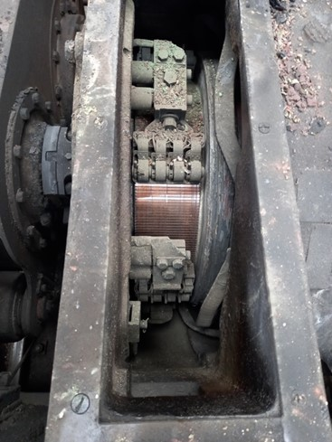
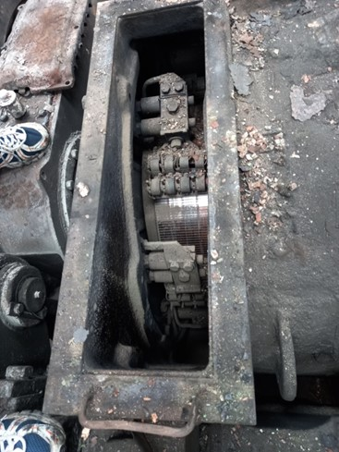
Relay 015₁₀ for control of the temperature of the transformer oil (75-85°С) did not work.
Fig. 4.28. TE №3
Fig. 4.27. TE №2

From the inspections and findings, it can be concluded that the most likely cause of the fire in locomotive No. 91520044169-8 was the ignition of the transformer oil of engine-pump 238 on the second cooling circuit. Due to uncertain operation of the engine pumps and lack of oil cooling control, an ignition temperature of 163°С was reached (report No. 6 - fig. 4.21) and it ignited. The transformer oil overheated the rubber joint, causing it to explode and tear. This is an additional source of combustion

    - Infrastructure manager.
Analysis of the railway infrastructure condition.
Non applicable.
    - Entities in charge of the technical maintenance.
"BDZ-Passenger Services" EOOD owns the Certificate of Entity in charge of maintenance No BG /31/0021/ 0001, valid from 19.04.2021 to 18.04.2026;
SE NRIC has a Certificate of Entity in charge of maintenance with UIN BG /31/0020/ 0003, valid from 01.07.2020 to 30.06.2025.
SE NRIC has a Certificate of Entity in charge of maintenance of railway vehicles with UIN BGRA 2020/0004, valid from 01.07.2020 to 16.06.2023.
    - Manufacturers or providers of rolling stock and railway products.
Non applicable.
    - National Safety Authority.
Railway Administration Executive Agency is the National Safety Authority for railway transport in the Republic of Bulgaria.
    - Notified bodies or Risk assessment bodies.
Non applicable.
    - Certifying bodies of the entities in charge of maintenance.
The Railway Administration Executive Agency as the National Safety Authority for railway transport performs certification of the entities in charge of the vehicles maintenance (ECM) in accordance with Directive 2004/49/EC and Regulation (EU) 445/2011, as per Ordinance No 59 on the railway transport safety management and on the maintenance functions in accordance with Directive 2004/49/EC and Regulation (EU) 445/2011.
From June 16, 2020 the RAEA performs certification of the ECM as per the Commission Implementing Regulation (EU) 2019/779 of 16 May 2019 laying down detailed provisions on a system of certification of entities in charge of maintenance of vehicles pursuant to Directive (EU) 2016/798 of the European Parliament and of the Council and repealing Commission Regulation (EU) No 445/2011.
    - Persons or entities involved in the event, documented or not in the respective safety management systems or indicated in register.
• SE NRIC implements Safety Procedure SP 2.09 "Methodology for determining, assessing and managing of the risk" version 05 effective from 01.03.2019, part of the SMS.
• BDZ PS EOOD implements Quality Procedure QP-2-15 "Safety Management of Passenger Transportation. Monitoring and information" from 13.12.2018 and Methodology for assessing the safety risk in BDZ PS EOOD from 23.02.2012.
  - Rolling stock and technical facilities:
    - Factors, deriving from the design of the rolling stock, railway infrastructure or technical facilities.
Non applicable.
    - Factors deriving from the installation and placing into service of the rolling stock, railway infrastructure and technical facilities.
Non applicable.
    - Factors deriving from manufacturers or another provider of railway products.
Non applicable.
    - Factors deriving from manufacturers or another provider of railway products.
Non applicable.
    - Factors due to the entity in charge of the technical maintenance, workshops for technical maintenance and other technical maintenance service providers.
Non applicable.
    - Other factors or consequences considered as involved within the investigation objectives.
Non applicable.
  - Human factor:
    - Individual human characteristics:
      - Training and development, including skills and experience.
Railway undertaking:
• Locomotive driver of locomotive № 91520044169-8 – License № 21665 for obtaining professional qualification training performed within the period 08.04.÷17.05.2019, training institution HST ,,Todor Kableshkov – Sofia, issued by RAEA;
Locomotive driving license BG 71 2021 0022, issued by RAEA;
License № III-1167 for position, Locomotive driver“ in BDZ PS EOOD dated 12.05.2022.
Additional certificate № 00000819208 from BDZ PS EOOD for rolling stock for which is permitted the driver to handle – series 43, 44, 45 000 dated 05.12.2021 along the national railway infrastructure of the Republic of Bulgaria until 05.11.2024.
• Assistant locomotive driver of locomotive № 91520044169-8 – License № 15138 for obtaining professional qualification for „Assistant locomotive driver“, training performed within the period 12.09.2011÷10.02.2012, training institution Professional Training Centre (PTC) of Bulgarian State Railways (BDZ), issued by RAEA;
License № III-598 for position, “Assistant locomotive driver at BDZ PS EOOD dated 20.05.2019.
• Train master, passenger traffic of FT № 2610 – License № 21348 for obtaining professional qualification for „Train master“, training performed within the period 03.12.2018 ÷ 13.02.2019, training institution Professional Training Centre (PTC) of Bulgarian State Railways (BDZ), issued by RAEA;
License № VI-438 for position Train master, passenger traffic at BDZ PS EOOD dated 01.04.2022.
Railway infrastructure:
• Traffic manager, first person in Mezdra South station – Diploma № 23938, ,,Technology and organization of the railway transport“, training performed within the period 1988 ÷ 1991, issued by MNHT ,,Todor Kableshkov – Sofia;
License № 6492 for position Traffic Manager TOSAMD – Sofia from 01.01.2023.
• Post switchman in Mezdra South station – License № 23837 for obtaining professional qualification for „Post switchman“, training performed within the period 27.09.÷12.11.2021, training institution PQC at SE NRIC;
License № 5419 for position Traffic manager in TOSAMD – Sofia from 16.12.2021.
      - Medical and personal circumstances, which influence the event, including the presence of physical and psychological stress.
Railway undertaking:
• Locomotive driver of locomotive № 91520044169-8:
Single health information dossier № 836 dated 04.04.2022, issued by National Multi-profile Transport Hospital -Sofia.
Conclusion: suitable for locomotive driver.
Psychological certificate № 156/28.01.2021, issued by the Psychological Laboratory - Railway Transport Sofia at the National Multi-profile Transport Hospital Sofia as a locomotive driver.
Conclusion: allowed for a period of 3 years.
• Assistant locomotive driver of locomotive № 91520044169-8:
Single health information dossier № 870 dated 05.04.2022, issued by National Multi-profile Transport Hospital -Sofia.
Conclusion: suitable for Assistant-locomotive driver.
Psychological certificate № 91/20.01.2021, issued by the Psychological Laboratory - Railway Transport Sofia at the National Multi-profile Transport Hospital Sofia as an assistant locomotive driver.
Conclusion: allowed for a period of 5 years.
• Train master, passenger traffic of FT № 2610:
Card for periodic medical exam № 2921 dated 30.12.2022, issued by National Multi-profile Transport Hospital – Gorna Oryahovitsa.
Conclusion: suitable for train master, passenger traffic.
Psychological certificate № 1054/23.11.2018, issued by the Psychological Laboratory - Railway Transport Gorna Oryahovitsa at the National Multi-profile Transport Hospital Gorna Oryahovitsa for Train master.
Conclusion: allowed for a period of 5 years.
Railway infrastructure:
• Traffic manager in Mezdra South station:
Single health information dossier № 1394 dated 02.06.2022, issued by National Multi-profile Transport Hospital -Sofia.
Conclusion – suitable for traffic manager.
Psychological certificate № 1519/19.11.2019, issued by the Psychological Laboratory - Railway Transport Sofia at the National Multi-profile Transport Hospital Sofia as a traffic manager.
Conclusion: allowed for a period of 5 years.
• Post switchman in Mezdra South station:
Single health information dossier dated 01.12.2021, issued by Labour Medicine Service at SE NRIC;
Conclusion: suitable for post switchman.
Psychological certificate № 109/25.01.2023, issued by the Psychological Laboratory - Railway Transport Sofia at the National Multi-profile Transport Hospital Sofia as a traffic manager.
Conclusion: allowed for a period of 3 years.
      - Fatigue.
Railway undertaking:
• Locomotive driver of locomotive № 91520044169-8:
Break/rest: from 05.01.2023 an hour and 18 minutes 30 until 06.01.2023 an hour and 04 minutes 05;
Started work: 06.01.2023 an hour and 04 minutes 30 – (09 hours and 35 min.)
• Assistant locomotive driver of locomotive № 91520044169-8:
Break/rest: from 05.01.2023 an hour 22 minutes 30 until 06.01.2023 an hour and 04 minutes 05
Started work: 06.01.2023 hour 04 minutes 30 – (09 hours and 05 min.)
• Train master, passenger traffic of FT № 2610:
Break/rest: from 05.01.2023 hour and 00 minutes 37 until 06.01.2023 an hour 07 minutes 52
Started work: 06.01.2023 an hour 07 minutes 52 – (15 hours and 52 min.)
Railway infrastructure:
• Traffic manager Mezdra station:
Break/rest: from 03.01.2023 an hour 18 minutes 30 until 06.01.2023 hour 07 minutes 00
Started work: 07.06.2022 hour 07 minutes 00 – (60 hours and 30 min.)
• Post switchman in Mezdra South station:
Break/rest: from 04.01.2023 an hour 18 minutes 30 until 06.01.2023 an hour 07 minutes 00
Started work: 06.01.2023 an hour 07 minutes 00 (36 hours and 30 min.)
      - Motivation and attitudes
Non applicable.
    - Work related factors:
      - Tasks planning.
• SE NRIC – railway infrastructure manager, carries out maintenance, repair and operation of the railway infrastructure. Prepares a year-round schedule for the movement of all the train categories on the main and secondary railway lines. Prepares schedules and timetables on requests submitted by railway undertakings/carriers for movement of trains and vehicles on all railway lines.
• ,,BDZ-Passenger Services“ EOOD – national railway undertaking, which performs passenger transport under approved Schedule of train movement and Train composition plan under the Contract for passenger service with the state.
      - Constructive particularities of the facilities that influence the connection human-machine.
Non applicable.
      - Communication means.
The communication connections in the Mezdra South station and in the Mezdra South - Zverino interstation are carried out with DCCM - 8, as well as in both stations with the switch posts.
In the locomotives, there are installed TDRC devices for establishing a radio connection between the locomotive driver and the traffic manager on duty at the respective station and with the train dispatcher. The personnel working on a shift basis in the SE NRIC and BDZ PS EOOD are provided with official mobile phones for quick communication.
      - Practices and processes.
Non applicable.
      - Operation rules, local instructions, staff requirements, prescriptions for technical maintenance and applicable standards.
• BDZ PS EOOD and SE NRIC apply national and departmental normative acts part of SMS referring the entities activity.
      - Working time of the involved personnel.
• The staff involved in the accident of both entities BDZ PS EOOD and SE NRIC works in shifts regime of 12-hour working shift. In accordance with the requirements of the normative acts - Labour Code and Ordinance № 50 of 28.12.2001 for the working hours of the managerial and executive staff, engaged in providing the transportation of passengers and freights in the railway transport.
      - Risk treatment practices.
• SE NRIC applies safety procedure SP 2.09 „Methods of evaluation, assessment and management of the risk „version 05 effective from 01.03.2019, which is part of the SMS.
• ,,BDZ-Passenger services“ EOOD applies the following procedures:
- Methods of the safety risk assessment at BDZ PS EOOD;
- Quality procedure QP-2-15 „Safety management of passenger services. Monitoring and information exchange“;
- Hazard register within operation, repair and maintenance of PTRRS within BDZ PS EOOD.
      - Context, machinery, equipment and indications for shaping the working practices
Non applicable.
    - Organizational factors and tasks:
      - Planning of the working force and the working load.
In the entities BDZ PS EOOD and SE NRIC, in accordance with the requirements of national regulations, developed methodologies and shared good European practices, the work is planned and related in accordance with SMS to the personnel directly responsible for the safe operation of railway transport.
      - Communications, information and teamwork.
Non applicable.
      - Recruitment, staffing requirements, resources.
• In BDZ PS EOOD, personnel selection is carried out according to an approved "Human Resources Management System", which includes:
- Rules for staff recruitment and selection;
- Rules for appointment and changes in employment relationships;
- Staff training and development rules;
- Rules for ensuring SHWC, Ecology, and organization of the activity of STM.
The entity's personnel is selected and appointed with the relevant legal capacity, professional qualification and skills for working in the management and executive staff.
• SE NRIC has an approved "Strategy for Human Resources Management 2021÷2025".
In the SE NRIC, the selection of personnel is carried out according to the established "Rules for recruitment, selection and appointment of personnel in the central administration of the SE NRIC" in force from 01.12.2020.
The recruitment, selection and appointment of personnel is carried out by the "Human Resources Management" department, which is responsible for:
- Recruitment;
- Maintaining a database of the personnel;
- Creation of a system of selection techniques for recruitment;
- Carrying out the selection together with the head of the unit;
- Documenting the process and communicating with staff;
- Appointment.
      - Implementation management and supervision
Non applicable
      - Compensation (remuneration).
• BDZ PS EOOD has approved "Internal rules for wages" effective from 01.07.2013, which regulate the general conditions for the organization of wages:
- Formation and distribution of funds for salary in the company;
- Determination and amendment of the basic salaries by position;
- Determination of the types and amounts of additional and other remunerations;
- Regulation of the order and manner of payment of staff salaries.
• SE NRIC has approved "Internal rules for wages" in force from 01.09.2014, which regulate issues related to the wages of the company's personnel:
- General provisions for the organization of the salary in the entity;
- Determining and distributing the funds for wages - sources, order and way of forming the remuneration;
- Determination and amendment of wages and additional remuneration;
- Regulation, order and method of payment of wages.
      - Leadership, powers related issues.
Non applicable.
      - Organizational culture.
Non applicable.
      - Legal issues (including the respective European and national rules and provisions).
Non applicable.
      - Regulatory framework conditions and safety management system application.
Railway undertaking.
- Directive (EU) 2016/798 of the European Parliament and of the Council of 11 May 2016 on railway safety;
- Commission Delegated Regulation (EU) 2018/762 of 8 March 2018 establishing common safety methods on safety management system requirements pursuant to Directive (EU) 2016/798 of the European Parliament and of the Council and repealing Commission Regulations (EU) No 1158/2010 and (EU) No 1169/2010;
- COMMISSION IMPLEMENTING REGULATION (EU) 2019/779 of 16 May 2019 laying down detailed provisions on a system of certification of entities in charge of maintenance of vehicles pursuant to Directive (EU) 2016/798 of the European Parliament and of the Council and repealing Commission Regulation (EU) No 445/2011;
- COMMISSION IMPLEMENTING REGULATION (EU) No 402/2013 of 30 April 2013 on the common safety method for risk evaluation and assessment and repealing Regulation (EC) No 352/2009;
- Railway Transport Act;
- ORDINANCE No 59 dated 5.12.2006 on the railway transport safety management.
Railway infrastructure.
- Directive (EU) 2016/798 of the European Parliament and of the Council of 11 May 2016 on railway safety;
- Commission Delegated Regulation (EU) 2018/762 of 8 March 2018 establishing common safety methods on safety management system requirements pursuant to Directive (EU) 2016/798 of the European Parliament and of the Council and repealing Commission Regulations (EU) No 1158/2010 and (EU) No 1169/2010;
- COMMISSION IMPLEMENTING REGULATION (EU) 2019/779 of 16 May 2019 laying down detailed provisions on a system of certification of entities in charge of maintenance of vehicles pursuant to Directive (EU) 2016/798 of the European Parliament and of the Council and repealing Commission Regulation (EU) No 445/2011;
- COMMISSION IMPLEMENTING REGULATION (EU) No 402/2013 of 30 April 2013 on the common safety method for risk evaluation and assessment and repealing Regulation (EC) No 352/2009;
- Railway Transport Act;
- ORDINANCE No 59 dated 5.12.2006 on the railway transport safety management.
    - Environmental factors:
      - Labour conditions (noise, illumination, vibrations).
Non applicable for SE NRIC and BDZ PS EOOD.
      - Meteorological and geographic conditions.
• Mezdra South station geographically is located in the north-western part of the rail network;
• The accident occurred in the light part of the day at 10:50 a.m.;
• Air temperature +13ºС;
• Wind speed and direction around 13 m/s, west;
• Weather – clear with normal visibility of the signals;
      - Construction works, performed on the spot or in very proximity.
In the area of the Mezdra South station, as well as in the Mezdra South - Zverino interstation, no construction works on the railway infrastructure (railway and facilities, catenary and signalling equipment) have been carried out by the manager of the railway infrastructure.
    - Any other significant factor for the investigation objectives
Non applicable.
  - Feedback and control mechanisms, including risk and safety management, as well as monitoring processes:
    - Regulatory framework conditions.
Commission Delegated Regulation (EU) 2018/761 of 16 February 2018 establishing common safety methods for supervision by national safety authorities after the issue of a single safety certificate or a safety authorisation pursuant to Directive (EU) 2016/798 of the European Parliament and of the Council and repealing Commission Regulation (EU) No 1077/2012
Commission Delegated Regulation (EU) 2018/762 of 8 March 2018 establishing common safety methods on safety management system requirements pursuant to Directive (EU) 2016/798 of the European Parliament and of the Council and repealing Commission Regulations (EU) No 1158/2010 and (EU) No 1169/2010
ORDINANCE No 59 dated 5.12.2006 on the railway transport safety management.

    - Processes, methods and results from the activities on the risk assessment and monitoring that the involved entities performed:
      - Railway undertakings.
• "BDZ-Passenger Services" EOOD implements the Quality Management System QP 2-15 "Safety Management of Passenger Services. Monitoring and exchange of information". In section 6.7. "SMS implementation control, item 6.7.2. "Periodic control of the implementation of the SMS is carried out through internal audits: monthly and complex (annual). Complex audits are conducted once a year on all the safety-related structures."
• In accordance with the requirements of the "Methodology for safety risk analysis and assessment in force from 23.02.2012", the railway entity BDZ PS EOOD prepares and presents monthly reports for the current year, as well as a complex (annual) audit report for the previous year regarding risk monitoring.
      - Railway Infrastructure.
- SE NRIC applies Safety Procedure SP 2.09 "Methodology for identification, assessment and risk management" version 05 in force from 01.03.2019 which is part of the SMS.
      - Entities in charge of the technical maintenance.
Railway undertaking
- “BDZ-Passenger Services" EOOD owns the Certificate of an entity in charge of maintenance No BG /31/0021/ 0001, valid from 19.04.2021 to 18.04.2026;
- SE NRIC has a Certificate of an entity in charge of maintenance with UIN BG /31/0020/ 0003, valid from 07/01/2020 to 30/06/2025;
- SE NRIC has a Certificate of an entity in charge of maintenance of railway vehicles with UIN BGRA 2020/ 0004, valid from 01.07.2020 until 16.06.2023.

      - Manufacturers and all other participants.
Non applicable
      - Reports for independent risk assessment.
No assessment has been made by an Independent Assessor (AsBo) of any changes in operating conditions or factors relevant to the occurred accident.
    - Safety management system of the involved:
      - Railway undertaking.
"BDZ-Passenger Services" EOOD implements "Methodology for Analysis and Assessment of Risk Safety ", which is part of the SMS.
      - Railway Infrastructure.
SE NRIC implements a safety procedure SP 2.09 "Methodology for determining, assessing and managing the risk" version 05 effective from 01.03.2019, which is part of the SMS.
    - Safety Management System of the entities in charge of the technical maintenance.
"BDZ-Passenger Services" EOOD implements an approved "Safety Management System" effective from 30.07.2017, which also regulates the technical maintenance of traction and non-traction rolling stock.
SE NRIC implements Safety Procedure SP 7.01 "Regulations for maintaining the signalling system (Signalling equipment)", which is part of the SMS;
SE NRIC implements approved "Rules for current maintenance of the rail track" effective from 2021.
    - Results from the supervision, performed by the National Safety Authority.
The results of the performed audits and inspections regarding the functioning of the Safety Management System of SE NRIC and "BDZ-Passenger Services" EOOD in accordance with the requirements of Regulation (EU) 2018/761, Regulation (EU) No. 1169/2010, Ordinance No. 56 and Ordinance No. 59 for respecting the specific requirements of European legislation and national rules for the design, maintenance and operation of the managed railway infrastructure, show that the companies maintain the SMS and can fulfil the requirements provided for in the relevant legal acts.
In the period from 19.10.2020 to 30.10.2020, the National Safety Authority (NSA) carried out an annual planned supervision of the SMS of SE NRIC.
In the period from 21.11.2020 to 25.11.2022, the National Safety Authority (NSA) carried out a supervisory inspection of the ECM part of the SMS of SE NRIC.
In the period from 08.02.2021 to 19.02.2021, the National Safety Authority (NSA) carried out an annual planned supervision of the SMS of "BDZ-Passenger Services" EOOD.
In the period from 22.11.2022 to 09.12.2022, the National Safety Authority (NSA) carried out an audit on SMS, before issuing a single safety certificate to "BDZ-Passenger Services" EOOD.
    - Permits, certificates and assessment reports, provided by the National Safety Authority or other Conformity Assessment Bodies:
      - Safety certificates of the involved railway infrastructure managers.
Safety Authorization No BG 21/2018/0001 valid from 01.07.2018 to 30.06.2023.
      - Safety certificates of the involved railway undertakings.
,"BDZ-Passenger Services" EOOD owns a Single Safety Certificate with EU ID number BG 10 2022 0298, valid from 31/12/2022 to 30/12/2027;
      - Authorizations for placing in service of permanently fixed equipment and permits for placing on the market of vehicles.
Non applicable.
    - Other system factors.
Non applicable.
  - Previous similar cases.
NAMRTAIB has investigated accidents of a similar nature - fires in rolling stock, including fire in the same locomotive No. 91520044169-8, which serviced fast train No. 1621 in the Elin Pelin - Vakarel interstation on 13.10.2015. During the movement of fast train No. 1621, serviced by locomotive No. 91520044169-8, in the Elin Pelin - Vakarel interstation, the following rules were observed operational requirements regulating the safe movement of the train. The speed of the train was 60 km/h, with a permissible 60 km/h for the interstation. At the time of the investigation, the locomotive was registered in the fleet of Locomotive Depot Plovdiv under "BDZ Passenger Services" EOOD. The Investigation Commission found the direct cause that led to the fire: a changed cam profile on contact S2, from power contactor block 0155 on the autotransformer switch (ATP). As a result, the ATP's disc selector arms were commutating under load and this caused a voltage arc, causing the oil pressure in the ATP's sump to rise sharply and the housing to explode. The high temperature ignited the leaked transformer oil and this led to the fire in the locomotive.

- Conclusions
  - Summary of the analysis for the event causes.
The Investigation Commission carried out several on-site inspections of the burnt locomotive No. 91520044169-8 at the Gorna Oryahovitsa Locomotive Depot, got acquainted with the provided documentation on the technical condition (operation and repairs) of the locomotive.
The Investigation Commission carried out several comprehensive inspections of the engine compartment of the locomotive, as well as samples of individual machines and units. Then interviewed accident, operation and repair personnel and read testimony. The documentation related to the operation and maintenance of the locomotive was studied and analysed.
From the measurements of individual units and systems in the locomotive, at the Gorna Oryahovitsa Locomotive Depot, the following conclusions can be drawn about their technical condition:
    - On the I-st circulation pump of the cooling system, when supplied with external voltage, the pump worked normally without load;
    - On the II-nd circulation pump of the cooling system, which has traces of external burning, during disassembly, no damage was found to the working elements and the active electrical part; when supplied with external voltage, the pump worked normally without load;
    - The capacity of the capacitors of the circulation pumps does not correspond to the nominal values;
    - After dismantling the two baroscopes of the two cooling circuits, it was found that both have membranes in a non-working state;
    - The system for commercial measurement of locomotive traction electricity:
        - The panel with electricity meter, modem and protective fuses in the first cabin are functional;
        - The voltage transformer with high voltage fuse and its casing are functional;
        - The connecting wire to the voltage transformer is functional;
        - The current transformer is functional;
        - The connecting wires to the current transformer are functional.
The Investigation Commission considers that the "Commercial traction electricity measurement system of the locomotive" (electronic power meter) in the investigated accident has no relation to the causes for the ignition of the locomotive.
A possible cause, analogous to previous ignitions, is that due to the dynamic effects when the locomotive is moving, it is possible to pull out the flexible high-voltage cable from the cable shoe to the voltage transformer of the electricity meter and cause a short circuit, causing the appearance of a high-voltage arc (25 kV).
    - There were performed tests of the field weakening circuits, with an external 48 V power source on wires 398, 400 and 401 from the locomotive management controller (due to visual damage on the accumulation battery from the fire):
      - Due to the failure of the pneumatic installation and the impossibility of supplying compressed air with the required pressure, the presence of voltage was checked on the control EPVs of shunt contactors 061₂, 062₂, 063₂, 064₂, 065₂, and 066₂. Normal activation of EPVs 063₂, 064₂, 065₂ and 066₂ was found;
      - A visual check was made for the integrity and serviceability of the shunt resistors. A protocol of tests and measurements was drawn up and the Investigation Commission considered that the condition of the system was working and had no connection with the ignition of the locomotive;
    - A measurement of the dielectric strength of the transformer oil was performed with a sample temperature of 20º C, an average value of 40 kV/cm. A protocol was drawn up with a conclusion from the samples of the transformer oil of the locomotive, they do not correspond to the requirements of the dielectric strength indicator.
From the inspections and findings, it can be concluded that the most likely cause of the fire during movement in locomotive No. 91520044169-8, servicing FT No. 2610, was ignition of the transformer oil. Due to the reduced flow rate of the second engine pump, lack of oil cooling control and the presence of oil in the transformer area, it is possible to reach a higher than measured flame temperature of 163°С at an allowable 135°С (protocol No. 6 - fig. 4.21 ), which led to ignition. The rubber joint was further heated by the transformer oil, causing it to explode and tear and spread the fire.
Another possible cause of the fire is transformer oil getting into the engine-pump terminal box. In this case, ignition of the oil is possible from current flowing through the oil between the two poles of the bus bars or from an electric spark due to loose terminal connections. The Commission does not rule out this reason, but considers it less likely, as sufficient evidence for it is not available from observations made on other locomotives of the same series.
  - Undertaken measures after the event occurrence.
The manager of the railway infrastructure undertakes timely organization and actions to restore the traffic and the capacity of the railway infrastructure, through inspections and measurements of the catenary and the rail track. Traffic was restored at 12:30 p.m. according to schedule.
The composition of Fast train No. 2610 departed with 135 minutes delay from Mezdra South station with locomotive No. 91520044162-3 in Sofia station direction.
The burnt locomotive No. 91520044169-8, servicing FT No. 2610, was moved with shunting locomotive No. 98520052034-6 to the Mezdra Locomotive Depot for outfitting and moving to the Gorna Oryahovitsa Locomotive Depot (housing location).
  - Additional findings.
- As part of FT No. 2610, diesel locomotive No. 92520007126-2, which has a design speed of 100 km/h, is attached between train locomotive No. 91520044169-8 and the first coach of the train at Varna station. In the section from Varna station to Dzhuliunitsa station, the maximum permissible speed according to the train schedule is 100 km/h and it is respected. In the interstation Dzhuliunitsa - Gorna Oryahovitsa FT No. 2610 moves with a maximum speed of 110 km/h, which is permissible for the train in the interstation (fig. 4.5, item 1). The maximum permissible speed of the diesel locomotive No. 92520007126-2 attached to the train is 100 km/h, with which the permissible speed of movement is exceeded by up to 10 km/h (Fig. 4.5, item 2). The locomotive crew was not provided with a document to limit the speed of the train.
- The commission found out that in 2018 the railway entity "BDZ-Passenger Services" EOOD introduced a new internal departmental regulation PLS 100/18, in which the inter-repair mileages of the locomotives were significantly increased compared to those stipulated in LS 0108/1979. The locomotives are highly depreciated as a result of accumulated significant mileage and deteriorated technical condition, which is why such an increase in the intervals between repairs quoted in PLS 100/18 is not justified. The maximum extension of the intervals between repairs should be limited to 10% proposed by the manufacturer.

- Safety recommendations
In order to improve the safety in the rail transport, the Investigation Commission at NAMRATIB proposes to the Railway Administration Executive Agency the following safety recommendations adapted to SE NRIC and “BDZ-Passenger Services” EOOD.
- Recommendation 1, proposes that SE NRIC and "BDZ-Passenger Services" EOOD familiarize the interested personnel with the contents of the report;
- Recommendation 2, proposes that BDZ PS EOOD restores the performance of monthly talks and trainings for the operation and repair personnel in the locomotive depots;
- Recommendation 3, proposes that BDZ PS EOOD replace all the elastic joints in the cooling circuits of the transformer oil of locomotives series 44 and 45 with metal elastic joints;
- Recommendation 4, proposes that BDZ PS EOOD within TI to carry out checks on the serviceability of the baroscopes to control the operation of the engine-pumps, as well as the condition of their starting capacitors;
- Recommendation 5, proposes that BDZ PS EOOD design, develop and install a new FEI on the locomotive series 44 and 45;
- Recommendation 6, proposes that BDZ PS EOOD create an organization for amending and supplementing the departmental regulation PLS 100/2018 for the restoration of capital repairs and the inter-repair runs of locomotive series 43, 44 and 45;
- Recommendation 7, proposes that BDZ PS EOOD take actions to limit the access of the locomotive crew to the apparatus and electrical hard connections for control in apparatus cabinets M1 and M2 in the first and second cabins of locomotives series 44 and 45;
- Recommendation 8, proposes that BDZ PS EOOD install video recorders on the two front walls of the locomotives with visibility to the railway infrastructure and in the two command cabins of the locomotives.
With reference to the requirements of art. 24, paragraph 2 of Directive (EU) 2016/798, and art. 91, paragraph 3 of Ordinance No 59 dated 5.12.2006, the member of the Management Board of NAMRATIB on 13.04.2023 provides a final report that contains information on the investigation of the accident with formulated and agreed safety recommendations in order to improve safety in railway transport.
In accordance with Art. 26, paragraph 3 of Directive (EU) 798/2016, that the National Safety Authority (RAEA) and other bodies or structures to which the safety recommendations are addressed, to report regularly to the member of the management board of the NAMRATIB on the measures taken or planned as a result (sequence) from the recommendations.

Chairperson:
Dr Eng. Boycho Skrobanski
Deputy President of the NAMRTAIB AB
Members:
    - .............(s)............. (External expert)
    - .............(s)............. (External expert)
    - .............(s)............. (External expert)

