Translation from Bulgarian language

REPUBLIC OF BULGARIA
MINISTRY OF TRANSPORT,
INFORMATION TECHNOLOGIES AND COMMUNICATION

9, Diakon Ignatiy Street, 1000 Sofia bskrobanski@mtitc.government.bg
тел: +359 2 940 9317 mail@mtitc.government.bg
факс: +359 2 940 9350

SPECIALIZED UNIT FOR INVESTIGATIONS OF ACCIDENTS AND INCIDENTS IN RAILWAY TRANSPORT AT MTITC

FINAL REPORT
by
Railway Accident Investigation - Derailment of an International Direct Freight Train (IDFT) № 48009 at switch № 74 of Plovdiv Station on February 16, 2019

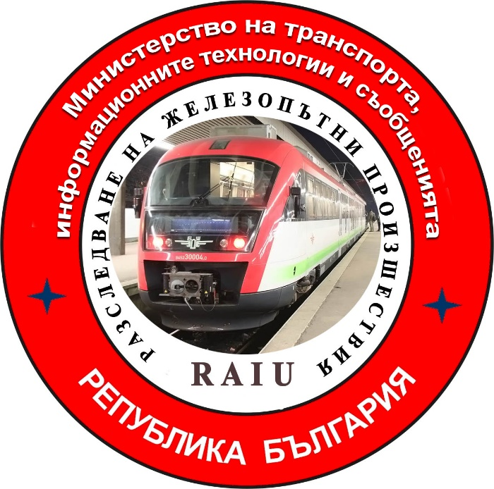

2019

FINAL REPORT

Purpose of the investigation and degree of responsibility

The Investigation of serious accidents, accidents and incidents is carried out by an independent investigation authority of the Republic of Bulgaria - "Specialized Unit for Investigation of Accidents and Incidents in Railway Transport" in the "Ministry of Transport, Information Technologies and Communications" (MTITC) and it aims:
To identify the circumstances and the reasons that led to their implementation with a view to improve safety and prevent from others without seeking personal responsibility and guilty.
The investigation is carried out in accordance with the requirements of Directive 2004/49 / EC of the European Parliament and of the Council upon safety of the Community's railways transpositioned in the Law for Railways ( LR ), Ordinance № 59 from December 5, 2006 about the management of safety in railway transport, Ordinance № H-32 from September 19, 2007 about the coordination of the actions and the exchange of information during investigations of railway accidents and incidents and the Agreement for interaction during investigations of accidents and incidents in the air, waterway and railway transport between the Prosecutor's Office of the Republic of Bulgaria, Ministry of Interior and MTITC from April 17, 2018.

CONTENTS

1. Summary………………………………………………………………………...….....………4
2. Direct facts and circumstances ………………………………………………..…..……...….5
3. General data established during the investigation process.…………………..…...............11
4. Deaths, injuries and material damages.……………………………………….……......…..13
5. External circumstances - weather and geographic conditions.……………………..…...…13
6. Data for railway infrastructure and railway enterprise staff related to the accident .......…………….……………………………………………………………………..……......…14
7. Data from other investigations. Summary of testimony………………………..…..….......17
8. System of Safety Management (SSM).....………………………….……..…………............17
9. Rules and norms ..……………………………………………………….…..………...…….19
10.Functional condition of rolling stock and technical facilities of the railway infrastructure.……………………………………………….……………………..……...........20
11.Operational System Documentation - reviews, inspections, repairs, maintenance.………………………………………...……………………....….………...….….20
12. Health and Safety work conditions …………...…………………………………….…..…21
13. Accidents of similar nature previously registered…………….…….................................21
14. Analysis and conclusions………...………………………………………….…..……...…..21
15. Description of measures already taken as a consequence of the accident……................46
16. Recommendations issued in order to avoid accidents upon the same reasons................46

- Summary.
  - Brief description of the event.
On February 13, 2019, the railway carrier “Bulmarket Rail Cargo” EOOD with request№ 8 at 07:45 hours has requested to the "Railway Infrastructure" NC to draw up a timetable and to appoint IDFT № 48009 for the transport of goods under Class 2 of RID. RINC has developed a timetable and has assigned in the schedule for movement IDFT № 48009 on the route Dimitrovgrad ZS - Voluyak - Iliyantsi.
On February 13, 2019 at 14:20 hours, from Dimitrovgrad Zheleznica Srpska (ZS) IDFT № 48009 has departed composed by - electric locomotive № 87017 and auxiliary locomotive № 86003 with 14 tank wagons, 13 of which are filled with liquefied gas ( propane-butane) and 1 wagon empty for prevention, 56 axles, 981 tonnes. The train arrived at Dragoman Station at 15:10 hrs and after the commercial and technical inspection and testing of the train automatic brakes has left at 15:43 hrs. The train has arrived at Iliyantsi station at 16:34 hrs.
On February 13, 2019, the railway carrier “Bulmarket Rail Cargo” EOOD with request № 8 at 07:45 hours has requested to the "Railway Infrastructure" NC to draw up a timetable and to appoint IDFT № 48009 for the transport of goods under Class 2 of RID. RINC has developed a timetable and has assigned in the schedule for movement IDFT № 48009 on the route Dimitrovgrad ZS - Voluyak - Iliyantsi.
On February 13, 2019 at 14:20 hours, from Dimitrovgrad Zheleznica Srpska (ZS) IDFT № 48009 has departed composed by - electric locomotive № 87017 and auxiliary locomotive № 86003 with 14 tank wagons, 13 of which are filled with liquefied gas ( propane-butane) and 1 wagon empty for prevention, 56 axles, 981 tonnes. The train arrived at Dragoman Station at 15:10 hrs and after the commercial and technical inspection and testing of the train automatic brakes has left at 15:43 hrs. The train has arrived at Iliyantsi station at 16:34 hrs.
On February 15, 2019, the railway company “Bulmarket Rail Cargo” EOOD with request № 7 at 13:20 hrs has requested from RINC to draw up a timetable and to appoint a movement of IDFT № 48009 for transportation of cargo under Class 2 of RID. RINC has developed a timetable and assigned in the schedule for movement IDFT № 48009 with the route Dimitrovgrad ZS - Voluyak - Iliyantsi - Pirdop - Karlovo - Filipovo - Plovdiv - Plovdiv - distribution.
On February 15, 2019, at 19:18 hrs, IDFT № 48009 has departed from railway station Dimitrovgrad (ZS) in composition: electric locomotive № 86003.4 and auxiliary locomotive № 86001.8 with 13 tank wagons, 12 of which are filled with liquefied petroleum gas (propane-butane) and 1 wagon empty for prevention, 52 axles, 896 tons. The train arrived at Dragoman Station at 19:55 hrs and after a commercial and technical inspection and testing of the automatic train brakes left at 20:15 hrs. The train arrived at Iliyantsi station at 21:05 hrs.
At Iliyantsi station, both stocks are joined. The train has undergone a commercial and technical inspection and testing of the automatic train brakes. From Iliyantsi station, IDFT has departed with the same № 48009 along Iliyantsi - Pirdop - Karlovo - Filipovo - Plovdiv - Plovdiv - distribution route (Fig. 1).
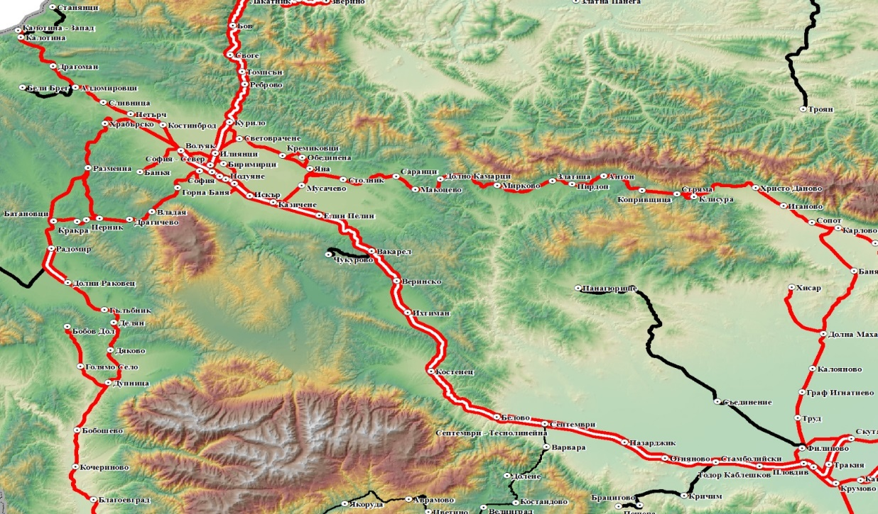

Dimitrovgrad JS
Iliyantsi
Karlovo
Пловдив разпределителна
Plovdiv
Fig. 1
IDFT № 48009 has departed from Iliyantsi station at 23:22 hrs composed by: locomotive № 86003.4 and auxiliary locomotive № 86001.8, with 27 wagons, 108 axles, 1895 tons, of which 25 tank wagons filled with propane-butane and 2 empty wagons - tanks for prevention. Due to the change of direction at Karlovo station, a maneuver with the locomotives has been made and locomotive № 86003 is placed first in the composition. The train departs from Karlovo station at 02:57 hrs and travels to Plovdiv station with one stop at Graf Ignatievo station. The duty staff at the stations along the route haven't t noticed anything unusual in the train..
1.2. Immediate cause of the accident:
Upon train's leading locomotive № 86003 entering the area of the tongue part of railroad switch № 74 in Plovdiv station a vertical fracture of the left curved tongue has followed, immediately before the passage of the first wheel pair axle of the leading locomotive. The breaking zone is realized between the 13th and 14th traverses in the transition of the tongue from normal rail to tongue profile, where the shape and cross section of the curved tongue are changed.
1.3. Summary of the main recommendations.
The recommendations issued by the Investigation Commission at MTITC are methodical and technical in order to prevent other accidents of this nature.
The recommendations are addressed to the national safety authority Executive Agency "Railway Administration", concerning "Railway Infrastructure" NC (RINC) and the railway carrier “Bulmarket Rail Cargo” EOOD.
1. Recommendation № 1 proposes the staff in operation of RINC and “Bulmarket Rail Cargo” EOOD to get known with the contents of the report;
2. Recommendation № 2 proposes RINC to make an amendment to Art. 94 of the "Rules on the movement of trains and maneuvering in railway transport" (РМТМ).
3. Recommendation № 3 proposes RINC to undertake non-destructive monitoring of railway switches in accordance with the category of railway lines.
4. Recommendation № 4 proposes EA "Railway Administration" to take control measures in relation to the violations of the normative acts related to railway safety by “Bulmarket Rail Cargo” EOOD and RINC during the investigation.
2. Direct facts and circumstances.
2.1. Date and time of the event.
On February 16, 2019, at 16:05 hrs, IDFT № 48009 passed transit through Filipovo Station. After train passing through Filippovo station, the head of traffic at Plovdiv station has prepared a route with Route-relay centralization (RRC-Russian block) for train transit on second reception - dispatch track. The route includes switches № 16, 18, 28, 42, 72, 74 and 86. In Plovdiv station, Second track is specialized for the reception of freight trains transit to Plovdiv-distribution station. According to the train schedule and "Plan II-24" for reception and dispatching freight trains, IDFT № 48009 is transit through the station.
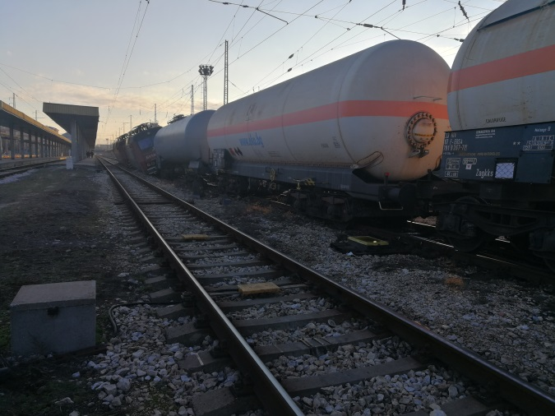
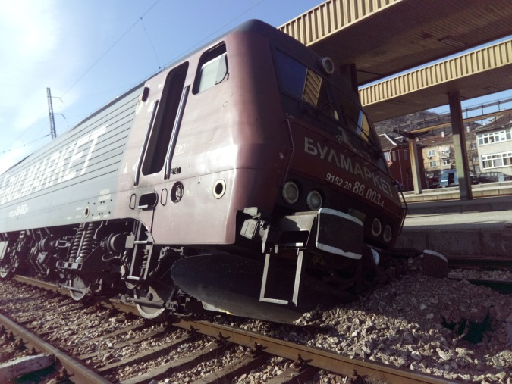
At 04:13 hrs the train has passed the entrance signal at Plovdiv station at a speed of 33 km/h, after which the speed has increased to 36 km/h. At 04:15 hrs a speed reduction has started to 33 km/h and then the speed has fallen sharply to 0 km/h, the train stops on the second track 340 m from the axis of the station reception building.
Fig. 3
Fig. 2
After the train stop, the locomotive brigades ascertain derailing of both locomotives with all axles to the left 2nd track direction. The first three wagons have also derailed, as the first and the second have derailed with all axles, and the third has derailed with only both axles of the first bogie, also to the left of the track. The first tank wagon is empty for prevention and the second and third are filled with liquefied gas (propane-butane). The left curved tongue and right stock rail of switch № 74 are broken, about 50 meters of the track is destroyed, safety equipment and signaling in the derailment area were destroyed too (Fig. 2, 3, 4, 5, 6, 7).
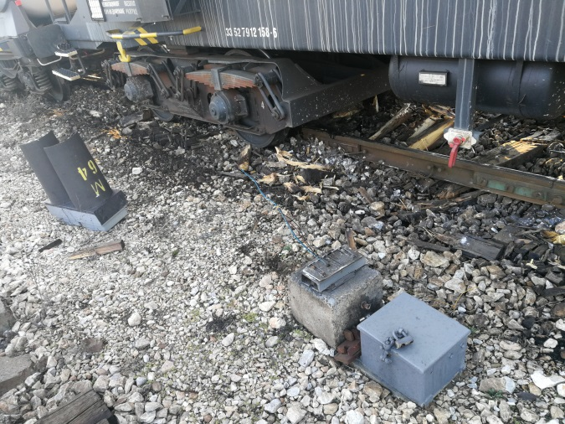
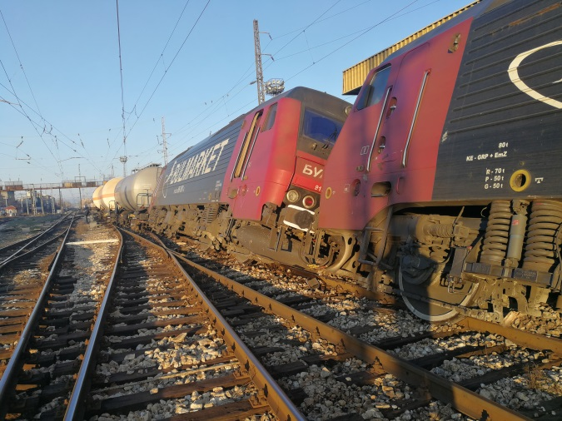
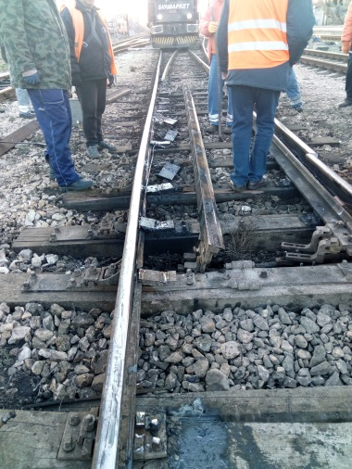
The locomotive № 86003 motorman has informed the interested persons and services on the official mobile phone.
Fig. 6
Fig. 4
Fig. 5
2.2. Event’s location.
Plovdiv Station is a junction station located on the first main railway line Sofia - Plovdiv - Svilengrad at km155 + 574, between Todor Kableshkov and Krumovo stations. It is the starting station of the eighth main railway line Plovdiv - Filipovo - Stara Zagora - Karnobat - Burgas. It is the starting station for the departing trains on secondary lines with directions - 19th Plovdiv - Asenovgrad, 81st Plovdiv - Panagyurishte and 82nd Plovdiv - Karlovo.
2.3. Event’s classification.
On February 16, 2019, at about 16:50 hrs, the Head of the Specialized Unit for Investigation of Railway Accidents and Incidents (SUIRAI) at the Ministry of Transport, Information Technology and Communications (MTITS) Is notified by phone about a railway accident IDFT № 48009 transiting on second track of Plovdiv station, on switch № 74 derail two locomotives and the first three tank wagons carrying dangerous cargo.
The information is submitted in accordance with the requirements of the “Safety Procedure SP 2.03.” of Railway Infrastructure National Company (RINC) dated September 01, 2018.
After the coordination and clarification of the information in situ, the head of the SUIRAI has changed the classification of the event - a serious railway accident, in accordance with the requirements of Art. 19 (1) of Directive 2004/49 / EC, Art. 115k, para. 1, item 1 of the Railway Transport Act (RTA) and Art. 71, para. 2 of Ordinance No. 59, for which interested parties are notified.
2.4. Consequences of the Event:
- no injured personnel and other persons in the station area;
- no environmental damage;
2.4.1. Damage to “Railway Infrastructure” NC:
To the railroad:
- at about 50 m long section of 2nd track’s railroad, in the derailment zone, is damaged;
- left curved tongue of switch № 74 - broken;
- right stock rail of switch № 74 - broken;
To the security technics:
- damaged two COA 3 switch apparatus for switches № 72 and № 86;
- Switches № 72/74 and switches № 86/88 are cut off.
To the signalisation:
- damaged and broken maneuver traffic light № M64 for the second track;
2.4.2. Damage to ,,Bulmarket Rail Cargo“ EOOD:
to traction rolling stock:
- Electric locomotives № 86003-4 and № 86001-8 – damage to the running gear of both locomotives;
to non-traction rolling stock:
- Wagon-tank empty № 84529370013-2, property of ,,Bulmarket Rail Cargo“ EOOD, damage to the running gear of the wagon;
- Wagon-tank full № 33527912158-6, property of ,,ECO
Bulgaria “, damage to the running gear of the wagon;
- Wagon-tank full № 33877919267-7, property of ,,ERMEWA“ France, damage to the running gear of the wagon;
2.5. Decision to initiate an investigation:
In accordance with the requirements of Art. 19 (1) (a) of Directive 2004/49 / EC, Art. 115k, para. 1, item 1 of RTA, Art. 76, para 1, item 1 and art. 78, para. 1 of Ordinance № 59 from December 5, 2006, the Head of SUIRAI undertakes an investigation of the accident.
2.5.1. Composition of the commission:
In MTITC an independent investigation commission is appointed. The head of SUIRAI is the Chairman of the commission. The commission consists of external experts with appropriate qualifications and professional relevance to the accident.
2.5.2. Investigation:
On February 16, 2019, after a received notification at about 07:30 hours, the Head of the SUIRAI at MTITC arrives at Plovdiv station, and he is provided with access to the accident. After getting acquainted with the situation in situ by the Head of the Operational Group (OG) of RINC, they start to carry out joint inspections, first examining the condition of the station centralization for traffic management in Plovdiv station. It was found that the prepared and locked route for transiting on 2nd track is in a not unlocked position (Fig. 8). Following consultation with the investigating authorities, the route is unlocked to download the train exit signal in order to ensure traffic from Plovdiv Distribution station and Trakia stations. Until the arrival of the members of the Investigation Commission, inspections of the derailed rolling stock and of the railway infrastructure are carried out.
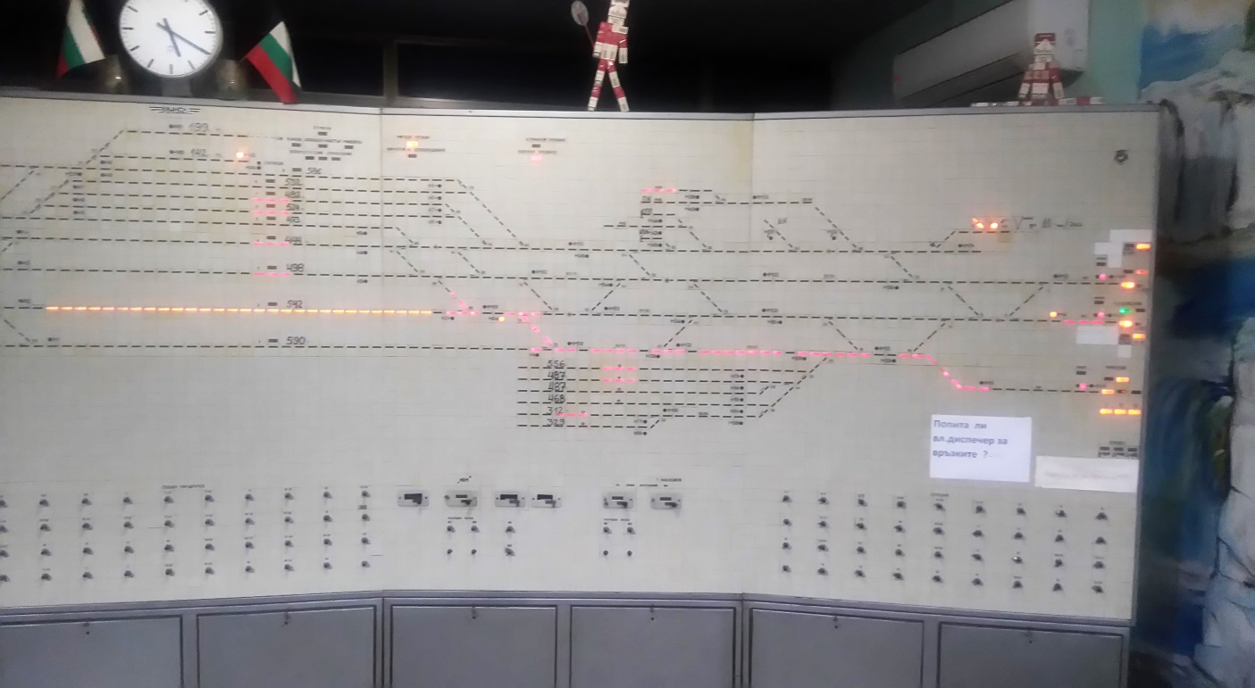
At 10:00 hrs, members of the Investigation Commission arrive at Plovdiv Station.
Фиг. 8
At about 1:00 pm the investigative bodies from the National Investigation Service (NIS) - Sofia arrive at Plovdiv station. After the exchange of information between both investigative structures, the inspections continue in parallel.
The Investigation Commission interviews the locomotive brigades operating both locomotives of ,, Bulmarket Rail Cargo “ EOOD, DHT at Plovdiv station and the security technics mechanic on duty who has arrived first at the station after the accident.
The Investigation Commission conducts joint inspections with representatives of the Operational Group on February 16, 2019 at Plovdiv Station on:
- the centralization at Plovdiv Station (MRC - Russian Block), by which the route for transiting along the second track to Plovdiv-distribution station is ordered and locked for IDFT № 48009. The incoming freight trains, according to plan II-24, transit Plovdiv station on the second track to Plovdiv-distribution station;
- damage to the security equipment (ground-level maneuvering traffic light M64 and 2 pcs СОА-3 switches);
- the railway infrastructure (railway and switches № 72/74 with radiuses R = 300 m, it is found that the left tongue of switch № 74 is broken in the transition from rail to tongue profile);
- the ordered and locked route, involving 7 pcs. switches from the first entry switch № 16, at station Filipovo side, to the point of derailment switch № 74, on the second track;
- derailed two electric locomotives № 86003.4 and № 86001.8 in terms of their technical and operational status;
- derailed tank wagons - complex inspection;
The Investigation Commission got known to the Statement Minutes drawn up by the OG on:
- the status of the security equipment and devices;
- the technical condition of the railroad;
The Investigation Commission found a blow at the right wheel rim of the first wheel pair axle of the first locomotive in the upper right area, straight at the head of the broken tongue. There is no visible sign of a rim rising along the head of the tongue.On February 18, 2019 in the locomotive depot of Plovdiv Ascertaining protocols are drawn up for the technical condition of locomotives № 86-001 and № 86-003 by a commission of OG;

On February 18, 2019, in the Locomotive Depot Plovdiv on a bench system, а commission in the presence of representatives of RINC and "Bulmarket Rail Cargo" EOOD carries out the measurement of the static load of both locomotives, bogie by bogie, axle by axle and of wheels; the commission also measures the parameters of the running gear of the locomotives.
On February 18, 2019, in Wagon Depot Plovdiv, a commission of OG prepares ascertainment protocols on the measured parameters of the derailed three wagons;
On February 21, 2019, the Investigation Commission carried out several more inspections of switch № 74 at Plovdiv station after its full restoration and release to service.
On February 22, 2019, at Plovdiv distribution station - of the wagon balance, OG carries out a control measurement of the gross mass of all full of propane-butane wagons of the train;
On February 22, 2019, at locomotive depot Plovdiv inspections of both derailed bogies released from locomotive № 86003 are carried out. The Investigation Commission finds two radially parallel part-of-railhead-shaped marks on the right-hand wheel surface of the first driving wheel axle of the locomotive located perpendicular to the direction of its movement.
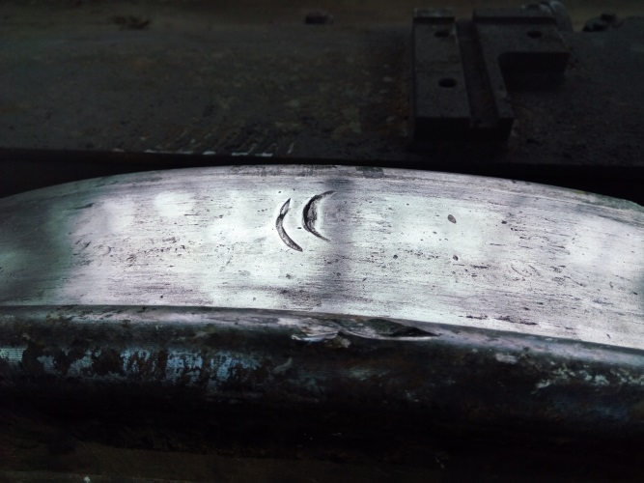
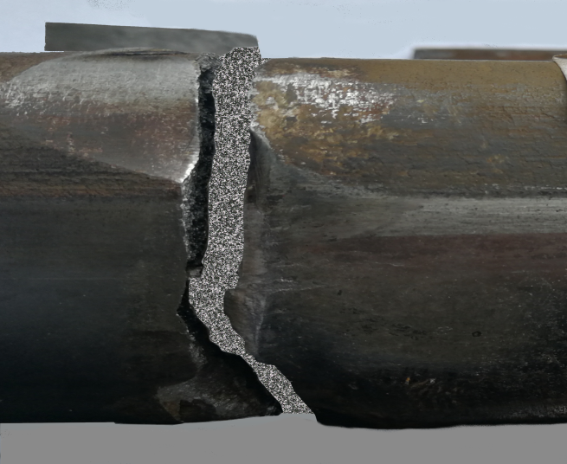
Precise measurements are made with measuring instruments to both marks on the wheel and then on the foreheads of the broken left tongue in the area of its transition. From the comparisons made with the dimensions, it is found that the marks on the wheel are caused by the radial rounding of the profile of the railhead of the broken tongue of switch № 74, from which it follows that the wheel had passed over a preliminarily broken tongue. This has been followed by a blow to the right wheel flange, which has left a visible mark on the head of the profile tongue part and the wheel has derailed between the tongue and the stock rail (Figs. 9 and 10). It has been followed by the derailment of the other wheels of the first locomotive, the wheels of the second locomotive and the three wagons.
Fig. 9
Fig. 10
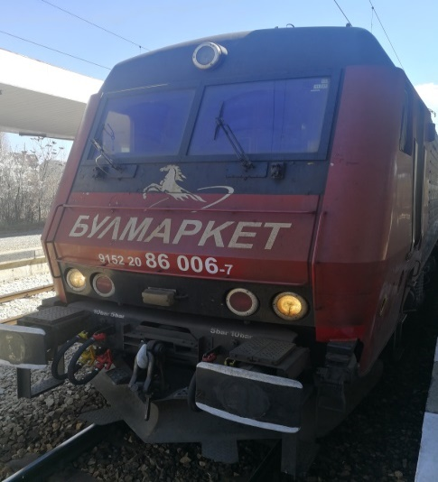
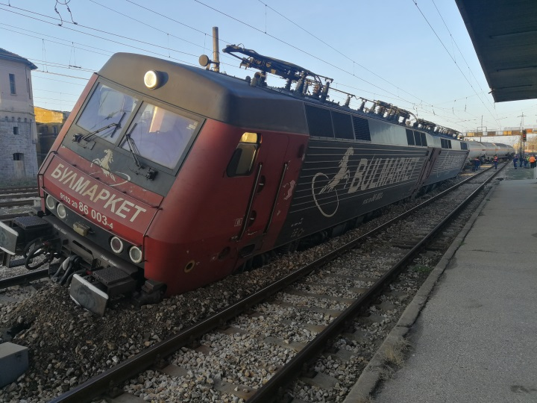
On March 06, 2019 a standard modification form for change of the number in the National
Fig. 12
Fig. 11
Register of Vehicles (NRV) of electric locomotive № 91522086003-4 is submitted by letter № 86 of the manager of "Bulmarket Rail Cargo" EOOD, owned by "Bulmarket DM" OOD to EA "Railway Administration". (Fig. 11).
By letter № 10-19-18 /March 08, 2019 EA "Railway Administration" informs the manager of "Bulmarket Rail Cargo" EOOD that electric locomotive № 91522086003-4 is enrolled with 12-digit number 91522086006-7 in NVR, as the company "Bulmarket DM" OOD is registered as the owner of the locomotive and the company "Bulmarket Rail Cargo" EOOD is registered as the user and the entity responsible for the maintenance of the locomotive (Fig. 12).
On March 15, 2019, the materials collected and prepared by OG are submitted to the Chairman of the Investigation Commission at MTITC.
On March 29, 2019, a speed-braking road test of locomotive № 86006.7 (86003.4) is carried out in the Poduyane - Iskar inter-station. Representatives from NIS, "Bulmarket Rail Cargo" EOOD and the Investigation Commission at MTITC participate in the tests;
In the course of the investigation, the report submitted by OG and the documents collected to it, as well as the materials subsequently requested by the railway enterprises, are analyzed.
Information and records are provided from the recording equipment of the NC "Railway Infrastructure" concerning the management and movement of IDFT № 48009 from Dimitrovgrad (ZS) Station to Plovdiv Station.
Information is provided by "Bulmarket Rail Cargo" EOOD railway undertaking regarding the carriage of the cargo, as well as documentation on the traction and non-traction rolling stock (locomotives and wagons).
An opinion was provided on the impact damage on the wheel pair axles of the first bogie of an electric locomotive № 86003 by the Manager of "Express Service" OOD.
From the broken elements (left divergent tongue and right curved stock rail) of switch № 74, the National Investigation Service takes samples, on the basis of which expert opinions are assigned and prepared by court experts.
Expert opinions are prepared at the Institute of Metal Science, Facilities and Technologies with a Center for Hydro and Aerodynamics (MSFTCHA) - "Acad. Angel Balevski ”at the Bulgarian Academy of Sciences (BAS).
In accordance with the established legal order, the Investigation Commission at MTITC requested from Plovdiv Regional Prosecutor's Office and received reports, expert opinions and other materials related to the accident, assigned and collected by the National Investigation Service:
- Expert opinion of MSFTCHA - BAS;
- Forensic and technical expertise of the records of the parameters of the movement of electric locomotives № 86003 and № 86001 during derailing of freight train № 48009 at Plovdiv station on February 16, 2019;
- Forensic and technical expertise on the technical condition of electric locomotive № 86003, the first in the composition of IDFT № 48009;
- Information provided by "Bulmarket Rail Cargo" EOOD;
- Inspection reports at Plovdiv station on February 16., 17.., 22. and on March 30, 2019;
- Interrogation reports of the personnel involved in the accident;
The Chairman of the Commission accepted the written opinions of the external experts involved in the investigation commission in the performance of the safety investigation tasks assigned to them.
2.6. Rescue and emergency-restoration actions:
The access of all persons is restricted, except for the working teams of the "Fire Safety and Population Protection" RD (FS&PP) - Plovdiv and the Regional Directorate of the MoI - Plovdiv. Due to suspected gas (propane-butane) leakage from the derailed tank wagons, the voltage in the contact network is switched off at 05:17 hrs, upon the order of FS&PP authorities. After the inspection of the wagons and failure to detect leaks, the voltage in the contact network is switched on at 06:17 hrs.
After the inspections, the non-derailed tank wagons are authorized to be uncoupled and towed to another track in order for the initiation of remedial activities on the rolling stock and railway infrastructure to commence.
At 10:30 hrs specialized machinery arrives at Plovdiv station - UNIMOG for lifting the derailed rolling stock.
At 13:27 the movement in Plovdiv - Todor Kableshkov interstation is restored under special conditions for passing with downed pantographs at the switches.
At 14.30 hrs the third derailed tank is straightened.
At 15:00 hrs, the second derailed tank is straightened.
At 15:55 hrs, the first derailed tank is straightened.
At 19:46 hrs the movement in Plovdiv - Todor Kableshkov inter-station is restored according to a timetable.
At 21:05 the first locomotive № 86003 is straightened.
At 21:55 the second locomotive № 86001 is straightened.
On February 19, 2019 at 16:10 hrs, after the restoration activities are carried out on switches № 74, № 86 and 50 m railway of 2nd track, the movement for all trains and vehicles is restored.
3. General data established during the investigation process.
3.1. Participating officers:
At Plovdiv station, from RINC
- duty head of trafic first official ;
- duty head of trafic second official;
- duty head of trafic second official;
from "Bulmarket Rail Cargo" EOOD
- locomotive motorman Ist official on electric locomotive № 86003.4;
- locomotive motorman IInd official on electric locomotive № 86003.4;
- locomotive motorman I^{-st} official on electric locomotive № 86001.8.;
3.2. Data on rolling stock:
- electric locomotive № 86003.4 – with regular registration in Vehicles’ register;
- electric locomotive № 86001.8– with regular registration in Vehicles’ register;
After inspecting the wagons and analyzing the information from the train documents, it was found that the wagons from the composition of IDFT № 48009 have serial numbers with the following modes of exchange: out of a total of 27 wagons, 26 ones start with serial № 33 ... and 1 with № 84... .
Tank wagons, which serial number begins with 84, are intended for movement only within the railway administration in which they are registered. For the remaining 26 wagons, the serial numbers start with 33, which means that the wagons technically meet international transport requirements.
The information from EA "Railway Administration" shows that the tank wagons of IDFT № 48009 as of February 16, 2019, are regularly registered in the European Virtual Vehicle Register and have a responsible entity for their maintenance..
3.3. Data on the railway enterprise:
"Bulmarket Rail Cargo" EOOD possesses:
- License to provide rail transport services № 212/May 14,2015;
- Valid Safety certificate part ,,А“ BG 11 2015 0002 and part ,,В“ BG 12 2015 0002;
- Valid certificate or an entity responsible for maintenance (ERM) BGRA/2015/003;
- The carriage IDFT № 48009 on February 13, 2019 г. and on February 15, 2019 is committed by the railway enterprise "Bulmarket Rail Cargo" EOOD;
3.4. Train type, number and category:
In accordance with the requirements of Regulation № 45 from November 30, 2001 on the rules for numbering of international and domestic passenger and freight trains, the train is:
- freight № 48009, international, direct;
3.5. Train tractive rolling stock type and number:
- Electric locomotive № 86003.4;
- Electric locomotive № 86001.8;
3.6. Train non-tractive rolling stock type and series:
- tank wagon – series Zagkks, 25 pcs full;
- tank wagon – series Uas, 1 empty for prevention;
- tank wagon – series Zacs, 1 empty for prevention;
3.7. Railway infrastructure description:
3.7.1.Railroad and switches:
- Plovdiv station has 11 reception and dispatch tracks, of which 3 main, 8 diversion and 7 front tracks;
- Railway in the station: rails S 49, concrete sleepers ST-4, fastening type "K" with propped rail fish plates.
- place of derailment: switch № 74, inclining 1 ‰ in a downward direction to the 2nd track;
3.7.2. Signalization, station safety installations and between-station security technics:
- Plovdiv station is equipped with Route Relay Centralization (RRC-Russian Block);
- Filipovo Station is equipped with Route Relay Centralization (RRC - MN-70);
- between Filipovo and Plovdiv stations the traffic is carried out with Autoblock (AB) equipped with through signals;
3.7.3. Contact network:
- chain, compensated;
3.10. Train protection:
- electric locomotives № 86003.4 and № 86001.8 are equipped with a vigilance device;
3.11. Communication system:
- Plovdiv station is equipped with an automatic telephone connection, a station telephone connection to the switch posts, an inter-station telephone connection with the adjacent stations, a train dispatch radio and an official mobile phone;
- the locomotive crews in both locomotives make contact by official mobile phones;
3.12. Performed repair work at the accident site.
- The following repairs and measurements were carried out at Plovdiv station, switch № 74 until the accident occurred:
• 2002 - Left tongue rail of switch № 74 replaced;
• October 27, 2016 - change of lead rail;
• December 14, 2016 - change of lead rail;
• from February 21 till September 25, 2017 - change of 15 pcs. sleepers;
• December 21, 2017 - bindings of fastening;
• December 13, 2017 - non-destructive control of switch № 74 - no defect rails;
• April 02, 2018 - heavy road machinery treating;
• October 15/2018 manual measurement - normal;
• December 18, 2018, manual measurement - normal;
• January 17/2019 manual measurement - normal;
• Protocol № 1 / October 10, 2018, for a six-month inspection of Plovdiv station, switches - in operation;
• Protocol № 01 / January 23, 2019 for a monthly inspection of Plovdiv station, switch № 74 - meets the requirements, Art. 49 of Ordinance № 58 - in operation;
4. Deaths, injuries and material damages.
4.1. No deaths;
4.2. No injured personnel;
4.3. Material damages:
4.3.1. За "Bulmarket Rail Cargo" EOOD
- Report dated March 14, 2019, of "Bulmarket Rail Cargo" EOOD for damages of derailed locomotives № 86003.4 and № 86001.8 in the amount of BGN 247 460,75;
- Report from June 25, 2019, of "Bulmarket Rail Cargo" EOOD for damages of 3 tank wagons № 84529370013-2, №33527912158-6, № 33877919267-7 in the amount of 22 140,58 BGN;
4.3.2. For "RINC"
- Railway and facilities – 44 525.26 BGN
- Signaling, messaging and telecommunications – 14 942,00 BGN;
- contact network - no damages:
Expenses:
- RINC Restoration Funds - BGN 6 979,67.
- Change in the timetable for the movement of RINC trains according to delayed, canceled and assigned trains and vehicles - BGN 3 205,98;
- Transshipment of passengers and increase of working time of the transport crews of "BDZ - Passenger Transport" EOOD - BGN 2 843,25;
- Service of the recovery means by transport personnel from "BDZ Passenger Transport" EOOD - BGN 1 243,98;
4.3.3. For the environment – none:
Total damage from the accident amount to: 343 341,47 BGN.
5. External circumstances - weather and geographic conditions.
- in the dark part of the day – 04:15 hrs;
- air temperature at 05:00 hrs, +2,5ºС;
- wind speed – 9 km/h;
- weather – variable, cloudy.
6. Data for railway infrastructure and railway enterprise staff related to the accident.
6.1. Position, place of work, sex and age:
Personnel of RINC
- duty head of trafic first official – Plovdiv station – RI NC, man of 45 years;
- duty head of trafic second official – Plovdiv station – RI NC, man of 42 years;
- duty head of trafic second official – Plovdiv station – RI NC, man of 41 years;
"Bulmarket Rail Cargo" EOOD - locomotive motorman Ist official on № 86003 – "Bulmarket Rail Cargo" EOOD, man, 47 years old;
- locomotive motorman IInd official on № 86003 – "Bulmarket Rail Cargo" EOOD, man, 44 years old;
- locomotive motorman Ist official on № 86001 – "Bulmarket Rail Cargo" EOOD, man, 33 years old;
6.2. Position certificate and certificate data:
RINC
- Certificate № 721/March 02, 2010 for occupying position duty head of trafic first official – Plovdiv station;
- Certificate № 715/September 21, 2007 for occupying position duty head of trafic second official – Plovdiv station;
- Certificate № 3328/September 01,2014 for occupying position duty head of trafic second official – Plovdiv station;
"Bulmarket Rail Cargo" EOOD - Certificate № 189/December 18, 2017 for occupying position – locomotive motorman Ist official on № 86003;
- Certificate № 108/ December 04, 2015 for occupying position – locomotive motorman IInd official on № 86003;
- Certificate № 78/ September 01, 2015 for occupying position locomotive motorman Ist official on № 86001;
Additional professional qualifications:
locomotive motorman Ist official on № 86003
- Qualification certificate № 2462/May 28,2018, acquired qualification locomotive motorman of highway electric locomotives series 85.00 and 87.00, teaching structure HTS ,,Todor Kableshkov“ Sofia;
- Qualification certificate № 2513/May 28,2018, acquired qualification locomotive motorman of highway electric locomotives series 86.00, teaching structure HTS ,,Todor Kableshkov“ Sofia;
locomotive motorman IInd official on № 86003
- Qualification certificate № 2447/May 28,2018, acquired qualification motorman of highway electric locomotives series 85.00 and 87.00, teaching structure HTS ,,Todor Kableshkov“ Sofia;
- Qualification certificate № 2598/May 28,2018, acquired qualification motorman of highway electric locomotives series 86.00, teaching structure HTS ,,Todor Kableshkov“ Sofia;
locomotive motorman Ist official on № 86001
- Qualification certificate № 2430/May 28,2018, acquired qualification motorman of highway electric locomotives series 85.00 and 87.00, teaching structure HTS ,,Todor Kableshkov“ Sofia;
- Qualification certificate № 2481/May 28,2018, acquired qualification motorman of highway electric locomotives series 86.00, teaching structure HTS ,,Todor Kableshkov“ Sofia;
6.3. Qualification certificate:
RINC
- duty head of trafic first official, Plovdiv station – Qualification certificate № 568/July 25,1998, Acquired certification for Train Master, Commercial Operations Manager, Head of Traffic and Train Dispatcher, training period August 30,1993 – July 25,1998, teaching structure HMTS ,,Todor Kableshkov“ Sofia;
- duty head of trafic second official, Plovdiv station – Qualification certificate № 742/July 24,1999, Acquired certification for Train Master, Commercial Operations Manager, Head of Traffic, training period August 31,1996 – July 24,1999, teaching structure HMTS ,,Todor Kableshkov“ Sofia;
- duty head of trafic second official, Plovdiv station – Qualification certificate № 1922, Acquired certification for Head of Traffic training period April 05,2004 – November 26, 2004, teaching structure CPC-RINC, Protocol № I-17-ВП-9 from December 10, 2004;
"Bulmarket Rail Cargo" EOOD - locomotive motorman Ist official, № 86003 – Qualification certificate № 257, acquired qualification for: Electric locomotive Motorman series 42.00, 43.00, 44.00, 45.00, training period October 01, 2002 –February 02, 2003, teaching structure CPC-RINC, Protocol № I-17-П-10 from February 06,2003.
License for driving locomotives BG 71 2017 0895.
- locomotive motorman IInd official, № 86003 – Qualification certificate № 2733, acquired qualification for: Electric locomotive Motorman series 42.00, 43.00, 44.00, 45.00, 46.00 training period May 03, 2005 –July 22, 2005, teaching structure HTS ,,Todor Kableshkov“ Sofia, Protocol № 123-PQC from July 27,2005.
License for driving locomotives BG 71 2016 0052.
- locomotive motorman Ist official, № 86001 – Qualification certificate № 11461, acquired qualification for: Electric locomotive Motorman series 43.00, 44.00, 45.00, training period September 14, 2009 – November 19, 2009, teaching structure CPO-BDZ, Protocol № 9-647-597 from December 08,2009.
License for driving locomotives BG 71 2016 0045.
6.4. Document for professional qualification:
RINC
- duty head of trafic first official at Plovdiv station – a diploma for completed high education № 000673/ July 23,1998, civil specialty – TORT, teaching structure HMTS ,,Todor Kableshkov“ Sofia;
- duty head of trafic second official, Plovdiv station – a diploma for completed high education № 000910/July 23,1999, civil specialty – TORT, teaching structure HMTS ,,Todor Kableshkov“ Sofia;
- duty head of trafic second official, Plovdiv station – Secondary special education diploma № 006524 / June 30, 1997, specialty Agricultural technician of MV and AM, teaching structure of SPS on mechanization of agriculture, Karlovo;
For "Bulmarket Rail Cargo" EOOD
- locomotive motorman Ist official on № 86003 – a diploma for completed secondary education № 939297/June 28,1990, professional qualification: Motorman assistant , teaching structure Transport SPS,,Gotse Delchev“ – Plovdiv;
- locomotive motorman IInd official on № 86003 – a diploma for completed secondary education № 0037746/July 01,1993, professional qualification: Motorman assistant, teaching structure Transport SPS,, Gotse Delchev“ – Plovdiv;
- locomotive motorman Ist official on № 86001 – a diploma for completed secondary education № 065460/June 21,2005, teaching structure Secondary School ,,Sveti Sedmochislenitsi“ – Plovdiv;
6.5. Certificate as per Ordinance № 56 from 2003:
RINC
- duty head of trafic first official, Plovdiv station – Protocol № XI-22-18 / May17,2018;
- duty head of trafic second official, Plovdiv station – Protocol № XI-22-18 / May17,2018;
- duty head of trafic second official, Plovdiv station – Protocol № XI-22-18 / May17,2018.
За "Bulmarket Rail Cargo" EOOD
- locomotive motorman Ist official, № 86003 – Protocol № XI-20-14 / April 16,2018 ;
- locomotive motorman IInd official, № 86003 – Protocol № XI-20-14 / April 16,2018;
- locomotive motorman Ist official on, № 86001– Protocol № XI-20-87/October 03,2018.
6.6. Personnel break duration before staff time:
In accordance with the requirements of the normative acts - Labour Code and Ordinance № 50 / December 28, 2001, and as reported by the duty group the personnel are provided with the required rest period before their work:
RINC
- duty head of trafic first official, Plovdiv station – rests from 19:00 hrs on February 14,2019 till 19:00 hrs on February 15,2019 ;
- duty head of trafic second official, Plovdiv station – rests from 19:00 hrs on February 14,2019 till 19:00 hrs on February 15,2019;
- duty head of trafic second official, Plovdiv station – rests from 19:00 hrs on February 14,2019 till 19:00 hrs on February 15,2019;
"Bulmarket Rail Cargo" EOOD - locomotive motorman Ist official on, № 86003 – rests from 10:00 hrs on February 14,2019 till 23:00 hrs on February 15,2019;
- locomotive motorman IInd official, № 86003 – rests from 22:00 hrs on February 14,2019 till 23:00 hrs on February 15,2019;
- locomotive motorman Ist official on, № 86001– rests from 04:00 hrs on February 14,2019 till 23:00 hrs on February 15,2019;
6.7. Work experience:
RINC
- duty head of trafic first official, Plovdiv station – 21 years;
- duty head of trafic second official, Plovdiv station – 20 years;
- duty head of trafic second official, Plovdiv station – 17 years;
"Bulmarket Rail Cargo" EOOD - locomotive motorman Ist official on, № 86003 – 25 years;
- locomotive motorman IInd official, № 86003 – 22 years.;
- locomotive motorman Ist official, № 86001 – 12 years;
6.8. Shift (travel) briefing:
RINC
- Personnel at Plovdiv Station is briefed for duty on February 15 / 16, 2019 and they sign in the instruction book stating that they were cheerful, rested and haven’t used an alcohol and other narcotics;
"Bulmarket Rail Cargo" EOOD
- Locomotive crews of locomotive № 86003 and № 86001 are briefed for their shift on February 15, 2019 at 23:00 hrs by the head of transport - "Bulmarket Rail Cargo" EOOD at Iliyantsi station and by signing in the instruction book motormen have declared that they were cheerful, rested and have not used alcohol and other intoxicants. No alcohol test is performed on the locomotive crews.
7. Data on the investigations. Summary of testimony.
7.1On December 10, 2016, freight train № 90570 operated by "Bulmarket Rail Cargo EOOD" derailed on switch № 5 at Hitrino station. The derailment resulted in a breakdown in the tank of a full tank wagon, gas leakage and subsequent ignition. As a result of the derailment and the ensuing fire, residents of the village of Hitrino were also seriously injured. Damage has been caused to the railway infrastructure and rolling stock, to the settlement and the environment. The locomotive motormen serving the train, work in the same railway carrier.
7.2. The investigation commission does not have any testimony about the accident being investigated due to its occurrence in the early hours of the day.
8. System of Safety Management (SSM).
8.1. Safety procedures set out in SSM of RINC:
8.1.1. Procedures, which are a part of SSM, concerning the section "Railway Traffic Management and Station Activities" (RTMSA) - Plovdiv. As can be seen in the report of the OG and the actions of the staff on shift at Plovdiv station and the materials presented by the section on safety in traffic management, the safety procedures are followed;
8.1.2. Procedures, which are a part of SSM, concerning the repair, maintenance, and operation of the railway and the railway switches from Plovdiv railway section:
8.1.2.1. Railway and switches repair and control measurements at Plovdiv station;
8.1.2.2. Completed periodic inspections of railway facilities at Plovdiv station - 2018 ÷ 2019, in accordance with the requirements of Ordinance № 58 / August 2, 2006;
8.1.2.3. Performed periodic repairs and measurements of railway switches at Plovdiv station;
8.1.2.4. Approved annual schedule for 2017 for non-destructive control of the track, welded railway fish plates and switches with UDS2-RDM22 and UDS1-RDM-1M1 defectoscopes;
8.1.2.5. Approved annual schedule on January 03, 2018 for non-destructive control of the track, welded springs and railway switches with UDS2-RDM22 and UDS1-RDM-1M1 defectoscopes;
8.1.2.6. Approved annual schedule onMay 22, 2019 for non-destructive control of the track, welded springs and railway switches with UDS2-RDM22 and UDS1-RDM-1M1 defectoscopes;
8.1.2.7. By order № 900 /June 02,2009 of the Director-General of RINC approved the "Rules for the certification of railway switches";
8.1.2.8. Order № 318 / March 07, 2009 of the Director-General of NRIC approves the "Rules for the organization of non-destructive control of rails, railroad switches, welded joints and of railway track restoration";
Under item 8.1.2.1, the Investigation Commission established:
- gaps in filling in the data in the Technical Passport of switch № 74;
- lack of measurement data on the axis and longitudinal level of the straight and the curved track at the indicated locations;
- lack of data on the condition of the joining, the condition of the slippers' grill, the hardening of the ballast prism;
- there is no general assessment of the railway switch condition ;;
- - change of left curved tongue RL of the switch in 2002;
Under item 8.1.2.2, the Investigation Commission established:
- On October 10, 2018, a commission at Plovdiv station has conducted a six-month inspection regarding the maintenance and operation of the railway infrastructure;
- The minutes of the Commission states that all railway infrastructure facilities at Plovdiv station are in good operational order;

On January 23, 2019, a monthly inspection of railway facilities and devices is carried out in the area of Plovdiv station;
- The minutes of the Commission states that switch № 74 meets the requirements of Art. 49 of Ordinance № 58 - in operation;
According to item 8.1.2.3 of the information provided to the Railway Section - Plovdiv for the ongoing repair of switch № 74, the Investigation Commission determined:
- Replacement of 15 switch sleepers in 2017;
- Tightening joining- clamping kits - 350 pcs - 2017 and 350 pcs - 2018;
- Treatment of the switch with Heavy Road Machinery (HRM) on April 02, 2018;
- Replacement of 2 pcs. lead rails (not mentioned) in 2016;
- Manual measurement of switch number 74:
- on October 15, 2018 the switch is normal;
- on December 18, 2018 the switch is normal;
- on January 17, 2019, the switch is normal;
Upon item 8.1.2.4, the implementation of the 2017 Non-destructive Switch Control Schedule, the Investigation Commission established:

- In the working log of the NDC unit, in the period January 19 ÷ December 18, 2018, with the RDM-1M1 type defectoscope, measurements of 66 switches are recorded in Plovdiv and Plovdiv-distribution stations, as switch 74 does not appear in the report;
Upon item 8.1.2.6 of the implementation of the Non-destructive Switch Control Schedule in 2019, the Investigation Commission determined:
- The 2019 timetable is approved on 22 May 2019;
- The data presented in the work schedule does not correspond to the approved annual schedule of the NDC unit for January 2019;
- In the working log of the unit for the non-destructive control of the number of switches from January 31, 2019 measurements of 4 switches are recorded by a defectoscope type RDM-1M1, the 4th and 6th tracks were measured at Plovdiv station, as switch № 74 does not appear in the report;
Under item 8.1.2.7 the text reads as follows:
,, item 4.3.3.10. Condition of the switch elements - for cracks, breaks and other malfunctions the track elements are checked by:
- monthly visual inspection;
- annual ultrasonic non-destructive testing;
- capillary control if necessary;
The elements to be controlled are:
- in the tongue part - the transition from tongue to rail profile in the tongue section;
- in the lead and crossing parts - all rail elements;
Under item 8.1.2.8, in accordance with the approved regulations - Section III "Periodicity of non-destructive testing" states:
,, Art. 12, para. 1: The frequency of non-destructive testing of rails and railway switches must be appropriate to the category of railways…. "
,, item 1 rail highways and Category I railroads are controlled by BC methods twice a calendar year; "
Evident from the approved annual schedules and the reports in the logs of the non-destructive inspection units, the quoted periods under item 7 and item 8 for the control of railway switches are not observed.
8.2. Following the procedures in SSM of "Bulmarket Rail Cargo" EOOD;
The Investigation Commission is presented some safety procedures, part of SSM, concerning the rolling stock of "Bulmarket Rail Cargo" EOOD:
- Safety Procedure SP-08, "Instructions for inter-repair runs and the cyclicity of routine inspections and repairs of electric locomotives 86.00 series ";
- Safety Procedure SP-13, "Instructions for Inspection in Operation of Electric Locomotives 86.00 Series";
- Safety procedures SP-52, "Instruction for Lifting Repair of locomotives 86.00 series";
- Safety Procedure SP-77 'Instructions for performing brake tests and providing trains with brake mass";
- Safety Procedure SP-07 " Manual for the Locomotive Motorman";
- Safety Procedure SP-52, "TRS Brake Periodic Inspection Instructions";
- Safety Procedure SP-01 "Plan for the maintenance of traction and non-traction rolling stock";
- Safety Procedure SP-06 "Guidance on the Vigilance Device of the Locomotive Motorman in TRS";
- Safety Procedure SP-66, "Manual for Locomotive Road list;
- Тhe safety procedure for the carriage of dangerous goods by rail;

- Protocol for measuring the control distances from the suspension of electric locomotive № 86003, carried out by "Express Service" Ltd. on November 13, 2018, in norms.
- Static Wheel Load Measurement Card of Electric Locomotive № 86003, made by "Express Service" Ltd. on November 13, 2018, in norms.
- Protocol for inspection of the technical serviceability of the braking system of electric locomotive № 86006.7 (86003.4) by a Commission on the proposal of the NIS, carried out on March 29,2019, in the Poduyane - Iskar interstation - in operation.
- Protocol for acceptance of the braking system and additional pneumatic equipment of electric locomotive № 86003, performed by “Express Service” Ltd. on June 29,2017, in norms.
- A protocol of Lifting repair of electric locomotive № 86003, performed at "Express Service" OOD and submitted for operation - in operation on June 03, 2015;
- A protocol of Lifting repair of electric locomotive № 8600,1 executed at "Express Service" OOD and submitted for operation - in operation on February 06, 2015;
- A protocol of a small periodic repair of an electric locomotive № 86001, performed at "Express Service" OOD and submitted for operation - in operation on October 03, 2018;
- A protocol of a small periodic repair of an electric locomotive № 86003, executed at Express Service OOD and submitted for operation - in operation on March 30, 2018;
- A protocol of technical inspection № 2 of electric locomotive № 86001, made in "Express Service" OOD and submitted for operation - in operation on January 22, 2019;
- A protocol of technical inspection № 2 of electric locomotive № 86003, made in "Express Service" OOD and submitted for operation - in operation on January 08, 2019;
The verification of the documentation regarding compliance with the requirements of the Safety Procedures, relevant to the observance of the terms of the performed cyclic repairs, inspections and servicing of electric locomotives № 86003.4 and № 8686.8, are met.
No violations of the procedures in the safety management system or of the technologies in the organization of the transport were found.
9. Rules and norms.
9.1. The staff on shift at the railway station Plovdiv, immediately, before and during the accident, acted in accordance with the requirements of national rules and "Rules for the movement of trains and maneuvering in the railway transport" (RMTMRT), as well as the rules regulating the safe operation of rail transport.
9.2. The locomotive personnel of "Bulmarket Rail Cargo" EOOD who has carried the train during the accident has been acting in accordance with the requirements of the national rules and internal rules Safety Procedure SP-07 "Manual for the operation of the locomotive motorman", Regulation № 58 from August 2, 2006 on the rules for the technical operation, movement of trains and signaling in rail transport, RMTMRT and the rules governing the safety of carrying dangerous goods by rail.
- Signaling and speeds are observed while driving through Plovdiv Station;
9.2.1. During the movement of the train in the section Karlovo - Plovdiv the exceeding of the allowed speed of movement in individual inter stations was detected (item 14.2.1);
9.3. The rules for drawing up a Certificate for Brake Mass for the provision of trains with brake mass by the staff of "Bulmarket Rail Cargo! EOOD at Dimitrovgrad (ZS) and at Iliyantsi Station, as well as the rules for sample D at Karlovo Station (item14.4).
9.4. The rules for checking the clocks at Iliyantsi Station and Karlovo Station (14.4) are not respected.
10. Functional condition of rolling stock and technical facilities of the railway infrastructure.
10.1. Functional condition of the railway infrastructure:
- derailed locomotives 86003 and 86001 - damaged under running gear and functionally unfit for use. The automatic motion recorders of the locomotives are switched on, sealed and their data are downloaded and decrypted;
- derailed 3 tank wagons - damaged under running gear, without tank breakage and functionally unfit for use;
- the technical condition of the other 24 tank wagons - in operation;
10.2. Functional condition of the railway infrastructure:
Railway and switches:
- Damaged 50 m of the railway on the 2nd track;
- damaged switch № 74;
Signaling, Messaging and Telecommunications:
- damaged ground maneuvering traffic light - 1pc;
- damaged traffic light foundation - 1pc;
- damaged COA-3 switch deflection unit - 2 pcs .;
Contact network - in operation;
10.3. Interpretation of locomotive № 86003.4 speed provided by "Bulmarket Rail Cargo" EOOD:
- “ On February 16, 2019, train № 48009 with locomotive № 86003 departs from station Graf Ignatievo at 03:52 hours. The locomotive is moving at speed in a timetable. At 04:13:15 hrs the locomotive passes the entrance signal of Plovdiv station at a speed of 33 km / h, followed by a movement of about 600 m at a constant speed of about 32 ÷ 33 km / h. The locomotive smoothly accelerates the speed and reaches 36 km / h at 04:14:50 hrs, the locomotive continues at a speed of 36 km / h until 04:15:00 hrs. This is followed by a slow speed reduction of down to 33 km / h and for the time of 04 sec. by 04:15:04 hrs it runs about 40 m. A sharp decrease in speed follows and within 30 meters at 04:15:10 hrs the locomotive sharply stops with 0 km / h.
All limitations and maximum speed for the section have been complied throughout the journey.“
11. Operational System Documentation - reviews, inspections, repairs, maintenance.
11.1. Measures taken by the staff to regulate trains movement.
The Operational Movement Unit (OMU) and the RTMSA ​​- Plovdiv together with Central Dispatch Management (CDM) of RINC, take timely operational actions regarding changes in the train timetable in Karlovo - Plovdiv section and Plovdiv station. Passenger and freight trains in the section Karlovo - Plovdiv have been designated and canceled. The route for the movement of freight trains in the direction Karlovo - Plovdiv has been changed.
Other subsequent written and verbal instructions regarding the accident are described in item 2.6.
The railway enterprise BDZ "Passenger Transport" EOOD has organized the transshipment of passengers from the railway station Filipovo to the railway station Plovdiv by bus.
11.2. Measures taken to protect and guard the scene of accident.
Due to the increased risk of propane-butane gas leakage and leakage from the derailed 2 full tank wagons and gassing of the population, the area of the accident is torn off and access is restricted by the authorities of the Ministry of Interior - Plovdiv. Access to the derailed tank wagons is provided only to the specialized services of RD FS&PP - Plovdiv. After the inspections carried out by the specialized services, no gas leakage and gas hazard were detected and permission was given for the commencement of emergency restoration works.
12. Health and Safety work conditions.
12.1. With reference to the requirements of Art. 13 para. 1 and Art. 14, para. 1 of Ordinance №50 / December 28, 2001 no violations are observed in the reporting of personnel working hours at RINC and "Bulmarket Rail Cargo" EOOD.
12.2. With reference to the requirements of Art. 20, para. 2 of Ordinance № 54 / June 02, 2003 the officials of RINC and "Bulmarket Rail Cargo" EOOD, related to the accident, have valid certificates for psychological examination.
13. Accidents of similar nature previously registered.
The MTITC Investigation Commission has conducted an investigation in 2017 of a serious accident - derailment of freight train № 90570 at arrow № 5 upon entering the third diversion track at Hitrino station at a speed of 80 km / h at a maximum allowed of 40 km/h on December 10, 2016. The train has been carrying dangerous goods (propylene and LPG) in tank wagons. As a result of the over speed, when passing through switch № 5, after the 5th wagon, 12 full tanks have derailed, of which the 10th tank is drilled and ignited. The resulting blast and fire cause the death of 7 people and another 29 caused serious injuries - residents of the village of Hitrino. Residential and administrative buildings are destroyed. Damage to the derailed rolling stock and to the railway infrastructure are caused. Environmental damage is also done. The train is operated by the same carrier "Bulmarket Rail Cargo" EOOD, other locomotive staff.
13.1. The rolling stock derailed at the Plovdiv station has no other registered similar accidents except locomotive 86-003, which has been the leading locomotive in the accident at Hitrino station on December 10, 2016.
13.2. The personnel of the railway enterprise (motormen) and the railway infrastructure (on-duty supervisors) involved in the accident, do not have previous similar accidents registered;
13.3. There are no previous similar accidents registered in Plovdiv station area.
14. Analysis and conclusions.
14.1. Description of the chain of events based on established facts.
The Investigation Commission at MTITC collects the necessary documentation and materials, analyzes all available facts and evidence, as well as the preceding circumstances, establishing the causes that have led to the accident. Repeated inspections and analyzes of the railway, the security equipment, rolling stock, as well as the analysis of the submitted materials and documents by the Operational Group, the prepared and submitted technical expertise, the opinions of the experts involved in the investigation, the interview conducted with the staff, and the materials provided by the National Investigation Service (NIS) allow to establish the following:
- derailment of freight train № 48009 occurred on February 16, 2019, at 04:15 hrs on switch № 74 in a prepared and locked transit route along the second track of Plovdiv station for Plovdiv-distribution station;
- derailment of the leading train locomotive № 86003 is realized in the tongue part of switch № 74. The left curved tongue has broken in the transition from the rail to the tongue profile just before the locomotive passes through it. Subsequently, the second locomotive and the first three tank wagons also derail at the same place to the left side of the railway in the direction of movement. The switch has a radius of R = 300 m and a length of 33,230 m;
- the speed of train movement at the time of derailment has been 34 km/h, with a clearance of up to 40 km/h;
- after the derailment, the train stops on the 2nd track 340 meters from the axis of the station reception building;
14.2. Analysis of the facts and conclusions on the causes of the accident.
14.2.1. Train movement analysis.
The download of the information from the locomotive recorder is carried out in the presence of NIS bodies and the Investigation Commission at MTITC. Records reading is done with DEUTA WERKE ADS3 software. The information downloaded from the locomotive recorder is decrypted and a detailed analysis of train movement is performed by the Investigation Commission at MTITC.
Upon appointment, on-duty locomotive motormen who will be servicing IDFT № 48009 report to the office of the carrier company at Iliyantsi Station, and a pre-travel briefing is carried out to them and travel sheets are submitted to both crews. The travel sheet received by locomotive motormen guarantees the fitness of the staff signed by the issuing official (Figs. 13 and 14).
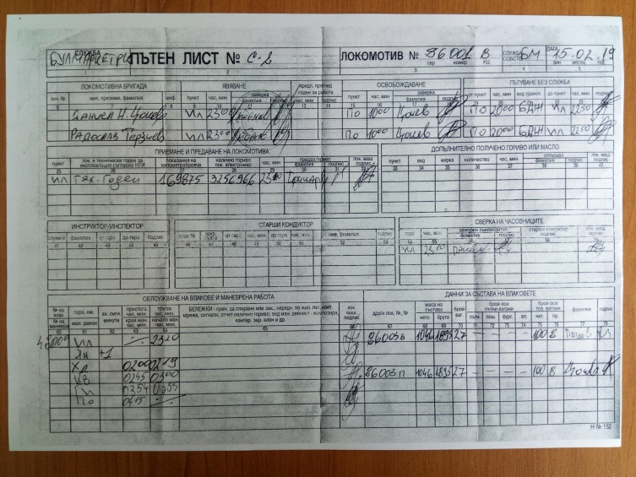
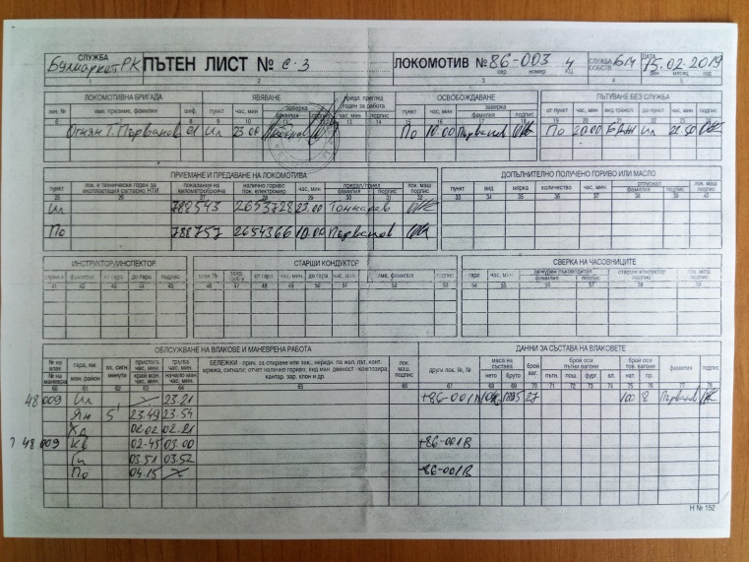
The train departs from Dimitrovgrad ZS at 19:18 hrs in a composition according to a wagon list (Fig. 15):
Fig. 13 Fig. 14

- Two locomotives in operation:
  - № 86003;
  - № 86001;
- An open wagon with special structure for bulk cargo type F, № 88536656505-3 - prevention;
- 12 pcs. tank wagons filled with liquefied petroleum gas propane-butane:
- 33807922131-7 | - 33877916771-1
- 33807919101-5 | - 33877916884-2
- 33527919135-7 | - 33527912158-6
- 33877916014-6 | - 37807923357-3
- 33877919574-6 | - 33527912160-2
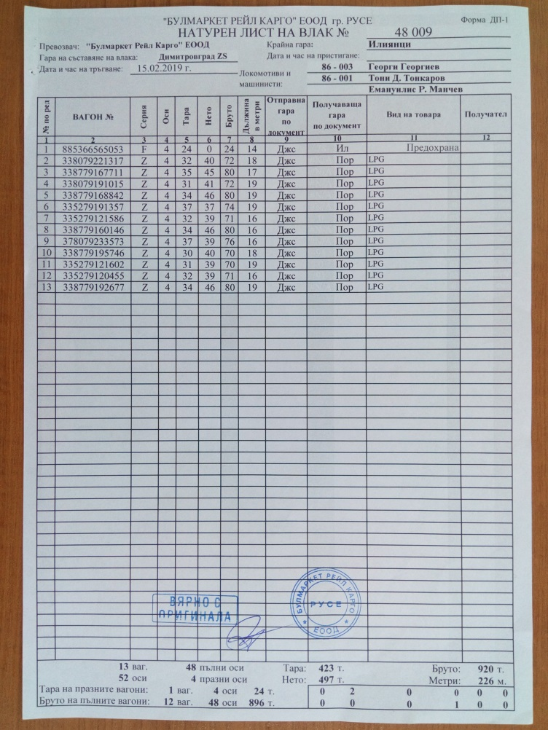  - 33527912045-5  Fig. 15 | 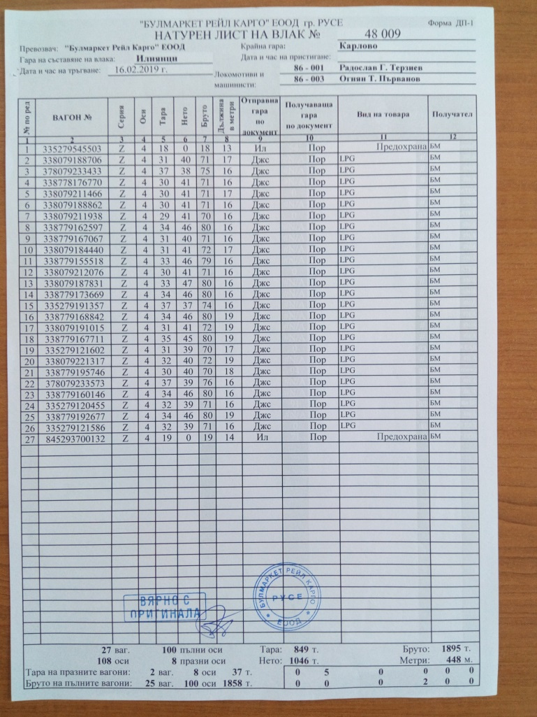  - 33877919267-7  Fig. 16
In this composition, the train moves to Iliyantsi station, where it arrives at 21:05 hrs.
At Iliyantsi station, the composition of the train is changed, as wagon № 88536656505-3 is removed, 13 additional tank wagons are added, and two tank wagons placed at both ends for prevention. The train is thus formed into the following composition on wagon list (Fig. 16):
- Two locomotives in operation:
  - № 86-001;
  - № 86-003;
- Wagon № 33527954550-3 – empty for prevention;
- Wagons №№:
- 33807918870-6 | - 37807923343-3
- 33807817677-0 | - 33807921146-6
- 33807918886-2 | - 33807921193-8
- 33877916259-7 | - 33877916706-7
- 33807918444-0 | - 33877915551-8
- 33807921207-6 | - 33807918783-1
- 33877917366-9 | - 33527919135-7
- 33877916884-2 | - 33807919101-5
- 33877916771-1 | - 33527912160-2
- 33807922131-7 | - 33877919574-6
- 37807923357-3 | - 33877916014-6
- 33527912045-5 | - 33877919267-7
- 33527912158-6
- Wagon № 84529370013-2 – empty for prevention.
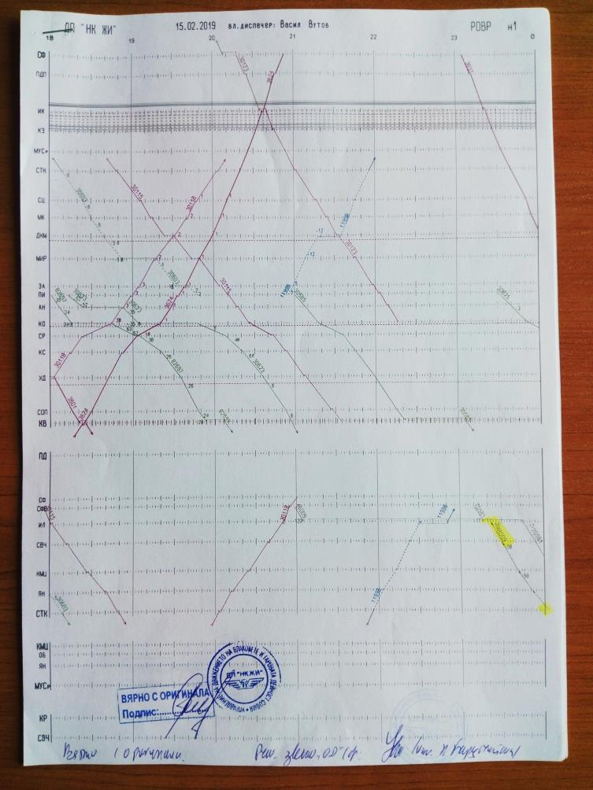
According to the RINC timetable, IDFT № 48009 was supposed to depart from Iliyantsi station at 00:20 hrs, but in fact, it has departed at 23:20 hrs according to the road map of locomotive 86-001, which leads in the section from Iliyantsi station to Karlovo station. As can be seen from the train schedule taken from NRIC MRTW from February 15, 2019, the train has left Iliyantsi station at 23:22 hrs (Fig. 17). According to locomotive 86-001 road map at Iliyantsi station, the locomotive 86-001 clock is checked at 23:10 hrs (Fig. 14).
Fig. 17
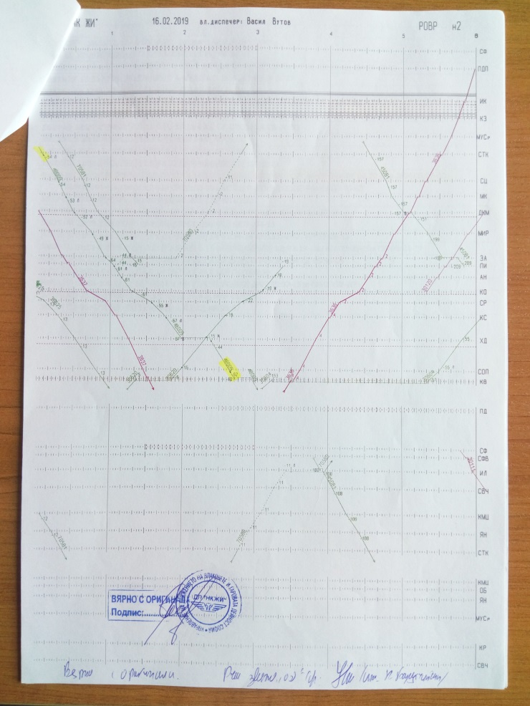
Fig. 18
In the section Iliyantsi - Karlovo, the train moves with haste, passing all the stations without stopping except for Hristo Danovo station, where it stays 19 minutes to meet freight train № 30620 (Figs. 18 and 19).
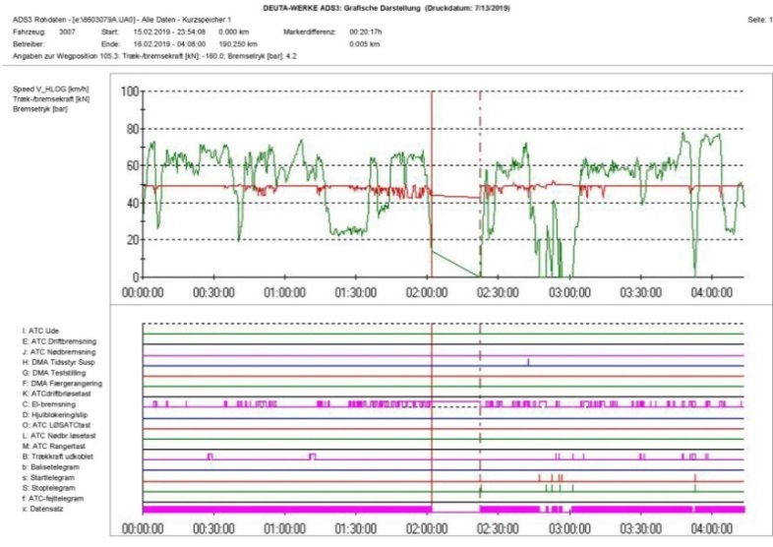
Fig. 19
Analysis of the train movement 48009 from Karlovo to Plovdiv.
The analysis is made on the basis of the information stored on the locomotive 86-003 onboard computer from its travel, which is decrypted using the software product ADS3 of the company DEUTA WERKE, whose production is the recorder itself. The locomotive device records the speed of travel, the pressure in the main air duct and the actuation of the locomotive's electrodynamic brake.
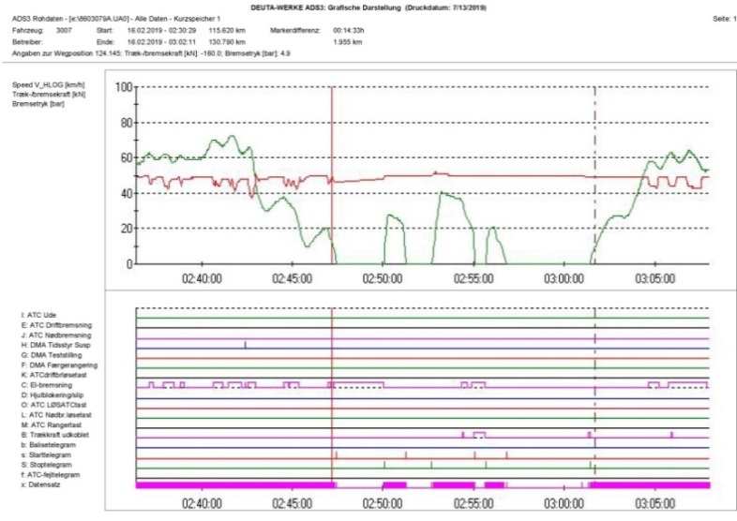
The information is stored in graphical and tabular form. The device records every second, at a speed of up to 60 km/h the step is 5 meters and at a speed of over 60 km/h, the step is 10 meters. The distance traveled is recorded according to the readings of the recorder of the locomotive. If necessary, any indication thereof may be compared with the actual position of the locomotive along with the track's mileage at any time, because the distance recorded corresponds to the actual distance traveled. The astronomical time is recorded on the clock of the locomotive and diverges from the actual one described in the station documents..
Fig. 20

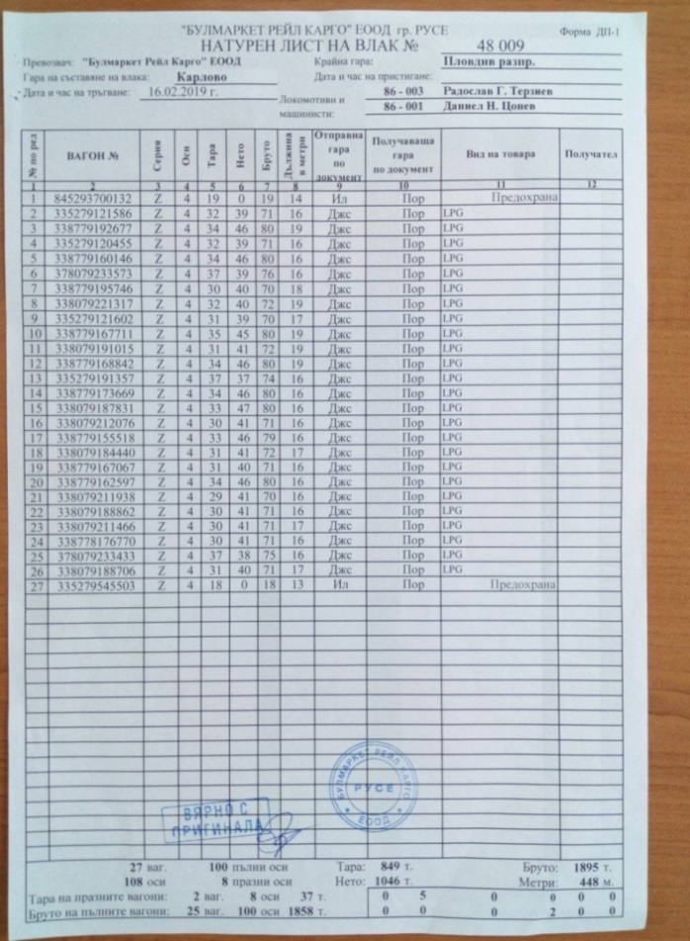
Train 48009 arrives in Karlovo at 02:41:33 hrs (Fig. 20). It stays 2 minutes and 36 seconds, during which time both locomotives disengage from the train and prepare to perform maneuvering movements to reverse the direction of movement of the train and to set themselves on the other side of the train composition. At 02:44:09 hrs, locomotives start moving at up to 28 km/h, traverse 445 meters and stop at 02:45:26 hrs. At this point, they stand for 1 minute and 24 seconds, and at 02:46:50 hrs they head in the opposite direction, in which case locomotive 86-003 leads, and locomotive 86-001 is the second, coupled to the first. After leaving, both locomotives speed up to 41 km/h, traverse 1185 meters and settle in the western throat of Karlovo at 02:49:13 hrs. They stay there for 35 seconds and at 02:49:48 hrs they move eastward to the train composition. Locomotive 86-001 leads in this movement. Both locomotives speed up to 21 km/h, they pass 245 meters and at 02:50:57 hrs they couple to the train. Locomotive 86-001 is coupled to the wagons and locomotive 86-003 is the leading one (Fig. 21). In these movements, the operating pressure in the main air duct changes from 4.9 to 5.1 bar due to the different settings of the crane drivers of both locomotives. When the main train airline is switched on, the leading locomotive 86-003 maintains a pressure of 4.9 bar. The locomotives stay for 4 minutes and 33 seconds. As can be seen from the decoding of locomotive 86-003 recorder, there is no registration for performing sample D before train departure (Fig. 20).
Fig. 21
1
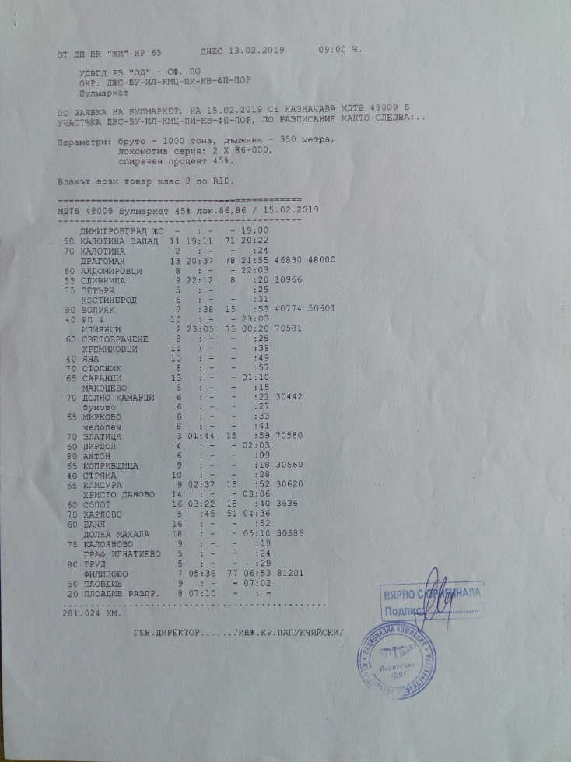
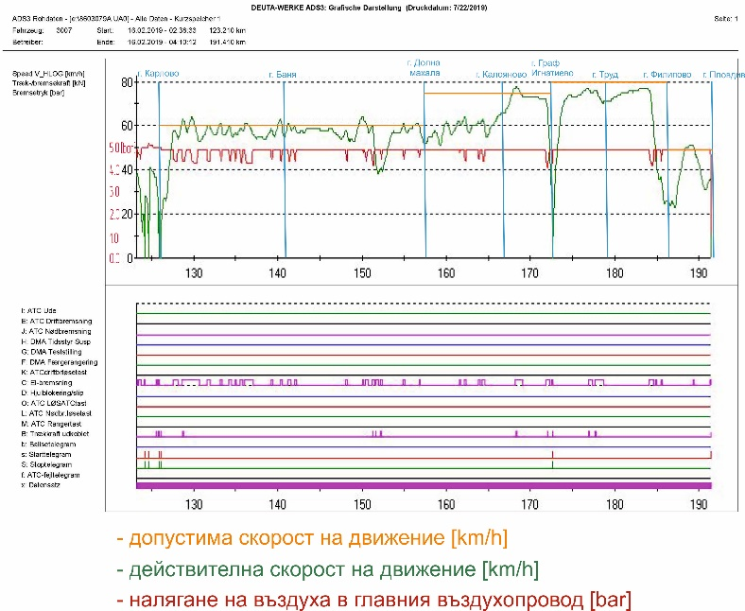
Влак Train № 48009 leaves Karlovo station at 02:55:30 hrs (Fig. 23). In the Karlovo - Banya inter-station it moves at a speed of between 54 and 64 km/h at a permissible speed of 60 km/h for the inter-station (Figs. 22 and 23). The motorman often uses the train brake to adjust the speed of the train, since the path follows a downhill. From km 128 + 535 at 02:59:51 hrs till km 128 + 915 at 03:00:13 hrs for 380 meters in 22 seconds, the speed reaches 63 km/h. The motorman holds the train brake at km 128 + 515 at 02:59:50 hrs, reducing the pressure in the main air duct to 4.3 bar. At km 129 + 070 at 03:00:23 hrs the brake is fully released and shortly thereafter the speed starts to increase. From km 129 + 495 at 03:00:49 hrs. till km 130 + 055 at 03:01:22 hrs for 560 meters in 33 seconds the speed reaches 64 km/h. The motorman applies the train brake at km 129 + 575 at 03:00:54 hrs and reduces the pressure in the main air duct initially to 4.4 and then further to 4.3 bar. The brake is fully released at km 130 + 445 at 03:01:47 hrs, i.e. the brake is applied for 280 meters for 18 seconds. From km 133 + 095 at 03:04:37 hrs. till km 133 + 165 at 03:04:41 hrs for 70 meters in 4 seconds the speed is 61 km/h. During this time the train brake is applied, the pressure in the main air duct is reduced to 4.4 bar and then the brake is loosened as a result of which the speed decreases and then starts to increase to 60 km/h. From km 136 + 100 at 03:07:48 hrs till km 136 + 320 at 03:08:01 hrs the speed is 61 km/h, during which time the motorman applies the train brake, reducing the pressure in the main air duct to 4, 3 bars, after which the speed starts to decrease. From km 140 + 030 at 03:12:01 hrs till km 140 + 430 at 03:12:25 hrs for 400 meters in 24 seconds the speed reaches 63 km/h. The motorman applies the train brake again, reducing the pressure in the main air duct to 4.4 bar, which causes the speed to start to decrease.
Fig. 22
Fig. 23
The train passes through Banya station at 03:12:40 hrs at 55 km / h.
In Banya - Dolna Mahala inter-station, the speed varies between 38 and 64 km/h with an allowance of 60 km/h for the inter-station (Figs. 22 and 23). From km 141 + 205 for 120 meters in 7 seconds at 03:13:14 hrs till km 141 + 325 at 03:13:21 hrs the speed reaches up to 61 km / h; from km 149 + 600 at 03:22:08 hrs till km 150 + 500 at 03:23:01 hrs for 900 meters in 53 seconds - up to 64 km/h. At km 149 + 980, at a speed of 64 km/h, train braking applying to 4.5 bar is observed, at which the speed starts to decrease to 63 km/h at km 150 + 140. The speed is reduced to 62 km/h, followed by a new, deeper hold - down to 4.4 bar at km 150 + 310, resulting in a speed reduction to 57 km/h. At km 154 + 820, a movement at a speed of 61 km/h with a duration of 130 meters (up to km 154 + 950) is observed, followed by a train brake. At km 156 + 480, the speed is 61 km/h and continues for 110 meters (up to km 156 + 590). At km 156 + 670, the motorman holds the train brake reducing the pressure in the main air duct to 4.5 bar and then to 4.4 bar, resulting in a speed reduction to 51 km/h. The locomotive transits Dolna Mahala station at 03:31:45 hrs at a speed of 55 km / h.
The permitted max. speed in scheduled traffic in Dolna Mahala - Kaloyanovo inter-station is 75 km/h (Figs. 22 and 23). The speed of movement from km 159 + 790 to km 160 + 160 for 370 meters in 22 seconds in Dolna Mahala - Kaloyanovo inter-station is 61 km/h. Speed is reduced by the natural resistance to train movement without motorman intervention. From km 161 + 235 to km 161 + 675 from 03:35:06 hrs till 03:35:32 hrs for 440 meters in 26 seconds the speed is 61 km/h. The motorman holds the train brake, reducing the pressure in the main air duct to 4.5 bar, which reduces the speed to 60 km/h. From km 161 + 845 at 03:35:42 hrs till km 162 + 365 at 03:36:13 hrs for 520 meters in 31 seconds, the speed is 64 km/h. The motorman holds the train brake at km 162 + 085 at 03:35:57 hrs by reducing the pressure in the main air duct to 4.4 bar at a speed of 63 km/h, as a result of which the speed starts to decrease and reaches 57 km/h, and then it starts to increase again. The speed from km 163 + 665 at 03:37:33 hrs till km 164 + 465 at 03:38:20 hrs for 800 meters in 47 seconds reaches values of 63 km/h. The motorman holds the train brake from km 163 + 745 at 03:37:38 hrs till km 164 + 025 at 03:37:54 hrs for 280 meters in 16 seconds. The speed does not decrease, that is why the motorman holds the train brake again at km 164 + 215 at 03:38:06 hrs and reduces the pressure in the main air duct to 4.4 bar. At km 164 + 475 at 03:38:21 hrs the speed is 60 km/h and continues to decrease to 55 km/h, after which it starts to increase again. At km 165 + 630 at 03:39:34 hrs it reaches 60 km/h with the brake released and from that moment it rises upwards.

At km 166 + 690 at 03:40:33 hrs the train passes Kaloyanovo station at a speed of 67 km/h. After Kaloyanovo station, the permissible speed is again 75 km/h (Figs. 22 and 23). The motorman begins to accelerate, at km 167 + 960 the actual speed is 76 km/h in 03:41:41 hrs. The speed continues to increase and at km 168 + 300 at 03:41:56 hrs it reaches a value of 78 km/h, which is maintained till km 168 + 350 at 03:41:59 hrs, after which it starts to decrease. The motorman applies the electrodynamic brake of the leading locomotive 86-003 at km 168 + 170 at 03:41:50 hrs and this continues till km 169 + 080 for 910 meters in 44 seconds, with the speed decreasing to 73 km/h.
At this speed, the train moves from km 168 + 980 to km 170 + 930 for 1950 meters in 1 minute and 37 seconds. From km 170 + 940 at 03:44:07 hrs, the speed drops to 72 km/h and continues to km 171 + 820 at 03:44:51hrs with a duration of 880 meters in 44 seconds. At km 171 + 760, the motorman holds the train brake and reduces the pressure to 4.0 bar. As a result, from km 171 + 820 at 03:44:58 hrs the speed starts to decrease. At km 172 + 210 at 03:45:14 hrs the pressure in the main air duct is raised to 4.9 bar and the train brake is fully loosened. The speed continues to decrease, albeit at a slower pace and at km 172 + 470 at 03:45:39 hrs, the motorman restrains with the train brake, reducing the pressure in the main air duct to 3.9 bar, which causes train speed decreasing to 0 km/h and at 03:46:02 hrs the train stops at km 172 + 600 at Graf Ignatievo station.
At Graf Ignatievo Station, the train stays from 03:46:02 hrs to 03:47:06 hrs (1 minute and 4 seconds) (Fig. 24).
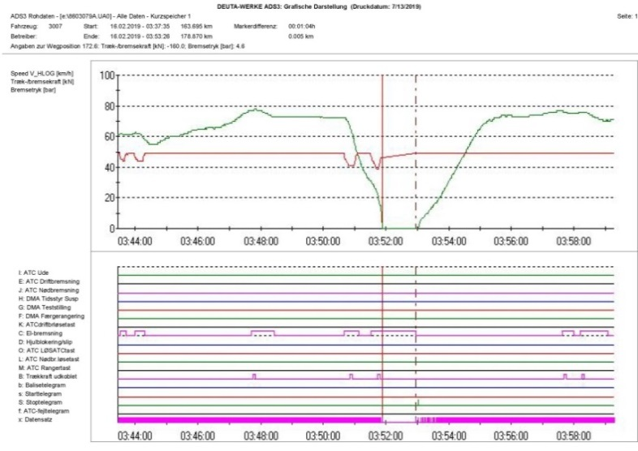
The train leaves Graf Ignatievo station at 03:47:06 hrs, accelerates and at km 174 + 440 at 03:49:49 hrs it develops a speed of 74 km/h which maintains till km 174 + 600 at 03:49:57 hrs for 160 meters in 8 seconds. At km 176 + 280 at 03:51:19 hrs the speed is 76 km/h and at km 176 + 610 at 03:51:35 hrs - 77 km/h, which is the highest speed in the inter-station. From km 176 + 890 at 03:51:48 hrs, the speed starts to decrease gradually, because from km 176 + 840 at 03:51:46 hrs till km 177 + 320 at 03:52:09 hrs for 480 meters for 23 seconds and from km 177 + 560 at 03:52:21 hrs till km 178 + 630 at 03:53:14 hrs the locomotive electrodynamic brake is used for 1070 meters in 53 seconds. The permissible speed in the Ignatievo - Trud inter-station is 80 km/h (Figs. 22 and 23).
Fig. 24
The train transits through Trude station at 03:53:16 hrs at a speed of 70 km/h and continues to Filipovo station. The max. allowed speed in Trud - Filipovo inter-station is 80 km/h (Figs. 22 and 23). The speed of train movement in this inter-station increases and at km 181 + 700 at 03:55:47 hrs it reaches a value of 76 km/h. From km 183 + 020 at 03:56:50 hrs to km 183 + 880 at 03:57:30 hrs the train reaches its maximum speed in Trud - Filipovo inter-station for 860 meters in 40 seconds. At km 184 + 020 at 03:57:37 hrs the motorman applies the train brake and reduces the pressure in the main air duct to 4.2 bar. As a result of these actions from km 184 + 090 at 03:57:40 hrs, the speed of 76 km/h begins to decrease. At km 184 + 600 at 03:58:08 hrs at 55 km/h the brake is fully loosened, but the speed is still decreasing. The motorman holds the brake again at km 184 + 730 at 03:58:17 hrs at a speed of 50 km/h, reducing the pressure in the main air duct to 4.4 and very briefly to 4.3 bar, after which the train brake is fully loosened at 184 + 925 at 03:58:33 hrs at 42 km/h. The speed continues to decrease to 35 km/h, after which it starts to gradually increase and at km 185 + 370 at 03:59:17 hrs it reaches a value of 37 km/h. The motorman applies the train brake at km 185 + 395 at 03:59:20 hrs at a speed of 37 km/h, reducing the pressure in the main air duct to 4.4 bar. At km 185 + 550 at 03:59:36 hrs at 33 km/h the motorman loosens the brake and at km 185 + 570 at 03:59:38 hrs after 20 meters and 2 seconds at 31 km/h the brake is fully loosened. The speed continues to decrease, varying between 22 and 26 km/h, thus crossing the area of Filippovo station at 04:00:57 hrs. Running in this speed range, the train passes 1400 meters in 3 minutes and 29 seconds from km 187 + 140 at 04:03:30 hrs to km 185 + 740 at 04:00:01 hrs where it starts to accelerate.
After Filippovo station, the speed of the train is increased and at km 188 + 815 at 04:06:05 it reaches 51 km/h as the allowed max. inter-station speed is 50 km/h (Figs. 22 and 23). At that speed, the train goes to km 189 + 275 at 04:06:38 hrs for 460 meters in 33 seconds. At km 189 + 285 at 04:06:39 hrs the motorman holds the train brake and reduces the pressure in the main air duct to 4.5 bar, then almost immediately performs a complete loosening and restores its pressure at km 189 + 360 at 04: 06:45 hrs. As a result of these actions, the speed of the train decreases to 50 km/h, after which it gradually continues to decrease. The train passes the warning signal at Plovdiv station (km 189 + 500) at 04:06:55 hrs at a speed of 47 km/h and the brake is loosened. The speed continues to decrease and at km 190 + 500 at 04:08:27hrs it passes the entrance signal of Plovdiv station at the speed of 32 km/h, in which case the brake is also loosened. The distance between the two signals the train takes for 1 minute and 32 seconds (Fig. 25).
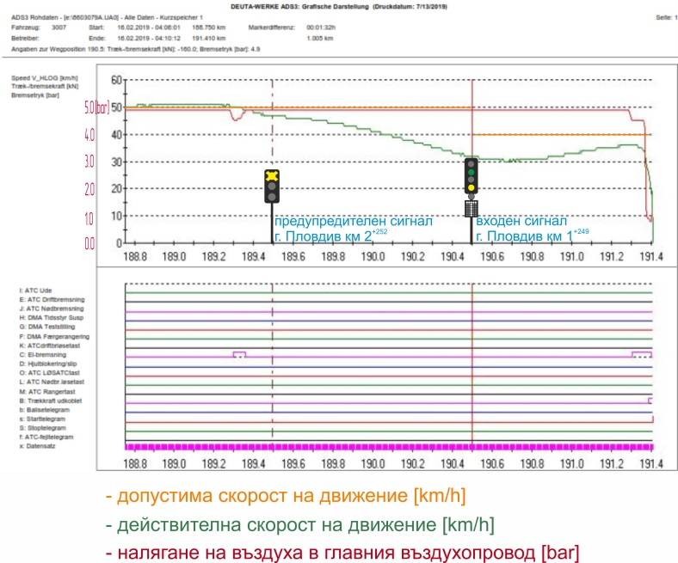
After the entrance signal, the speed continues to decrease for some time and after 50 meters reaches 30 km/h and continues to fluctuate between these values for 200 meters, after which it starts to gradually increase due to the fact that the road is slightly down ( Fig. 26). The speed increase continues till km 191 + 274 (0 + 497 from the railway mileage) at 04:09:55 hrs, where it has already reached 36 km/h and at 04:09:57 hrs at km 191 + 295 ( 0 + 476 from the railway mileage) the motorman holds a gradual hold to 4.5 bar in the main air duct (Fig. 26, item 1). The discharge of air from the main air duct takes 2 seconds, during which the train passes 15 meters and is located at 191 + 305 km (0 + 461 from the railway mileage) (Fig. 26, item 2). The speed does not change its value and continues to be 36 km/h for 30 meters to km 191 + 335 (0 + 431 from the railway mileage) at 04:10:01 hrs (Fig. 26, pos. 3), when is reduced to 35 km/h.
Fig. 25
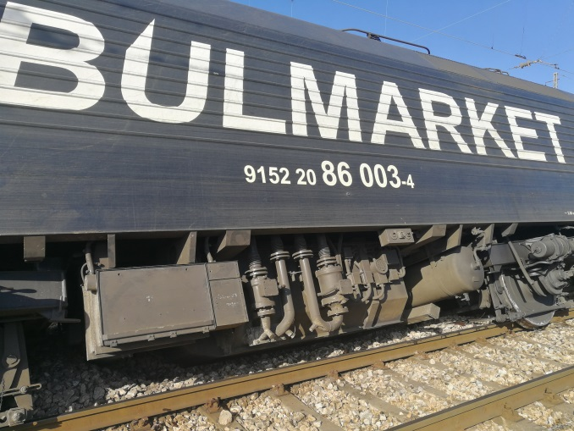
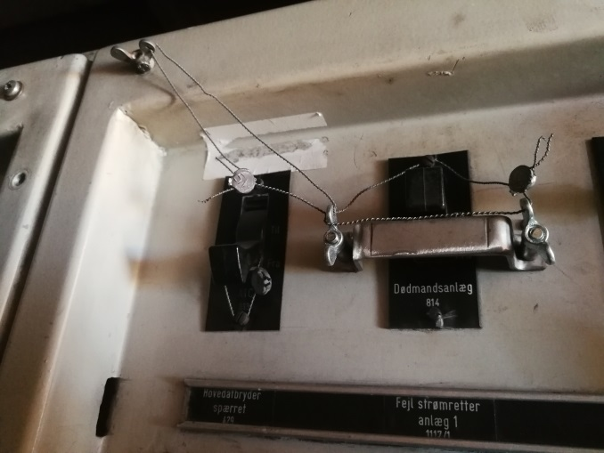
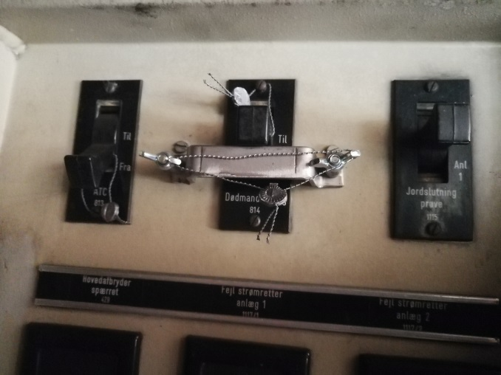
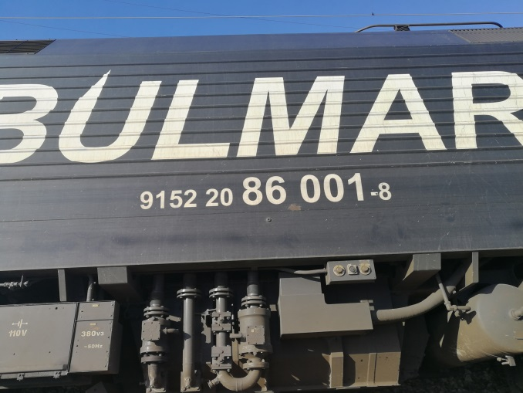
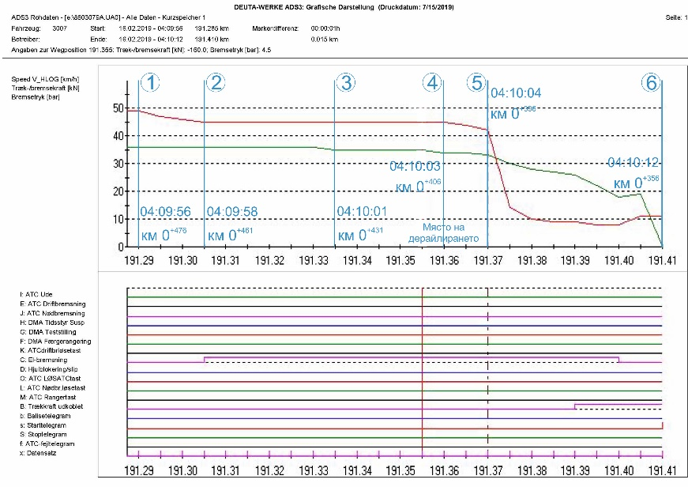
This is followed by a new speed reduction to 34 km/h, which is registered at 04:10:03 hrs when the train is at km 191 + 360 (0 + 406 from the railway mileage) and this is the moment of derailment of the first axle of the leading locomotive 86-003, at switch № 74 (Fig. 26, item 4).. At the same time, a second official restraint is carried out and the pressure in the main air duct is reduced to 4.2 bar. It seems at this point that the motorman has sensed that the locomotive has been derailing, because only after 1 second at 04:10:04 hrs at km 191 + 370 (0 + 396 from the railway mileage) he makes an emergency stop with the train brake, as in for a short time (from 04:10:05 hrs to 04:10:09hrs) the pressure in the main air duct is reduced to 0.8 bar (Fig. 25, item 5). The speed is rapidly reduced to 0 km / h and at 04:10:12 hrs the train stops at 191 + 410 (0 + 340 from the railway mileage) (Fig. 26, item 6).
Fig. 27
Fig. 28
Fig. 30
Fig. 29
Fig. 26
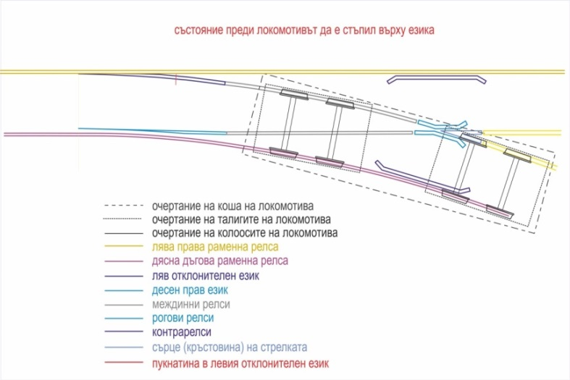
The inspection of the locomotives 86003.4 and 86001.8 at Plovdiv station shows that the vigilance devices of the locomotives have worked and with regular seals (Figs. 27, 28, 29, 30).
Fig. 31
14.2.2. Railway analysis.
In Plovdiv station, switch №74 is of type 49; deviation 1: 9; radius R = 300 m; right on wooden sleepers and propped up fish plates. There is no cant in the railway.
- Tongues - 2 pcs. - left curved one and a right one, rail elastic profile(ERP). The tongues are driven by a switch machine (COA-3) with electrical controls when locked.
- Stock rails - 2 pieces, of which a left straight stock rail and a right curved one.
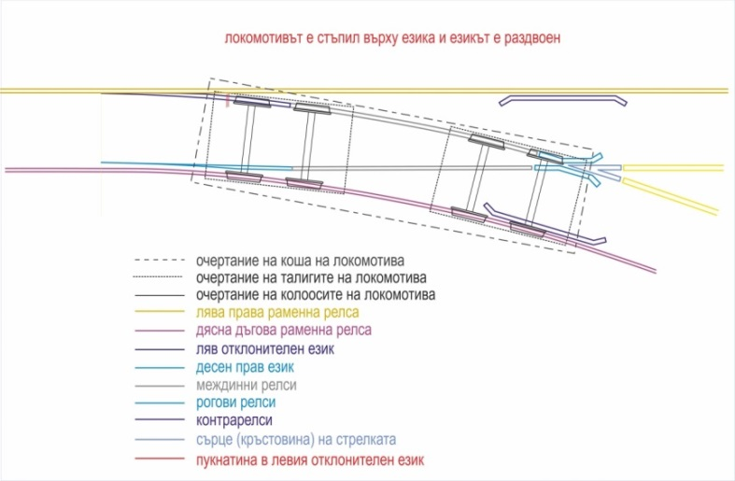
For the reception of trains and other railway vehicles in an ordered route for deviation involving switches with radiuses R = 190 m and R = 300 m, the maximum permissible speed is 40 km/h and the speed is related to the indication of the signaling (entrance and warning traffic lights). Upon entry of IDFT № 48009 in the right-hand deviation of switch № 74, with a radius of the curve R = 300 m, the break of the deflection tongue has occurred immediately in front of the leading right-hand wheel of the first locomotive. From the inside, the tongue is pressed against the rims of the wheel pair axles. When moving in curves (in the case of radius R = 300 m), the rims of the wheel pair axles are firmly adhered to the working part of the outer rail (in this case in the left deflection tongue) (Fig. 31).
Fig. 32
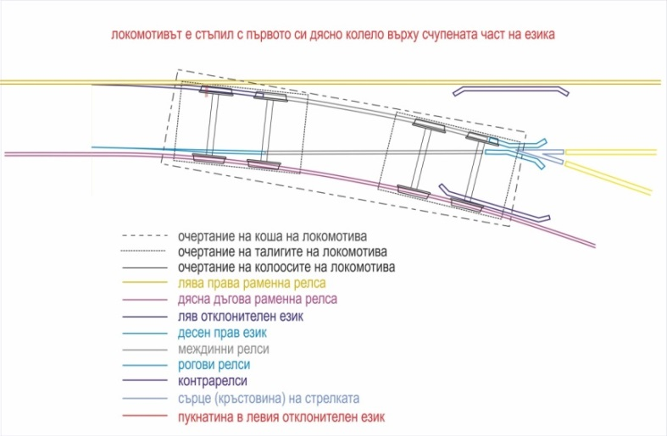
The derailment is caused by a transverse fracture of the left curved tongue, between the 13th and 14th sleepers of the tongue section, in a location immediately to the beginning of the transition from the normal rail to the tongue profile, where the shape and section of the curved tongue change. On the tongue profile, the height is smaller with the increased width and thickness of the profile step (heel). On the 13th sleeper, the last 11th slider is mounted - double and clamped to the left straight stock rail. A special pad is mounted on the 14th sleeper, which is clamped from the outside of the left stock rail with a clamping kit. On the inside, without a clamping set, to allow the tongue to slide freely, the pad is tied by railway screws to the sleepers. In front and after the point of breaking of the tongue in the elastic part of the left stock rail, 4 support wedges are mounted, which are intended to prevent in inverted diversion position(-) of the left curved tongue an excess of the admissible norms on track gauge in order to guarantee safe movement.
Fig. 33
It can be seen that the final fracture of the tongue has occurred immediately in front of the leading right wheel of the first locomotive, but the destructive deformations has begun with previously passed trains along this route (Figs. 32 and 33).
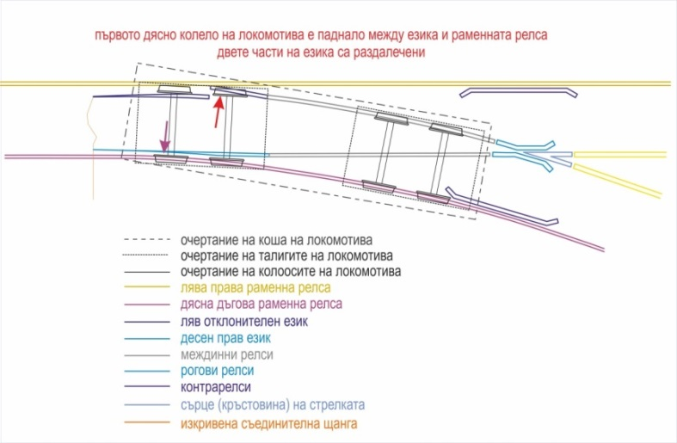
The break point is located between the 13th and 14th sleepers of the tongue section, where the spacing between props is 68 cm, and the same between the 14th and 15th sleepers is 53 cm. This has occurred after the collapse of the derailed right wheels between 13th and 14th sleepers. After the breaking of the tongue, two parts are formed. The first part has a length of 5.33 m, which is in the rail profile and is stationary since on the outside it tightly adheres to two pieces of support wedges, mounted on the left straight stock rail and to the ribs of the mounted special washers on the 15th. and the 18th sleepers. On the inside, the tongue is pressed against the rims of the wheel pair axels. When traveling in curves (in the case of radius R = 300 m), the rims of the wheels firmly adhere to the working part of the outer rail (in this case, the outer left curved tongue). The second part is 7.42 m long and is entirely in the tongue profile, with its outer non-working side restricted and tightly adhered to the support wedges. With a cross-section of less than 50 mm to the tip of the tongue, when in the inverted position, it rests on the left stock rail and there is no restriction to allow it to move freely between (+) and (-) positions.
Fig. 34
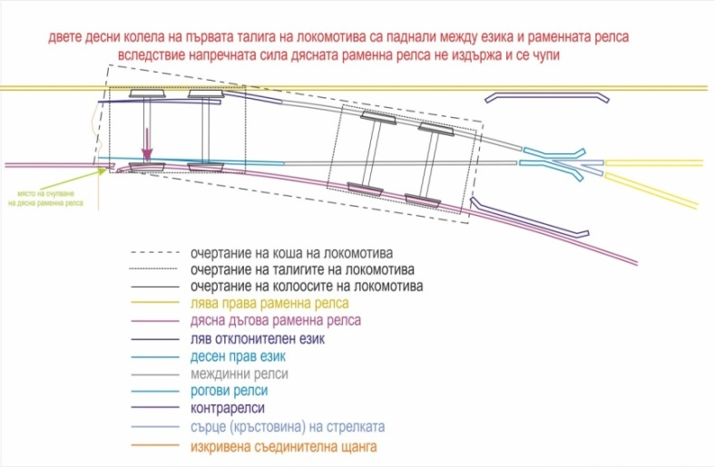
After a vertical fracture of the tongue along its full cross-section, a horizontal discrepancy between the first and the second part by about 70 ÷ 80 mm has been instantly obtained. This has resulted in an impact of the right wheel flange in the head of the second part of the tongue. Evidence of this is the visible trace of the impact of a flange approximately 20 ÷ 25 mm wide and about 25 ÷ 30 mm high in its right inoperative part. Driven by the centrifugal force (in a curve with R = 300 m, without cant), the wheel slides between the non-working side of the second part and the left straight stock rail (Fig. 34). As the width of the bandage is 140 mm, it further displaces the second part to the axis of the deflection track. It is now considered that the integrity of the track is interrupted and this allows the other 17 wheels to derail at the same place without contacting the already remote second part of the tongue. If the horizontal misalignment of the second to the first part is less than 70 mm, then the rim of the first right wheel would ascend over the head of the tongue, leaving a trace of the rim on the railhead. The rule is that the slower the speed, the longer the track and vice versa. After the collapse of the right wheels, the left ones move normally on the right stock rail for about 6 m at a value between both stock rails about 1530 mm, due to the following fact (Fig. 35):
Fig. 35

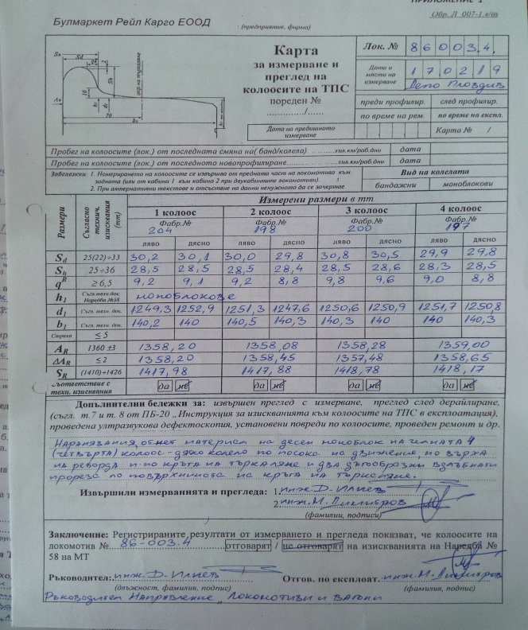
Fig. 36

- The value is 32 mm + 1358 mm + 140 mm = 1530 mm, as:
- 32 mm is the thickness of the rim of the left wheel of the first wheel pair axle, standing on the right stock rail;
- 1358 mm is the measured distance between the inner wheel surfaces;
- 140 mm is the width of the right guide wheel (Fig. 36).
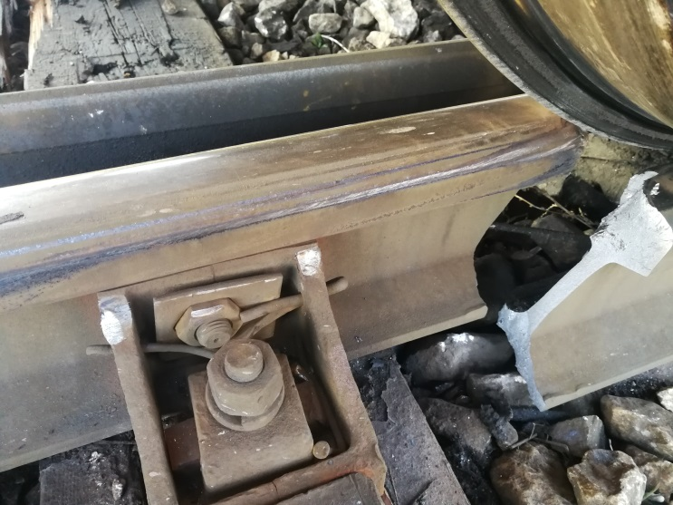
Due to the decreasing distance between both stock rails at a value of about 1498 mm, the left wheel of the first wheel pair axle (WPA) exerts a strong horizontal pressure and therefore breaks the right stock rail at 2.93 m from its beginning. As a result of the fracture of the right stock rail, the left wheel passes through the broken compartment, slides left on the stock rail and begins to move on the sleeper grid (Fig. 37).
Fig. 37
The subsequent breakage of the stock rail is followed by the passage of the other 17 wheels, which are left to the right stock rail in the direction of movement of the train and further away from it (Fig. 38).
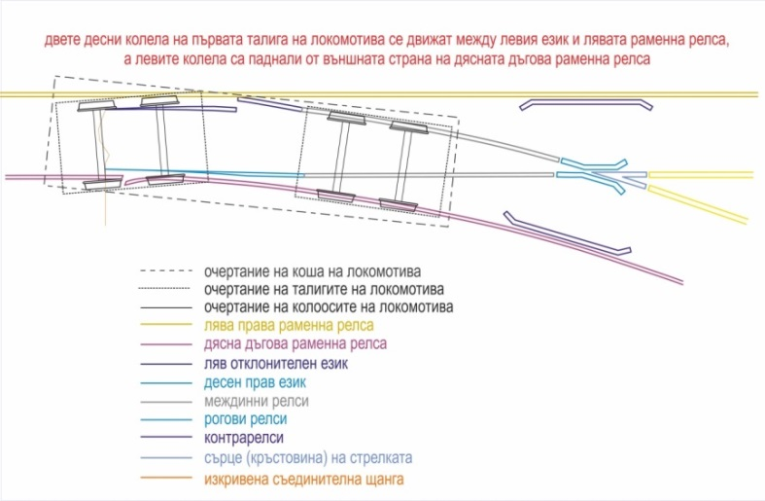
The characteristics of the railway, regarding its technical condition and control, exercised, were prepared on the basis of the documentation provided by the Plovdiv Railway Section and personal findings from the measurements and in situ inspections. The break of the tongue has occurred in the transition of changing the profile from tongue to rail. The site is located between the 13th sleeper, on which a double tongue slider is mounted, and the 14th sleeper, with a special pad, mounted on it in the elastic part of the tongue.
Fig. 38
The necessary inspections have been carried out at the facilities in Plovdiv station, for which there are relevant protocols, namely:
From the visual inspection of the lead part of switch № 74 in the range of 20 m in front of and at the place of derailment and 5.33 m of the tongue part, the following is found:
- The ballast prism is in a relatively good condition. There is no hardened ballast prism leading to large concealed collapses;
- The following irregularities are identified with respect to the sleepers grid in the lead part of the switch:
(a) at the 6th sleeper on the outer curved rail lacks one rail screw and two other miss on either side of the inner curved rail.
(b) on the 7th and 11th sleepers, there are four rail screws missing, two on each side of the inner curved rail.
(c) on the 12th and 13th sleepers, there is an incision of the metal pads in the wood of the sleepers up to 10 mm along the outer and inner curved rails, which is within the limits.
d) no missing rail brace is found with respect to the clamping kits.
e) the condition of the sleeper grid is relatively good.
f) there is no narrowing of the gauge, which to lead to severe lateral bending and breaking of the tongue.
The irregularities found have not been an obstacle to the safe passage of trains so far and have no connection with the fracture of the left curved tongue at the location of the fracture.
The ascertaining protocol for the condition of the railway does not contain data on measurements of vertical and horizontal actuation of the tongue in the fracture area (a full rail profile), as well as a measured flash 20 m before the location of the fracture of the tongue. The protocol states that no defectoscopy performs for the switches in the tongue profile. From the measurement data on the condition of the railway in terms of level and gauge it can be seen that the railway meets the technical requirements for speeds up to 40 km/h.
The visual inspection of the tongue and the outer lead curved rail clearly shows that there is no actuation of the same, and there are no visible deviations along the axis in the deflection track.

14.2.3. Expert opinion of elements of switch № 74 in Plovdiv station
The expert opinion is prepared by the Institute of Metal Science, Facilities and Technologies with a Center in Hydro and Aerodynamics "Acad. Angel Balevski "- BAS based on the study of materials seized from the accident and submitted to IMSFTCHA-BAS from the National Investigation Service:
Object № 1 - 35 cm - part of the left curved tongue profile (Fig. 39);
Object № 2 - 25 cm - part of the left curved tongue profile (Fig. 39);
Object № 3 - 25 cm - part of the right curved stock rail (Fig. 40);
Object № 4 - 15 cm - part of the right curved stock rail (Fig. 40);
Object № 5 - 11 cm - part of a piece of the heel of the left straight stock rail (Fig. 41).
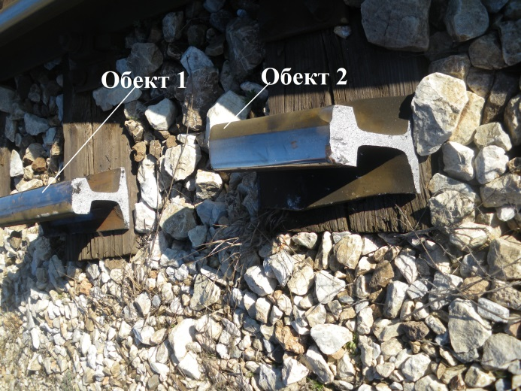 | 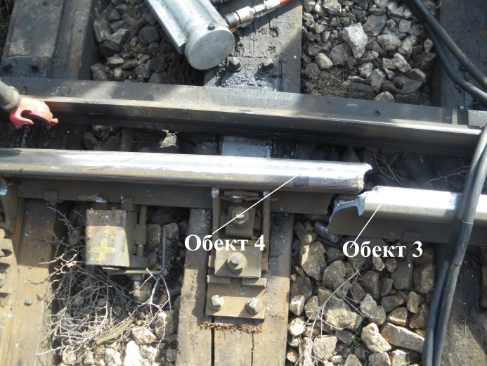
Fig. 39 Objects № 1 and № 2 ( left curved tongue profile ) | Fig. 40 Objects № 3 and № 4 ( right curved stock rail )
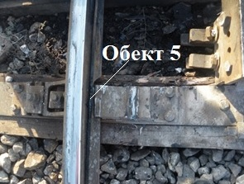 | 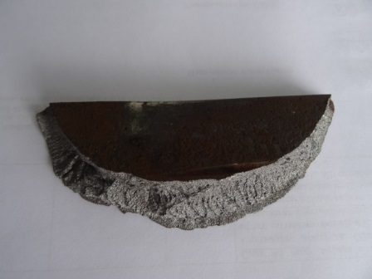
a. Location of object № 5 | b. General view of object № 5
Fig. 41 Object № 5 - part of a piece of the heel of the left straight stock rail

Fig. 42 Location of the studied objects
The chemical composition of steel of objects № 2, № 3 and № 5 is researched by the method of optical emission spectrometry. The results obtained are presented in Table 1. Data on the chemical composition of R260 and R350HT rail steels according to RINC TS-RR 023-2011 Technical Specification Railway Rail are also presented in the table.

Table 1
 | Chemical composition [% by mass]
 | C | Si | Mn | P | S | Cr | Al | V | N
Object №2 | 0,690+0,064 | 0,287+0,018 | 1,05+0,05 | 0,015+0,003 | 0,019+0,006 | ˂0,499  (0,04) | - | - | -
Object №3 | 0,703+0,063 | 0,439+0,018 | 1,18+0,05 | 0,016+0,003 | 0,017+0,007 | ˂0,499  (0,07) | - | - | -
Object №5 | 0,757+0,064 | 0,247+0,017 | 0,89+0,03 | 0,016+0,003 | 0,025+0,006 | ˂0,499  (0,07) | - | - | -
R260 | 0,60/0,82 | 0,13/0,60 | 0,65/1,25 | 0,030  max | - | 0,15 max | 0,004 max | 0,030 max | 0,010
R350HT | 0,70/0,82 | 0,13/0,60 | 0,65/1,25 | 0,025  max | - | 0,15 max | 0,004 max | 0,030 max | 0,010
From the obtained results it can be claimed that taking into account the uncertainty of the measurement result, the chemical composition of the metal of object № 2 (part of the left curved tongue profile), object № 3 (part of the right curved stock rail) and object № 5 (part of the heel of the left straight stock rail) meet the requirements for the chemical composition of rail steels, in accordance with technical specification TS-RR 023-2011 of RINC.
The microstructure of the steel of objects № 2, № 3 and № 5 is determined by the light microscopy (LM) method. The survey is carried out near the upper working surface of the objects. The microstructure of the steel of object № 2 (part of the left curved tongue profile) is found to be 100% perlite - ball 6, with a distance of 1 μm between the plates.
The microstructure of the steel of object № 3, part of the right curved stock rail, is perlite-ferrite, as the structural constituents of perlite (P) and ferrite (F) being in the ratio of 95% P: 5% F. The perlite is small - sorbitollike, with a distance of 0.2 μm between the plates.
The microstructure of steel of object № 5, a small part of the heel of the left straight stock rail, is perlite-ferrite with a structural ratio of 95% P: 5% F. Perlite is a ball 6 - mid-plate, with a distance of 1 μm between the plates..
The observed amount of non-metallic inclusions and oxides in the metal is negligible. In objects № 2 and № 3 it is less than in object №5.
RINC TS-RR 023-2011 does not specify requirements for the microstructure of the rail steel. However, in item 9.1.4.2 of BSS EN 13674-1: 2011, referenced by TS-RR 023-2011, it is stated that the rail steel must be "fully perlitic" without martensite, bainite or cementite at the borders.
The microstructure of the steel of object № 2 (part of the left curved tongue profile) - complies with the requirements of TS-RR 023-2011.
The microstructure of steels № 3 (part of the right curved stock rail) and № 5 (a small part of the heel of the left straight stock rail) is slightly different from the requirements due to the presence of 5% ferrite.
Mechanical/strength characteristics of the metal of the studied objects.
The strength characteristics of the steel have been tested after the creating of test pieces from objects № 2 and № 3, in accordance with the requirement of BSS EN ISO 6892-1: 2018, to which LIMC is accredited. In item 9.1.9.2 of BSS EN 13674-1: 2011, which is referenced by RINC TS-RR 023-2011, there is an additional requirement - the tensile test must be carried out after heating the test specimens for 6 hours at a temperature of 200 C. Due to the lack of sufficient material from objects № 2 and № 3, test pieces for conducting the tensile test after heating are made from objects № 1 and № 4.
The strength characteristics of object № 5 are not studied because of the shape and its limited size thus making it impossible to produce test pieces.
The data obtained after the mechanical tests are presented in Table 2. The same table also shows the mechanical parameters of R260 and R350HT rail steels, according to RINC TS-RR 023-2011 Technical Specification.
Table 2
Studied samles | Conditioned yield limit [MPa] | Tensile strength Rm  [MPa] | Relative total elongation  [%]
Object №1 (annealed) | 595,53+54,94 | 963,29 + 98,80 | 11,07 + 5,35
Object №2 (not annealed) | 530,40 + 69,65 | 922,15 + 93,04 | 9,50 + 1,22
Object №3 (not annealed) | 824,39 + 76,53 | 1244,00 + 128,82 | 11,63 + 2,47
Object №4 (annealed) | 811,31 + 91,24 | 1214,77 + 134,64 | 11,33 + 2,15
Object №5 | --- | --- | ---
R260 | --- | min 880 | min 10
R350HT | --- | min 1175 | min 9

Brinell Hardness is tested for objects № 2, № 3 and № 5. The data obtained after the measurements are presented in Table 3. The same table also shows the Brinell hardness values of R260 and R350HT rail steels according to the "Railway Rails" Technical Specification TS-RR 023-2011 of RINC.
Table 3
 | Object 2 | Object 3 | Object 5 | Steel  R260 | Steel R350HT
Brinell Hardness [HBW] | 280,67+10,33 | 357,20+14,16 | 300,33+46,34 | 260-300 | 350-390
According to the values of the Brinell hardness characteristics, objects № 2 (part of the left curved tongue profile) and № 5 (part of the heel piece of the left straight stock rail) correspond to steel R260, and object № 3 (part of the right curved stock rail) corresponds to steel R350HT.
Fractographic studies are performed by observation with a light stereomicroscope (LM) and scanning electron microscope (SEM) on the destroyed surfaces of object № 1 (Fig. 45), object № 2 (Figure 46), object № 3 (Figure 47), and object № 5 (Fig. 41b). No micrographs of object № 4 are taken due to the big unevenness of the destroyed surface.
The conclusions drawn for object №3 are also valid for object № 4, since they are both mirror images of the same destroyed surface.
The destruction of the tongue profile between objects №1 and № 2 occurred at a location immediately prior to the transition from the normal rail profile to the tongue profile, where the shape and bearing cross-section of the rail change (Fig. 48). In a preliminary exterior inspection, it was found that on the upper surfaces of the heads of objects № 1 and № 2 there are sores (traces of mechanical impact) at the site of destruction and the edges are bent inwards (Fig. 43). It is noteworthy that the sored section in object № 1 is located near the longitudinal axis of the tongue and has no traces of corrosion on it, and the sored portion of object № 2 is located in an area farther from the axis and is corroded.
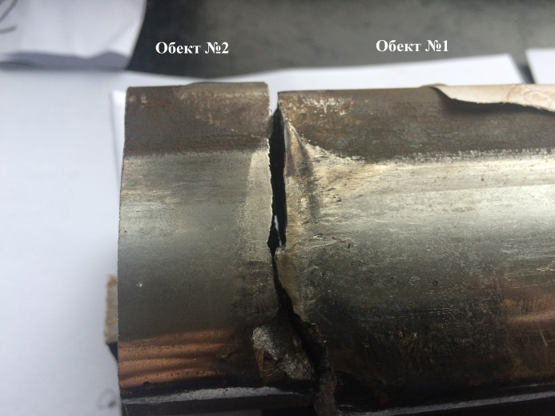 | 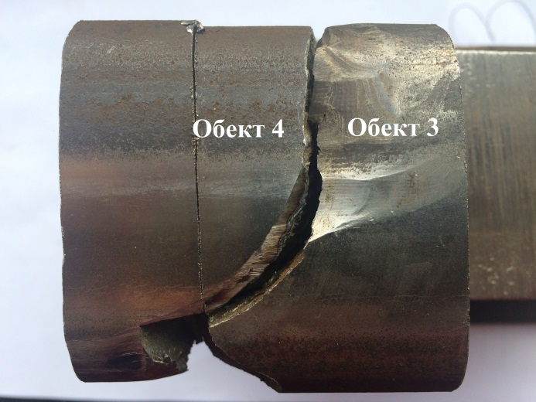
Fig. 43. Object № 1 and № 2 | Fig. 44. Object № 3 and № 4
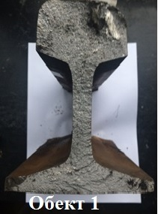 | 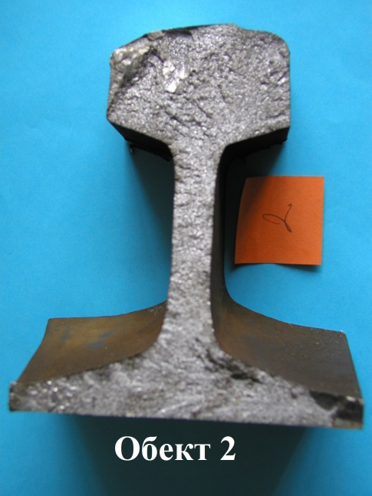 | 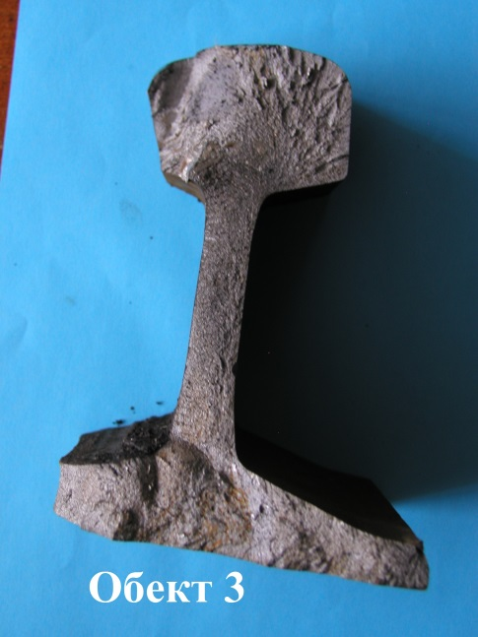
Fig. 45. General view of the destroyed surface of object № 1 - part of the left curved tongue profile . | Fig. 46. General view of the destroyed surface of object № 2 - part of the left curved tongue profile . | Fig. 47. General view of the destroyed surface of object № 3 - part of the right curved stock rail .
On the working surface of the railhead in object № 3, a significantly wider area with dents and more pronounced deformation traces is observed, located towards the inside of the railroad (Fig. 44). It is noteworthy that such an area is missing from the neighboring object № 4.
The destroyed surfaces of all the studied objects are bright gray, uneven, with rough relief and are typical of the cases in which the destruction occurs by a brittle mechanism. Ridges are observed on them, this term is used in fractography to refer to the lines of tearing of the material in the spread of cracks oriented in several different directions. The site of convergence of the ridges is usually considered to be the place where the destruction begins.
On the destroyed surfaces of objects № 1 and № 2, near the upper surface of the profile heel, a darker, smoother zone of fatigue fracture is clearly visible (Figs. 45, 46 and 50). A zone of fatigue fracture, but of a much smaller size, is also observed up to the upper surface of the heel of object № 3 (Figs. 47 and 51).
On the surface of the fatigue break up of objects № 1 and № 2, dark (brown) corrosion products are deposited. This indicates that this break up has occurred and existed long enough before the final destruction of the rail by a brittle mechanism.
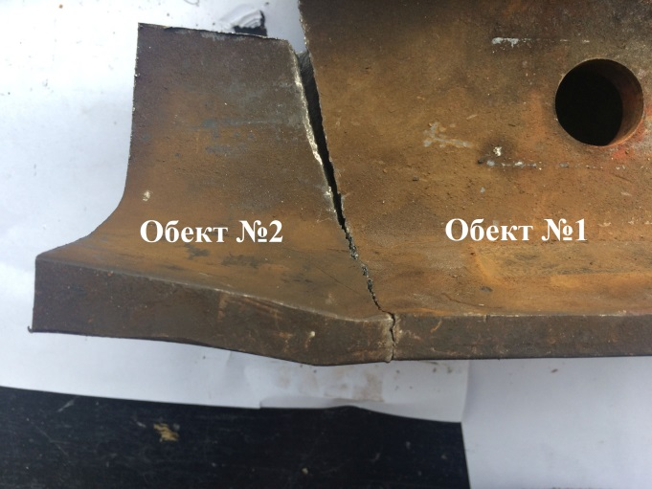 | 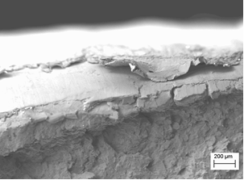
Fig. 48. Objects № 1 and № 2, transition from normal rail to special tongue profile. Place of destruction.. | Fig. 49. Object № 3, rail head  Destroyed surface adjacent to the upper surface, SEM
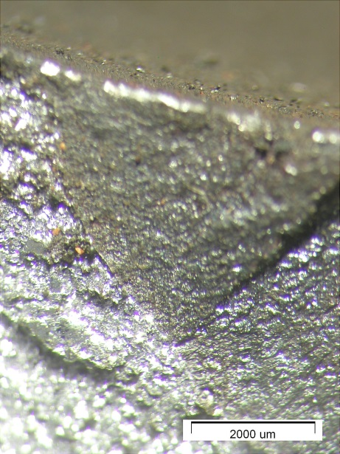 | 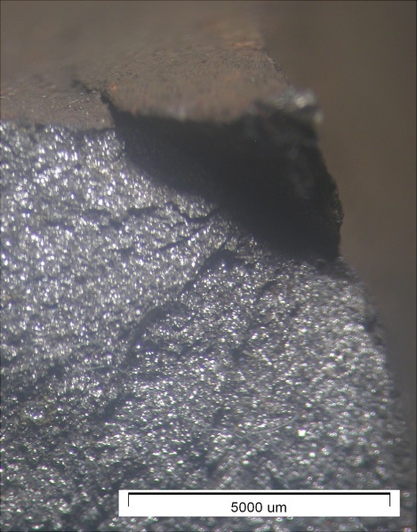
Fig. 50. Object №2, heel of the tongue. Dark fatigue zone and transition from fatigue to britle destruction, LM | Fig. 51. Object №3, heel of the tongue. Dark fatigue zone. LМ

On the destroyed surface of objects № 1 and № 2, there is a convergence of detachment ridges to two zones:
a) to the rail heel, close to the fatigue destruction zone (Figs. 45 and 52) and b) to the transition zone from the head to the neck of the rail (Fig. 46). On the destroyed surface of object № 3 (Fig. 47), ridges are observed in the railhead, as their center of convergence located near the head-neck transition.
The relatively small size of the fatigue destruction zone and the weak relief of the tear ridges in the heels of objects № 1 and № 2 give us reason to believe that the fatigue crack zone is not the main source of the highway crack that has led to the extreme destruction of the left curved tongue profile.
The other found centre for the origin of the cracks that have led to the extreme brittle destruction of objects № 1-№2 and № 3-№4 is the head-neck transition zone.
In the fractographic study of object № 5, it is found that the destruction of the piece of the heel of the left straight stock rail has happened on a brittle mechanism. The destroyed surface is gray-shiny, no fatigue elements are observed (Fig. 53).
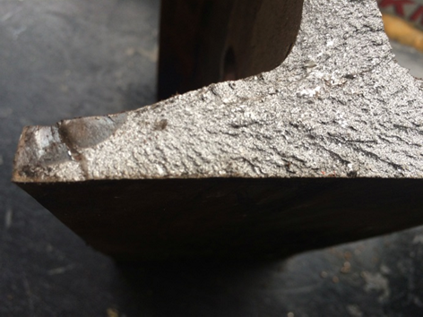 | 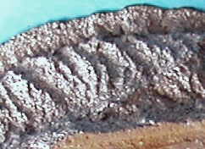
Fig. 52. Object № 1. A convergence of the ridges from the zone of brittle destruction to the fatigue zone in the heel of the rail. LM | Fig. 53. Object № 5 - general view of the destruction zone. LM
Upon item 1 and item 2 of Decree № 24 /February 19, 2019, of NIS:
Following the tests and analysis of the results, the following conclusions can be drawn as to the conformity of the material of the studied objects with the requirements of RINC "Railway Rails" Technical Specification:
Table 4
 | Conformity of the metal of the studied objects with the following steel brands, according to TS-RR 023-2011:
 | Chemical composition | Steel micro structure | Tensile strength | Relative elongation | Трърдост по Бринел
Left curved tongue profile | R260 | R260  R350HT | R260 | R260  R350HT | R260
Right curved stock rail | R260 | R260  R350HT | R260  R350HT | R260  R350HT | R350HT
Left straight stock rail | R260  R350HT | R260  R350HT | --- | --- | R260  R350HT

Upon item 3 of Decree № 24/February 19,2019, of NIS:
What is the degree of wear of the material from which the physical evidence submitted for examination is made?
No visual deterioration is observed during the visual inspection of the studied objects.
IMSTCHA-BAS does not have the necessary technical means to measure the degree of wear.

Upon item 4 of Decree № 24/February 19,2019, of NIS:
What is the degree of aging of the material from which the material evidence submitted for study is made?
No signs of aging are detected in the microstructure of the metal by light microscopy. The established conformity of the mechanical properties of the material with the requirements of TS-RR 023-2011 is an indicator of the absence of such aging.

Upon item 5 of Decree № 24/February 19,2019, of NIS:
What is the reason for breaking the switch tongue between object № 1 and object № 2, and between object №3 and object №4?
The destruction of the tongue profile between objects № 1 and № 2 has occurred in a location immediately prior to the transition from the normal rail to the tongue profile, so that the reduced bearing cross-section and the change of the shape of the tongue profile in this zone and instantaneous overload during the operation of the railway has created prerequisites for the accident.
The breakage of the rail between objects № 3 and № 4 is most likely to have occurred after the breakage between objects № 1 and № 2 and is a direct consequence of the breakage of the tongue profile.
Based on the studies done, it can be concluded that the relatively small fatigue zone observed in the area of the heel of objects № 1 and № 2, as well as the insignificant one present in the same area of objects № 3 and № 4, cannot be the leading cause of the fragile destruction of the left curved tongue profile and the right curved stock rail. Destruction in the area of fatigue cracks probably has occurred later, when the spread of the primary fragile cracks has led to a significant reduction in the profile cross section.

Upon item 6 of Decree № 24/February 19,2019, of NIS:
What forces and stress have acted on the tongue of the switch and stock rail in order to break them?
IMSTCHA does not have the experts and the established methods to carry out the necessary research and answer the question posed.

Upon item 7 of Decree № 24/February 19,2019, of NIS:
Could the cause of the breakage be determined in a timely and adequate examination of the railway and switch №74?
IMSTCHA does not have the experts and the established methods to carry out the necessary research and answer the question posed.

Upon item 8 of Decree № 24/February 19,2019, of NIS:
Could the breakage be prevented?
IMSTCHA does not have the experts and the established methods to carry out the necessary research and answer the question posed.

14.2.4. Circumstances preceding the accident..
Fig. 55
Fig. 54
The MTITC Investigation Commission requested from the RINC a piece of information from the timetable for trains passing on the same route on February 15/16, 2019 in the interval 19:00 to 07:00 hrs. The Commission finds that prior to the derailment of IDFT № 48009, two freight trains have passed the same route in Plovdiv Station at 00:09 hrs № 30620 with a mass of 2466 tonnes and at 00:33 hrs № 30585 with a mass of 756 tonnes. The locomotive crews of both passed trains have not felt and signaled irregularities on the railway. After their passing, there is no indication on the control panel at the duty head of traffic for violation of the integrity of the railway and failure of the signaling. The destruction of the left curved tongue probably has begun with the earlier passage of both trains. When passing freight train № 48009 at 04:15 hrs on the same ordered and locked route, it has traveled at a speed of 40 km/h, at which speed the final breakage of the left deflection tongue and derailment of the train has occurred. Upon train's entering Plovdiv station, they observe the permit readings of the warning traffic light pursuant to Art. 317, item 3 and art. 318 of Ordinance № 58 (Fig. 54) and the entrance traffic light according to Art. 324, para. 4, item 6 and art. 325, item 2 of Ordinance № 58, limiting the speed to 40 km/h (Fig. 55).
14.3. Conclusions.
14.3.1. Immediate and major causes of the accident, additional factors related to the technical condition of rolling stock and railway.
Immediate cause of the accident.
The breakage of the tongue is the main reason that has led to the derailment of both locomotives and the three wagons, as the breakage has originated in the transition from the rail to the tongue profile, at 7.42 meters from the tip of the tongue.
The main factors that can cause tongue breakage are as follows:
1. Lateral and vertical actuation, as well as corrosion thereof, which leads to a decrease in its cross-section, and consequently to a decrease in its inertial and resistance moment and increased stresses from the rolling stock passing;
2. Tightening of the gauge, which creates conditions for the wheels engaging, tongue bending and subsequently breakage;
3. The presence of clusters of inconvenient sleepers in combination with a hardened ballast prism with large concealed collapses;
4. Sharp unilateral and chess collapses and axial deviations leading to additional loading;
5. Wavy wear of the tongue at the point of breakage due to crushing and slipping on it.
The inspection finds that there are no irregularities in the five points listed.
The combination of a fatiguing crack in the heel area with a center for the spread of cracks in the head-neck transition zone has led to extreme brittle destruction at the site of the tongue fracture.
14.3.2. Hidden concomitant reasons related to procedures and maintenance.
In the approved schedule for Plovdiv railway section for 2018, switch № 74 is not planned for non-destructive testing. In connection with the requirements of the approved "Railway Switch Certification Rules" / July 01, 2009, of RINC, the switch elements are subjected to ultrasonic non-destructive testing annually.
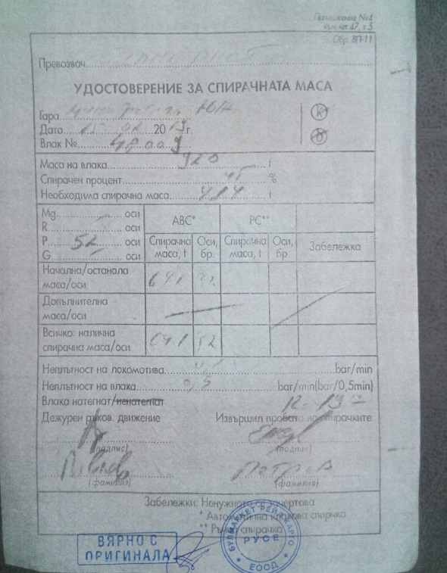
14.4. Other conclusions and observations relating to failures, deficiencies and regulatory breaches found during the investigation but irrespective of the causes.
Fig. 56
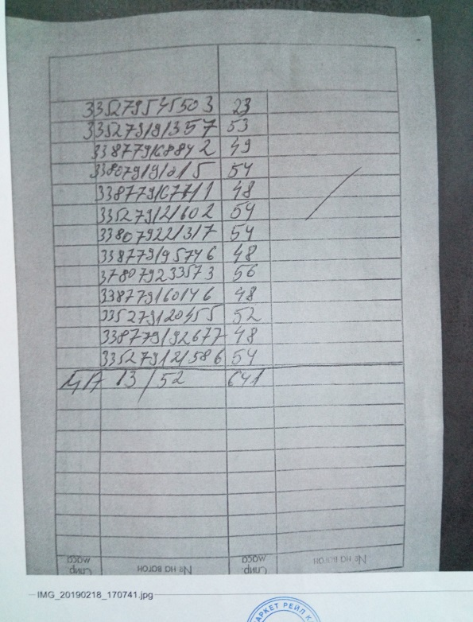
Prior to the departure of train № 48009 from Dimitrovgrad ZS station on February 15, 2019, sample A is carried out and a Brake Mass Certificate is issued (Figs. 56 and 57) to it. When comparing the Wagon List (Fig. 58) to the Certificate of Brake Mass (Fig. 56), it is clear that the arrangement of the wagons in the Wagon List (Fig. 58) differs from that in the Certificate of Brake Mass (Fig. 56). The arrangement of the wagons in the Brake Mass Certificate is done arbitrarily and does not reflect the actual arrangement of the wagons in the train composition. Only two of the wagons have their matching locations in both documents (green in Table 5). In addition, it can be seen that the Certificate for the brake mass contains a wagon that is not marked on the Wagon List (yellow in Table 5, right column). At the same time, the prevention wagon noted in the Wagon List does not exist in the Certificate of Brake Mass (red in Table 5, left column).
Fig. 57
Table 5
№ in the train composition | List of wagons in WAGON LIST | List of wagons from the BRAKE MASS CERTIFICATE
1 | 88536656505-3 | 33527954550-3
2 | 33807922131-7 | 33527919135-7
3 | 33807919101-5 | 33877916884-2
4 | 33877916884-2 | 33807919101-5
5 | 33527919135-7 | 33877916771-1
6 | 33527912158-6 | 33527912160-2
7 | 33877916014-6 | 33807922131-7
8 | 37807923357-3 | 33877919574-6
9 | 33877919574-6 | 37807923357-3
10 | 33527912160-2 | 33877916014-6
11 | 33527912045-5 | 33527912045-5
12 | 33877919267-7 | 33877919267-7
13 | 33877916771-1 | 33527912158-6
Prior to the departure of train № 48009 from Iliyantsi station, due to changes in the composition of the train, sample A is carried out and a Brake Mass Certificate is issued (Figs. 59 and 60). There are many mistakes in it, incompleteness and inaccuracies:
- The numbers of the wagons are written with the last 8 digits, not with 12, as noted in Art. 23, para. 3 of Safety Procedure SP-77 - "Instructions for performing brake tests and providing trains with brake mass";
Fig. 58
- The number of wagons in the composition is 27 with 108 axles in the Wagon List and 26 wagons with 104 axles are noted in the certificate of brake mass (Fig. 59, Pos. 1, 2, 3 and Fig. 60, Pos. 1, Fig. 61, pos.1);
- There is an illegible number on the back of the brake mass certificate (Fig. 60, pos.2)
- The required brake mass is incorrectly calculated - it is enrolled a bigger one than the actual mass;
- The available brake mass is calculated incorrectly - it is enrolled a bigger one than the actual mass (1279 tonnes are recorded, the actual mass is 1258 tonnes);
- The number of axles of the braking systems in operation and on is incorrectly enrolled (Fig. 59, Positions 1, 2 and 3);
- The type of friction devices of the braking systems is not noted (Fig. 59);
- The arrangement of the wagons in the brake mass certificate does not correspond to their arrangement in the Wagon List (Fig. 60, Fig. 61, Table 6) - the yellow marked wagons in Table 6 appear in the relevant document but not in the other one, and the blue number in the brake mass certificate is repeated in the same document.);

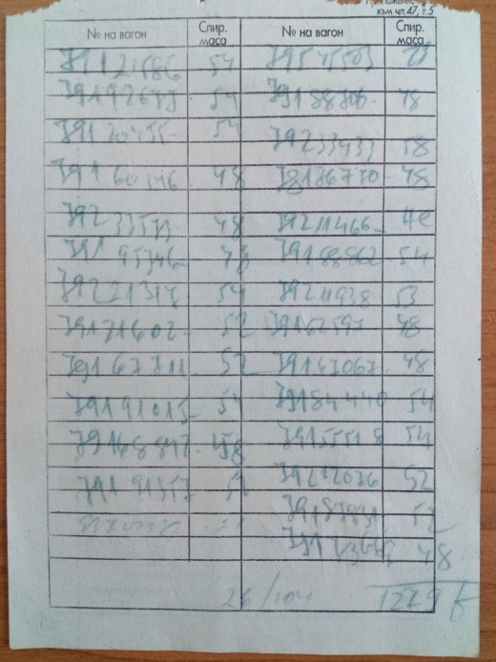
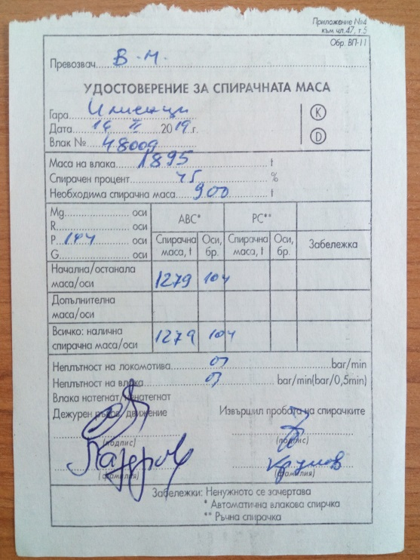
Fig. 60
1
2
Fig. 59
2
3
1

Table 6
№ in the train composition | List of wagons in WAGON LIST | List of wagons from the BRAKE MASS CERTIFICATE
1 | 33527954550-3 | 7912158-6
2 | 33807918870-6 | 7919268-8
3 | 37807923343-3 | 7912045-5
4 | 33807817677-0 | 7916014-6
5 | 33807921146-6 | 7923357-3
6 | 33807918886-2 | 7919574-6
7 | 33807921193-8 | 7922131-7
8 | 33877916259-7 | 7912160-2
9 | 33877916706-7 | 7916771-1
10 | 33807918444-0 | 7919101-5
11 | 33877915551-8 | 7916884-2
12 | 33807921207-6 | 7919131-7
13 | 33807918783-1 | 7954550-3
14 | 33877917366-9 | 7918870-6
15 | 33527919135-7 | 7923343-3
16 | 33877916884-2 | 7818677-0
17 | 33807919101-5 | 7921146-6
18 | 33877916771-1 | 7918886-2
19 | 33527912160-2 | 7921193-8
20 | 33807922131-7 | 7916259-7
21 | 33877919574-6 | 7916706-7
22 | 37807923357-3 | 7918444-0
23 | 33877916014-6 | 7915551-8
24 | 33527912045-5 | 7921207-6
25 | 33877919267-7 | 7918783-1
26 | 33527912158-6 | 7917366-9
27 | 84529370013-2 | ---------------

In addition, the following train movement offenses are admitted
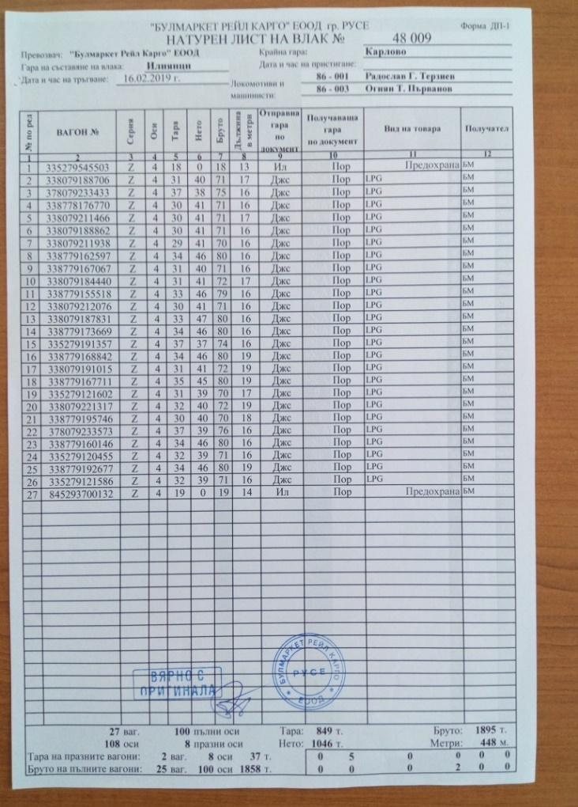
Fig. 61
1
- At Karlovo station, after the change of direction, there has been no verification of the clocks of the recorder of locomotive 86-003, which becomes the leading one in the composition from Karlovo to Plovdiv station;
- In the "Rules of Train Movement and Maneuvering in Rail Transport" (RTMMRT) approved by the Director-General of RINC from 2019 Chapter Three, Section I, "Checking the Clocks", in the texts of Art. 94 there is no text regulating the time adjustment of the clock and the recorder of the locomotive when changing the direction of movement of a train serviced by more than one locomotive.
- In accordance with the requirements of Art. 245, para. 1, item 6 of Ordinance № 58, Art. 301, item 6 of RTMMRT, Art. 29, para. 1, item 6 of SP-77 "Instructions for performing brake tests and providing trains with brake mass / March 20, 2019", part of SSM of "Bulmarket Rail Cargo" EOOD at Karlovo station no sample D is performed before departure of the train established by the downloaded records of the locomotive recorder 86-003 (Fig. 20).;
Fig. 62
15. Description of measures already taken as a consequence of the accident.
1. Since July 2019, a new generation UDS2M-RDM 11 Ultrasonic Fault Detector is commissioned at RINC for non-destructive control of the tongue profiles of switches in the railroad.
2. RINC has amended and supplemented the "Rules for the certification of railway switches" Appendix 4 - Railway switch technical datasheet.
16. Recommendations issued in order to avoid accidents upon the same reasons.
In accordance with the requirements of Art. 94 para. 1 and para. 3 of Ordinance № 59 from December 5, 2006 in order to improve safety in railway transport, EA "Railway Administration" upon advisability to order "Bulmarket Rail Cargo" EOOD and RINC to implement the given safety recommendations.

  - Recommendation № 1 proposes the staff in operation of RINC and “Bulmarket Rail Cargo” EOOD to get known with the contents of the report.

  - Recommendation № 2 proposes RINC to make an amendment to Art. 94 of the "Rules on the movement of trains and maneuvering in railway transport" (РМТМ).

  - Recommendation № 3 proposes RINC to undertake non-destructive monitoring of railway switches in accordance with the category of railway lines.

4. Recommendation № 4 proposes EA "Railway Administration" to take control measures in relation to the violations of the normative acts related to railway safety by “Bulmarket Rail Cargo” EOOD and RINC during the investigation.

With reference to the implementation of Art. 94 para. 4 of Ordinance № 59 from December 5, 2006 for Railway Safety Management EA "Railway Administration" to notify in writing the head of SUIRAI in MTITC for the implementation of the given recommendations.

Sofia
July 31 2019

Chairman:
Dr. Eng. Boycho Skrobanski
Head of NIB in MTITC

