**FINAL REPORT**

**from**

**Investigation of railway accident – derailment of wagons from the composition of direct freight train № 20692 in Mezdra station on 14.12.2021.**

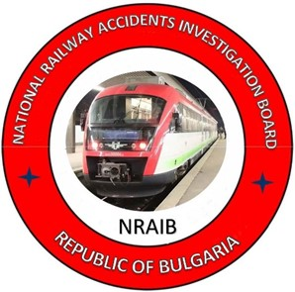

**2022**

**OBJECTIVE OF INVESTIGATION AND EXTENT OF RESPONSIBILITY**

The National Air, Maritime and Railway Transport Accidents Investigation Board (NAMRTAIB), which is an independent body performs the investigation of significant accidents, accidents and incidents. The National Board is within the Council of Ministers (CM) of the Republic of Bulgaria, and aims to find the circumstances and causes that led to the accidents and incidents occurrence in order to improve the safety and to avoid such in future, **without searching personal fault and responsibility.**

The investigation is performed in accordance with the requirements of Directive (EU) 2016/798 of the European Parliament and of the Council of 11 May 2016 on railway transport safety, the Railway Transport Act (RTA), Ordinance No59 dated 5.12.2006 on the rail transport safety management, and Ordinance No Н-32 dated 19.09.2007 on the coordination of the activities and information exchange during the railway accidents and incidents investigation, as well as per Agreement dated 17.04.2018 on the interaction during investigation of accidents and incidents in the air, maritime and railway transport between the Prosecutor's Office of the Republic of Bulgaria, Ministry of Interior, and the Ministry of Transport, Information Technology and Communications.

The Investigation reports follow the requirements of Regulation (EU) 2020/572 of the Commission dated 24 April 2020 on the reporting structure for railway accident and incident investigation reports.

|  |  |  |
| --- | --- | --- |
| **TABLE OF CONTENTS** | | |
| № | Title of section | Pg. |
|  | **Summary** | 5 |
|  | **Investigation** | 8 |
|  | **Description of the event** | 13 |
|  | **Analysis of the event** | 25 |
|  | **Conclusions** | 40 |
|  | **Safety recommendations** | 41 |

**ABBREVIATIONS, USED IN THE REPORT**

BDZ PS Ltd. – ,,BDZ-Passenger Services“ Ltd.

,,Bulmarket Rail Cargo“ Ltd. – licensed railway undertaking for freight traffic services

WIS – Wagon inspection section

MAD – Main air duct (depending on the context)

MAS – Main air switch (depending on the context)

SE NRIC – State enterprise „National railway Infrastructure Company “(railway infrastructure manager)

RODU – Regional operational dispatching unit

DFT – Direct freight train

RTA – Railway Transport Act

RAEA – Railway Administration Executive Agency

km – kilometre along the railway infrastructure

OCL – Overhead contact line (catenary)

ECM – Entity in Charge of Maintenance

IDFT – International direct freight train

RRI Н68 – Route-relay interlocking type Н68

Ordinance № 59 – Ordinance on the rail transport safety management

NAMRTAIB – National Air, Maritime, and Railway Transport Accidents Investigation Board (Independent Specialized National Investigation Body)

TF – Task Force

RRS – Rail Rolling Stock

TOMR – Train operation management and reporting (in real time)

RSPSM – Rail self-propelled specialized machine

SMS – Safety Management System

TMWI – Technician-mechanic wagon inspector

DCCM – Device for communications, connections and messages

MSL – Manual switch lock type ,,Hook bolt“

1. **Summary**

***1.1. Brief Description of the Event.***

On 14.12.2021 at 14:30 p.m. DFT № 20692 departed from Ruse marshalling yard according to a prepared schedule with a route of movement Ruse marshalling yard - Gorna Oryahovitsa - Mezdra - Beli Izvor. The train consists of 24 wagons (empty) series Fals, 96 axles, 585 tons with locomotive № 91522086004-2. The railway freight company „Bulmarket Rail Cargo“ EOOD serviced the train.

DFT № 20692 arrived at Borovo station at 16:58 p.m., it stayed 10 minutes to perform a shortened test "D" (given the profile of the descent in the next two interstations). The train departed to Morunitsa station at 17:08 p.m., passed without stopping through Morunitsa station at 17:16 p.m., and through Byala station at 17:30 p.m. also without stopping.

DFT № 20692 arrived at Pordim station at 19:50 p.m., it stayed for 7 minutes to perform a shortened test "D" (given the descent profile) and left to Pleven station.

While passing DFT № 20692 at 21:08 p.m. without stopping along the fourth main track of Cherven Bryag station, the switchman at Post № 1 reported to the traffic manager on-duty that when the train passed the post, located on the right in the direction of traffic on the train, one of the wagons made a strange sound and sparks emanated from the wheel-sets of one of the wagons. The traffic manager on duty reported to the train dispatcher that sparks were coming out of the train. The train dispatcher ordered the traffic manager on-duty at Karlukovo station to stop DFT № 20692 for inspection by the locomotive crew. The locomotive drivers went around the train and announced that everything was in order and the train could depart. After receiving the departure from Roman station, at 21:40 p.m., the first person traffic manager on- duty at the Mezdra station ordered through the RRI an entrance route for third free track in deviation.

Around 22:00 p.m., DFT № 20692 passed the entrance signal at Mezdra station and the traffic manager on -duty first person opened the exit signal for the train to pass without stopping on the third track to Ruska Byala station. When the train entered in Mezdra station, the speed was 30 km/h. When meeting the train, the switchman at Post № 2 noticed that part of the train hit the devices at switches № 9 and № 11, after which it stopped at about 22:03 p.m. at the station. After the on-site inspection, it was established that the train was split and five wagons were derailed (Fig. 1.1).

**Fig. 1.1.**

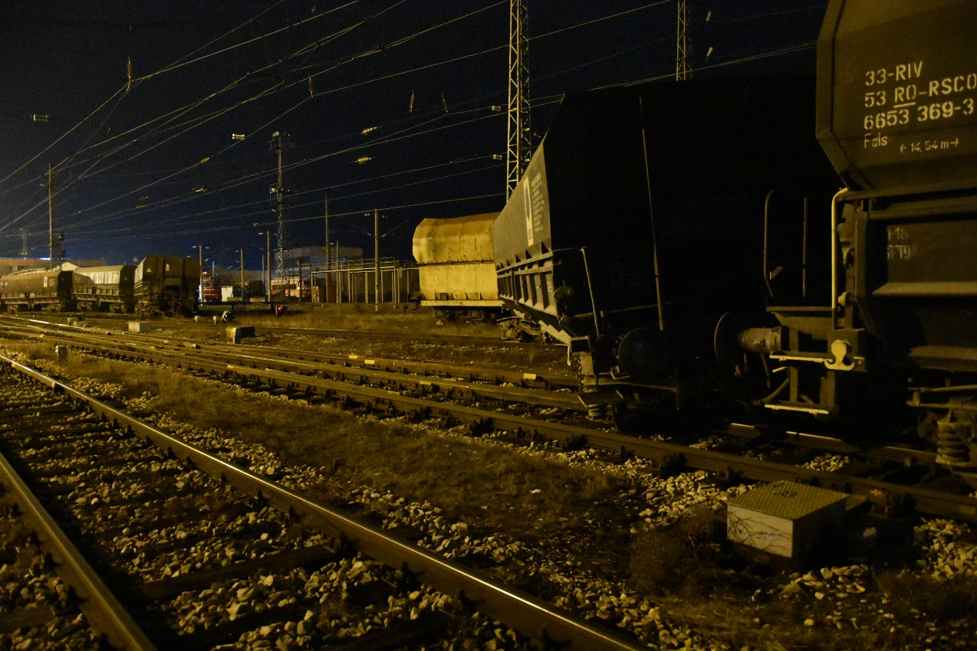

Посока на движение

Because of the derailment, no staff from the station and the train were injured. Damage was inflicted on the derailed five wagons, on the signalling equipment and on the rail track and the facilities.

On 15 and 16.12.2021, after the completion of the repair and restoration works on the rail track and the signalling equipment, the traffic through Mezdra station on track № 1 and track № 2 from and to Roman station was allowed.

* 1. ***Location and time of the event occurrence.***

At 21:55 p.m. on 14.12.2021, when DFT № 20692 entered in Mezdra station, the derailed wheel-set left traces on the rail track, as the first were found 180 cm from the top of the frog of switch № 101 (Fig. 1.2, pos. 1).

**Fig. 1.2. Switch № 101, to which were found the first traces from the derailment of wagon № 33536653810-6.**

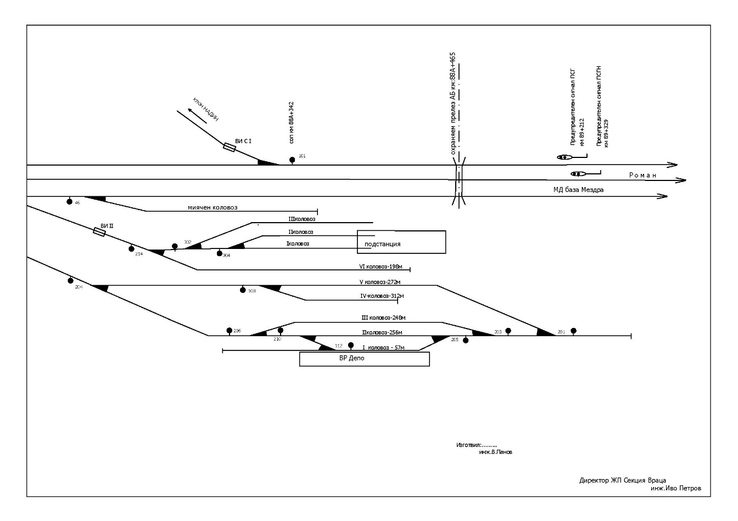

***1***

**Fig. 1.3. Distance from the point of ascend of switch № 101 to the beginning of switch № 1.**

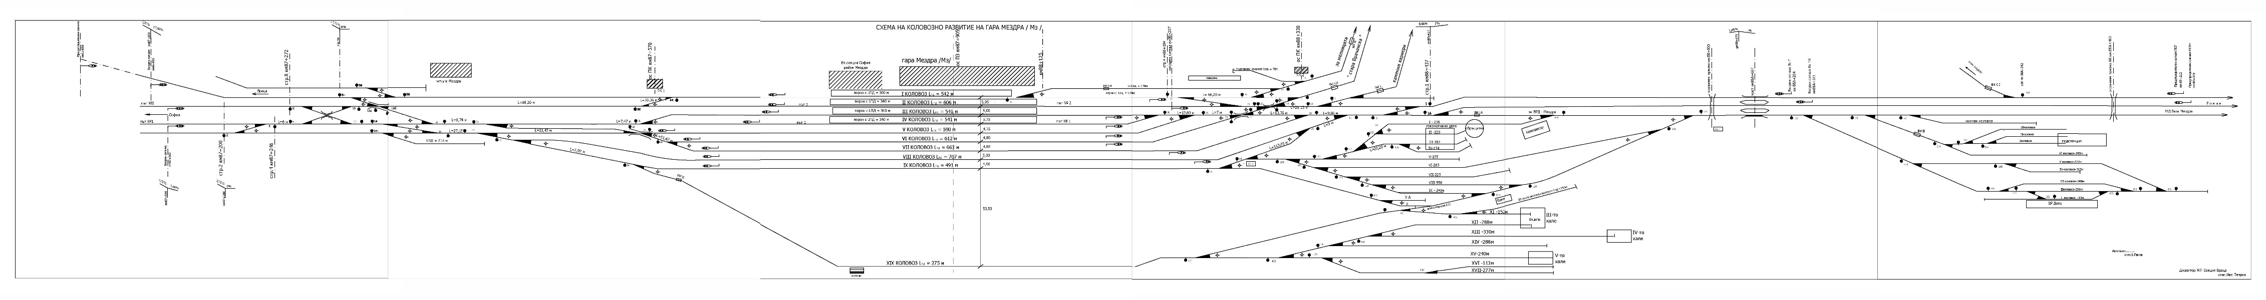

***519 m***

From the point of ascent of switch № 101 to switch № 1, the train travelled 519 meters without any traces on the fastenings and the sleeper gird of the rail track. Traces were found on the outside of the head of the right rail in the direction of the train to Mezdra station. The area of the train movement after switch № 101 was in the left curve with radius R = 800 m with cant H = 70 mm, with profile in downhill 1.5 ‰ (Fig. 1.3).

* 1. ***Factors determining and contributing the event.***

The determining factor for the accident is the spreading of the bandage (flange) bracelet of the right wheel of the second wheel-set on the first bogie of wagon № 33536653810-6, 13th of the train composition.

A contributing factor to the occurrence of the accident is the passage through the switches of the hole at Mezdra station, which caused significant dynamic horizontal transverse forces.

* 1. ***Direct causes and consequences of the event.***

The immediate cause of the accident was derailment of the first bogie of the 13th wagon, which was a consequence of the spreading of the band bracelet during the train movement, combined with the significant horizontal transverse forces when passing through the entrance of Mezdra station. The unravelling of the bandage (flange) bracelet probably occurred long before Mezdra station, given the condition of the wheel and the bandage (flange) bracelet after the derailment.

* 1. ***Safety recommendations and addressees to which they are addressed.***

In order to prevent other similar accidents that could have serious consequences for the railway infrastructure and rolling stock, the Investigation Commission proposes to the National Safety Authority RAEA safety recommendations related to Bulmarket Rail Cargo EOOD and SE NRIC.

Recommendation 1 proposes that SE NRIC and Bulmarket Rail Cargo EOOD shall acquaint the interested staff with the content of this report.

Recommendation 2 proposes that Bulmarket Rail Cargo EOOD shall carry out precise control of the technical condition of the wagons, both at the border and train-forming stations, and during their movement along the national railway network.

Recommendation 3 proposes that Bulmarket Rail Cargo EOOD shall specify the personnel controlling the technical condition of the wagons in the hub stations along the route of the trains.

Recommendation 4 proposes that Bulmarket Rail Cargo EOOD shall request refreshment and control of the marking on the outside of the bandage (flange) wheels for quick and easy control of the flange-disc assembly.

Recommendation 5 proposes that the RAEA shall inform the National Safety Authority of Romania and the certification body SCONRAIL Ltd of the two consecutive accidents with rolling stock registered in the Romanian Vehicle Register, with owner, user and person responsible for the maintenance ROLLING STOСK COMPANY SA, due to possible poor maintenance of 665/Fals series wagons.

1. **Investigation**
   1. ***Decision for starting the investigation.***

The decision to initiate an investigation of the accident has been taken with respect to the seriousness and its impact on the safety. The investigation aims to prevent this type of accidents, which in similar circumstances could lead to significant accidents with big material damages.

* 1. ***Motives for the decision to initiate the investigation.***

The Decision to initiate the investigation is taken by the member of the NAMRATIB Managing Council, head of rail transport based on art. 20, paragraph 2, (а), (b) and (c) of Directive (EU) 2016/798, art. 115к, paragraph 1, item 2 of RTA, art. 76, par. 1, item 2 of Ordinance No 59 dated 5.12.2006, and by Order of the NAMRATIB for assignment of Commission for investigation of the railway accident.

* 1. ***Scope and restrictions of the investigation.***

The scope of the investigation examines and analyses the movement of DFT № 20692, the technical condition of RRS and the railway infrastructure, violations of regulations implemented by entities in performing technical support and safe operation when rolling stock (wagons) from foreign railway administration enter. The specialized wagons of the Fals series, intended for bulk cargo, are owned by the railway company ROLLING STOSK COMPANY SA. The wagons are leased under a contract by Holcim Bulgaria AD - Vratsa for loading with aggregates (clinker) for the Republic of Romania.

Given the caused damages, the investigation is focused on the circumstances that led to the accident - derailment of five wagons of DFT № 20692 at Mezdra station, which in slightly different circumstances could lead to an accident with significant material damages.

* 1. ***Competences of the persons, involved in the investigation.***

The Deputy President of the Management Board of the NAMRATIB, head of railway transport field headed the Investigation Commission. The composition of the commission includes external independent experts - habilitated persons from the scientific circles and experts with free profession with qualification and professional orientation in fields of activity – railway infrastructure, and rail rolling stock.

* 1. ***Communication and consultations with the persons and entities, involved in the event.***

The Commission defined the parameters of the investigation and coordinated its actions with the Task Force, which includes representatives from both entities. The Task Force collected all documents and samples, as well as the records from the registration device of locomotive №91522086004-2 towing the train. They were handed over to the Chairperson of the Investigation Commission in the NAMRATIB. An interview was conducted with the persons directly involved in the accident. The entities were requested and provided information on the maintenance of the rail track and facilities at Mezdra station, information on repairs, maintenance and persons who performed technical inspections of the wagons of DFT № 20692. An interview was conducted with the safety authorities of both entities and the management the railway companies Bulmarket Rail Cargo EOOD and SE NRIC.

* 1. ***Degree of cooperation from the participating entities.***

During the investigation, the railway company Bulmarket Rail Cargo EOOD and SE NRIC, incl. the officials involved in the accident fully cooperated and provided the Investigation Commission at NAMRATIB with access to rolling stock and railway infrastructure.

* 1. ***Methods and techniques of investigation and analysis.***

On 14.12.2021 at 21:56 p.m., a written notification was received by SMS and a verbal notification was received at 22:46 p.m. by mobile phone from the on-duty officials of the railway infrastructure manager for an occurred accident. The member of the Management Board of NAMRATIB, responsible for the railway transport, analysed the received information, notified the two entities (SE NRIC and Bulmarket Rail Cargo EOOD) and departed for the place with external experts.

In view of the caused material damages to the railway infrastructure and the rolling stock, the Mezdra District Prosecutor's Office has instituted pre-trial proceedings to establish the circumstances and causes that led to the accident and to identify the guilty officials.

On the spot, the Chairperson of the NAMRATIB Investigation Commission prepared an action plan with the representatives of the investigative bodies in the pre-trial proceedings from the Regional Directorate of the Ministry of Interior - Mezdra under the supervision of a prosecutor from the Regional Directorate - Mezdra in connection with the initiated pre-trial proceedings independent investigation.

The records have been downloaded from the registration device of locomotive №91522086004-2 servicing the train, for decryption, analysis and expertise. Preliminary data showed that when he entered in Mezdra station, the train was moving at a speed of about 30 km/h.

An interview was conducted with the staff involved in the accident by the railway infrastructure manager (first and second person traffic managers on duty, post-1 switchman at Mezdra station, railway infrastructure repair and maintenance staff) and the railway undertaking/carrier (the locomotive crew of locomotive № 91522086004-2, serviced DFT № 20692). In addition, written testimony was requested and presented by the shift staff at Cherven Bryag station.

Inspections of the non-derailed 11 wagons on the 3rd track of the DFT № 20692 with train locomotive № 91522086004-2 were performed. Inspections were also carried out on the derailed five wagons 12th, 13th, 14th, 15th and 16th of the train and the area of the rail track and facilities, including the distance from the ascending point of the wheel on the rail to the final stop of the train. The perimeter of the affected (damaged) rail track, railway switches and elements of the signalling equipment was determined. The ascending point of the wheel and the mechanism of the subsequent derailment was determined. It was established that the 13th wagon of the train derailed first and followed the other four wagons that also derailed.

At switch № 1, turned for the third diversion track, wagon № 33536653810-6 - 13th of the train, derailed with the second wheel-set of the first bogie. Traces of slipping of the left wheel on the second wheel-set of the first bogie on the fastenings of the left guardrail and blade are clearly visible. The derailed second wheel-set of the first bogie of the 13th wagon of the train destroyed the electric switch-turning device (ESTD) of switch № 11. It unlocked the route and the left switchblade moved away from the left guardrail under the action of significant dynamic horizontal transverse forces in the wheel-rail contact. In this zone, the second bogie of wagon № 13, together with wagons №№ 14, 15 and 16 of the train, directed to the eighth track, because of which the train broke. The first bogie of the 13th wagon moved between the seventh and eighth track, and the second bogie - on the eighth track stopped 25 m after the switch № 19.

During the inspection of the 13th derailed wagon № 33536653810-6 (stopped between the seventh and eighth tracks) was found that the bandage (flange) bracelet on the right wheel of the second wheel-set of the first bogie found in the middle part of the axle (between the two wheels) was pressed - Fig.2.1.

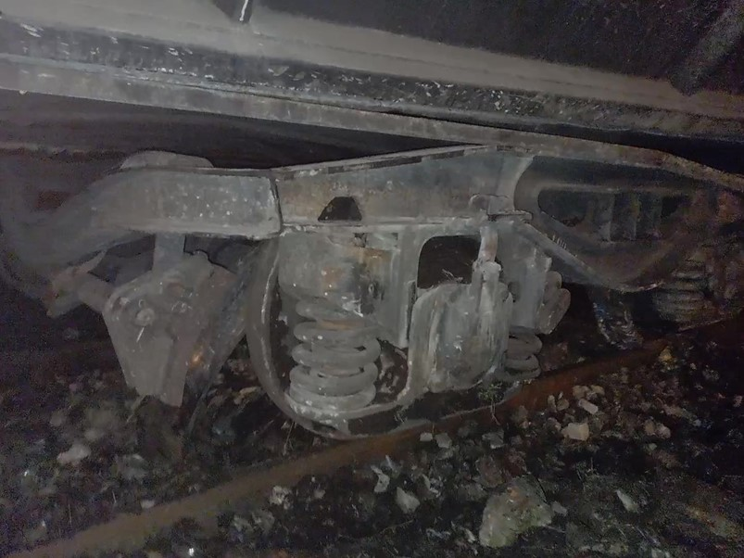

**Fig. 2.1. The right wheel with fallen flange.**

Flange bracelet,

pressed and fallen from the wheel.

The position of the 12th derailed wagon hauled by the 13th wagon is at an angle of 45 ° to the axis of the rail track.

Following the completion of the inspections, in order to restore quickly the movement and capacity of the railway infrastructure, the Investigation Commission of the NAMRATIB and the investigative body of the pre-trial proceedings gave written permission to the railway infrastructure manager to start emergency recovery activities.

The last eight non-derailed wagons were towed back to the neighbouring Roman station.

At the place of the accident, the pre-trial bodies together with the Investigation Commission of the NAMRATIB and the representatives of the two entities, measured the parameters of the rail track in the area (point) of derailment of the 13th wagon of DFT № 20692 and prepared a Statement of findings.

The National Safety Authority RAEA provided a reference on the regular registration in the European Register of Vehicles for all the wagons of DFT № 20692.

On 27.01.2022, the first derailed 13th wagon № 33536653810-6 was moved to the Mezdra Wagon Repair Depot, where inspections and measurements were performed by the Task Force in the presence of representatives of the Investigation Commission of NAMRATIB and pre-trial proceedings. RD MI Mezdra and RD - Mezdra. A Statement of findings was drawn up for the technical condition of the wagon in accordance with the requirements of the national regulations.

On 01.02.2022, the Investigation Commission received the collected documentation, submitted by Task Force at TOSAMD- Sofia, regarding the investigation of a railway accident - derailment of 5 wagons of the DFT № 20692 at Mezdra station on 14.12.2021.

On 02.03. 2022 in the Wagon-repair depot Mezdra in the presence of the Investigation Commission of NAMRATIB and representatives of the pre-trial proceedings from the Regional Directorate of the Ministry of Interior - Mezdra conducted an experiment to establish the presence of a safety ring between the bandage (flange) bracelet and the disc. The bandage (flange) bracelet was cut in two places at an angle of 90 °. After the cut, it was found that the safety ring was in place (in the technological channel of the bandage/flange bracelet) the upper part of the disc was cut, the lower part was flared due to friction between the flange and the wheel disc, and visible two-sided cracks on the side of the groove were formed.

* 1. ***Difficulties faced during the investigation.***

The Investigation Commission of the NAMRATIB, the representatives of the Task Force and the safety authorities of the Railway Infrastructure Manager and the Railway Undertaking/Carrier fully cooperated during the investigation. The activities for the reconstruction of the railway infrastructure and the rolling stock started after a written permission from the investigative structures of the pre-trial proceedings and the chairperson of the Investigation Commission of the NAMRATIB.

* 1. ***Interaction with the judicial authorities.***

In accordance with the Agreement on Interaction between the bodies of the pre-trial proceedings and the Investigation Commission of the NAMRATIB in force from 17.04.2018, information, documents and materials were exchanged between the parties during the investigation. On the part of the pre-trial proceedings, the supervising prosecutor in the case of the Regional Prosecutor's Office - Mezdra with a prosecutor's order detained the derailed 13th wagon of DFT №20692 until the completion of the pre-trial and technical investigation.

* 1. ***Other important information for the investigation context.***

In the context of the ongoing investigation on 01.01.2022, a second similar case followed with the same series of Fals wagons with flange wheel-sets, empty with registration in the European Register of Vehicles by the railway company ROLLING STOCK COMPANY SA - Republic of Romania.

*Brief description of the accident:*

On 01.01.2022 at 15:25 p.m. DFT № 10693 departed from Dupnitsa station in a composition of 26 wagons (empty), 657 tons, towed by locomotive № 91521080028-9, serviced by locomotive driver I-st person and a locomotive driver II-nd person. The train run on a schedule to Lyubenovo transmission station. During the train movement, it respected the speeds of movement.

At Dolni Rakovets station DFT № 10693 arrived at 15:58 p.m., accepted on the third acceptance-departure track. Passenger train № 50231 of BDZ PS Ltd. was accepted on the second main track. After the meeting of the two trains at 16:04 p.m. the traffic manager on -duty ordered the routes for simultaneous departure of passenger train № 50231 and DFT № 10693. DFT № 10693 departed, at the same time, the assistant locomotive driver of passenger train № 50231 saw that from the composition of DFT № 10693 derailed a wagon on the third track and notified the traffic manager on- duty by phone. The locomotive driver of the passenger train № 50231 gave signal "General alarm" with the locomotive whistle. The traffic manager on-duty, through the station interlocking, activated the "closed signal" button on the third track for DFT № 10693. The train travelled 140 meters and stopped in front of the closed exit semaphore at 16:05 p.m. The post switchman of Post № 2, prepared the route for receiving FT № 5622 on the fourth track, found that the manual locks of switch № 5, type "Kolben-Danek" were broken due to the derailed wagon from DFT № 10693. During the inspection of DFT № 10693 by the traffic manager on-duty and the locomotive crew found that the 21st wagon № 33536654970-7 derailed with the two wheel-sets of the first bogie.

The cause for the derailment is a loosen flangeon the right wheel of the first wheel-set from the first bogie of the wagon. The wagons in the composition of DFT № 10693 were of the same series - 665 / Fals.

Before the departure of DFT № 10693 from Dupnitsa station, test "A" (full test) was performed by a technician mechanic, wagon inspector (TMWI) - employee of "Bulmarket Rail Cargo" EOOD, the train was delivered technically sound.

The derailment occurred under the same circumstances and for the same causes as in the derailment of the 13th wagon of DFT № 20692 at Mezdra station on 14.12.2021.

1. **Description of the event**
   1. ***Information on the event and the context.***
      1. *Description of the event type.*

On 12.12.2021 the railway undertaking/freight carrier Bulmarket Rail Cargo EOOD submitted a written application to SE NRIC for the appointment of IDFT № 54641 with a route Giurgiu North - RP Danube - Ruse marshalling yard. The appointment of the train is based on a contract between the railway company ROLLING STOCK COMPANY SA and the company "Holcim Bulgaria" AD - Vratsa for rail transport between the Republic of Romania and the Republic of Bulgaria. The transport will be carried out with specialized wagons series 665 / Fals, designed for bulk aggregates (clinker), provided by ROLLING STOCK COMPANY SA. The railway undertaking / freight carrier Bulmarket Rail Cargo EOOD will service the trains.

By a dispatch order of a senior dispatcher in the CDR at the SE NRIC State, the IDFT № 54641 was appointed for traffic on the technological route № 23 with the following schedule:

**Offered schedule:**

|  |  |  |  |  |
| --- | --- | --- | --- | --- |
| IDFT № 54641, brake percentage 45%, Loc. 601 / 12.12.2021 | | | | |
|  | Giurgiu North | - | - : - | 22:55 |
| 60 | RP Danube | 18 | - : - | 23:13 |
|  | Ruse marshalling yard | 7 | 23:20 | - : - |

**Real schedule:**

|  |  |  |  |  |
| --- | --- | --- | --- | --- |
| IDFT № 54641, brake percentage 45%, Loc. 601 / 12.12.2021 | | | | |
|  | Giurgiu North | - | - : - | 15:55 |
| 60 | RP Danube | 18 | - : - | 16:13 |
|  | Ruse marshalling yard | 7 | 16:20 | - : - |

After the arrival of IDFT № 54641 at 16:20 p.m. in Ruse marshalling yard, which is an exchange border station for arriving and departing trains to and from the Republic of Romania, a technical mechanic wagon inspector (TMWI), employee Bulmarket Rail Cargo EOOD, performed a technical and commercial inspection. During the technical inspection of the train, no irregularities were found on the wagons, endangering the safety of movement.

On 14.12.2021 the railway undertaking/carrier Bulmarket Rail Cargo EOOD submitted a written request to SE NRIC to appoint DFT № 20692 for traffic from Ruse marshalling yard to Beli Izvor station (Fig. 3.1).

On 14.12.2021 in Ruse marshalling yard to DFT № 20692 a nature sheet was prepared by an employee of Bulmarket Rail Cargo EOOD for the composition of the train - 24 wagons series Fals (empty), 96 axles, 585 tons.

On 14.12.2021 in Ruse marshalling yard at 13:00 p.m., a technical mechanic wagon inspector (TMWI), an employee of Bulmarket Rail Cargo EOOD, performed a technical inspection and a complete test "A" of DFT № 20692. At 14:10 p.m. TMWI reported to the traffic manager on-duty at the station that the train was technically sound and ready to depart.

On 14.12.2021 from Ruse marshalling yard at 14:30 p.m. departed DFT № 20692, towed by locomotive № 91522086004-2 with locomotive driver and assistant locomotive driver, employees of Bulmarket Rail Cargo EOOD.

At 21:07 p.m., when the train passed without stopping on the fourth main track of Cherven Bryag station, the traffic manager on- duty met the train on the platform on the left side in the direction of traffic and did not notice any irregularities. After the train passed Post № 1, located on the right side in the direction of traffic, the switchman reported to the traffic manager on-duty that when the train passed the wagons made a strange sound and sparks came out of the wheels. The traffic manager on- duty reported to the train dispatcher that sparks were coming out of the train. The train dispatcher ordered the traffic manager on- duty at Karlukovo station to stop the train at the station for inspection by the locomotive crew. DFT № 20692 stopped at Karlukovo station at 21:19 p.m. on the first acceptance-departure track. The traffic manager on- duty at Karlukovo station informed the locomotive drivers about the order of the train dispatcher. The locomotive crew patrolled the train and reported that everything was in order and the train could leave. After a stay of eight minutes DFT № 20692 departed at 21:27 p.m. from Karlukovo station and passed without stopping Kunino station at 21:33 p.m. The train passed also without stopping Roman station at 21:40 p.m.

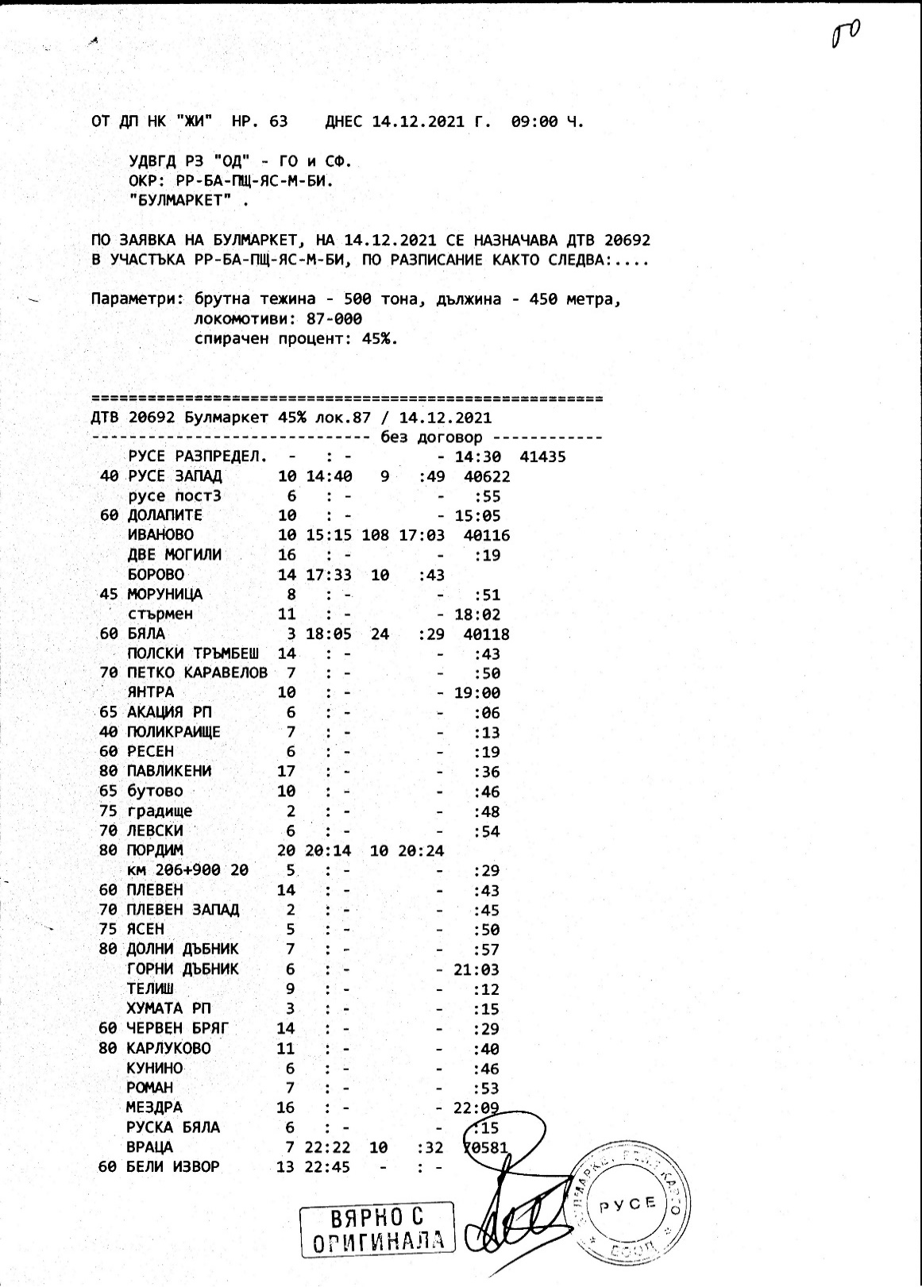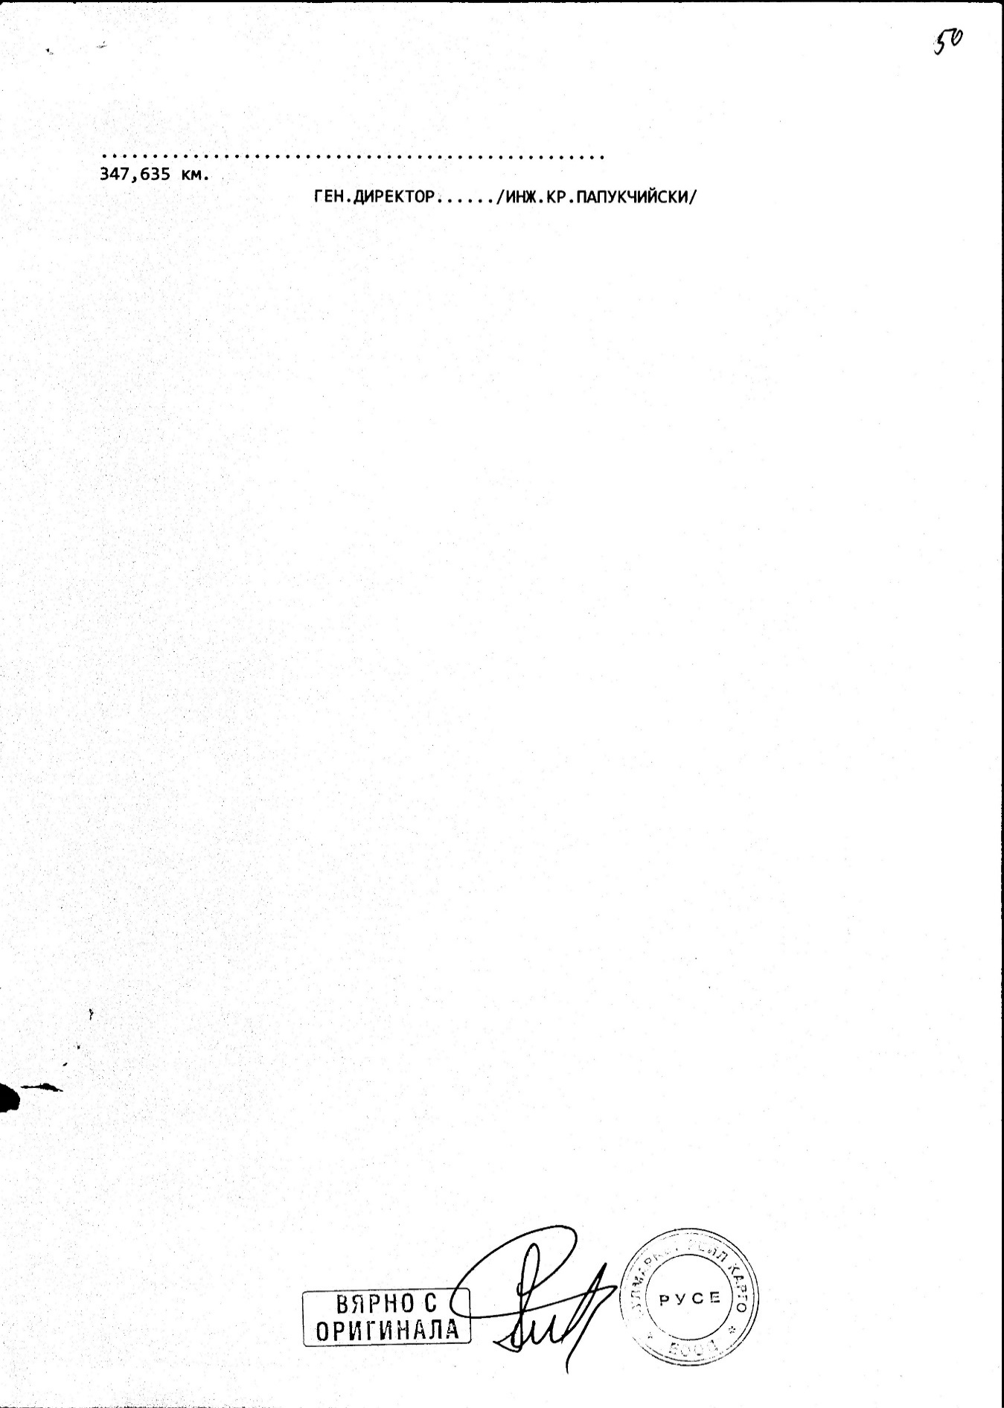

**Fig. 3.1. Schedule of movement of DFT № 20692**

Kunino and Roman stations were on the right in the direction of the train, but the traffic managers on- duty did not notice any visible faults.

After receiving the departure from Roman station, at 21:40 p.m., the first-person traffic manager on duty at Mezdra station, through the RRI, ordered an entrance route for the third acceptance-departure track in deviation without stopping.

Evident from the written indications of the locomotive driver on-duty in the Mezdra Sub-Operation Area (SOA), around 21:55 p.m., he heard a loud noise (collision) from the passing freight train.

At around 22:00 p.m., DFT № 20692 entered the third track at Mezdra station and the first-person traffic manager on -duty opened the exit signal for passing without stopping the train in the direction of Ruska Byala station. The train was traveling at a speed of 35 km/h, as evidenced by the transcript provided by the recording device of locomotive № 91522086004-2.

When DTV № 20692 was met by the second person traffic manager on- duty on the platform at Mezdra station, he noticed that in the hole at the entrance of the train on the third track, around switch № 39 the train stopped quickly.

When the switchman at Post № 2 accepted DFT № 20692 at Mezdra station, he noticed that part of the train derailed and hit the switch apparatuses at switches № 9 and № 11, then stopped at 22:03 p.m. After the switchman of Post № 2 performed an on-site inspection by, he found that the train was split and had a derailed group of wagons, and he informed the traffic manager on-duty first person at Mezdra station. Following the report received from the switchman, the traffic manager on-duty first person, according to the Emergency Action Plan, notified the interested officials.

When DFT № 20692 entered on the current track № 2 in Mezdra station, it left traces on the rail track and the facilities. The Investigation Commission of the NAMRTAIB, measured 180 cm found the first trace during an on-site inspection after the top of the frog of switch № 101. The switch is located at km 88 + 956 before the entrance signal at Mezdra station, accepted as a point of rise on the right wheel of the 13th wagon. From switch № 101 to switch № 1 the train travelled 519 meters (the wheel derailed and got on again) without leaving traces on the fastenings and the sleepers gird of the rail track. Traces were found on the external part of the head of the right rail and two counter points of the input signal in the direction of train movement damaged by the derailed right wheel.

The train was moving along the prepared route and on switch № 1, turned for the third deviation track, wagon № 33536653810-6 - 13th of the train derailed with the second wheel of the first bogie, with traces of derailment in the area between the left guard rail and the left blade of the switch (Fig. 3.3, pos. 1). There were partial traces of the derailed wheel-set on the right blade and the right inner intermediate rail. When the wagon passed through switch № 1, the left derailed wheel hit the left counter-rail (checkrail) head-on, because of which the first bogie derailed. The first bogie of wagon № 33536653810-6 - 13th of the train in its movement destroyed the electric switch turning device machine (ESTDM). In this area, the train broke and the second bogie of wagon № 13 together with wagons №№ 14, 15 and 16 of the train set off for the eighth track. The first bogie of the 13th wagon moved between the seventh and eighth tracks and the second bogie on the eighth track and stopped 25 m after switch № 19. When inspecting the derailed first wagon № 33536653810-6, the Investigation Commission found that under the first bogie of the wagon, located between the seventh and eighth track, the bandage (flange) bracelet fell from the right wheel of the second wheel-set between the two wheels (fig. 3.4).

**Fig. 3.2. Wagon № 33536651334-9 – 12th of the train composition** – **derailed.**

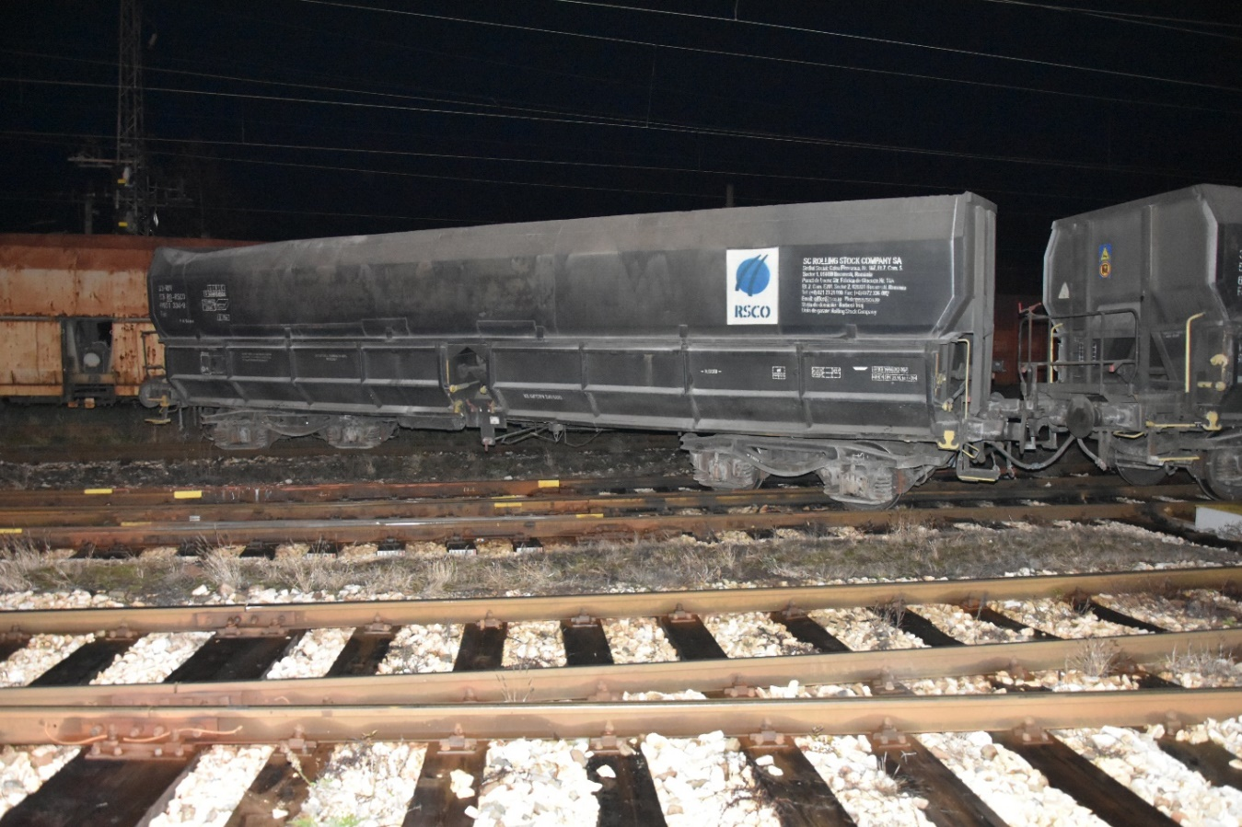

To wagon № 33536651334-9 – 12th of the train composition, last derailed the first bogie, as the derailment occurred in the end of the triple crossing of switch № 31, where were found traces of rising on the left check-rail and strengthening bolts of the left two wheels of the first bogie in the movement direction. The right wheels of the first bogie moved on the railhead (fig. 3.2).

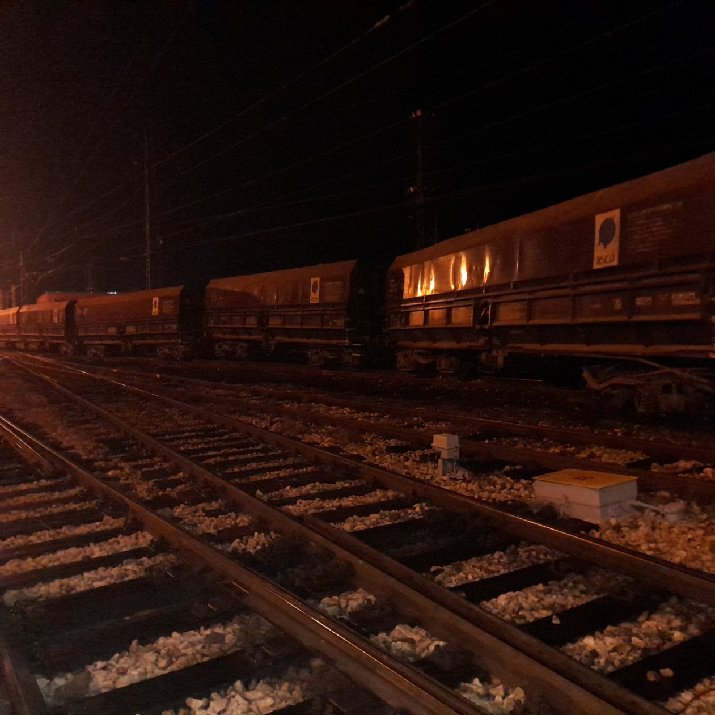

**Fig. 3.3. Derailed wagons 13-nth, 14-nth, 15-nth and 16-nth of the train composition.**

***16***

***14***

***13336***

***15***

Wagon № 33536652646-5 – 14 –nth of the train composition, derailed with the two bogies, as the first bogie derailed on 8th track, and the second bogie – after the end of switch № 19 (fig. 3.3, pos. 2).

Wagon № 33536656302-1 – 15th of the train composition, derailed with the two bogies as the first bogie was located in the crossing of switch № 19, and the second – around the area of switch № 19 (fig. 3.3, pos. 3).

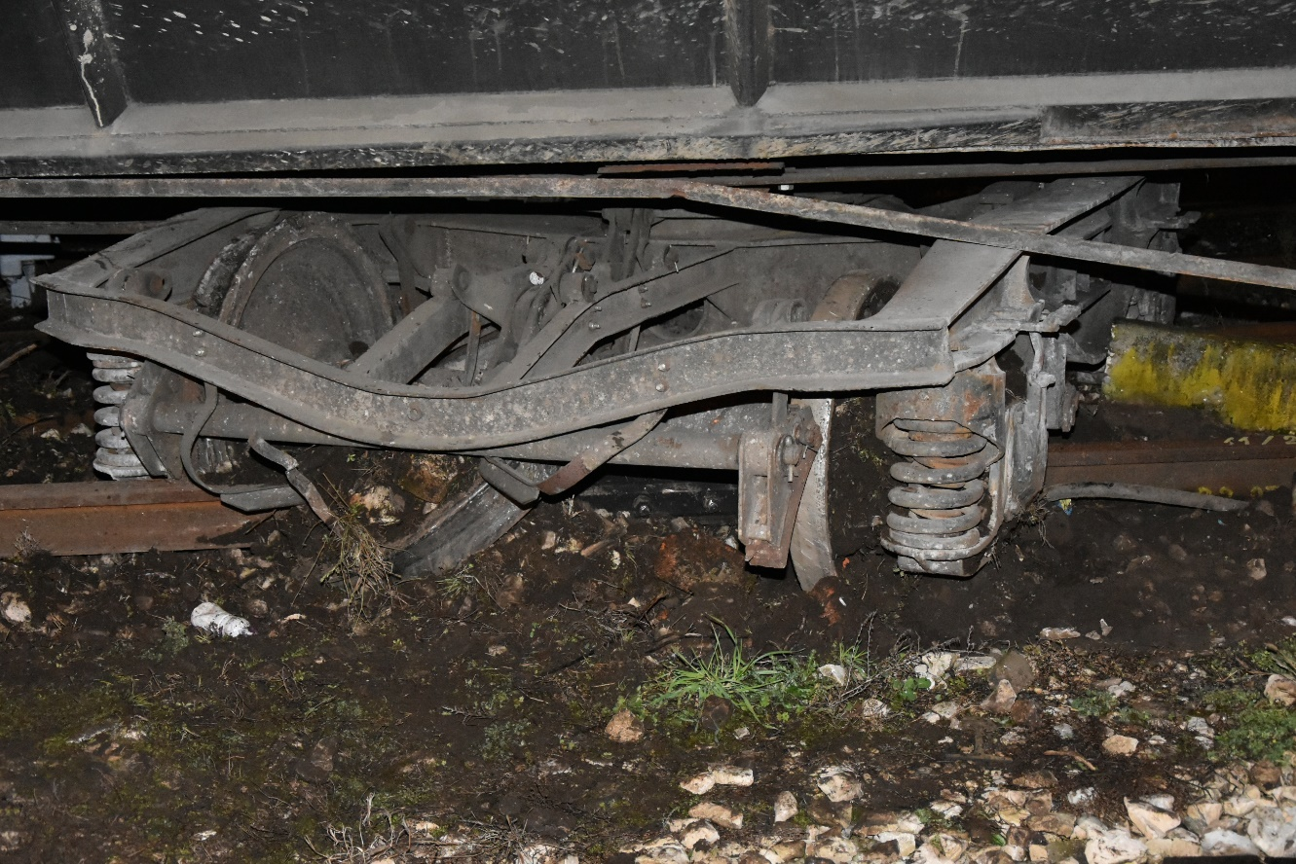

**Fig. 3.4. Pressed flange bracelet of the first derailed 13-nth wagon of the train composition, located between the two wheels.**

Wagon №33536654482-3 - 16th of the train derailed with the first bogie, which was located in the area of the blade of switch № 19, and the second bogie was in the normal position of the rail track around the end of switch № 11 (Fig. 3.3, pos. 4).

Because of the derailment of the wagons, the clearance gauge for the movement of trains in the direction of Roman station was closed.

A group of eight wagons from the end of the train were located on the rail track between switch № 11 and the entrance signal of Mezdra station Roman station side.

At 00:15 a.m., the head of the investigation in railway transport field at NAMRTAIB arrived at the place of the accident with two experts to inspect the accident. After the inspections, a written permission was given for the start of emergency recovery works on the rail track and the derailed RRS.

*3.1.2. Description of the event location:*

*Date, punctual time and location of the event.*

The train was appointed on main railway lines №№ 4, 2 and 7 with route of movement Ruse marshalling yard – RP Akacia – Polikraishte – Mezdra – Ruska Biala – Beli izvor (fig. 3.5).

The wagon derailment occurred on 14.12.2021 at 21:55 p.m. while DFT № 20962 was entering in Mezdra station at switch № 101 at 24 meters before the entrance signal.

**Fig. 3.6.** **Route of movement of DFT № 20692**

* Origin station of the train movement;
* Main stations on the train alignment;
* End destination station for the train movement;
* Place, where the accident occurred;
* Track that the train passed;
* Track that the train did not succeed to pass.

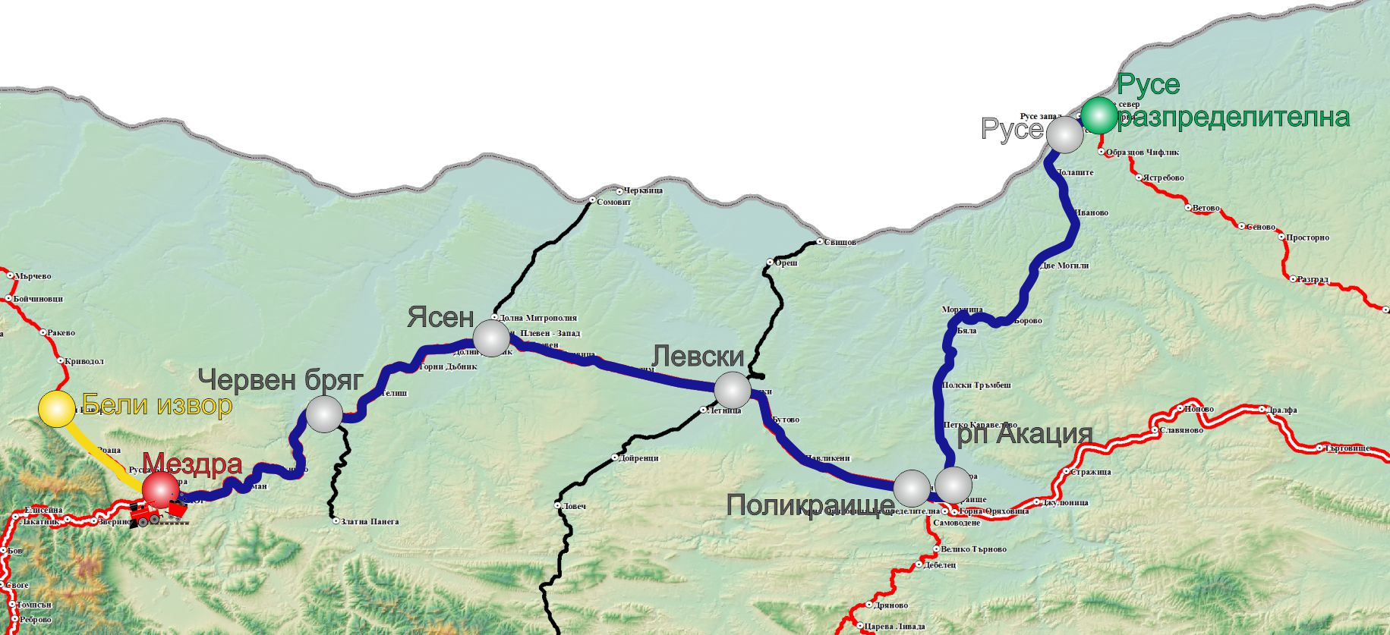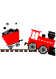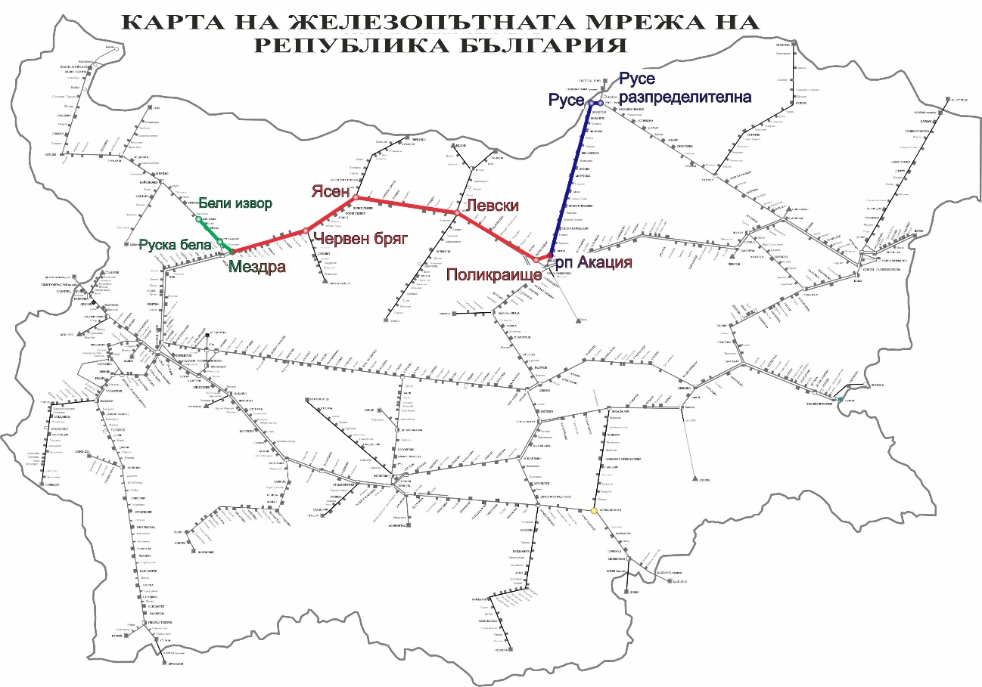

**Fig. 3.5.** **Map of the movement route of DFT № 20692**

* + - 1. *Location of the place of the accident.*

The railway accident occurred between the stations Roman and Mezdra, the ascent of the right wheel of the second wheel-set on the first bogie of the 13th wagon was realized at switch № 101 at km 88 + 956, the rail track is in a straight line with a profile of 1.5 ‰ in downhill. Roman and Mezdra stations are located on the main railway line № 2. The railway line is conventional with speeds up to 130 km/h (Fig. 3.6)

* + - 1. *Meteorological and geographical condition at the time of the event.*
* In the dark part of the day – 22:00 p.m.;
* Air temperature +1ºС;
* Wind speed around 5 km/h;
* Weather – cloudy, with normal visibility of the signals;
  + - 1. *Performance of construction activities on the site or in vicinity.*

Not applicable.

*Fatalities, injuries and material damages:*

* + - 1. *Employees of the railway infrastructure manager or railway undertaking.*

None.

* + - 1. *Other persons officially connected with the location of the event.*

None.

* + - 1. *Passengers.*

None.

* + - 1. *External persons.*

None.

* + - 1. *Cargo, luggage or other property.*

None.

* + - 1. *Environment.*

None.

* + - 1. *Rolling stock.*

• Financial account presented by Bulmarket Rail Cargo EOOD for the damages caused to the derailed five wagons №№ 33536651334-9, 33536653810-6, 33536652646-5, 33536656302-1, 33536654482-3, amounting to BGN 49,647.02.

* + - 1. *Railway infrastructure.*

• Financial account for the damages caused to the rail track and facilities in Mezdra station, because of the derailment, amounting to BGN 9,072.92;

• Financial account for the damages caused to the signalling equipment at Mezdra station, because of the derailment amounting to BGN 3,653.72;

• Total costs for damages: BGN 62 373,66.

* + 1. *Description of other consequences, including the event impact on the usual activity of the participants.*

In the period 14.12 ÷ 16.12.2021, for the reconstruction of the railway infrastructure the manager of the railway infrastructure and the railway undertakings have incurred additional expenses for changing the train schedule:

• Deviated trains of the railway undertakings – none;

• Cancelled trains of the railway undertakings – BGN 1 180,16;

• Appointed trains of the railway undertakings – none;

• Delayed trains of the railway undertakings – none;

• Costs for rehabilitation means – BGN 2 845,00;

Total other costs: BGN 4 025,16.

* + 1. *Identity of the participants and their functions.*
       1. *Railway infrastructure:*
* SE National railway infrastructure company has Safety Authorization № BG 21/2018/0001 valid from 01.07.2018 until 30.06.2023.

*SE NRIC personnel, involved in the accident*:

* Traffic manager on-duty, first person in Mezdra station;
* Traffic manager on-duty, second person in Mezdra station;
* Post switchman in Post № 2 in Mezdra station;

• Post switchman in Post № 1 in Cherven briag station.

* + - 1. *Railway undertaking:*

Bulmarket Rail Cargo EOOD has:

* + - License for performing railway transport services № 212 from 14.05.2015;

▪ Single Safety Certificate № BG 10 2020 0048 from 06.08.2020 valid to 05.08.2025;

▪ Certificate for Entity in charge of maintenance ROLLING STOСK COMPANY SA has ECM Certificate for railway vehicles № СН/31/0221/7405 valid until 12.07.2023.

Bulmarket Rail Cargo EOOD involved in the accident:

* Locomotive driver, first person of locomotive № 91522086004-2;

• Assistant locomotive driver of locomotive № 91522086004-2;

* + 1. *Description of the respective parts of the railway infrastructure and signalling system:*
       1. *Type of the track, railway switch, rail crossing etc.*

Main double-track railway line № 2, electrified in the interstation Roman - Mezdra, switch № 101 is located in an open line in a straight section with a profile of 1.5 ‰ downhill.

* + - 1. *Interstation block system, station installation, type of signalling.*

The Roman - Mezdra interstation is equipped with a semi-automatic block system (SABS). Roman and Mezdra stations are equipped with Route-Relay Interlocking (RRI).

* + - 1. *Train protection systems.*

There is no train protection system along Roman and Mezdra interstation. The stations Roman and Mezdra are equipped with a train dispatching radio connection (TDRC), with the help of which the locomotive driver makes a radio connection with a train dispatcher, with separate stations, with the trains along the respective section.

Locomotive № 91522086004-2 is equipped with an active type vigilance device and an electronic recorder type Program vizualizare inregistrari IVMS, Version 1.0.0.25132, SC Softronic Craiova.

* + 1. *Other information referring the event.*

The train documents „Way-bill“, „Brake mass certificate and „Nature sheet“(fig. 3.7 – 3.10) correspond to the hours of the actual movement of DFT № 20692 under the presented data of the TOMR and the locomotives encryption.

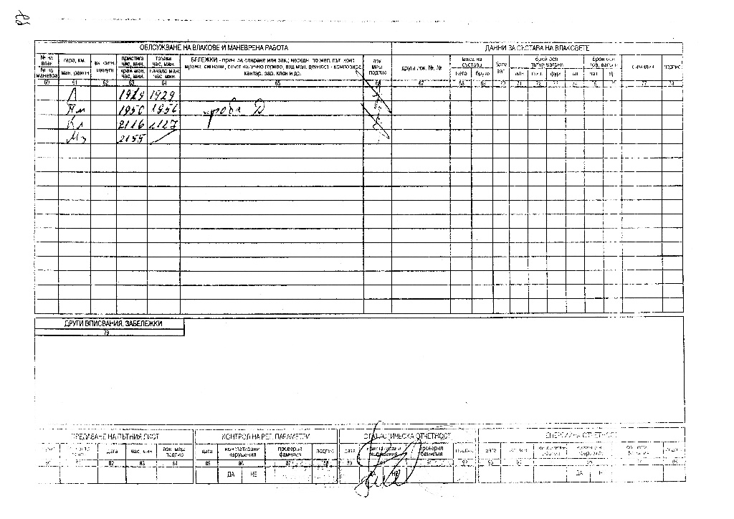

**Fig. 3.7.1. Way-bill of locomotive № 91522086004-2, pg. 2**

**Фиг. 3.7. Пътен лист на локомотив № 91522086004-2, стр. 1**

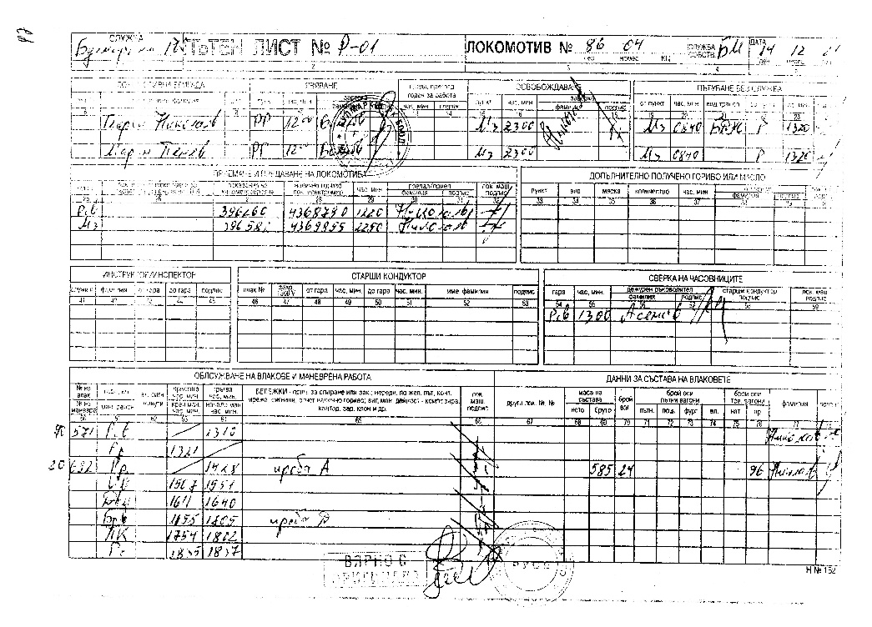

***3.2.Factual description of the occurred***

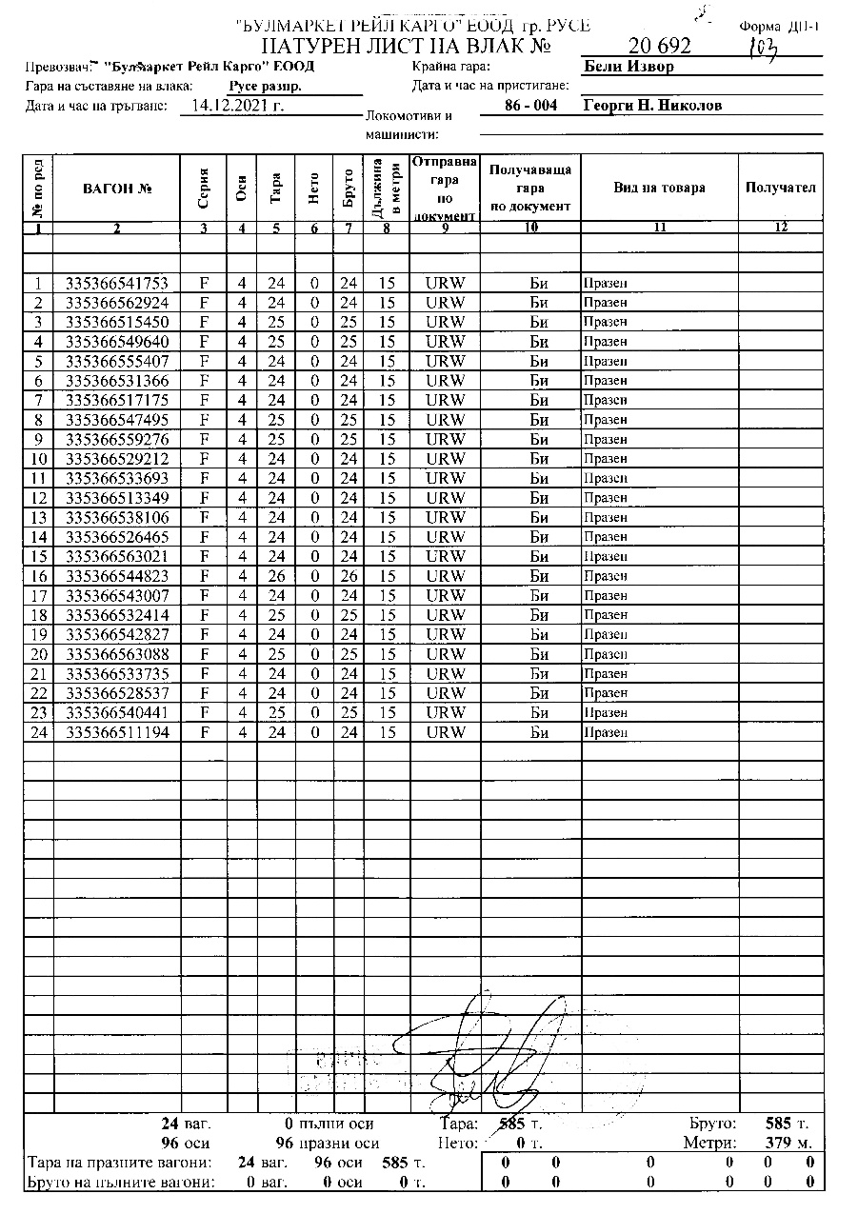

**Fig. 3.10. Nature Sheet of DFT № 20692**

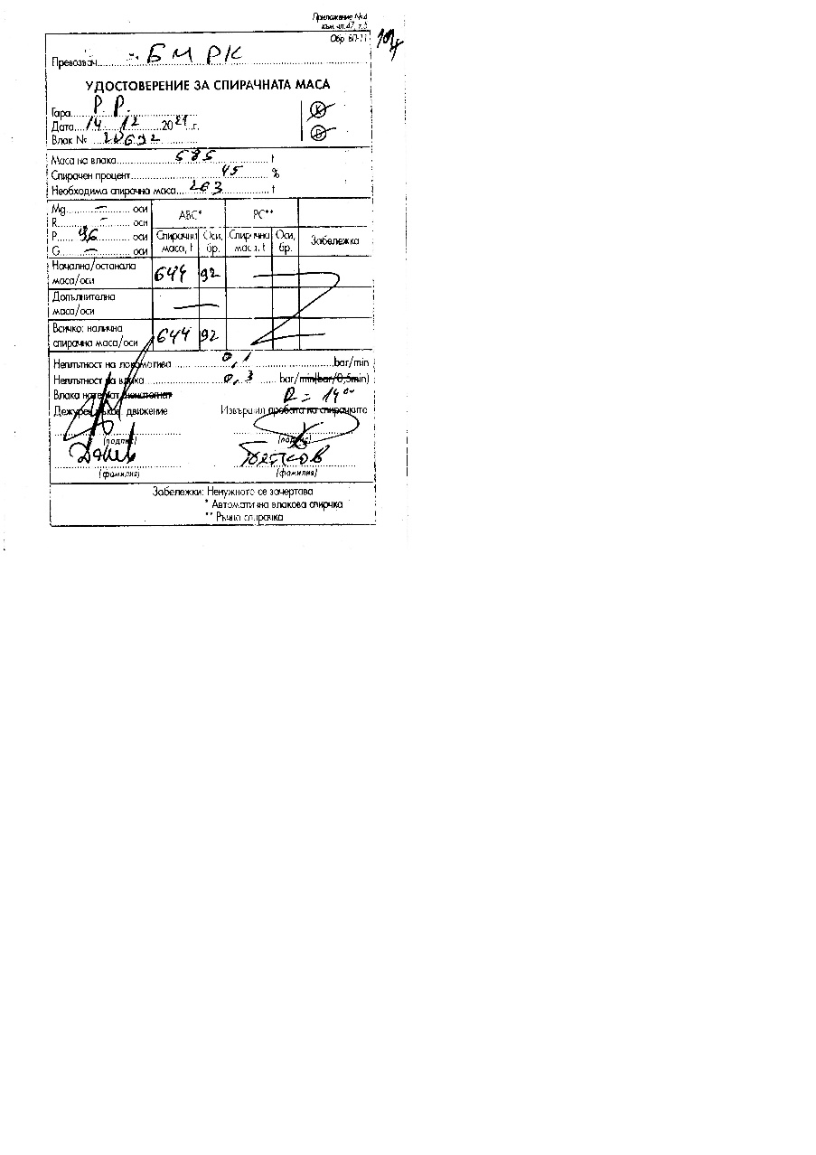

**Fig. 3.8. Brake Mass Certificate of DFT № 20692, front part**

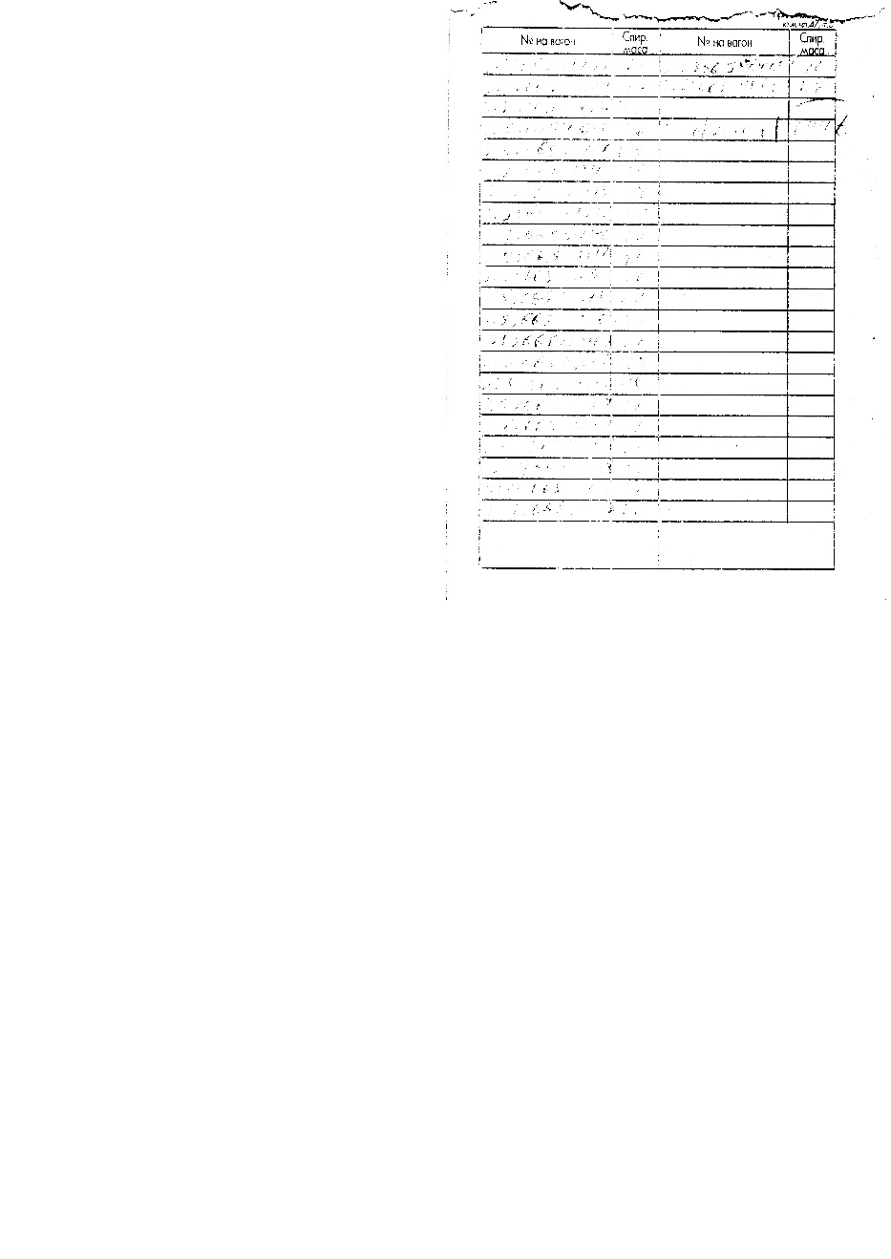

**Fig. 3.9. Brake Mass Certificate of DFT № 20692, rear part**

* + 1. *Immediate sequence of events that led to the accident, including:*
       1. *Actions that the involved in the event persons undertook.*

At 21:07 p.m. DFT № 20692 passed without stopping on the fourth main track of Cherven Bryag station. When the train passed Post № 1, the switchman informed the traffic manager on -duty that when the train passed the wagons made a strange sound and sparks came out of the wheels. The traffic manager on- duty reported to the train dispatcher that sparks were coming out of the train. The train dispatcher ordered the traffic manager on-duty at the Karlukovo station to stop the train at the station for inspection by the locomotive crew. DFT № 20692 stopped at Karlukovo station at 21:19 p.m. on the first acceptance-departure track. The locomotive crew patrolled the train and reported that everything was in order and the train could depart. After a stay of eight minutes DFT № 20692 departed at 21:27 p.m., passed without stopping Kunino station at 21:33 p.m. The train passed also without stopping Roman station at 21:40 p.m. The train was moving at a speed of about 80 km/h.

At 22:00 p.m. DFT № 20692 entered the third acceptance-departure deviation track at Mezdra station and the traffic manager on duty first-person opened the exit signal for passing without stopping the train in the direction of Ruska Byala station. At that moment, the train was moving at a speed of 35 km/h, as evidenced by the transcript of the recording device of locomotive № 91522086004-2.

During the acceptance of DFT № 20692 the traffic manager on-duty, second person at Mezdra station noticed that when the train entered the third track, in the area of switch № 39 the train stopped quickly.

While accepting DFT № 20692 switchman at Post № 2 at Mezdra station noticed that part of the train derailed and hit the switch apparatuses at switch № 9 and № 11, then stopped at 22:03 p.m. After the switchman of Post № 2 inspected the place, he found that the train was split and had a derailed group of wagons, for which he informed the traffic manager on-duty, first person at Mezdra station. Following the report received from the switchman, the traffic manager on-duty first person, according to the Emergency Action Plan, notified the interested officials.

After the stopping of DFT № 20692 at 22:03, the locomotive drivers inspected the train and the railway infrastructure and found that five wagons of the train derailed and caused damages to the rail track and facilities.

* + - 1. *Rolling stock and technical facilities functioning.*

Until the moment of the accident, the rolling stock, incl. the locomotive and 24 wagons were technically sound and were functioning normally.

The rail track at the Roman - Mezdra station at the time of derailment was technically up to standard, as evidenced by the measurements of the parameters of the rail track at the time of derailment, reflected in the Statement of Findings of 15.12.2021 by the Task Force and an extraction of tape for the section of measurement from track measuring laboratory from 2021.

With a Protocol from November 2021, a monthly inspection of the railway facilities and devices at Mezdra station was performed, in connection with the requirements of Art. 392 of the Rules for technical operation of the railway infrastructure of SE NRIC, all switches and tracks in the station meet the requirements for safe operation in accordance with Art. Art. 46,47,48 and 49 of Ordinance № 58.

* + - 1. *Operational system functioning.*

The operational system is regular with proper functions.

* + 1. *Sequence of events from the beginning of the accident to the end of the rescue services actions:*

At 21:55 p.m., when DFT № 20692 passed through switch № 101 in the area after the frog, the right wheel of the second wheel-set bounced on the first bogie of wagon № 33536653810-6 -13th and subsequently derailed. The train continued to run at 35 km/h and at switch № 1 at 22:00 p.m. four more wagons derailed, № 33536652646-5 -14th, № 33536656302-1 -15th, № 33536654482-3 - 16th and № 33536651334-9 - 12th of the train composition. While entering in Mezdra station on the third track, after the separation of the train between the 13th and 12th wagon, the first 11 non-derailed wagons with the locomotive stopped on the third track at 22:03 p.m., and the last 8 non-derailed wagons stopped on the current track № 2 Roman station side.

* + - 1. *Undertaken measures for protecting and guarding the event location.*

After the arrival of the bodies of the Regional Directorate of the Ministry of Interior - Mezdra and clarification of the situation, the region was seceded. External persons were not allowed, except for the bodies of the pre-trial proceedings, the Investigation Commission of the NAMRTAIB and the interested officials. Access to the media was limited.

* + - 1. *Actions of the emergency rescue services.*

Not applicable.

* + - 1. *Actions of the emergency rehabilitation services.*

On 14.12.2021 at 23:07 p.m. a senior train dispatcher in RODU - Sofia authorized the movement of rehabilitation means of the rehabilitation services of Mezdra and Sofia for emergency recovery works at Mezdra station.

On 14.12.2021 at 23:15 p.m. in Mezdra station, an UNIMOG recovery vehicle from the Mezdra rehabilitation service arrived and began restoration work at 01:35 a.m.

On 15.12.2021, at 02:30 a.m., a UNIMOG reconstruction vehicle from the Sofia Rehabilitation Service arrived at Mezdra station and began reconstruction works.

On 15.12.2021 at 04:32 a.m. in Mezdra station a recovery train from the Sofia Rehabilitation Service arrived and started reconstruction works.

At 00:57 a.m. from Roman station RSPM № 99529801001-9 was sent on track № 2 to km 88 + 204 to withdraw the last eight wagons from DFT № 20692 back to Roman station to free the hole and the interstation Mezdra - Roman track № 1 for starting the emergency recovery works. The train of eight wagons towed by RSPM № 99529801001-9 arrived on the fourth free track at Roman station at 02:40 a.m.

Wagon № 33536654482-3 - 16th of the train composition was lifted at 02:50 a.m. by hydraulic means and submitted to the track at the Mezdra Locomotive Depot.

Wagon № 33536656302-1 - 15th of the train composition was lifted at 03:00 a.m. by hydraulic means and placed on the track at the Mezdra Locomotive Depot.

Wagon № 33536652646-5 - the 14th of the train composition was lifted at 03:15 a.m. by hydraulic means and placed on the track at the Mezdra Locomotive Depot.

Wagon № 33536651334-9 - 12th of the train composition was lifted at 05:30 a.m. with a recovery crane and placed on the seventh track.

Wagon № 33536653810-6 - 13th of the train composition was lifted at 06:50 by hydraulic means and submitted to the eighth track.

After a visual inspection and measurements of the parameters of the rail track by representatives of Vratsa Railway Section at 04:25 a.m. on 15.12.2021 the movement of all trains and railway vehicles on the second track was restored, continuation of the current track № 2, with speed according to the schedule book.

After emergency restoration works on the superstructure of the rail track and repair on the axis and level by representatives of Vratsa Railway Section was allowed the movement of all trains and railway vehicles on the third track at Mezdra station along the current track № 1 and on the straight line elements of switches № 9, 11, 21, 23, 31 and 33. The switches were locked for the straight element with RHC type "Hook-bolt" and the movement of all trains and railway vehicles was allowed from 20:10 p.m., at a speed according to the schedule book.

With a protocol from 15.12.2021 of the Regional Directorate - Mezdra it was ordered to the Regional Directorate of the Ministry of Interior - Mezdra for responsible guarding of wagon № 33536653810-6 of DFT № 20692 in connection with an investigation into the pre-trial proceedings, to keep it in the area of the WR Mezdra depot until the end of the investigation.

1. **Analysis of the event**

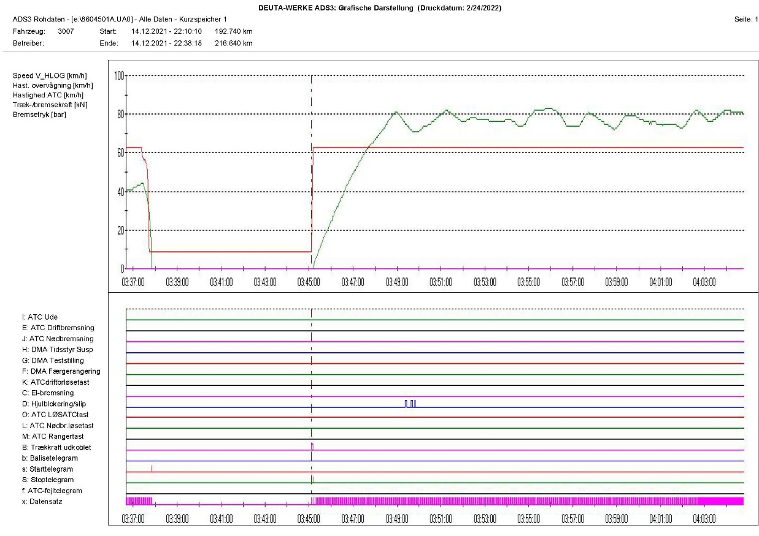

**Fig. 4.1. Diagram of departure time of DFT № 20692 from Karlukovo station.**

***1***

* 1. ***Participation and responsibilities of the entities, involved in the event***
     1. *Railway undertaking.*
        1. *Analysis of the movement of DFT №20692.*

An analysis of the movement of DFT № 20692 was made for the section from the last stop of the train at Karlukovo station to the moment of stopping at Mezdra station. However, it should be noted that the movement from Resen station to Mezdra station was several times exceeded than the permissible speed between trains up to 3 km/h, which lasted several kilometres.

The train departed from Karlukovo station at 21:27 p.m., reflected in the waybill, but the recording device of the locomotive registered 22:18:38 p.m., i.e. the time in which the train departed according to the recording of the device differs from the astronomical one by more than 1 hour. The time used by the markers of the locomotive recording device was used in the analysis.

DFT № 20692 departed from Karlukovo station at 22:18:38 p.m., accelerated for 2,945 meters and reached a speed of 81 km/h, after which the speed decreased to 71 km/h and continued to fluctuate between 71 and 83 km/h. when running along the interstation (Fig. 4.1). Several times the speed exceeded the allowable for the section for several kilometres (Fig. 4.1, pos. 1).

From 22:45:56 p.m. started to reduce gradually from 80 km/h to 24 km/h at 22:49:21 p.m. for 2 975 meters in 3 minutes (fig. 4.2). During that time, the locomotive driver held with the automatic train brake and the pressure in the main air duct decreased from 5,0 to 4,4 bar (fig. 4.2, pos. 1). As a result, from the decrease of the pressure in the main air duct, the speed reduced from 70 to 33 km/h (fig. 4.2, pos. 2). During that time, the train passed 540 meters for 32 seconds. For the infrastructure in the moment of retention, the locomotive was located at km 86+169. The end of retention was at km 86+709, which was 2 245 meters before the ascending point of the wheel on the rail head (fig. 4.2, pos. 3).

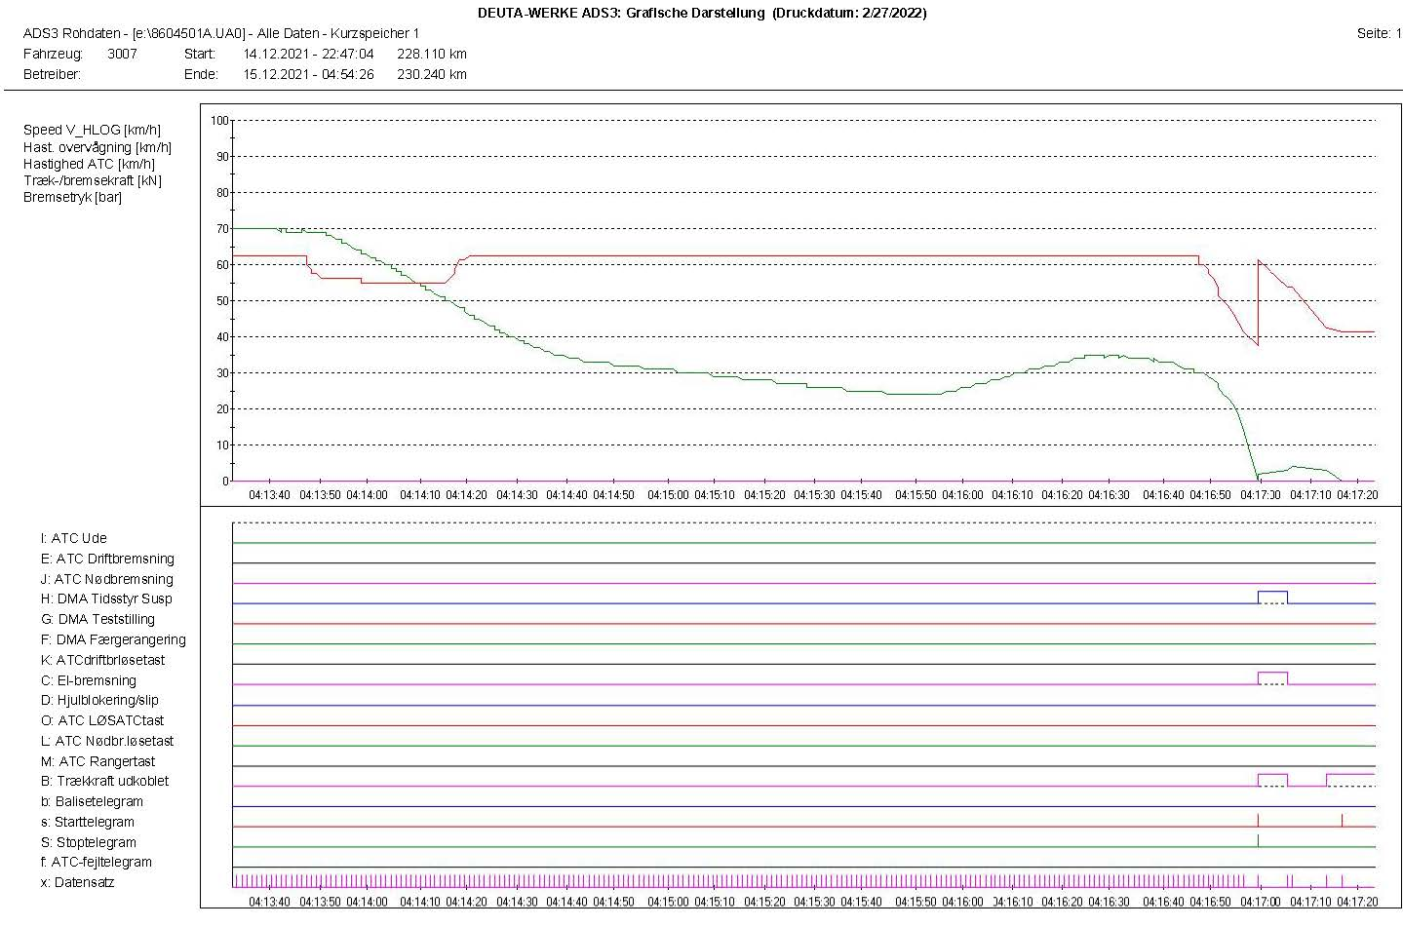

**Fig. 4.3. Diagram of the passed track of DFT № 20692 until the entering in Mezdra station.**

***1***

***3***

***2***

***5***

***4***

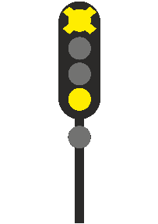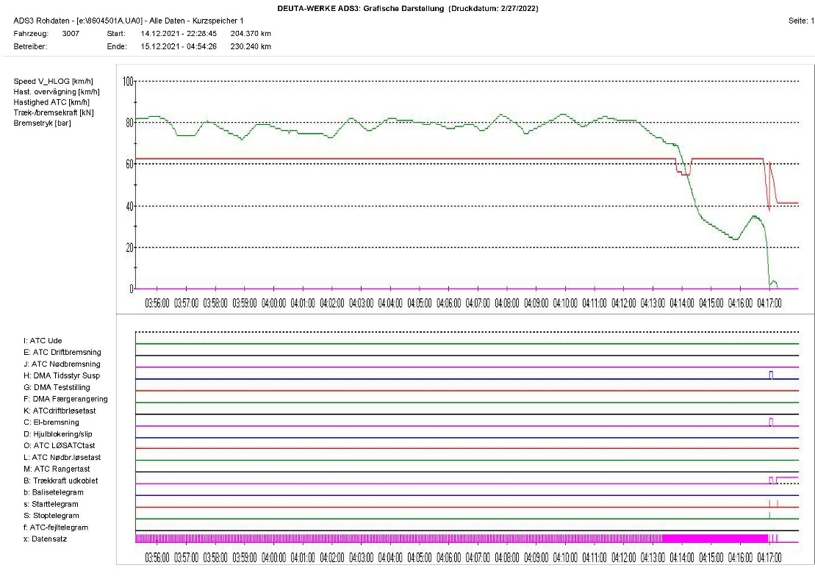

**Fig. 4.2. Diagram of movement of DFT № 20692 from Karlukovo station to the stopping in Mezdra station.**

***1***

***2***

***3***

After the recovery of the pressure in the main air duct, the speed continued to reduce and after 755 meters achieved 24 km/h (fig. 4.3, pos. 1), after that started to increase and after 290 meters reached 35 km/h (fig. 4.3, pos. 2). With that speed, the train entered in Mezdra station.

At 22:50:19 p.m. when the locomotive was located at km 87 + 944 at a speed of 30 km/h the automatic train brake was applied due to the splitting of the train (Fig. 4.3, pos. 3). From that moment, the speed began to decrease rapidly and at 22:50:31 p.m. it reached a speed of 0 km/h per km 87 + 989 on the third track at Mezdra station (Fig. 4.3, pos. 4). That was followed by a sharp increase in the pressure in the main air duct from 3.0 to 4.9 bar and an increase in speed up to 4 km/h due to the derailment of the five wagons of the train, and under these conditions the train run another 20 meters at km 88 + 009 (Fig. 4.3, pos. 5).

During the movement of DFT № 20692 from Ruse marshalling yard to Mezdra station in order to regulate the speed and to stop the train, the locomotive driver has repeatedly applied the automatic train brake; the total distance travelled by the train in braking mode was about 55 kilometres. That has always led to an increase in the temperature in the friction unit wheel - pad and to some extent probably contributed to the expansion and rotation of the bandage (flange) bracelet on the pressed wheel.

* + - 1. *Analysis of the derailed wheel assembly.*

The probable cause for the accident is the broken flange-disc assembly of the right wheel of the second wheel-set of the first bogie of wagon № 33536653810-6 (13th of the train in the direction of travel). From the photo shown in Figure 4.4, it can be seen that after the flange was sprayed, it passed into the middle zone of the axle (between the two wheels). Theoretically, this should be impossible.

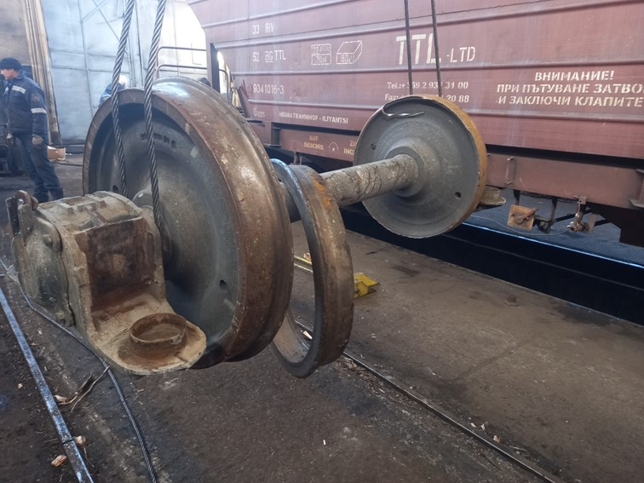

**Fig. 4.4. Flange bracelet of the right wheel.**

***2***

***1***

The rolling of the bandage (flange) is the result of a set of factors combining the realization of braking force by pressing the pads to the flange bracelet during the braking processes while the wagon was moving, and the transverse forces were acting on the wheel when passing through curves and switches.

The mounting of the bandage (flange) to the disc was done by hot-press assembly (preheating of the bandage (flange) bracelet, placing the disc with the shaft in the flange, subsequent cooling and "tightening" of the joint and placing a safety ring (indicated by position 7 in Fig.4.5).

Wagon № 33536653810-6 is property of ROLLING STOСK COMPANY SA – Romania, manufactured in 1986 – the latest revision of the wagon was performed on 31.10.2018/6+3М/ SIM.

On Fig.4.5. is displayed the drawing of the wheel-set construction (the left section in the drawing refers to flange wheel, and in the right is for flangeless/single block/ wheel).

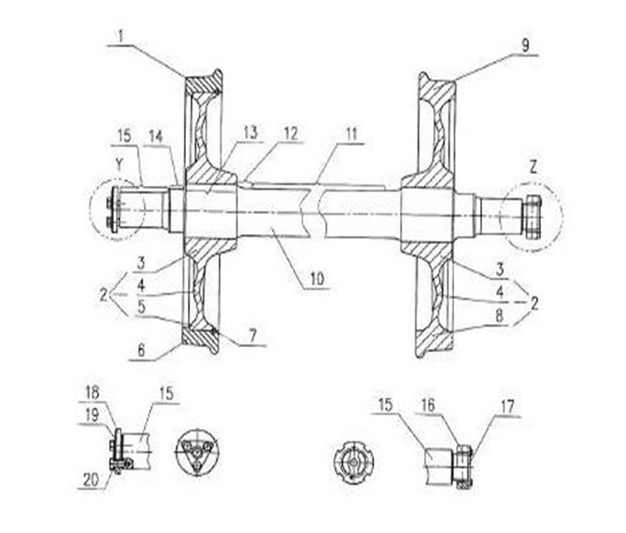

**Fig. 4.5. Constructive drawing of the flange and single block wheel.**



On fig.4.6. is shown the drawing of the flange with several cuttings.

Cutting „А“ is shows the technological groove, where the safety ring is installed, which (after possible release of the assembly) obstructs the extraction of the flange outside from the wheel, i.e. to the box.

Section "B" shows the securing board of the band (with an inner diameter that is 20 mm smaller than the outer diameter of the disc). In other words, the designers designed the flange and the wheel in a way that would prevent the flange from entering the area between the two wheels, but in fact, that happened in the investigated accident (Fig. 4.4).

The comparison of the drawing of the flange (Fig. 4.6) with the picture of the flange (Fig. 4.8) shows that the groove for the safety ring (section "A" in Fig. 4.6) is not visible due to wear of the safety ring from friction between the disc and the flange.

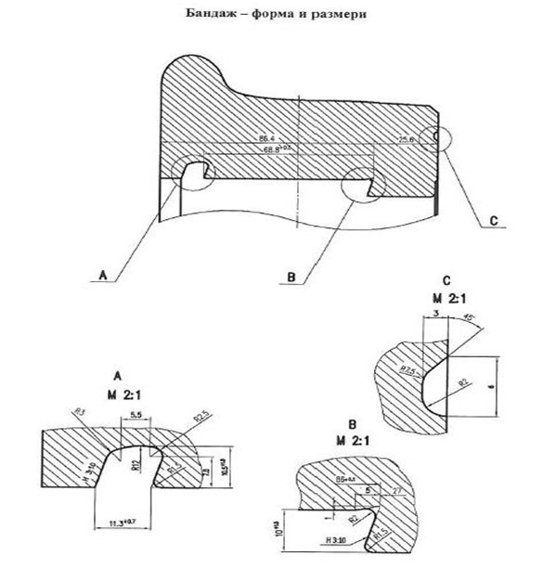

**Fig. 4.6. Drawing/flange cutting**

The above finding suggests that the bandage/flange was "rolled over" (the flange-disc assembly was broken) before the accident. The process of rolling between the disc and the flange during movement has led to wear of the disc and the bandage (flange) bracelet, Fig.4.8.

The moment the part of the safety ring that was supposed to interfere the fell of the flange from the wheel (even the assembly between them is compromised), was completely worn, the axle displacement of the flange with respect to the wheel on the axle has already not been limited.

From the results of the measured diameters of the wheel and the flange (after the accident), was found that the flange was with ellipse form (most probably because of its passing through the wheel, which is with greater external diameter from the internal diameter of the flange in the area of cutting „В“). That conclusion is based on fig.4.7. A sign confirming this hypothesis is the presence of a large flared part of the inner edge of the wheel (see Fig.4.4). An important factor for the passage of the already compressed flange in the area of the axle is the presence of significant guiding forces (horizontal / transverse) in the wheel-rail contact when passing through railway switches and crossings. On fig. 4.9 is displayed the cut on 02.03.2022 flange, which confirms the above conclusions. In the achieved sections are clearly defined:

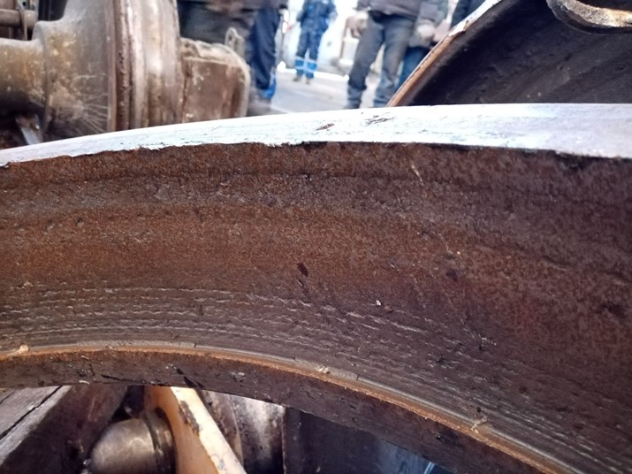

**Fig. 4.8. Part of the inner surface of the rolled flange.**

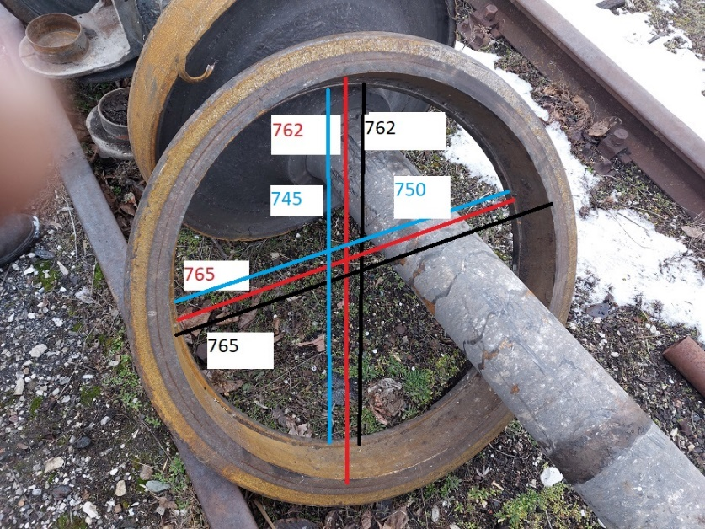

**Fig. 4.7. Measured diameters of the flange (А) and of the disc (В) in two sections.**

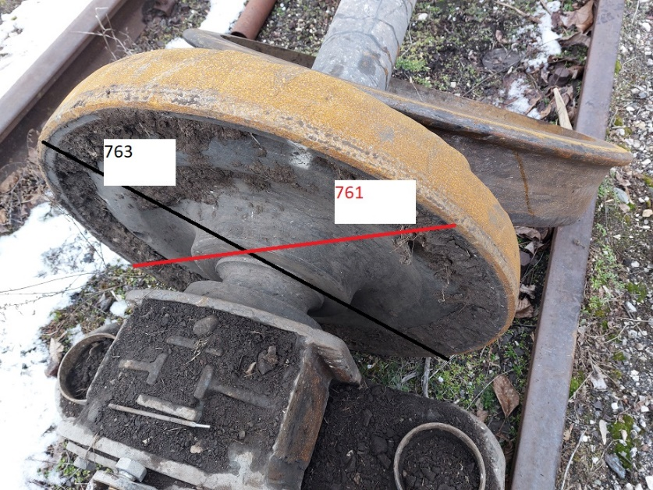

**А**

**В**

* The safety ring (what remained from it after the flange „rolling”);
* cracks in the flange area (Fig.4.6, to the left of cut „А”).

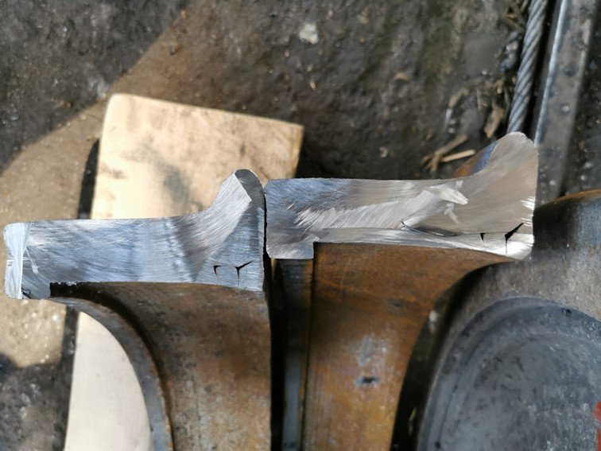

**Fig. 4.9 Transversal cut of the flange bracelet of the derailed wheel.**

**Safety ring**

**Crack in the flange area, to the left of cut „А” (Fig.4.6)**

* + 1. *Infrastructure manager.*
       1. *Analysis of the track under level*

The data taken from the Statement of Findings of the Task Force additionally performed by the Investigation Commission measurements on-site.

1. Cant transitions based on the distance between the central bolts of the thirteenth wagon

(L = 9 м).

А) Before the place of ascend;

Т. „0“ = 9 mm; p.9 = 5 mm; Difference = 4 mm

K = $\frac{L}{H}=\frac{9m.}{4mm.}=\frac{9000mm.}{4mm.}=2250;К=1:2250$

B) After the place of ascend;

Т. „0“ = 9 mm; p.(-9) = -6 mm; Difference = 15 mm

K = $\frac{L}{H}=\frac{9m.}{15mm.}=\frac{9000mm.}{15mm.}=600;К=1:600$

1. Transition in cant based on the distance between the wheel-sets and the bogie 1800 mm.

А) Before the place of ascend;

Т. „0“ = 9 mm; p.2 = 10 mm; Difference = 1 mm

K = $\frac{L}{H}=\frac{1.8m.}{1mm.}=\frac{1800mm.}{1mm.}=1800;К=1:1800$

B) After the place of ascend;

Т. „0“ = 9 mm; p.(-2) = 8 mm.; Difference = 1 mm.

K = $\frac{L}{H}=\frac{1.8m.}{1mm.}=\frac{1800mm.}{1mm.}=1800;К=1:1800$

The transitions in cant respect all the technical norms.

* + - 1. *Analysis of the rail track under rail gauge.*

Status of the rail track under rail gauge:

A) Before the point of ascent;

point "0" of rise = + 3 mm (1438 mm); adjacent measurements item 1 = + 2 mm (1437 mm), item (- 1) = + 4 mm (1439 mm)

Maximum track gauge = 6 + 9 mm (1444 mm)

B) After rising point;

Maximum at point -2 = + 5 mm (1440 mm)

The track gauge meets all technical standards.

There is no missing and upstretched fastening around the place of ascent, no hidden collapses/ twists have been found, as well as a hardened ballast prism.

* + 1. *Entities in charge of the technical maintenance.*

Not applicable.

* + 1. *Manufacturers or providers of rolling stock and railway products.*

Not applicable.

* + 1. *National Safety Authority.*

Railway Administration Executive Agency is the National Safety Authority for railway transport in the Republic of Bulgaria.

* + 1. *Notified bodies or Risk assessment bodies.*

Not applicable.

* + 1. *Certifying bodies of the entities in charge of maintenance.*

The Railway Administration Executive Agency as the National Safety Authority for railway transport performs certification of the entities in charge of the vehicles maintenance (ECM) in accordance with Directive 2004/49/EC and Regulation (EU) 445/2011, as per Ordinance No 59 on the railway transport safety management and on the maintenance functions in accordance with Directive 2004/49/EC and Regulation (EU) 445/2011.

From June 16, 2020 the RAEA performs certification of the ECM as per the Commission Implementing Regulation (EU) 2019/779 of 16 May 2019 laying down detailed provisions on a system of certification of entities in charge of maintenance of vehicles pursuant to Directive (EU) 2016/798 of the European Parliament and of the Council and repealing Commission Regulation (EU) No 445/2011.

The derailed wagon is registered with the owner, user and ECM - the company ROLLING STOСK COMPANY SA. That company holds a certificate with SIN № CH / 31/0221/7405 issued by a certification body SCONRAIL Ltd, Zuercherstrasse 41, 8400 Winterthur, Switzerland with EIN Number: CH / 30/0221/0001.

In this case, the National Safety Authority RAEA has no relation to the certified entity in charge of maintenance.

* + 1. *Persons or entities involved in the event, documented or not in the respective safety management systems or indicated in register.*

Not applicable.

* 1. ***Rolling stock and technical facilities:***
     1. *Factors, deriving from the design of the rolling stock, railway infrastructure or technical facilities.*

Not applicable.

* + 1. *Factors deriving from the installation and placing into service of the rolling stock, railway infrastructure and technical facilities.*

Not applicable.

* + 1. *Factors deriving from manufacturers or another provider of railway products.*

Not applicable.

* + 1. *Factors due to the entity in charge of the technical maintenance, workshops for technical maintenance and other technical maintenance service providers.*

Not applicable.

* + 1. *Factors due to the entity in charge of the technical maintenance, workshops for technical maintenance and other technical maintenance service providers.*

Not applicable.

* + 1. *Other factors or consequences considered as involved within the investigation objectives.*
       1. *Loading of the wagons.*
  1. ***Human factor:***
     1. *Individual human characteristics:*
        1. *Training and development, including skills and experience.*

*Railway undertaking:*

• Locomotive driver of locomotive № 91530400605-8 – License № 389 for obtaining professional qualification „Locomotive driver of electric locomotives“, training performed within the period 10.04.÷29.06.1989 issued by Professional Training Centre (PTC) of Bulgarian State Railways (BDZ);

Locomotive driving license BG 71 2016 0039 issued by RAEA;

License № 28 for position, “Locomotive driver in Bulmarket Rail Cargo EOOD from 01.09.2015.

Additional certificate issued on 22.12.2015 by Bulmarket Rail Cargo EOOD for rolling stock for which the driver is allowed to drive - series 85.000, 86.000 and 87.000 from 13.03.2019 on the national railway infrastructure of the Republic of Bulgaria to 12/22/2024.

• Assistant locomotive driver of locomotive № 91530400605-8 – License № 22757 for obtaining professional qualification „Assistant locomotive driver“, training performed within the period 17.07.÷30.09.2020 in Professional Training Centre (PTC) of Bulgarian State Railways (BDZ), issued by RAEA;

License № 25 for position, “Assistant locomotive driver in Bulmarket Rail Cargo EOOD from 12.04.2021.

*Railway infrastructure:*

• Traffic manager, first person in Mezdra station – Diploma № 23291 ,,Traffic manager” training performed within the period 20.08.1986 ÷ 19.08.1989 issued by HMS Todor Kableshkov;

License № 262 for position Traffic Manager TOSAMD – Sofia from 25.09.2007.

• Traffic manager, second person in Mezdra station – Higher School Diploma № 000193, from 28.07.1997, Railway traffic“, professional qualification, Traffic manager“, issued by HMS Todor Kableshkov.

License № 199 for position Traffic manager in TOSAMD – Sofia from 25.10.2007.

• Switchman/ level-crossing guard in Mezdra station – License № 15044 for obtained qualification for „Switchman/level-crossing guard“, training performed within the period 10.11.1997÷20.01.1998 issued by Professional Training Centre (PTC) of Bulgarian State Railways (BDZ);

License № 3880 for position, Switchman/level-crossing guard at TOSAMD – Sofia from 24.11.2014.

• Switchman/ level-crossing guard in Cherven briag station – License № 13888 for obtained qualification for “Switchman”, training performed within the period 06.02.÷22.03.1995 issued by Professional Training Centre (PTC) of Bulgarian State Railways (BDZ);

License № 4562 for position, Post switchman“ in TOSAMD – Sofia from 20.06.2017.

* + - 1. *Medical and personal circumstances, which influence the event, including the presence of physical and psychological stress.*

*Railway undertaking:*

• Locomotive driver of locomotive № 91530400605-8:

Card for preventive examination from 16.02.2021, issued by the Labour Medicine Service - Ruse.

Conclusion: suitable for locomotive driver.

Psychological exam № 751/25.07.2019, issued by the Psychological Laboratory - Railway Transport Gorna Oryahovitsa at the Sofia Multi-profile National Transport Hospital for a locomotive driver.

Conclusion: allowed for a period of 3 years.

• Assistant locomotive driver of locomotive № 91530400605-8:

Card for preliminary medical examination from 29.03.2021, issued by the National Multi-profile Transport Hospital - Gorna Oryahovitsa Railway Transport.

Conclusion: suitable for assistant locomotive driver.

Psychological exam № 419/29.03.2021, issued by the Psychological Laboratory - Gorna Oryahovitsa Railway Transport at the National Multi-profile Transport Hospital Sofia for a locomotive driver.

Conclusion: allowed for a period of 3 years.

*Railway infrastructure:*

• Traffic manager, first person in Mezdra station:

Single-health dossier № 196 from 03.02.2021, issued by National Multi-profile Sofia Transport Hospital.

Conclusion - suitable.

Psychological exam № 923/11.08.2020, issued by the Psychological Laboratory - Railway Transport Sofia at the National Multi-profile Transport Hospital Sofia as a traffic manager.

Conclusion: allowed for a period of 3 years.

• Traffic manager, second person in Mezdra station:

Single-health dossier № 3910 from 27.10.2021, issued by National Multi-profile Transport Hospital Sofia.

Conclusion - suitable.

Psychological exam № 1056/12.10.2021, Psychological Laboratory - Railway Transport Sofia at the National Multi-profile Transport Hospital Sofia as a traffic manager.

Conclusion: allowed for a period of 5 years.

• Switchman / level crossing guard in Mezdra station:

Single-health dossier № 2052 from 27.10.2021, issued by National Multi-profile Transport Hospital Sofia.

Conclusion - suitable.

Psychological exam № 413/25.03.2021 issued Psychological Laboratory - Railway Transport Sofia at the National Multi-profile Transport Hospital Sofia for switchman/level-crossing guard.

Conclusion: allowed for a period of 3 years.

• Post switchman in Cherven briag station:

Single-health dossier № 3620 from 28.10.2020, issued by National Multi-profile Transport Hospital Sofia.

Conclusion - suitable.

Psychological exam № 980/27.09.2021 issued Psychological Laboratory - Railway Transport Sofia at the National Multi-profile Transport Hospital Sofia for Post switchman.

Conclusion: allowed for a period of 3 years.

*4.3.1.3. Fatigue.*

*Railway undertaking:*

• Locomotive driver I-st person of locomotive № 91530400605-8:

Break/rest: from 09:50 a.m. on 13.12.2021 until 12:00 p.m. on 14.12.2021 (14 hours and 10 minutes);

• Assistant locomotive driver of locomotive № 91530400605-8:

Break/rest: from 23:40 p.m. on 12.12.2021 until 12:00 p.m. on 14.12.2021 (38 hours and 10 minutes);

*Railway infrastructure:*

• Traffic manager, first person in Mezdra station:

Break/rest: from 19:00 p.m. on 12.12.2021 until 18:00 p.m. on 14.12.2021 (47 hours and 00 minutes);

• Traffic manager, second person in Mezdra station:

Break/rest: from 19:00 p.m. on 11.12.2021 to 18:00 p.m. on 14.12.2021 (71 hours and 00 minutes);

• Switchman / level crossing guard in Mezdra station:

Break/rest: from 19:00 p.m. on 13.12.2021 until 18:00 p.m. on 14.12.2021 (23 hours and 00 minutes);

• Post switchman in Cherven briag station:

Break/rest: from 19:00 p.m. on 13.12.2021 until 18:00 p.m. on 14.12.2021 (23 hours and 00 minutes);

* + - 1. *Motivation and attitudes.*

Not applicable.

* + 1. *Work related factors:*
       1. *Tasks planning.*

Bulmarket Rail Cargo EOOD performs rail freight transport under the Train Composition Plan, appointed in the Train movement schedule and additionally assigned trains for movement by the railway undertaking with requests to the Railway Infrastructure Manager to develop timetables in the Schedule of movement.

SE NRIC - Railway Infrastructure Manager for maintenance, repair and operation of railway infrastructure.

* + - 1. *Constructive particularities of the facilities that influence the connection human-machine.*

Not applicable.

* + - 1. *Communication means.*

Not applicable.

* + - 1. *Practices and processes.*

Not applicable.

* + - 1. *Operation rules, local instructions, staff requirements, prescriptions for technical maintenance and applicable standards.*

Application of the European, national and internal normative acts and standards.

* + - 1. *Working time of the involved personnel.*

The staff involved in the accident of both entities SE NRIC and Bulmarket Rail Cargo EOOD works in shifts regime of 12-hour working shift. In accordance with the requirements of the normative acts - Labour Code and Ordinance № 50 of 28.12.2001 for the working hours of the managerial and executive staff, engaged in providing the transportation of passengers and freights in the railway transport. At the time of the accident, the requirements of the regulations for rest and working hours of the personnel involved in the accident have been met.

*Risk treatment practices.*

• SE NRIC applies safety procedure SP 2.09 „Methods of evaluation, assessment and management of the risk „version 05 effective from 01.03.2019, which is part of the SMS..

Bulmarket Rail Cargo EOOD applies the following procedures:

• SP-48 Methodology for risk analysis and assessment;

• SP-56 Safety Management;

• SP-39 Identification of risks related to external parties in relation to the railway system;

* + - 1. *Context, machinery, equipment and indications for shaping the working practices*

Not applicable.

* + 1. *Organizational factors and tasks:*
       1. *Planning of the working force and the working load.*

The work is planned in accordance with the requirements of the national regulations, developed methodologies and good practices concerning the personnel directly related to the railway safety.

* + - 1. *Communications, information and teamwork.*

Not applicable.

* + - 1. *Recruitment, staffing requirements, resources.*

The staff in both entities is selected and appointed to the relevant position with proven legal capacity, professional qualifications and skills for the respective positions.

* + - 1. *Implementation management and supervision.*

Not applicable.

* + - 1. *Compensation (remuneration).*

The personnel involved in the accident by both entities, in accordance with the requirements of national regulations, have permanent employment contracts, which determine and regulate the relevant remuneration and compensation for each position.

* + - 1. *Leadership, powers related issues.*

Not applicable.

* + - 1. *Organizational culture.*

Not applicable.

* + - 1. *Legal issues (including the respective European and national rules and provisions).*

Not applicable

* + - 1. *Regulatory framework conditions and safety management system application.*

*Railway undertaking.*

* Directive (EU) 2016/798 of the European Parliament and of the Council of 11 May 2016 on railway safety;
* Commission Delegated Regulation (EU) 2018/762 of 8 March 2018 establishing common safety methods on safety management system requirements pursuant to Directive (EU) 2016/798 of the European Parliament and of the Council and repealing Commission Regulations (EU) No 1158/2010 and (EU) No 1169/2010
* COMMISSION IMPLEMENTING REGULATION (EU) 2019/779 of 16 May 2019 laying down detailed provisions on a system of certification of entities in charge of maintenance of vehicles pursuant to Directive (EU) 2016/798 of the European Parliament and of the Council and repealing Commission Regulation (EU) No 445/2011;
* COMMISSION IMPLEMENTING REGULATION (EU) No 402/2013 of 30 April 2013 on the common safety method for risk evaluation and assessment and repealing Regulation (EC) No 352/2009;
* Railway Transport Act;
* ORDINANCE No 59 dated 5.12.2006 on the railway transport safety management.

*Railway infrastructure.*

* Directive (EU) 2016/798 of the European Parliament and of the Council of 11 May 2016 on railway safety;
* Commission Delegated Regulation (EU) 2018/762 of 8 March 2018 establishing common safety methods on safety management system requirements pursuant to Directive (EU) 2016/798 of the European Parliament and of the Council and repealing Commission Regulations (EU) No 1158/2010 and (EU) No 1169/2010
* COMMISSION IMPLEMENTING REGULATION (EU) 2019/779 of 16 May 2019 laying down detailed provisions on a system of certification of entities in charge of maintenance of vehicles pursuant to Directive (EU) 2016/798 of the European Parliament and of the Council and repealing Commission Regulation (EU) No 445/2011;
* COMMISSION IMPLEMENTING REGULATION (EU) No 402/2013 of 30 April 2013 on the common safety method for risk evaluation and assessment and repealing Regulation (EC) No 352/2009;
* Railway Transport Act;
* ORDINANCE No 59 dated 5.12.2006 on the railway transport safety management.
  + 1. *Environmental factors:*
       1. *Labour conditions (noise, illumination, vibrations).*

Not applicable.

* + - 1. *Meteorological and geographic conditions.*

• Mezdra station geographically is located in the northwestern part of the rail network;

* In the dark part of the day – 22:00 p.m.;
* Air temperature +1ºС;
* Wind speed and direction around 5 km/h;
* Weather – cloudy with normal visibility of the signals;
  + - 1. *Construction works, performed on the spot or in very proximity.*

Not applicable.

* + 1. *Any other significant factor for the investigation objectives.*

Not applicable.

* 1. ***Feedback and control mechanisms, including risk and safety management, as well as monitoring processes:***
     1. *Regulatory framework conditions.*

Commission Delegated Regulation (EU) 2018/761 of 16 February 2018 establishing common safety methods for supervision by national safety authorities after the issue of a single safety certificate or a safety authorisation pursuant to Directive (EU) 2016/798 of the European Parliament and of the Council and repealing Commission Regulation (EU) No 1077/2012

COMMISSION IMPLEMENTING REGULATION (EU) 2019/779 of 16 May 2019 laying down detailed provisions on a system of certification of entities in charge of maintenance of vehicles pursuant to Directive (EU) 2016/798 of the European Parliament and of the Council and repealing Commission Regulation (EU) No 445/2011, stipulated in:

*Article 5* Obligations of the parties involved in the maintenance process

“*Paragraph 4* Where an affected party, in particular a railway undertaking or an infrastructure manager, has evidence that a structure responsible for maintenance does not comply with the requirements of Article 14 of Directive (EU) 2016/798 or with the requirements of this Regulation, it shall immediately inform the certification body and the relevant national safety authority. The certifying authority or, in the event that the body responsible for maintenance is not certified, the relevant national safety authority shall take the necessary action and verify the validity of the non-compliance statement. "

ORDINANCE No 59 dated 5.12.2006 on the railway transport safety management.

* + 1. *Processes, methods and results from the activities on the risk assessment and monitoring that the involved entities performed.*
       1. *Railway undertakings.*

Bulmarket Rail Cargo EOOD applies the following procedures, part of the SMS:

- SP 5.1.3 procedures for determining the level of risk;

- SP 5.2.3 procedure and method for determination the level of risk in case of significant changes;

- SP 5.3.3 safety management procedure through hazard register.

*Railway Infrastructure.*

SE NRIC applies Safety Procedure SP 2.09 "Methodology for identification, assessment and risk management" version 05 in force from 01.03.2019 which is part of the SMS.

* + - 1. *Entities in charge of the technical maintenance.*

SE NRIC and Bulmarket Rail Cargo EOOD are certified ECM.

* + - 1. *Manufacturers and all other participants.*

ROLLING STOСK COMPANY SA – According to Art. 14 (2) of DIRECTIVE (EU) 2016/798, the structure responsible for maintenance ensures the safe operation of the vehicles for which maintenance it is responsible.

* + - 1. *Reports for independent risk assessment.*

No assessment has been made by an Independent Assessor (AsBo) of any changes in operating conditions or factors relevant to the occurred accident.

* + 1. *Safety management system of the involved:*

*4.4.3.1. Railway undertakings.*

The latest annual planned supervision over the SMS of Bulmarket Rail Cargo EOOD was performed in the period 27 ÷ 31.07.2020. In 2021 several specialized audits were performed - the latest one was in the period 08 ÷ 10.09.2021.

* + - 1. *Railway Infrastructure.*

The latest annual planned supervision of the SMS of SE NRIC was performed in the period from 19.10.2020 to 30.10.2020.

* + 1. *Safety Management System of the entities in charge of the technical maintenance.*

Not provided by the railway company Bulmarket Rail Cargo EOOD.

* + 1. *Results from the supervision, performed by the National Safety Authority.*

The results from the performed audits and inspections referring the functionality of the Safety Management System of SE NRIC and Bulmarket Rail Cargo EOOD as per the requirements of Regulation (EU) 2018/761, Regulation (EU) No 1169/2010, Ordinance No 56 and Ordinance No 59 on respect of the specific requirements of the European legislation and national rules for design, maintenance and operation of the managed railway infrastructure demonstrate that the entities maintain SMS and are able to respect the requirements, envisaged in the respective normative documents.

* + 1. *Permits, certificates and assessment reports, provided by the National Safety Authority or other Conformity Assessment Bodies:*
       1. *Safety certificates of the involved railway infrastructure managers*

Safety Authorization No BG 21/2018/0001 valid from 01.07.2018 to 30.06.2023.

* + - 1. *Safety certificates of the involved railway undertakings.*

Bulmarket Rail Cargo EOOD Safety Certificate part А BG 11 2018 0002, valid until 30.12.2023;

Safety certificate part B BG 12 2018 0002, valid until 30.12.2023;

* + - 1. *Authorizations for placing in service of permanently fixed equipment and permits for placing on the market of vehicles.*

Not applicable.

* + - 1. *Entities in charge of the technical maintenance.*

ROLLING STOСK COMPANY SA holds a Certificate of ECM for railway vehicles СН/31/0221/7405 valid until 12.07.2023.

Bulmarket Rail Cargo EOOD has a Certificate of ECM for railway vehicles BG/31/0020/0005 valid until 11.12.2025. In the specific case, the railway company is hired to transport the freights;

SE NRIC is responsible for the repair, maintenance and operation of the national railway infrastructure.

* + 1. *Other system factors.*

Not applicable.

* 1. ***Previous similar cases.***

The NTAMRAIB has not investigated accidents of similar nature of a rolled flange bracelet of rolling stock so far.

1. **Conclusions**
   1. ***Summary of the analysis for the event causes.***

The Investigation Commission visited the place of the accident several times, reviewed the documentation collected and provided for the repair and maintenance of the rail track, as well as the repair and maintenance of the derailed wagons arriving from the Republic of Romania.

The Investigation Commission examined in details the documentation provided by ROLLING STOSK COMPANY SA on the technical condition of the five derailed wagons №№ 33536651334-9, 33536653810-6, 33536652645-5, 33536656302-1, 33536654482-3 and in particular the 13th, the first derailed wagon.

The Investigation Commission was acquainted with the situation on the spot, made several detailed and careful inspections of the rail track, the rolling stock, interviewed the staff involved in the accident by both entities. It thoroughly analysed all the circumstances related to the derailment and made a summary of the accident.

The derailment occurred because of dispersal of the bandage on the right wheel of the second wheel of the first bogie of wagon № 33536653810-6, 13th of the train composition. Significant horizontal transverse forces occur during the passage through the switches of the hole at Mezdra station to the third deviation track, which helped to realize the accident.

* 1. ***Undertaken measures after the event occurrence.***

The railway infrastructure manager undertook the restoration of the damaged section of the rail track and facilities, as well as the signalling equipment at Mezdra station. After the inspections were completed, the Investigation Commission of the NTAMRAIB and the bodies of the pre-trial proceedings gave a written permission for recovery.

The derailed wagons №№ 33536651334-9, 33536652645-5, 33536656302-1, 33536654482-3 were repaired in the WR depot Mezdra, after which they were put into operation.

The first derailed wagon № 33536653810-6, 13th of the train composition was moved to the WR depot Mezdra, where the two wheel-sets of the derailed bogie were replaced and left under the supervision of the pre-trial authorities.

**5.3. *Additional findings.***

In the presence of the Investigation Commission of the NTAMRAIB and the bodies of the pre-trial proceedings in the Wagon Repair Depot - Mezdra on 28.01.2022 a precise measurement of the wheel-sets of wagon № 335366538106 – 13th of the train composition was performed. The results of the measurements are reflected in a Statement of findings.

In the presence of the Investigation Commission of the NTAMRAIB and the bodies of the pre-trial proceedings in the Wagon Repair Depot - Mezdra on 02.03.2022 was cut the flange bracelet of wagon № 335366538106 – 13th of the train composition in order to establish the availability of safety ring and clarify the causes for the accident.

1. **Safety recommendations**

In order to improve the safety in the rail transport, the Investigation Commission at NTAMRAIB proposes to the Railway Administration Executive Agency the following safety recommendations adapted to SE NRIC and Bulmarket Rail Cargo EOOD.

* Recommendation 1 proposes that SE NRIC and Bulmarket Rail Cargo EOOD shall acquaint the interested staff with the content of this report.
* Recommendation 2 proposes that Bulmarket Rail Cargo EOOD shall carry out precise control of the technical condition of the wagons, both at the border and train-forming stations, and during their movement along the national railway network.
* Recommendation 3 proposes that Bulmarket Rail Cargo EOOD shall specify the personnel controlling the technical condition of the wagons in the hub stations along the route of the trains.
* Recommendation 4 proposes that Bulmarket Rail Cargo EOOD shall request refreshment and control of the marking on the outside of the flange wheels for quick and easy control of the flange-disc assembly.
* Recommendation 5 proposes that the RAEA shall inform the National Safety Authority of Romania and the certification body SCONRAIL Ltd of the two consecutive accidents with rolling stock registered in the Romanian Vehicle Register, with owner, user and entity in charge of the maintenance ROLLING STOСK COMPANY SA, due to possible poor maintenance of 665/Fals series wagons.

With reference to the requirements of art. 24, paragraph 2 of Directive (EU) 2016/798, and art. 91, paragraph 3 and art. 94 par. 1 and par. 4 of Ordinance No 59 dated 5.12.2006, the interested parties are provided with a final report, which contains information from the conducted investigation with recommendations for improving the safety in railway transport.

**The Commission at NTAMRAIB, proposes a final report with safety recommendations on 01.04.2022.**

**Chairperson:**

**Dr. Eng. Boycho Skrobanski**

*Deputy President of the NTAMRAIB AB*