FINAL REPORT

from

  - Investigation of railway accident – derailment of locomotive № 46041 from direct freight train № 30602 while entering in Stolnik station on 15.01.2021

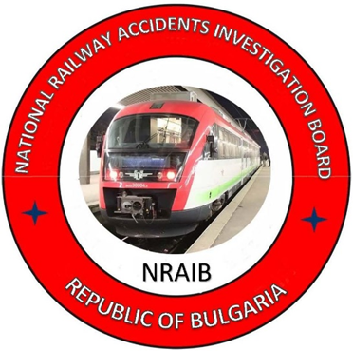

2021

OBJECTIVE OF THE REPORT AND EXTENT OF
RESPONSIBILITY
The National Air, Maritime and Railway Accidents Investigation Board (NAMRAIB), which is an independent body performs the investigation of serious accidents and incidents. The National Board is within the Council of Ministers (CM) of the Republic of Bulgaria, and aims to find the circumstances and causes that led to the accidents and incidents occurrence in order to improve the safety and to avoid such in future, without searching personal fault and responsibility.
The investigation is performed in accordance with the requirements of Directive (EU) 2016/798 of the European Parliament and of the Council of 11 May 2016 on railway safety. The Report structure follows the requirements of Regulation (EU) 2020/572 of 24 April 2020 on the reporting structure for railway accident and incident investigation reports, and in accordance with the Railway Transport Act (RTA), Ordinance No 59 dated 5.12.2006 on the rail transport safety management, and Ordinance No Н-32 dated 19.09.2007 on the coordination of the activities and information exchange during the railway accidents and incidents investigation, as well as per Agreement dated 17.04.2018 on the interaction during investigation of accidents and incidents in the air, maritime and railway transport between the Prosecutor's Office of the Republic of Bulgaria, Ministry of Interior, and the Ministry of Transport, Information Technology and Communications..

TABLE OF CONTENTS

№ | Title of section | Pg.
1. | Summary | 5
2. | Investigation | 6
3. | Description of the event | 10
4. | Analysis of the event | 14
5. | Conclusions | 35
6. | Safety recommendations | 42

ABBREVIATIONS, USED IN THE REPORT

BDZ-Cargo Ltd. – ,,BDZ-Cargo“ Ltd.
SE NRIC – State Enterprise “National Railway Infrastructure Company“(railway infrastructure manager)
RRI МН-70 – Route Relay Interlocking type МН-70
NAMRAIB – National Air, Maritime, and Railway Accidents Investigation Board (Independent National Investigation Body)
BDZ PS Ltd. – “BDZ Passenger Services” Ltd.
TOSARRT – Train Operation and Shunting Activity Rules in the Rail Transport
TF– Task Force
ALSN – Automatic Locomotive Signalling
RAEA – Railway Administration Executive Agency
ECM – Entity in Charge of Maintenance
LPP – Locomotive Park Prescription
DFT – Direct freight train

  - Summary
1.1. Brief Description of the Event.
On 15.01.2021 at 08:46 a.m. DFT № 30602, towed by electric locomotive №46041 with a locomotive driver and an assistant locomotive driver, passed without stopping through Sarantsi station to Stolnik station. The train was serviced by the railway undertaking for freight transport ,,BDZ-Cargo“ Ltd. At 08:45 a.m. the traffic manager on-duty at Stolnik station ordered the train route to pass a third diversion track without stopping to Iliyantsi station. в дясно по посока на движението. The train passed through switches № 1, № 3 and № 7 and at switch № 11 in the tongue device (blade) part at 09:00 a.m. the locomotive derailed with the first wheel from the first bogie, to the right in the movement direction. At 09:45 a.m. locomotive № 46045 was sent from Sarantsi station, which pulled the composition of DFT № 30602 back to the station. Locomotive № 46041 was lifted on the track at 11:55 a.m. on its own (self-propulsion) with the help of the rehabilitation service at SE NRIC. At 13:38 p.m. DFT № 30602, towed by locomotive № 43551 departed from Sarantsi station to Iliyantsi station. After the inspection of the derailed locomotive, at 15:37 p.m. it departed on a self-propelled mode to the Burgas Locomotive Depot, where it stayed. By order of the technical manager on the track, the traffic through switch № 11 and on the third track was interrupted from 15:50 p.m. to 00:55 a.m. on 16.01.2021. After the performance of rehabilitation works on the track, the train traffic on the third track and switch № 11 at Stolnik station was restored.
As a result from the derailment slight damages were caused to locomotive № 46041 and to the track in the area of derailment.
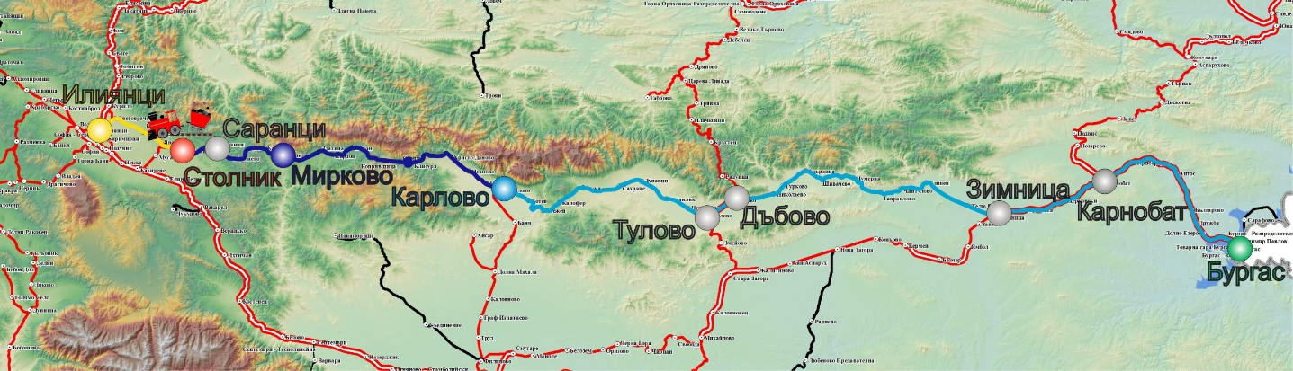
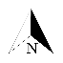
1.2. Location and time of the event occurrence.
Fig. 1.1. Movement route of DFT № 30602
- Original station for the movement of the train;
- More important stations on the train alignment;
- Station, from which the present locomotive crew handles the train;
- Last station, where the train stopped;
- Final destination station for the movement of the train;
- Place, where the accident occurred;
- route, which the train passed before the shift of the present locomotive crew;
- route, which the train passed, handled by the present locomotive crew;
- route, which the train did not succeed to pass.
The accident occurred while the DFT № 30602 was entering to the third acceptance-departure track in Stolnik station of switch № 11 in the tongue device (blade) part, where followed derailment of the first wheelset of locomotive № 46041 to the right of the switch at 09:00 a.m. (fig. 1.1, fig. 1.2).
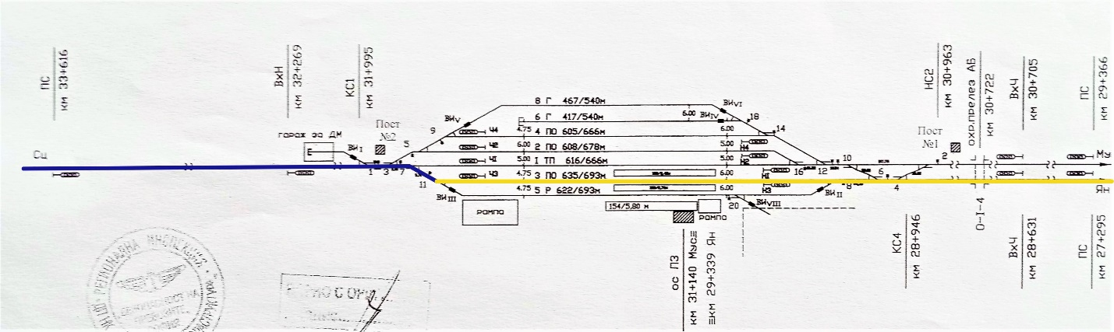
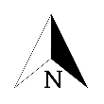
  - Factors, defining the event.
Fig. 1.2. Scheme of Stolnik station with the route of movement of DFT № 30602.
- Route, which the train passed;
- Part of the route, which the train did not pass;
- Place of derailment (switch № 11).
1
1
Determining factor for the occurrence of the accident is the – technical condition of switch № 11 - presence of a notch on the right deflection tongue (blade) for 400 mm and a maximum depth of 9 mm in the area of the tip of the tongue (blade) and a hidden depression in the area of the tip of the tongue (blade) of the switch. At a distance of 330 mm from its top to 730 mm with 400 mm length having permissible 300 mm, there is a notch with different depth, and in its middle part it reaches 9 mm having 8 mm permissible.
The ascertained parameters of the notching have values exceeding the admissible ones stipulated in Art. 49, item 6 of Ordinance № 58 and of item 7.4 of the Instruction for current maintenance of the railway track and switches.
  - Immediate causes and consequences of the event
Immediate cause for the accident occurrence (derailment of the first wheelset of locomotive № 46041 in the part of the tongue (blade) of switch № 11 leading to the third acceptance-departure track in Stolnik station) is a malfunction of the right deflection tongue (blade) of switch № 11. The notch in this area of the blade is a consequence of chipping metal from the surface of the blade in its upper thin part at a distance of 330 mm to 730 mm from the tip of the blade. This area of the blade is not subjected to vertical dynamic loading, but is determined by the lateral transverse horizontal force. The wheel flange interacts with the working part of the blade at a point before the point of contact between the wheel and the right stock rail. Due to the inadmissible notching, the wheel rises on the right stock rail and derails (Fig. 1.3).
  - Safety recommendations and addressees to which are directed.
- By recommendation 1 is proposed the SE NRIC to strengthen the control of the commissions for carrying out the monthly and six-monthly audits of the railway switches in the stations.
- By recommendation 2 is proposed the SE NRIC to bring switch № 11 in Stolnik station in accordance with the Technical requirements for the railway infrastructure (NRIC TSRI) and the Instruction for construction and maintenance of the railway track and switches, as no violation of art. 49, para. 6, item 2 of Ordinance № 58 / 2.08.2006 is permitted.
- By recommendation 3 is proposed BDZ Cargo Ltd. to adjust (balance) periodically the spring system of the locomotives, in order to equalize the vertical load in the wheels.
- Investigation
1. Decision for starting the investigation.
The decision to initiate an investigation of the accident took into account the seriousness and its impact on the safety. The investigation aims to prevent this type of accident, which in slightly different circumstances could lead to serious accidents.
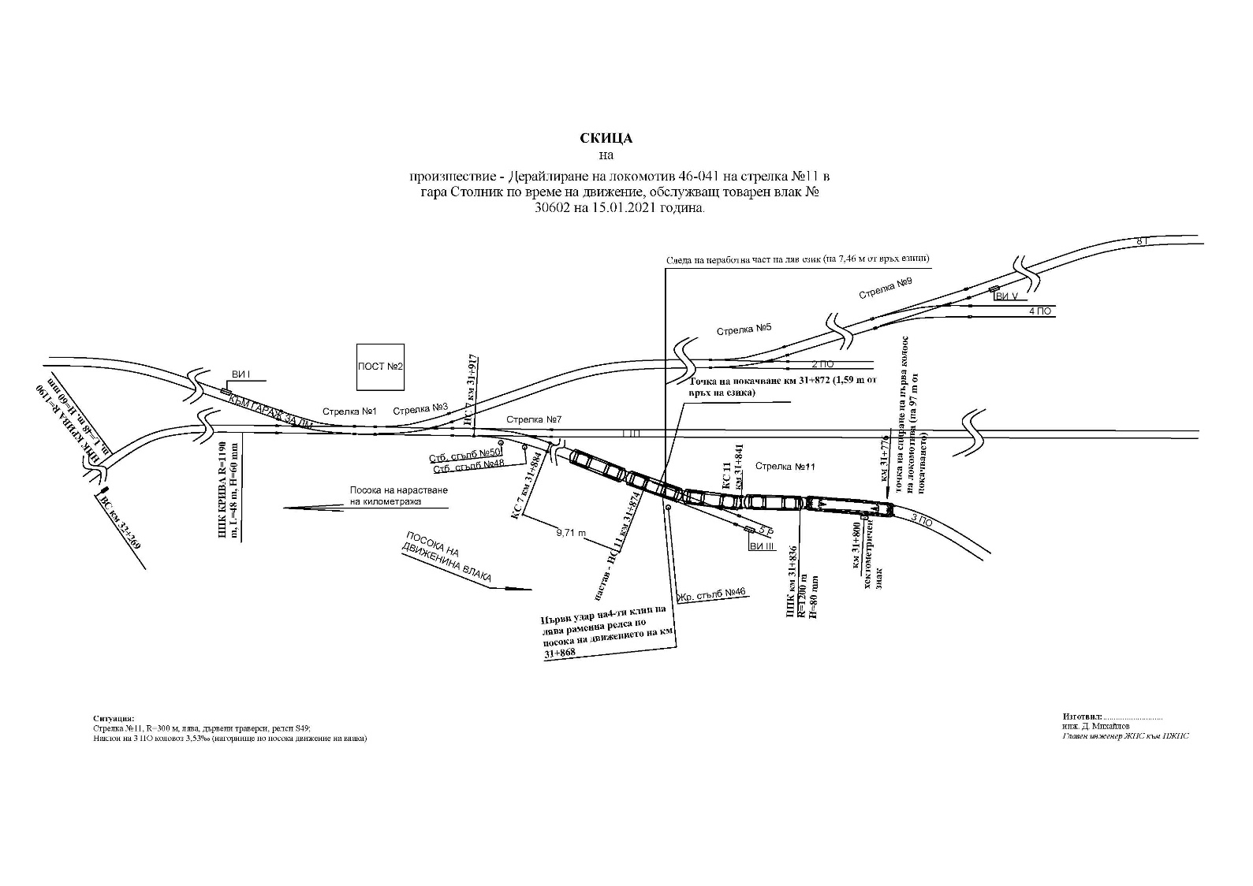
- Motives for the decision to initiate the investigation.
Фиг. 1.3. Схема на дерайлиране на ДТВ № 30602 в гара Столник.

The Decision for starting the investigation is based on art. 20, comma 2, (а) of Directive (EU) 2016/798, art. 115к, paragraph 1, item 3 of RTA, art. 76, par. 1, item 3 of Ordinance No 59 dated 5.12.2006, and by Order of the NAMRAIB was assigned a Commission for investigation of the railway accident.
- Scope and restrictions of the investigation.
The scope of the investigation will consider and analyse the violations of the regulations implemented by the entities (NRIC and BDZ-Cargo Ltd.) in the repair and maintenance of the track and in carrying out scheduled repairs of locomotives series 46000.
Given the realized minimal damages, the investigation will be limited to the circumstances that led to the technical causes for the derailment of locomotive No 46041 in Stolnik station.
- Competences of the persons, involved in the investigation.
The composition of the commission includes external independent experts - habilitated persons from the higher scientific circles and experts with free profession with qualification and professional orientation in fields of activity – track and structures, and rail rolling stock.
- Communication and consultations with the persons and entities, involved in the event.
During the investigation, the task force, which includes representatives of both entities, was consulted. The task force had collected all the books and samples, as well as telegrams and downloaded records from the recording device of locomotive No 46041. They were handed over to the Chair of the Investigation Commission. Interviews were conducted with the persons, directly involved in the accident. The entities were requested and then provided information on the rail track and switches maintenance at Stolnik station and on the repair and maintenance of the locomotive as well. Interviews were conducted with the heads of the entities, and with their safety authorities.
- Degree of cooperation from the participating entities
During the investigation, the participating entities (BDZ-Cargo Ltd. and SE NRIC), and the persons involved in the accident fully cooperated with the Investigation Commission.
- Methods and techniques of investigation and analysis.
After the received information on the accident occurrence and the taken decision for investigation, the Investigation Commission conducted the first conversations with staff from both railway entities, involved in the accident. It performed primary inspections of the derailed locomotive No 46041 and the permanent way of the switch № 11, and the 3-rd. track in the area of derailment at Stolnik station. There was required download of the records from the recording device of the locomotive. The Commission was acquainted with keeping of the operational station documentation and with the acceptance plan for train No 30602 in Stolnik station. It required all the documents for the repair and maintenance of switch № 11 and the track in Stolnik station for a one-year period from the date of the event. The Commission required all the documentation for the repair and maintenance of locomotive No 46041. After lifting the locomotive from the rails of the 3-rd track in Stolnik station, under the Investigation Commission instruction locomotive №46041 departed on its own (self-propelled) to the nearest locomotive depot Burgas. A Statement of findings for the technical condition of locomotive No 46041 was prepared in the presence of representatives of SE NRIC and BDZ Cargo Ltd. The Statement of finding includes:
- Overall inspection of the locomotive draft gear;
- Dimensional maps for the controlled dimensions of the locomotive wheelsets;
- Measurement of the static load of the wheels and adjusting the spring system of the locomotive;
- Measurement of the control distances from the suspension and leading of the locomotive bogies;
- Dismantling of the inter-bogie coupler (daixel/tender) of the locomotive.
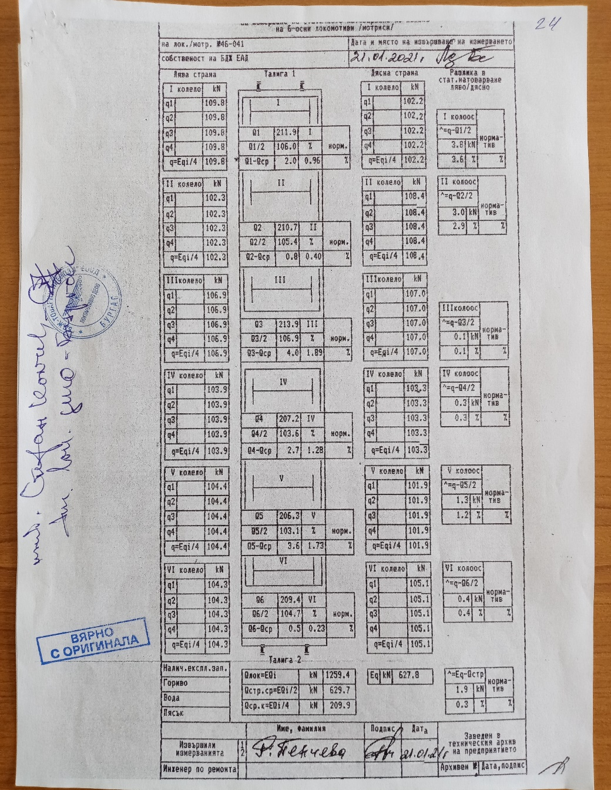
The Commission, which prepared the Statement of findings for locomotive № 46041 in Burgas Locomotive Depot on 21.01.2021 found that after the derailment was violated the balance of the spring system, then it was regulated, and the locomotive was brought within the thresholds (fig. 1.4).
Fig. 1.4. Card on the static weight balancing of the wheelsets of locomotive № 46-041 from measurement, performed in Burgas locomotive depot on 21.01.2021
The Investigation Commission performed analysis of the data, downloaded from the recording device of locomotive № 46041 on the movement speed of DFT № 30602 on 15.01.2021 from Karlovo station to Stolnik station.
Several inspections and measurements of switch № 11 in Stolnik station were performed. On 15.01.2021, on the day of the accident at Stolnik station, a Statement of findings was drawn up on the technical condition of the rail track, but no precise measurements were made of the chipped blade, as well as of the hidden failures (twists). On 02.02.2021, repeated measurements were performed at Stolnik station on switch № 11, in particular on the notched right tongue (blade) of the switch. Representatives of the involved parties participated during the measurements. Notches of the right blade were found for 400 mm and a maximum depth of 9 mm, measured at 530 mm from the tip of the blade. Deviations from the norms for repair and maintenance of the rail track were established. The Commission found that Plan II-24 for acceptance of DFT № 30602 on the 3rd acceptance-departure track without stopping at the station was complied with.
The Commission reviewed and analysed in detail the collected documentation, which the Task Force provided as per the requirements of art. 73 para. 3 and para. 4 of Ordinance No 59.
- Difficulties faced during the investigation.
During the investigation, the Commission did not encounter any difficulties or obstacles from the entities side in clarifying the circumstances and causes for the accident.
- Interaction with the judicial authorities.
Not applicable.
- Other important information for the investigation context.
There is no such.
3. Description of the event
а). Information on the event and the context.
- Description of the event type.
On 15.01.2021, DFT № 30602 Iliyantsi station left Burgas station. The train consists of 34 empty wagons, 136 axles, 818 tons, towed by an electric locomotive № 46041. The railway undertaking BDZ-Cargo Ltd. (Fig. 1.1) carries out the transport of DFT № 30602.
At Karlovo station, the train arrived at 03:42 a.m., and left at 04:34 a.m. The train run without stopping to Pirdop station. It arrived in Pirdop station at 05:52 a.m., and left at 07:10 a.m. The train arrived at Zlatitsa station at 07:16 a.m., stayed for 22 minutes and left to Mirkovo station, where it arrived at 07:52 a.m. At Mirkovo station, the train stayed for 28 minutes and departed at 08:20 a.m. The Traffic manager on-duty at Stolnik station has prepared the route with RRI at 08:50 a.m. for the acceptance of DFT № 30602 on the third acceptance-departure track without stopping in the station.
DFT № 30602 was accepted at Stolnik station with indication of the entrance signal for entering in deviation of the third acceptance-departure track and exiting on the straight-line track for Yana station.
After passing of the train through the first entrance switched №№ 1, 3 and 7, the locomotive is directed to switch № 11, leading to the 3rd acceptance-departure track. During the entering in the blade part of the switch, the locomotive crew felt vibrations in the cabin of the locomotive and the locomotive driver stopped the train with the automatic train brake. The train was moving at a speed of 22 km/h, with a permissible 40 km/h, and stopped after 98 meters. During the movement of the train on the route from Burgas starting station to Stolnik station the operation of the locomotive was accident-free.
- Date, punctual time and location of the event.
The derailment of the locomotive occurred on 15.01.2021 at 09:00 a.m. when passing through switch № 11, leading to the 3rd acceptance-departure track at Stolnik station.
- Description of the event location.
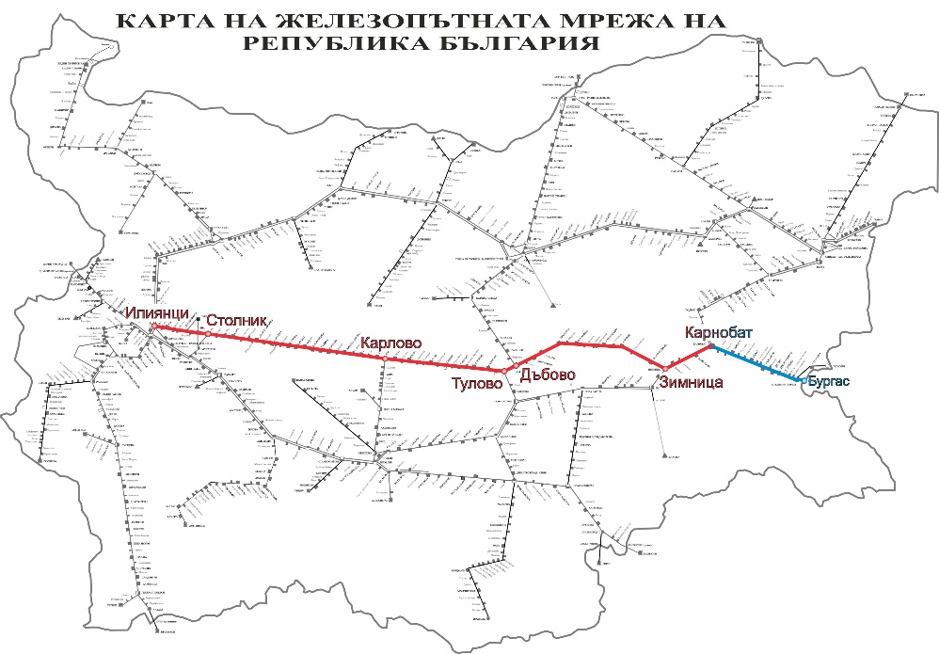
The railway accident occurred when the locomotive of DFT № 30602 on switch № 11 (left) entered in the area of the blade at 22 km/h (the right blade was notched above the thresholds), where the first wheelset of the locomotive rose on the right blade and the stock rail, and after 7 meters derailed to the right of the track. The switch led to the third track of Stolnik station with a profile of 3.53 ‰ uphill. Stolnik station is located on the third main railway line in the direction Iliyantsi - Karlovo - Dabovo - Zimnitsa - Karnobat - Burgas. A third main railway line is conventional with speeds of up to 130 km/h (Fig. 3.1).
Fig. 3.1. Route of DFT № 30602.
3а. Meteorological and geographical condition at the time of the event.
- in the daylight hours – 09:00 a.m.;
- air temperature minus 4ºС;
- wind speed 33 km/h;
- weather – cloudy – with normal visibility of the signals;
3b. Performance of construction activities on the site or in vicinity.
In the period of the accident occurrence were not performed any construction activities in Stolnik station area, nor on the track neither on the structures.
- Fatalities, injuries and material damages.
- Employees of the railway infrastructure manager or railway undertaking.
None.
- Other persons officially connected with the location of the event.
None.
- Passengers.
None.
- External persons.
None.
- Cargo, luggage or other property.
None.
- Environment.
None.
- Rolling stock and railway infrastructure.
Damages caused to the running gear of locomotive № 46041. The presented value account for damages – 933,76 BGN.
Damages caused to the signalling with presented finance account amounting to 1602,00 BGN.
Slight damages to the permanent way of 3-rd track in Stolnik station. No data on caused damages were presented.
The costs for rehabilitation activities amount to 545,00 BGN.
- Description of other consequences, including the event impact on the usual activity of the participants.
None.
- Identity of the participants and their functions, as well as of the involved entities.
Railway infrastructure:
- Traffic manager on duty in Stolnik station – employ of SE NRIC;
- SE ,,National Railway Infrastructure Company“ has;
- Safety Authorization No № BG 21/2018/0001 valid from 01.07.2018 until 30.06.2023
Railway undertaking:
- Engine driver, locomotive of locomotive No 46041 – employee of “BDZ-Cargo” Ltd.;
- Assistant engine-driver, locomotive of locomotive No 46041 employee of “BDZ-Cargo” Ltd.;
- “BDZ-Cargo“ Ltd. has:
  - License for performing railway services No 203/31.12.2018;
  - Safety Certificate part А BG 11 2017 0008, valid until 30.12.2022;
  - Safety Certificate part B BG 12 2017 0008, valid until 30.12.2022.
- Description and identifiers of the train and its composition, including the rolling stock and its registration numbers.
- Direct freight train № 30602, direct;
- Electric locomotive № 91520046041-7 – with valid registration in the Vehicles Register;
- Open wagons – series Eaos, 34 units registered in the Vehicles Register;
- Description of the respective parts of the railway infrastructure.
Description of the signalling and the block system:
- Stolnik station is equipped with RRI – Russian for small stations;
- The indications of the semaphores are on the speed signalling;
- The interstation Sarantsi – Stolnik – Yana are equipped with Automatic Block System (ABS) without passing signals with axle counters;
8а. Type of the track, rail switch etc. maint.
- Third acceptance-departure track in Stolnik station is with total length of 635 meters, with cant – 2,71 ‰ in uphill in Yana direction, equipped with exit signals on the speed signalling, electrified.
- Switch № 11 is left in deviation 1:9, rails S49, with radius R=300 m, wooden sleepers with cant 3,53 ‰ in uphill, (fig. 3.2).
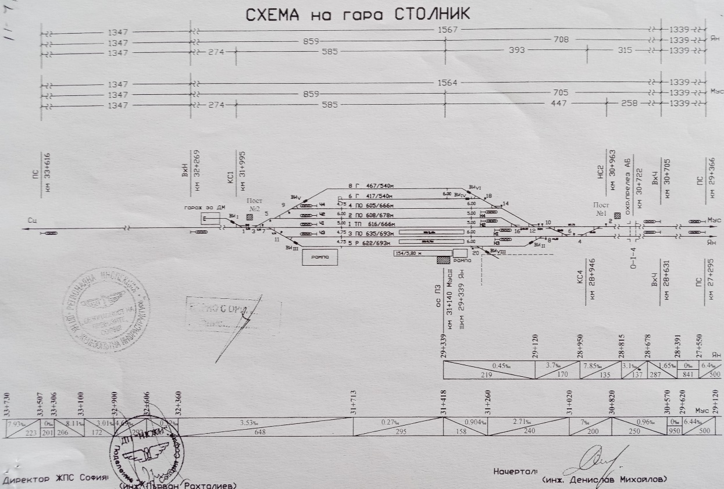
8b. Train protection systems.
Fig. 3.2. Scheme of the track layout in Stolnik station.
• The Sofia-Karlovo section is equipped with Automatic Block System (ABS) with axle counters.
• Stolnik station is equipped for part „radio connection „with Train-dispatching radio connection (TDRC). For the entrance and exit messages of the station, they are performed with Communication device, connections and messages (UKSS-8);
- Locomotive № 46041 is equipped with warning (supervision) device active type, registering speedometer type „Hasler“ RT9, and non registering speedometer type „Hasler“ А16.
- Other information referring the event.
The documents "Authorization for brake mass, form VP-11" and "Nature sheet", prepared at Pirdop station do not correspond to the hours of the actual movement of DFT № 30602 according to the data presented by ROVR and the speedometer tape.
b). Factual description of the occurred.
1. Immediate sequence of events that led to the accident, including:
1а. Actions that the involved in the event persons undertook.
By order of the train dispatcher, the traffic manager on-duty at Stolnik station gives consent to Sarantsi station to accept DFT № 30602. After the train passes without stopping through Sarantsi station at 08:46 a.m., the traffic manager on-duty at Stolnik station at 08:50 a.m. orders a route with RRI by opening the input and output signal for the train to pass on the third acceptance-departure track without stopping at the station.
Upon entering of DFT № 30602 on the ordered route in Stolnik station at switch № 11 the locomotive driver felt vibration of the locomotive and with the train brake he stopped the train. After the train stopped, the locomotive crew found that the locomotive had derailed with the first wheel. At 09:10 a.m., the locomotive driver informed the dispatcher on-duty of BDZ Cargo Ltd. and the manager on-duty at Stolnik station about the derailment.
1b. Rolling stock and technical facilities functioning.
The rolling stock has been regular with proper function until the moment of the accident.
The technical facilities in Stolnik station are regular with proper functions except for switch № 11.
1c. Operational system functioning.
The operational system is regular with proper functions.
- Sequence of events from the beginning of the accident to the end of the rescue services actions:
• At 09:00 a.m. derailed locomotive № 46041 of DFT 30602 while entering on 3-rd acceptance-departure track in Stolnik station;
- There was no immediate necessity of the rescue services actions.
2а. Undertaken measures for protecting and guarding the event location.
Not applicable.
2b. Actions of the emergency rescue services.
• Under an order of SE NRIC from Sofia station to Stolnik station on 15.01.2020 departed specialized rehabilitation vehicle UNIMOG for lifting the locomotive.
• At 11:36 a.m. locomotive № 46041 was lifted on the rails of the 3-rd track;
• At 13:39 p.m. DFT № 30602 with train locomotive № 43551, departed from Sarantsi station under the route to Iliantsi station;
• The train movement in Sarantsi-Stolnik interstation was interrupted in the interval 09:00 ÷ 11:30 a.m.;
• At 12:32 p.m. from Sarantsi station departed locomotive № 46045, which attached DFT № 30602 and the same was brought back in Sarantsi station;
• At 15:35 p.m. locomotive № 46041 departed from Stolnik station to Locomotive Depot Burgas with movement speed 40 km/h;
• The train movement along the 3-rd track in Stolnik station was interrupted in the interval 09:00 a.m. ÷ 00:55 a.m.
4. Analysis of the event when is necessary as it refers the individual facts.
а). Roles and responsibilities.
Participation and responsibilities of the entities, involved in the event.
1. Railway undertaking
Analysis of the operation of DFT No № 30602 from Karlovo station to Stolnik station.
DFT № 30602 moves on the route Burgas - Karnobat - Karlovo - Stolnik - Yana - Iliyantsi. At Karlovo station, the locomotive crew is changed and the new one handles locomotive № 46041, where the accident occurs. On the speedometer tape is recorded the movement of the train from Karlovo station to the place of the accident – switch № 11 at Stolnik station. The permissible speed of the train along the section from Karlovo station to Iliyantsi station is 60 km/h.
The train departed from Karlovo station at 4:10 a.m. (Fig. 4.1, pos. 1). In the interstation Karlovo - Sopot it developed up to 42 km/h and at 4:56 a.m. it stopped at Sopot station, holding the train brake in an emergency. The train stayed at the station for 5 minutes and at 5:01 a.m. left again (Fig. 4.1, pos. 2).
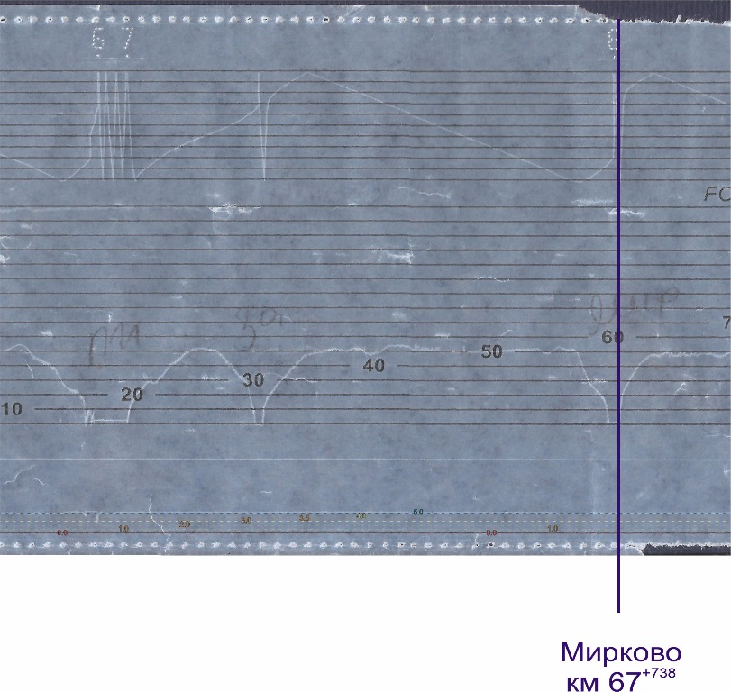
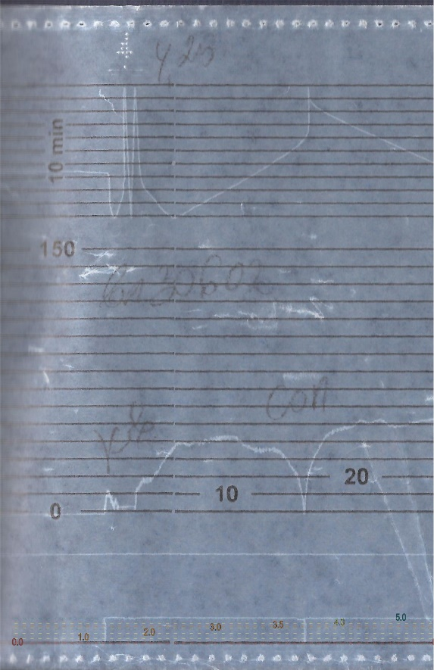
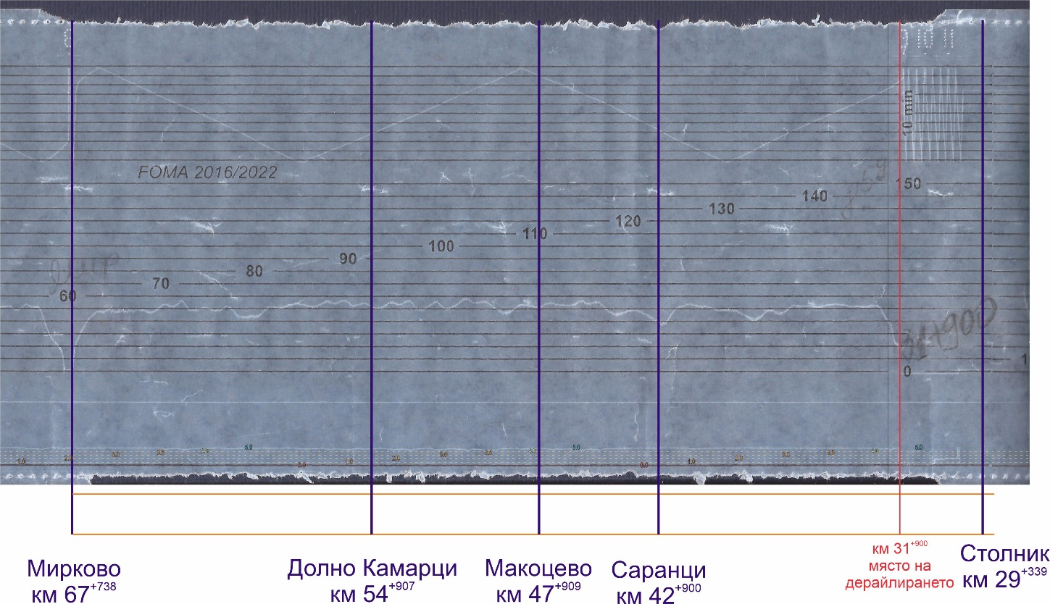
Fig. 4.2. Registered operation of DFT № 30602 from Pirdop to Mirkovo station
1
1
2
2
6
6
7
7
7
3
4
5
Fig. 4.1. Registered operation of DFT № 30602 from Karlovo station to Sopot station
1
1
2
2
Fig. 4.3. Parameters of the movement of DFT № 30602 from Mirkovo to Stolnik station
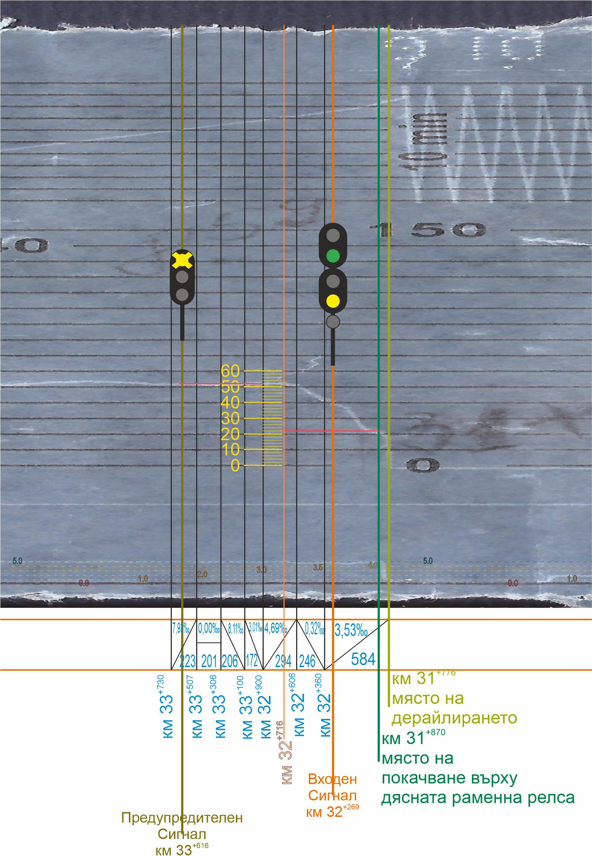
DFT № 30602 moves without stopping to Pirdop station, where it settles at 5:52 a.m. (Fig. 4.2, item 1). During its movement in the interstation, it reaches a speed of 52 km/h. After stopping at the station, there was a movement of up to 10 km/h for about 300 meters for 2 minutes and then the train stayed at Pirdop station for 1 hour and 13 minutes from 5:57 a.m. to 7:10 a.m. (Fig. 4.2, pos. 2).
Fig. 4.4. Parameters of movement of DFT № 30602 in the derailment situation.
1
2
2
900 м
3
4
6
5
7
8
8

The train departs from Pirdop station at 7:10 a.m., develops a speed of up to 52 km/h (Fig. 4.2, pos. 3), after which the speed gradually decreases and at 7:17 a.m. settles at Zlatitsa station (Fig. 4.2, pos. 4). The stay at Zlatitsa station is from 7:17 a.m. to 7:37 a.m. (20 minutes) and departs at 7:37 a.m.
In the section from Zlatitsa station to Mirkovo station DFT № 30602 runs, developing a speed of up to 52 km/h (Fig. 4.2, pos. 5). At 7:50 a.m. a gradual reduction of speed began and at 7:52 a.m. it was established at Mirkovo station (Fig. 4.2, pos. 6). It stays at the station for 25 minutes until 8:17 a.m. After its stay the train does not perform test D in violation of art. 245, para. 1, item 5 of Ordinance № 58 and Art. 301, item 5 of the TOSARRT (Fig. 4.2, pos. 7).
DFT № 30602 departs from Mirkovo station at 8:17 a.m. and until the moment of the accident at Stolnik station passes without stopping at the stations Dolno Kamartsi, Makotsevo and Sarantsi, developing up to 58 km/h (Fig. 4.3).
When moving from Karlovo station to Stolnik station, the locomotive driver of locomotive № 46-041 observes the section speeds and the reductions in the section.
DFT № 30602 passes the warning signal at Stolnik station at 8:56 a.m. at a speed of 52 km/h (Fig. 4.4, item 1). At this speed, the train moves from the warning signal at km 33⁺⁶¹⁶ to km 32⁺⁷¹⁶ for one minute, traveling 900 meters (Fig. 4.4, item 2). From this point on, the speed starts to decrease, and the decrease is due to the natural resistance acting on the train, without using the automatic train brake. Thus, when passing the entrance signal at Stolnik station, the speed is 40 km/h with a continuing tendency to decrease (Fig. 4.4, item 3). Immediately after passing the entrance signal, the locomotive driver applies the automatic train brake, reducing the pressure in the main air duct by 0.5 bar to 4.5 (Fig. 4.4, Item 4). After 200 meters and 30 seconds, the pressure is restored to 5.0 bar and the automatic train brake is completely released (Fig. 4.4, Item 5). However, the speed continues to decrease at different rates from the natural resistance of the train (the longitudinal slope is 3.5 ‰ uphill).
Upon entering in the area of switch № 11 and in contact of the first right wheel of the locomotive in the direction of movement with the right deflection blade of the switch, the wheel rises on the right straight stock rail. This happens at km 31⁺⁸⁷⁰ at a speed of 22 km/h and inertial motion (Fig. 4.4, pos. 6). After 50 meters, the locomotive driver applies the automatic train brake and holds in an emergency, reducing the pressure in the main air duct to 0 bar (Fig. 4.4, Item 7). After passing another 50 meters, the first wheelset derailed in the traffic direction, the speed decreases to 0 km/h and the locomotive settles on the third track of the station at 8:58 a.m. (Fig. 4.4, item 8).
Railway infrastructure.
When the train enters in Stolnik station, it passes through the first entrance switches at a speed of 37 km/h. When passing through switch № 11 around 09:00 a.m., at a speed of 22 km/h leading to a deviation for the third acceptance-departure track, the locomotive ascends with the first wheelset at the beginning of the blade part of the right stock rail of the switch. The locomotive derailed with the first wheelset, it travelled 91 m and stopped. The traces left by the derailed wheelset are as follows:
- The right leading wheel of the first wheelset ascends on the crown of the right stock rail in the area of the chipped right blade at 530 mm from the tip of the blade of switch № 11, and slides after 9 meters, to the right of the external side of the rail.
- There was also a slide on the left wheel from the inner side of the left rail 7 meters after the rise of the right wheel.
The speed of the train during the derailment is 22 km/h.
Assessment of the rail track condition.
In order to assess switch № 11, it is necessary to consider in detail the main parameters characterizing its condition. These are track gauge, transverse level, vertical and horizontal operation of the blades, condition of the sleeper gird and fasteners, contamination of the ballast prism, wavy wear (corrugation fatigue) on the surfaces of the stock rails and other minor factors.
- Lateral and vertical wear of the blade of switch № 11
  - The measurements of the track carried out by the Investigation Commission found that there was vertical wear (notching) of the blade, horizontally with a length of 400 mm and vertically with a maximum depth of 9 mm;
- Sleeper gird condition
  - The sleeper gird condition is good, there is no missing or loosen fastening;
  - The ballast prism is in good condition, without dirt.
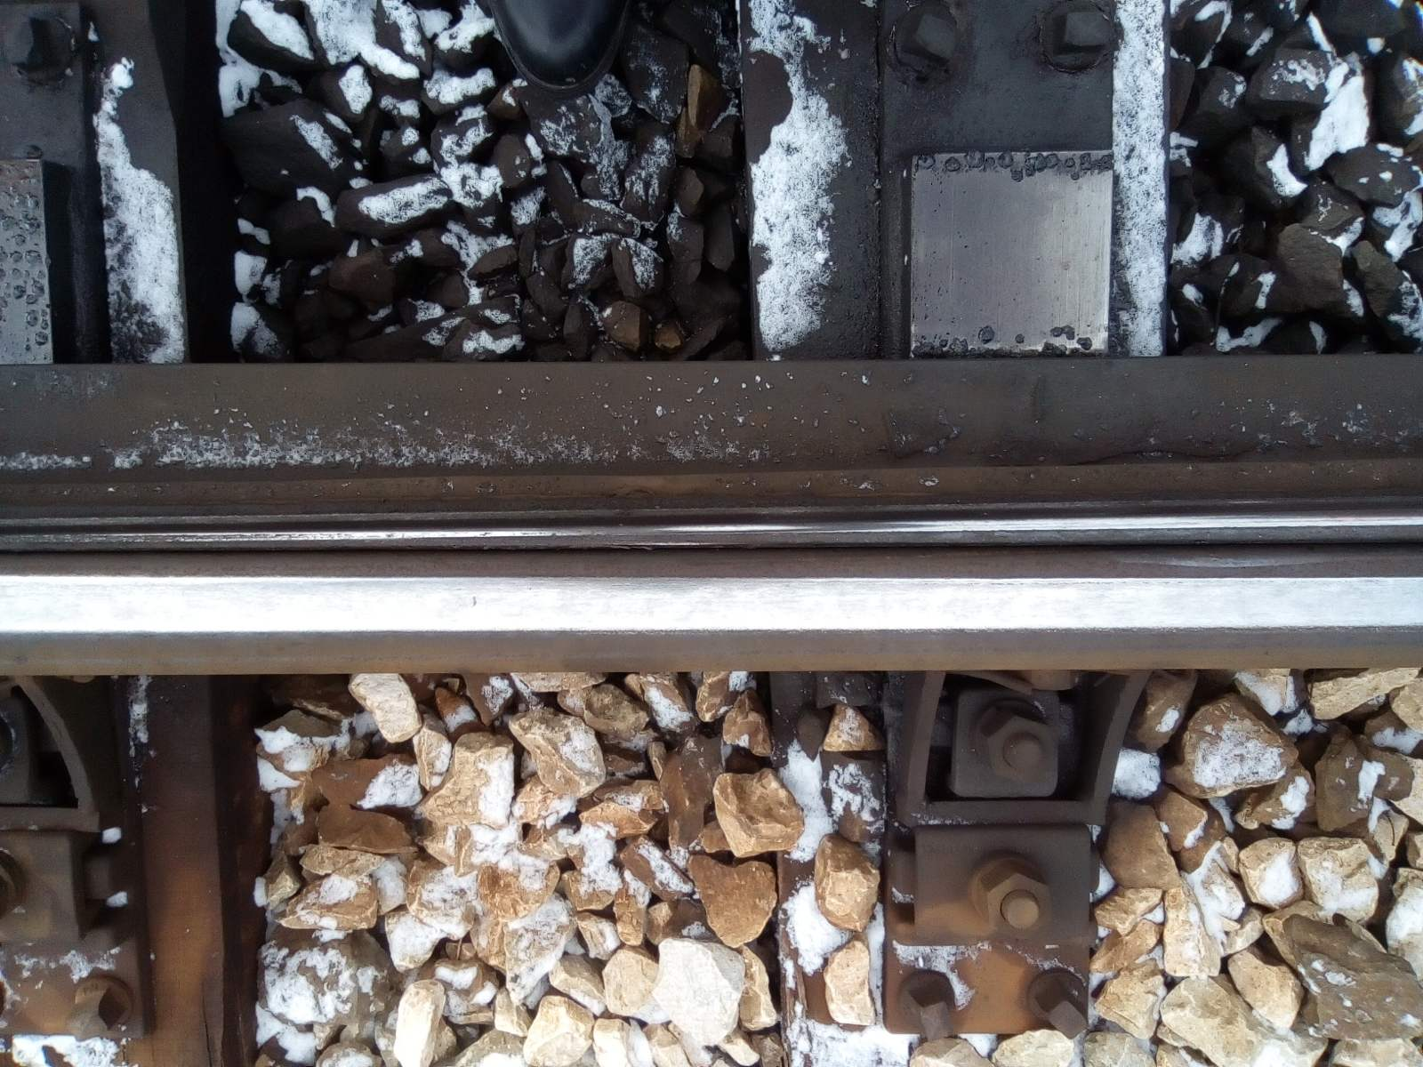
When inspecting the place of rise of the wheelset on the stock rail, it was visually found that from the inner working side surface of the right blade there were notches 330 mm from its tip. That caused a violation of the interaction when entering the right wheel of the first leading wheelset of the locomotive and the right blade of the switch, which led to a rise of the wheel in the notched blade of the switch. (Fig. 4.6).
Fig. 4.6. First trace of the rise of the first right wheel of the locomotive on the right stock rail.

2. Entities in charge of the technical maintenance.
During the investigation, the Commission requested and analysed the documents for the inspections and repairs of locomotive № 46041 and took note of the current technical condition of its running gear, in particular the spring suspension, the wheelsets and the inter-bogie coupling.
On 11.01.2021 in the Locomotive Depot Burgas were performed measurements of the controlled dimensions of the wheelsets of locomotive № 46041 before the accident. All the controlled dimensions meet the regulatory requirements (Fig. 4.7 and 4.8);

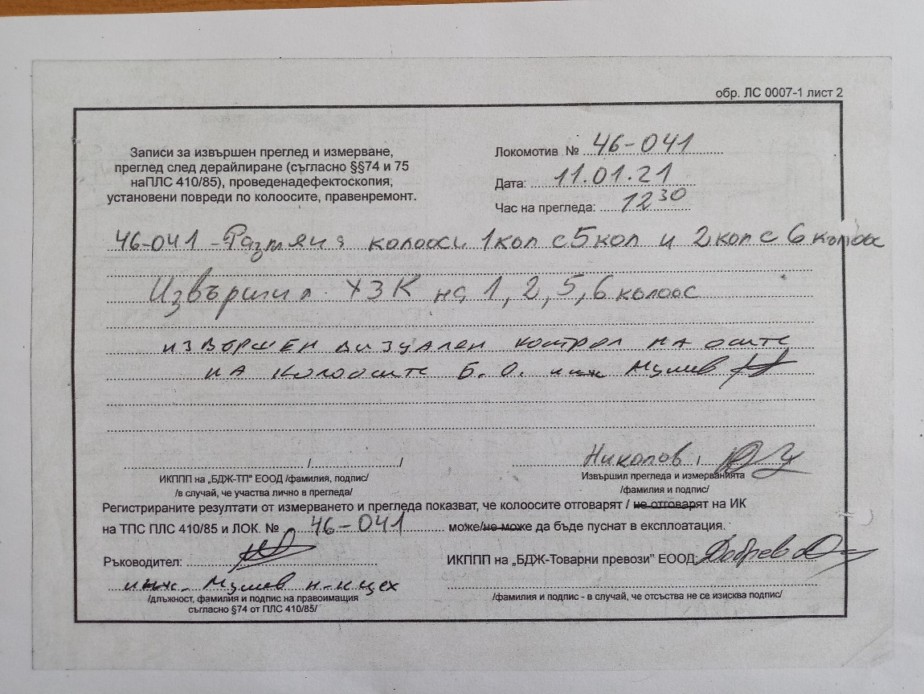
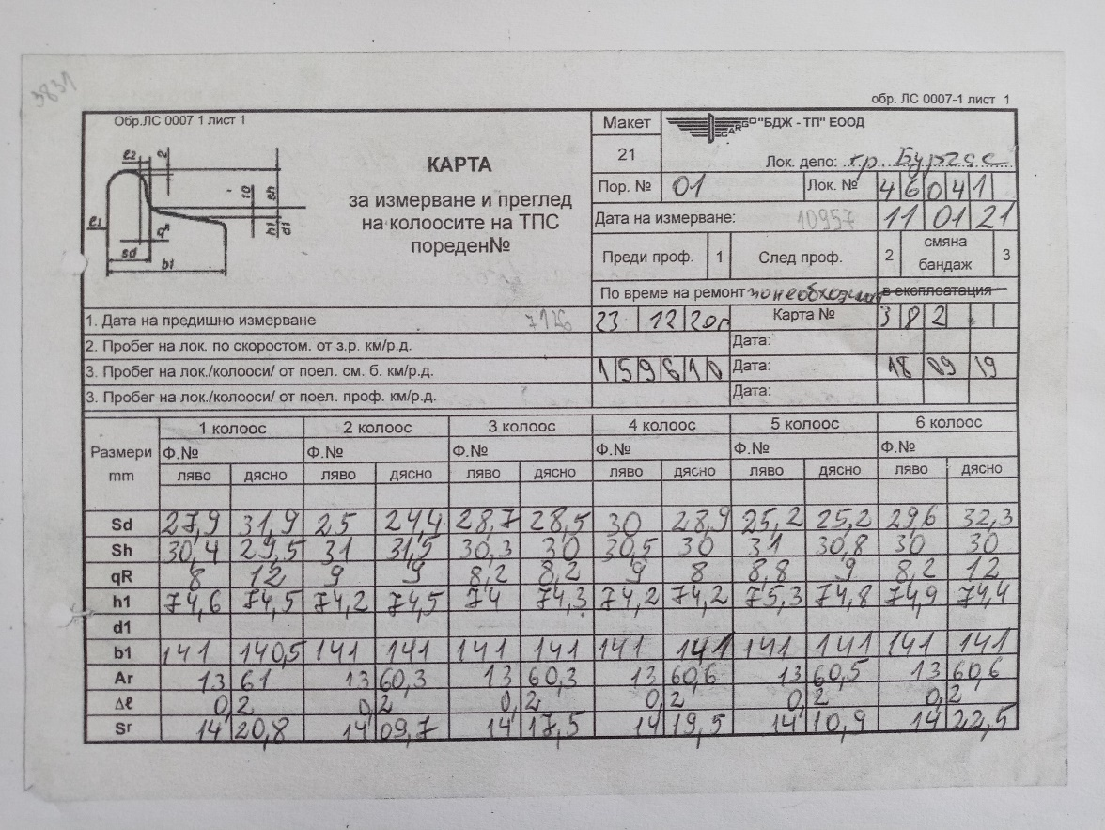
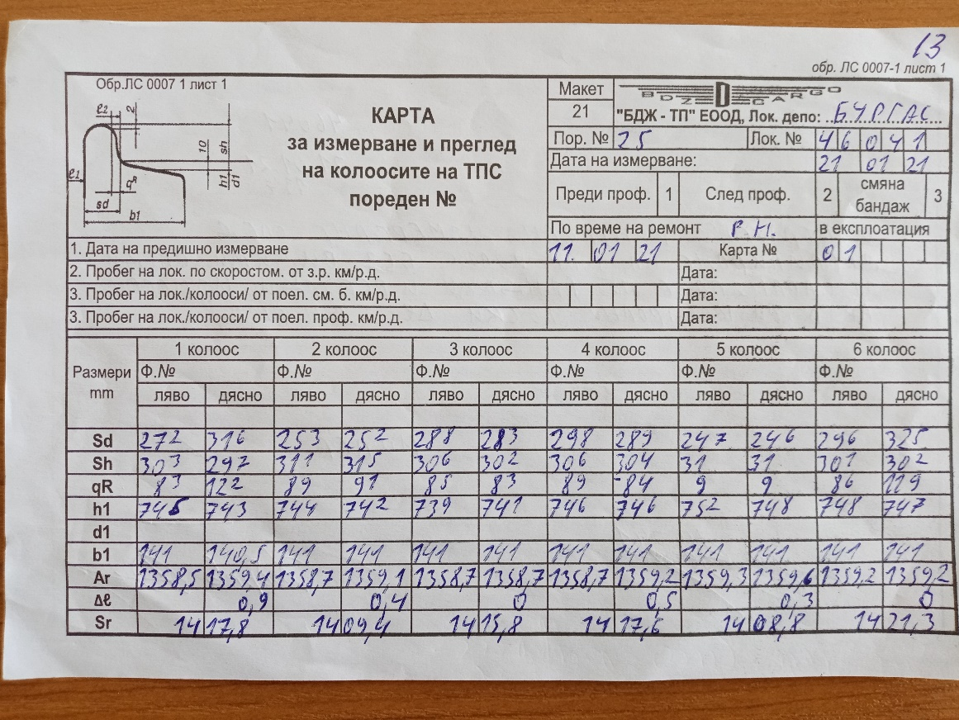
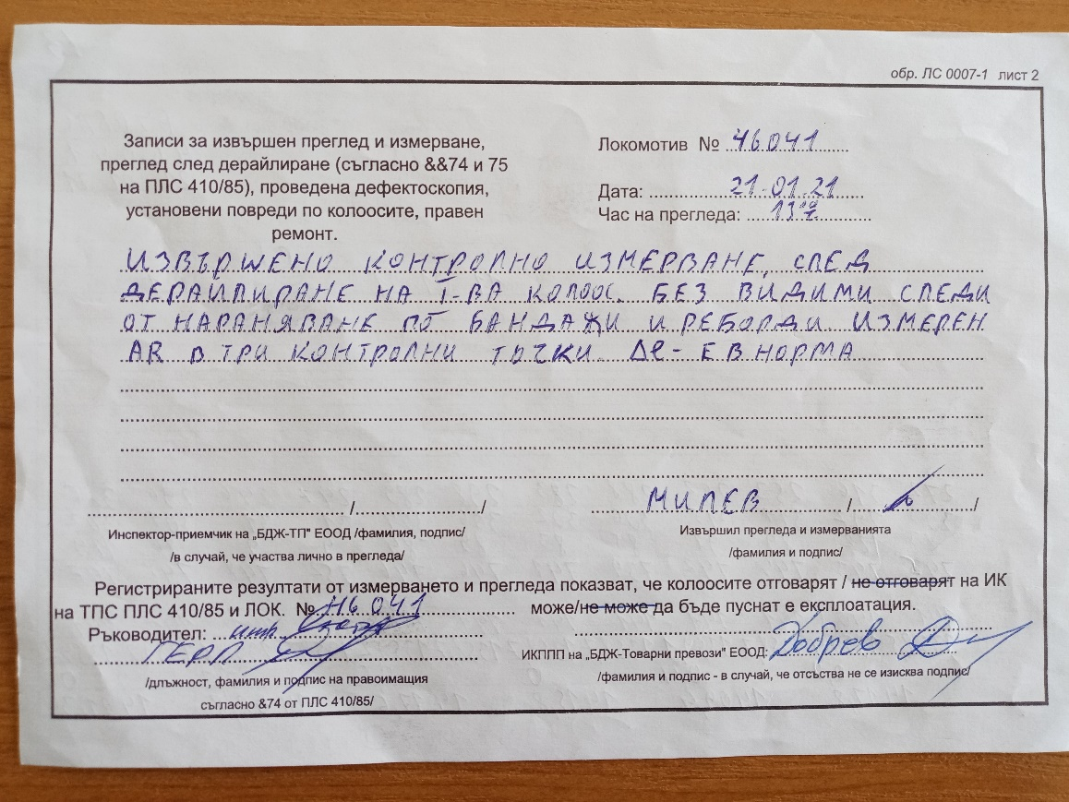
On 21.01.2021 in the Locomotive Depot Burgas were performed measurements of the controlled dimensions of the wheelsets of locomotive № 46041 after the accident. All the controlled dimensions meet the regulatory requirements (fig. 4.9 and fig. 4.10);
Fig. 4.8. Card of measurement of the wheelsets of locomotive № 46041 from measurement, performed in Burgas locomotive depot on 11.01.2021 – sheet 2.
Fig. 4.7. Card of measurement of the wheelsets of locomotive № 46041 from measurement, performed in Burgas locomotive depot on 11.01.2021 – sheet 1.
Fig. 4.9. Card of measurement of the wheelsets of locomotive № 46041 from measurement, performed in Burgas locomotive depot on 21.01.2021 after the derailment – sheet 1.
Fig. 4.10. Card of measurement of the wheelsets of locomotive № 46041 from measurement, performed in Burgas locomotive depot on 21.01.2021 after the derailment – sheet 2.

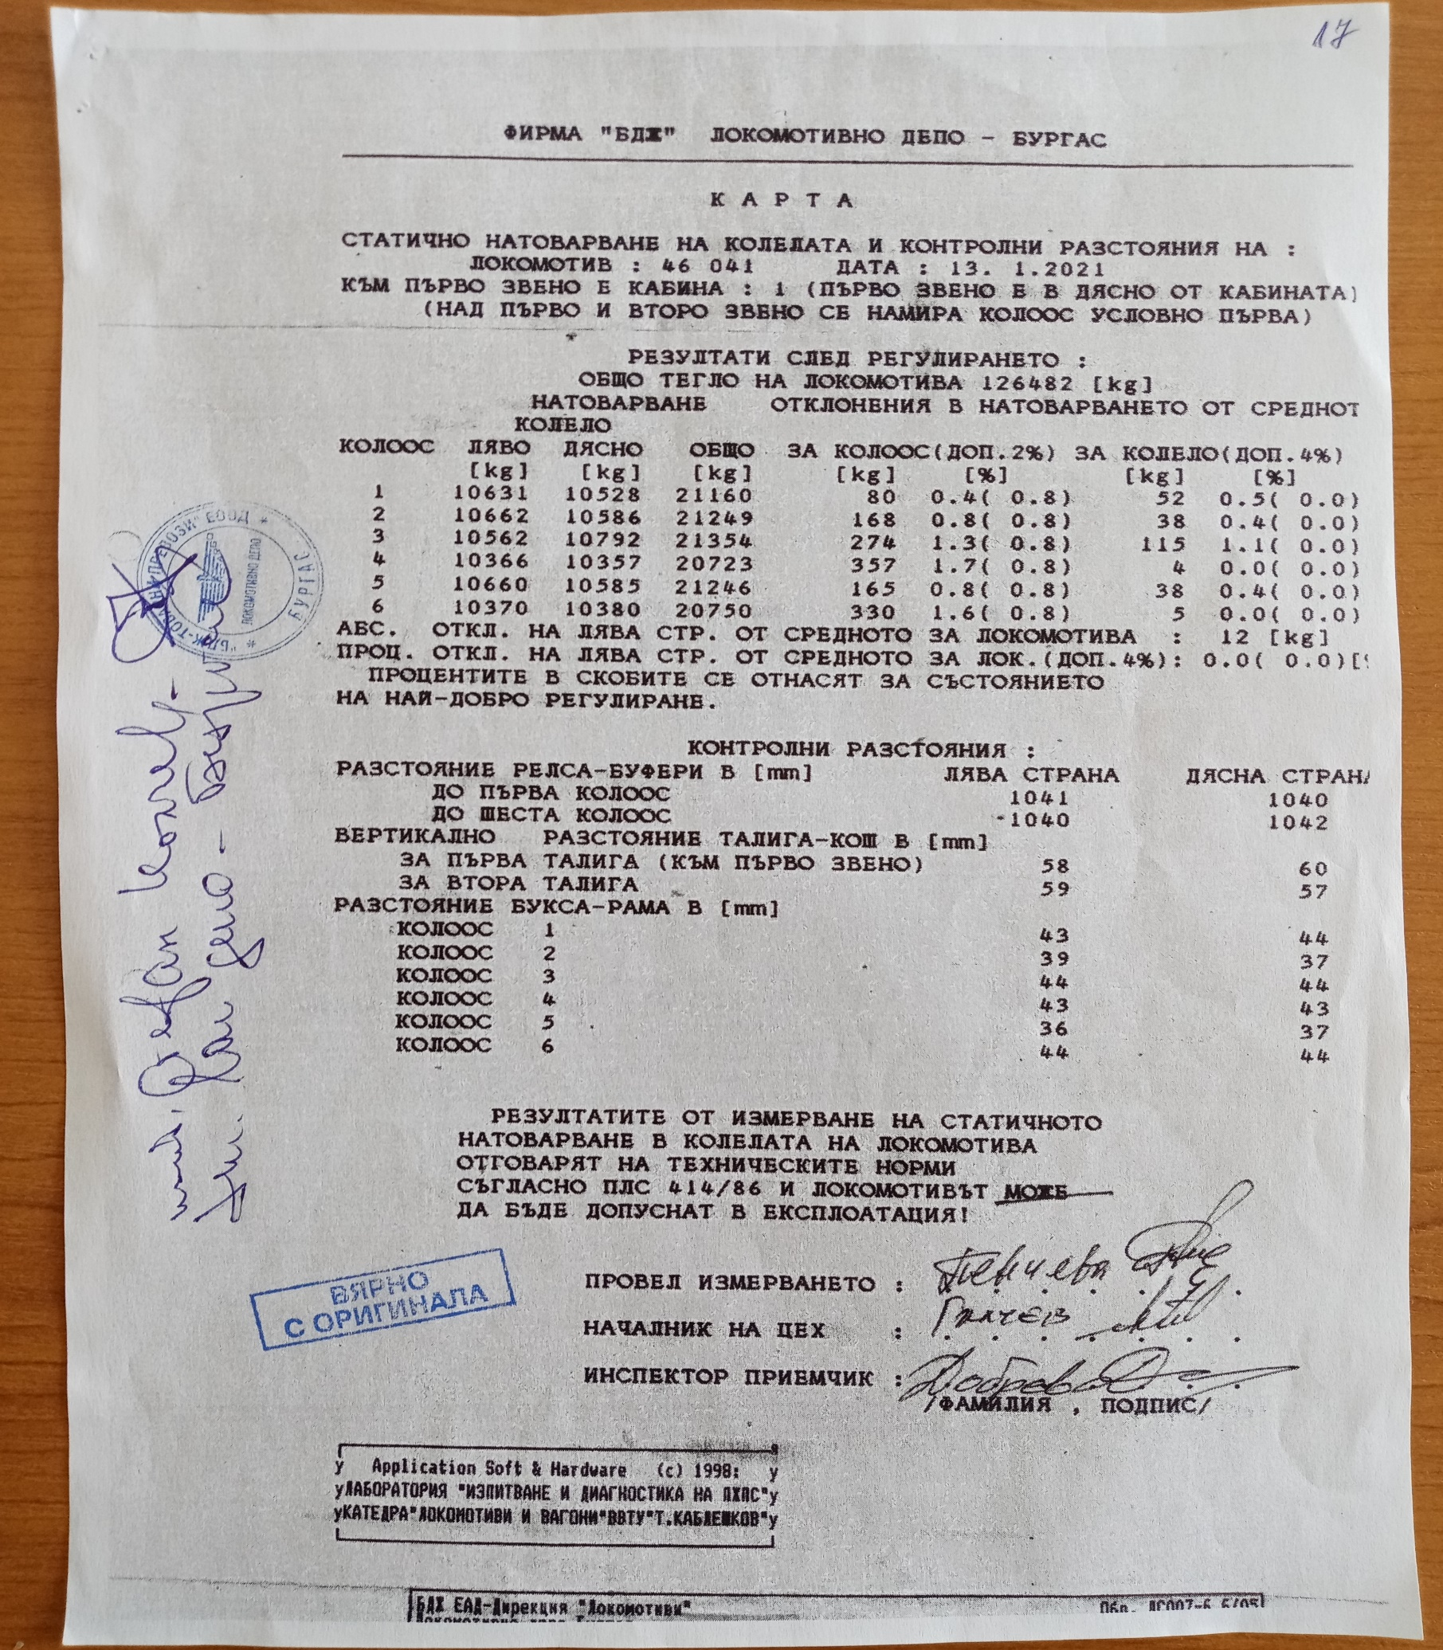
On 13.01.2021 in Burgas locomotive depot were performed measurements of the static load of the wheels of the locomotive under axles (before the accident) (fig. 4.11 and 4.12), as the obtained results respect the technical thresholds.
Fig. 4.11. Card of the static load and the controlled distances of locomotive 46041 from Burgas locomotive depot, issued on 13.01.2021.
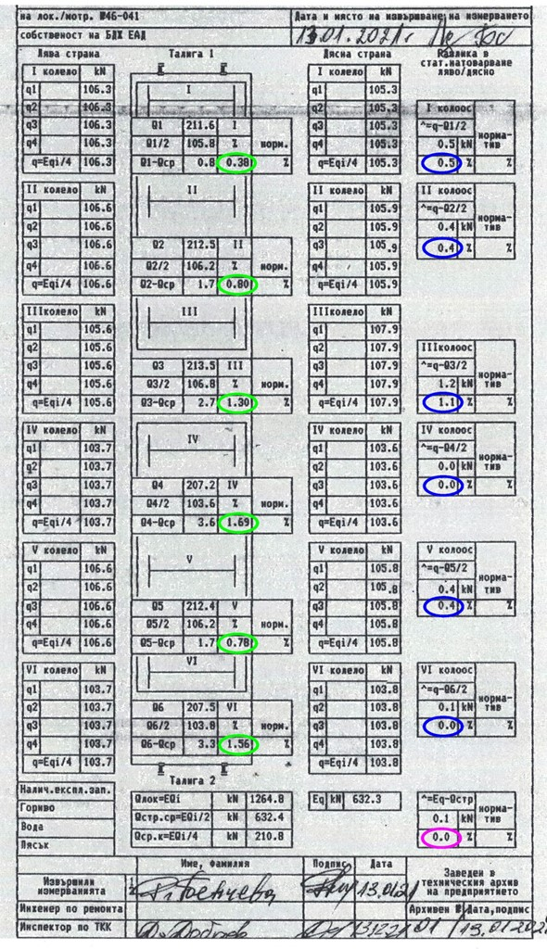
Fig. 4.12. Card of the static weight balancing of the wheelsets of locomotive № 46041 from measurement, performed in Burgas locomotive depot on 13.01.2021.
On 21.01.202 in Burgas locomotive depot were performed new measurements of the static load of the wheels of the locomotive under axles (on sets) (after the accident), and the results do not respect the technical thresholds, then the locomotive is balanced and brought within the thresholds (fig. 4.13 and 4.14).
Fig. 4.13. Card of the static load and the controlled distances of locomotive 46041 from Burgas locomotive depot, issued on 21.01.2021.
Fig. 4.14. Card of the static weight balancing of the wheelsets of locomotive № 46041 from measurement, performed in Burgas locomotive depot on 21.01.2021.
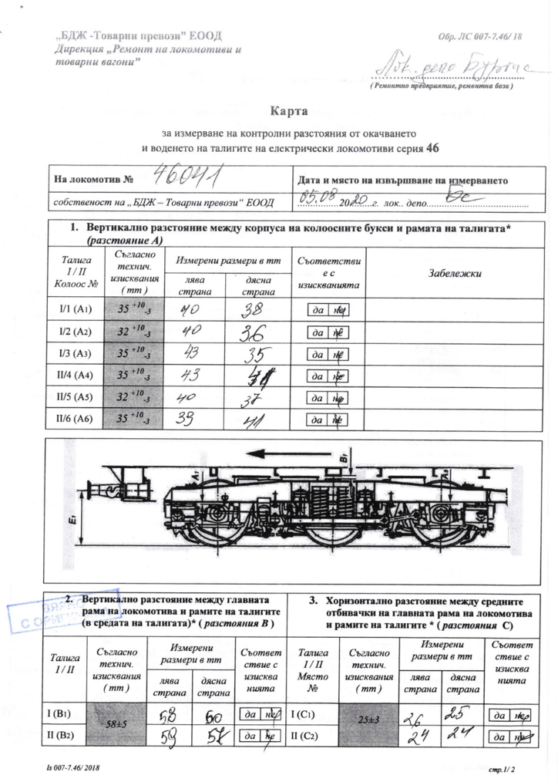
There are performed cards of measurement of the control distances from the suspension and guidance of the bogies of electric locomotive № 46041 from 13.01.2021. (before the accident) and on 21.01.2021 (before the accident) fig. 4.15 and fig. 4.16;
Fig. 4.15. Card of measurement of the controlled distances from the suspension and guidance of the bogies of locomotive № 46041, issued on 05.08.2020 – sheet 1

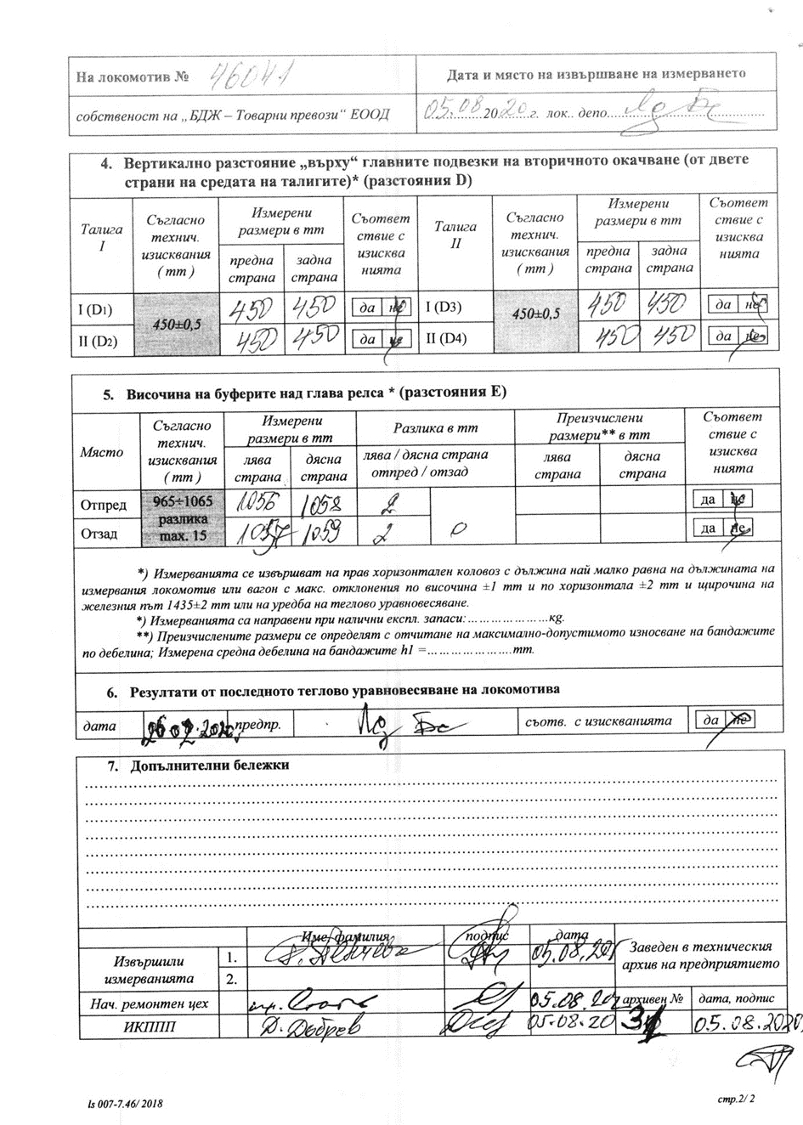
Fig. 4.16. Card of measurement of the controlled distances from the suspension and guidance of the bogies of locomotive № 46041, issued on 05.08.2020 – sheet 2
From the obtained results it is established that all the controlled dimensions and technical parameters of locomotive № 46041 are within the permissible limits and meet the regulatory requirements.
3. Manufacturers or providers of rolling stock and railway products.
Not applicable.
4. National Safety Authority.
Railway Administration Executive Agency is the National Safety Authority for railway transport in the Republic of Bulgaria.
5. Notified bodies or Risk assessment bodies.
Not applicable.
6. Certifying bodies of the entities in charge of maintenance.
The Railway Administration Executive Agency as the National Safety Authority for railway transport performs certification of the entities in charge of the vehicles maintenance (ECM) in accordance with Directive 2004/49/EC and Regulation (EU) 445/2011, as per Ordinance No 59 on the railway transport safety management and on the maintenance functions in accordance with Directive 2004/49/EC and Regulation (EU) 445/2011.
From June 16, 2020 the RAEA performs certification of the ECM as per the Commission Implementing Regulation (EU) 2019/779 of 16 May 2019 laying down detailed provisions on a system of certification of entities in charge of maintenance of vehicles pursuant to Directive (EU) 2016/798 of the European Parliament and of the Council and repealing Commission Regulation (EU) No 445/2011.

7. Persons or entities involved in the event, documented or not in the respective safety management systems or indicated in register.
Not applicable.
b). Rolling stock and technical facilities.
1. Factors, deriving from the design of the rolling stock, railway infrastructure or technical facilities.
Railway undertaking.
Locomotive No 46041 was constructed in 1987. It is a six-axle bogie locomotive with an individual start of the wheel-sets. It is known from the theory of the locomotive dynamics that six-axle locomotives are generally more difficult to fit when passing into curves with small radius and cause greater stresses in the rail track and in their own running gear, that is why their flanges are worn faster. In order to compensate the wear of the flanges of the leading wheel-sets of the two bogies when passing into curves with small radius, the locomotive is fitted with an elastic inter-bogie coupler, the purpose of which is to reduce the total wear of the flanges of the locomotive wheel-sets. Evident from the prepared Statement of findings and photo material in the presence of representatives of SE NRIC in the Locomotive Depot Burgas on locomotive № 46041 - the inter-bogie clutch meets the technical standards.

Railway infrastructure.
Stolnik Station is a two-way hub designed for the current economy in the region, long before the country joined the European Union. The straight track at the station is in the direction leading to the first main railway line. The diversion is leading for the third acceptance-departure track in the station and is in the direction of the third main railway line.
- Factors deriving from the installation and placing into service of the rolling stock, railway infrastructure and technical facilities.
Not applicable.
3. Factors deriving from manufacturers or another provider of railway products.
Not applicable.
4. Factors, deriving from the technical maintenance and/or modification of the rolling stock or the technical facilities.
Technical condition and maintenance of the rolling stock.
From the presented measurement cards and statements of finding from the inspection of locomotive 46041, the Investigation Commission found that before the accident the locomotive was technically in good condition.
Technical condition and maintenance of the railway infrastructure.
Evident from the records of commissions for monthly inspections of the track at Stolnik station, no qualitative inspections were performed on the technical condition of turnout № 11 for 3rd track, no measurements were made according to the requirements of the Instruction for current maintenance of the rail track and switches.
5. Factors due to the entity in charge of the technical maintenance, workshops for technical maintenance and other technical maintenance service providers.
Rolling stock.
Not applicable.
Railway infrastructure.
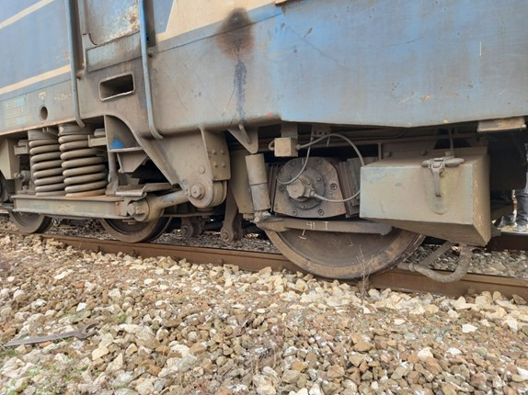
At the insistence of the Investigation Commission, repeated measurements were made on 02.02.2021 for establishing the technical condition of switch № 11. The measured notches on the right blade of switch № 11 further complicated the entry of the leading right wheel on the first wheelset of the locomotive, which increased the steering force of the wheel, and led to its rise on the right stock rail and after 9 meters the wheelset derailed to the right in the direction of train movement (Fig. 4.17 and 4.18).
Fig. 4.17. The right leading wheel of locomotive № 46041 after the derailment.
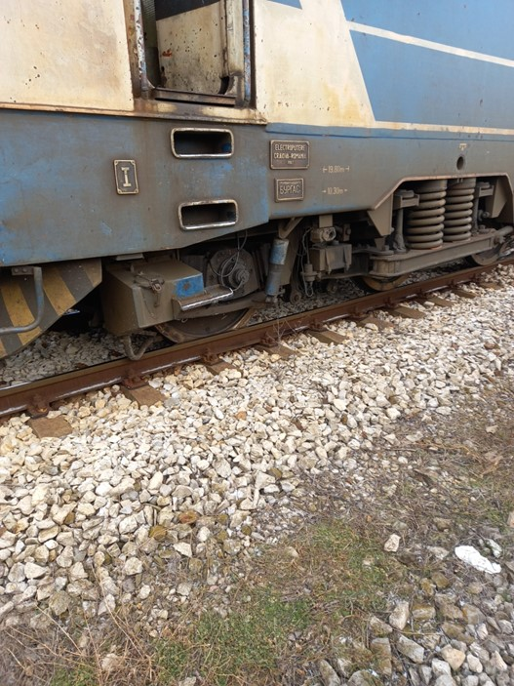
6. Other factors or consequences considered as involved within the inspection objectives..
Fig. 4.18. The right leading wheel of locomotive № 46041 after the derailment.
Not applicable.
c). Human factor.
1. Individual human characteristics:
а). Training and development, including skills and experience.
Railway undertaking:
- Engine driver – License No 12166 for obtaining professional qualification „Engine driver of electric locomotive“, training performed within the period 08.02÷31.04.2010, issued by Professional Training Center (PTC) of Bulgarian State Railways (BDZ);
Locomotive driving license BG 71 2017 1337 issued by RAEA;
License № 198 of position Engine driver at Cargo Division – Plovidv from 20.05.2014.
- Assistant engine driver – License No 21135 for obtaining professional qualification „Assistant engine driver“, training performed within the period 30.10.2017÷26.03.2018, issued by Professional Training Center (PTC) of Bulgarian State Railways (BDZ).
License № 756 of position Assistant engine driver at Cargo Division – Plovidv from 20.01.2019.
Railway infrastructure:
- Traffic manager on-duty in Stolnik station – Certificate of qualification № 16615 for ,,Traffic manager“, training performed within the period 24.03.÷27.08.2014, issued by the Professional Training Center at NRIC;
Certificate № 3818 for position Traffic manager at TOSAD – Sofia from 19.09.2014.
• Switchman-level-crossing guard in Stolnik station – Certificate of qualification № 14142 for „Switchman/level-crossing guard“, training performed within the period 05.06.÷19.07.1995. issued by the BDZ company;
Certificate № 2319 for position switchman-level-crossing guard at TOSAD – Sofia from 10.12.2009.
b). Medical and personal circumstances, which influence the event, including the presence of physical and psychological stress.
Railway undertaking:
- Engine driver:
  - Medical exam card dated 19.02.2020, issued by Multi-profile Transport Hospital Plovdiv. Conclusion: suitable for engine driver.
  - Physiological exam No 1008/11.09.2017, issued by Laboratory for physiological expertise at Plovdiv Multi-profile Transport Hospital for engine driver – conclusion: accepted for a 5-year period
- Assistant engine driver:
  - Medical exam card dated 26.02.2020, issued by Multi-profile Transport Hospital Plovdiv:
Conclusion: suitable for assistant engine driver.
  - Physiological exam No 129/04.02.2019, issued by Laboratory for physiological expertise at Plovdiv Multi-profile Transport Hospital for assistant engine driver:
Conclusion: accepted for a 3-year period.
Railway infrastructure:
- Traffic manager:
  - Single health dossier № 2664/23.09.2020 for periodic preventive examinations for traffic manager at SE NRIC, issued by National Multi-profile Transport Hospital Sofia, conclusion – suitable.
  - Physiological exam №920/11.08.2020, issued by Laboratory for physiological expertise at National Multi-profile Transport Hospital Sofia – accepted for traffic manager at SE NRIC for a 5-year period.
• Switchman-level-crossing guard:
o Single health dossier № 2663/29.09.2020 for periodic preventive examinations for traffic manager at SE NRIC, issued by National Multi-profile Transport Hospital Sofia, conclusion – suitable.
  - Physiological exam №1691/18.12.2020, issued by Laboratory for physiological expertise at National Multi-profile Transport Hospital Sofia – accepted for traffic manager at SE NRIC for a 3-year period.
c). Fatigue.
Railway undertaking:
- Engine driver:
  - Break/rest: from 04:05 a.m. on 13.01.2021 to 03:35 a.m. on 15.01.2021 (47 hours and 30 minutes).
- Assistant engine driver:
  - Break/rest: from 04:05 a.m. on 13.01.2021 to 03:35 a.m. on 15.01.2021 (47 hours and 30 minutes)
Railway infrastructure:
- Traffic manager:
  - Rest: from 07:00 a.m. on 12.01.2021 to 07:00 a.m. on 15.01.2021 (72 hours and 00 minutes).
• Switchman-level-crossing guard:
  - Rest: from 07:00 a.m. on 11.01.2021 to 07:00 a.m. on 15.01.2021 (96 hours and 00 minutes).
d). Motivation and attitudes.
Not applicable.
2. Work related factors
а). Tasks planning.
The cargo/freight traffic planning is performed under a Plan for train composition and carried out as per the Train Operation Schedule of “BDZ-Cargo”Ltd.

b). Constructive particularities of the facilities that influence the connection human-machine.
Not applicable.
c). Communication means.
Not applicable.
d). Practices and processes.
Not applicable.
e). Operation rules, local instructions, staff requirements, prescriptions for technical maintenance and applicable standards.
Application of the national normative acts – Ordinance № 58, TOR and TOSAR!
f). Working time of the involved personnel.
In accordance with the requirements of the normative acts - Labour Code and Ordinance № 50 of 28.12.2001 for the working hours of the managerial and executive staff, engaged in providing the transportation of passengers and goods in the railway transport. The staff of both entities works in shifts/suspension (when servicing a train or a vehicle - with a variable start and different working hours), in which a summary calculation of the working time shift in a 12-hour work shift is applied.
g). Risk treatment practices.
SE NRIC applies safety procedure SP 2.09 „Methods of evaluation, assessment and management of the risk „version 05 effective from 01.03.2019, which is part of the SMS.
BDZ-Cargo Ltd. Applies a procedure „Methods of analysis and assessment of the risk within BDZ-Cargo Ltd” effective from 2013 as part of the SMS.
h). Context, machinery, equipment and indications for shaping the working practices
Not applicable.
3. Organizational factors and tasks
а). Planning of the working force and the working load.
As per the requirements of the normative documents and best practices.
b). Communications, information and teamwork.
Not applicable.
c). Recruitment, staffing requirements, resources.
Not applicable.
d). Implementation management and supervision.
Not applicable.
e). Compensation (remuneration).
Not applicable.
f). Leadership, powers related issues.
Not applicable.
g). Organizational culture.
Not applicable.
h). Legal issues (including the respective European and national rules and provisions).
Accepted to operation is switch № 11, leading to the third acceptance-departure track in Stolnik station, which is in violation of Art. 49, para. 6 item 2 of Ordinance № 58.
i). Regulatory framework conditions and safety management system application.

Railway undertaking.
- Directive (EU) 2016/798 of the European Parliament and of the Council of 11 May 2016 on railway safety;
- Commission Delegated Regulation (EU) 2018/762 of 8 March 2018 establishing common safety methods on safety management system requirements pursuant to Directive (EU) 2016/798 of the European Parliament and of the Council and repealing Commission Regulations (EU) No 1158/2010 and (EU) No 1169/2010;
- COMMISSION IMPLEMENTING REGULATION (EU) 2019/779 of 16 May 2019 laying down detailed provisions on a system of certification of entities in charge of maintenance of vehicles pursuant to Directive (EU) 2016/798 of the European Parliament and of the Council and repealing Commission Regulation (EU) No 445/2011;
- COMMISSION IMPLEMENTING REGULATION (EU) No 402/2013 of 30 April 2013 on the common safety method for risk evaluation and assessment and repealing Regulation (EC) No 352/2009;
- Railway Transport Act;
- ORDINANCE No 59 dated 5.12.2006 on the railway transport safety management;
- TOR and TOSAR.
Railway infrastructure.
- Directive (EU) 2016/798 of the European Parliament and of the Council of 11 May 2016 on railway safety;
- Commission Delegated Regulation (EU) 2018/762 of 8 March 2018 establishing common safety methods on safety management system requirements pursuant to Directive (EU) 2016/798 of the European Parliament and of the Council and repealing Commission Regulations (EU) No 1158/2010 and (EU) No 1169/2010;
- COMMISSION IMPLEMENTING REGULATION (EU) 2019/779 of 16 May 2019 laying down detailed provisions on a system of certification of entities in charge of maintenance of vehicles pursuant to Directive (EU) 2016/798 of the European Parliament and of the Council and repealing Commission Regulation (EU) No 445/2011;
- COMMISSION IMPLEMENTING REGULATION (EU) No 402/2013 of 30 April 2013 on the common safety method for risk evaluation and assessment and repealing Regulation (EC) No 352/2009;
- Railway Transport Act;
- ORDINANCE No 59 dated 5.12.2006 on the railway transport safety management.
4. Environmental factors.
а). Labour conditions (noise, illumination, vibrations).
Not applicable.
b). Meteorological and geographic conditions.
The event occurred in the daylight hours, cloudy weather, with good visibility for the signals acceptance in Stolnik station.
c). Construction works, performed on the spot or in very proximity.
At Stolnik station in the area of the event have not been performed any construction works.
- Any other significant factor for the investigation objectives.
There is no such.
d). Feedback and control mechanisms, including risk and safety management, as well as monitoring processes:
      - Regulatory framework conditions.
- Commission Delegated Regulation (EU) 2018/761 of 16 February 2018 establishing common safety methods for supervision by national safety authorities after the issue of a single safety certificate or a safety authorisation pursuant to Directive (EU) 2016/798 of the European Parliament and of the Council and repealing Commission Regulation (EU) No 1077/2012;
- ORDINANCE No 59 of 5.12.2006 on the railway transport safety management.
      - Processes, methods and results from the activities on the risk assessment and monitoring that the involved entities performed:
Railway undertakings.
“BDZ-Cargo” Ltd. applies a procedure „Methods of risk analysis and assessment within BDZ-Cargo Ltd. “ effective from 2013 as a part of SMS.
Railway infrastructure.
SE NRIC applies a safety procedure SP 2.09 „Methods of risk evaluation and assessment „version 05 effective from 01.03.2019, which is a part of SMS.
2а. Entities in charge of the technical maintenance.
SE NRIC and “BDZ-Cargo” Ltd. are certified ECM.
SE NRIC applies a safety procedure SP 2.09 „Methods of risk evaluation and assessment“ version 05 effective from 01.03.2019, which is a part of SMS.
“BDZ-Cargo” Ltd. applies a procedure „Methods of risk analysis and assessment within BDZ-Cargo Ltd. “effective from 2013 as a part of SMS.
2b. Manufacturers and all other participants.
Not applicable.
Reports on independent risk assessment.
There have not been performed an assessment by independent Assessment Body (AsBo) on changes/modifications performed in operational conditions and factors that refer to the occurred accident.
3. Safety Management System of the involved:
Railway Undertakings.
The latest annual planned supervision of the SMS of “BDZ-Cargo” Ltd. was performed in the period from 13.01.2020 to 31.01.2020
Railway Infrastructure.
The latest annual planned supervision of the SMS of SE NRIC was performed in the period from 19.10.2020 to 30.10.2020.
4. Safety Management System of the entities in charge of the technical maintenance.
Not applicable – the entities are certified ECM and in 2020 have had performed planned audits.
5. Results from the supervision, performed by the National Safety Authority.
The results from the performed audits and inspections referring the functionality of the Safety Management System of SE NRIC and “BDZ-Cargo” Ltd. as per the requirements of Regulation (EU) 2018/761, Regulation (EU) No 1169/2010, Ordinance No 56 and Ordinance No 59 on respect of the specific requirements of the European legislation and national rules for design, maintenance and operation of the managed railway infrastructure demonstrate that the entities maintain SMS and are able to respect the requirements, envisaged in the respective normative documents;
6. Permits, certificates and assessment reports, provided by the National Safety Authority or other Conformity Assessment Bodies.
6а. Safety certificates of the involved railway infrastructure managers.
- Safety Authorization No BG 21/2018/0001 valid from 01.07.2018 to 30.06.2023.
6b. Safety certificates of the involved railway undertakings.
- Safety Certificate part А BG 11 2017 0008, valid to 30.12.2022;
- Safety Certificate part B BG 12 2017 0008, valid to 30.12.2022;
6c. Authorizations for placing in service of permanently fixed equipment and permits for placing on the market of vehicles.
Not applicable.
6d. Entities in charge of the technical maintenance.
“BDZ-Cargo” Ltd. has an ECM Certificate for railway vehicles BGRA/2017/0003 valid to 30.12.2022;
SE NRIC is in charge of the repair, maintenance and operation of the national railway infrastructure.
7. Other system factors.
There are no.
e). Previous similar cases.
Similar cases within similar or identical circumstances were witnessed 20 years ago, which were inspected and analysed.
5. Conclusions
а). Summary of the analysis for the event causes.
Railway undertaking:
Cards for measuring the static load in the wheels and adjusting the spring system are stored in the passport of locomotive 46041.
Data on the measured static load in the wheels of locomotive № 46041 on 13.01.2021 (before the accident) are displayed in the Card for measuring the static load in the wheels and adjusting the spring system in Fig. 4.12.
From the data presented in the Card it is established that:
- in the load of the 3rd wheelset of the locomotive is the largest deviation of the left/right wheel of 1.1% (with a maximum allowable difference of 5%). All 6 axles on this indicator are in the tolerance field (marked with ellipses in blue);
- in the wheelset load compared to the average wheelset load at the 4th wheelset of the locomotive there are deviations of 1.69% (with a maximum allowable difference of 3%). All 6 axles on this indicator are in the tolerance field (marked with ellipses in green);
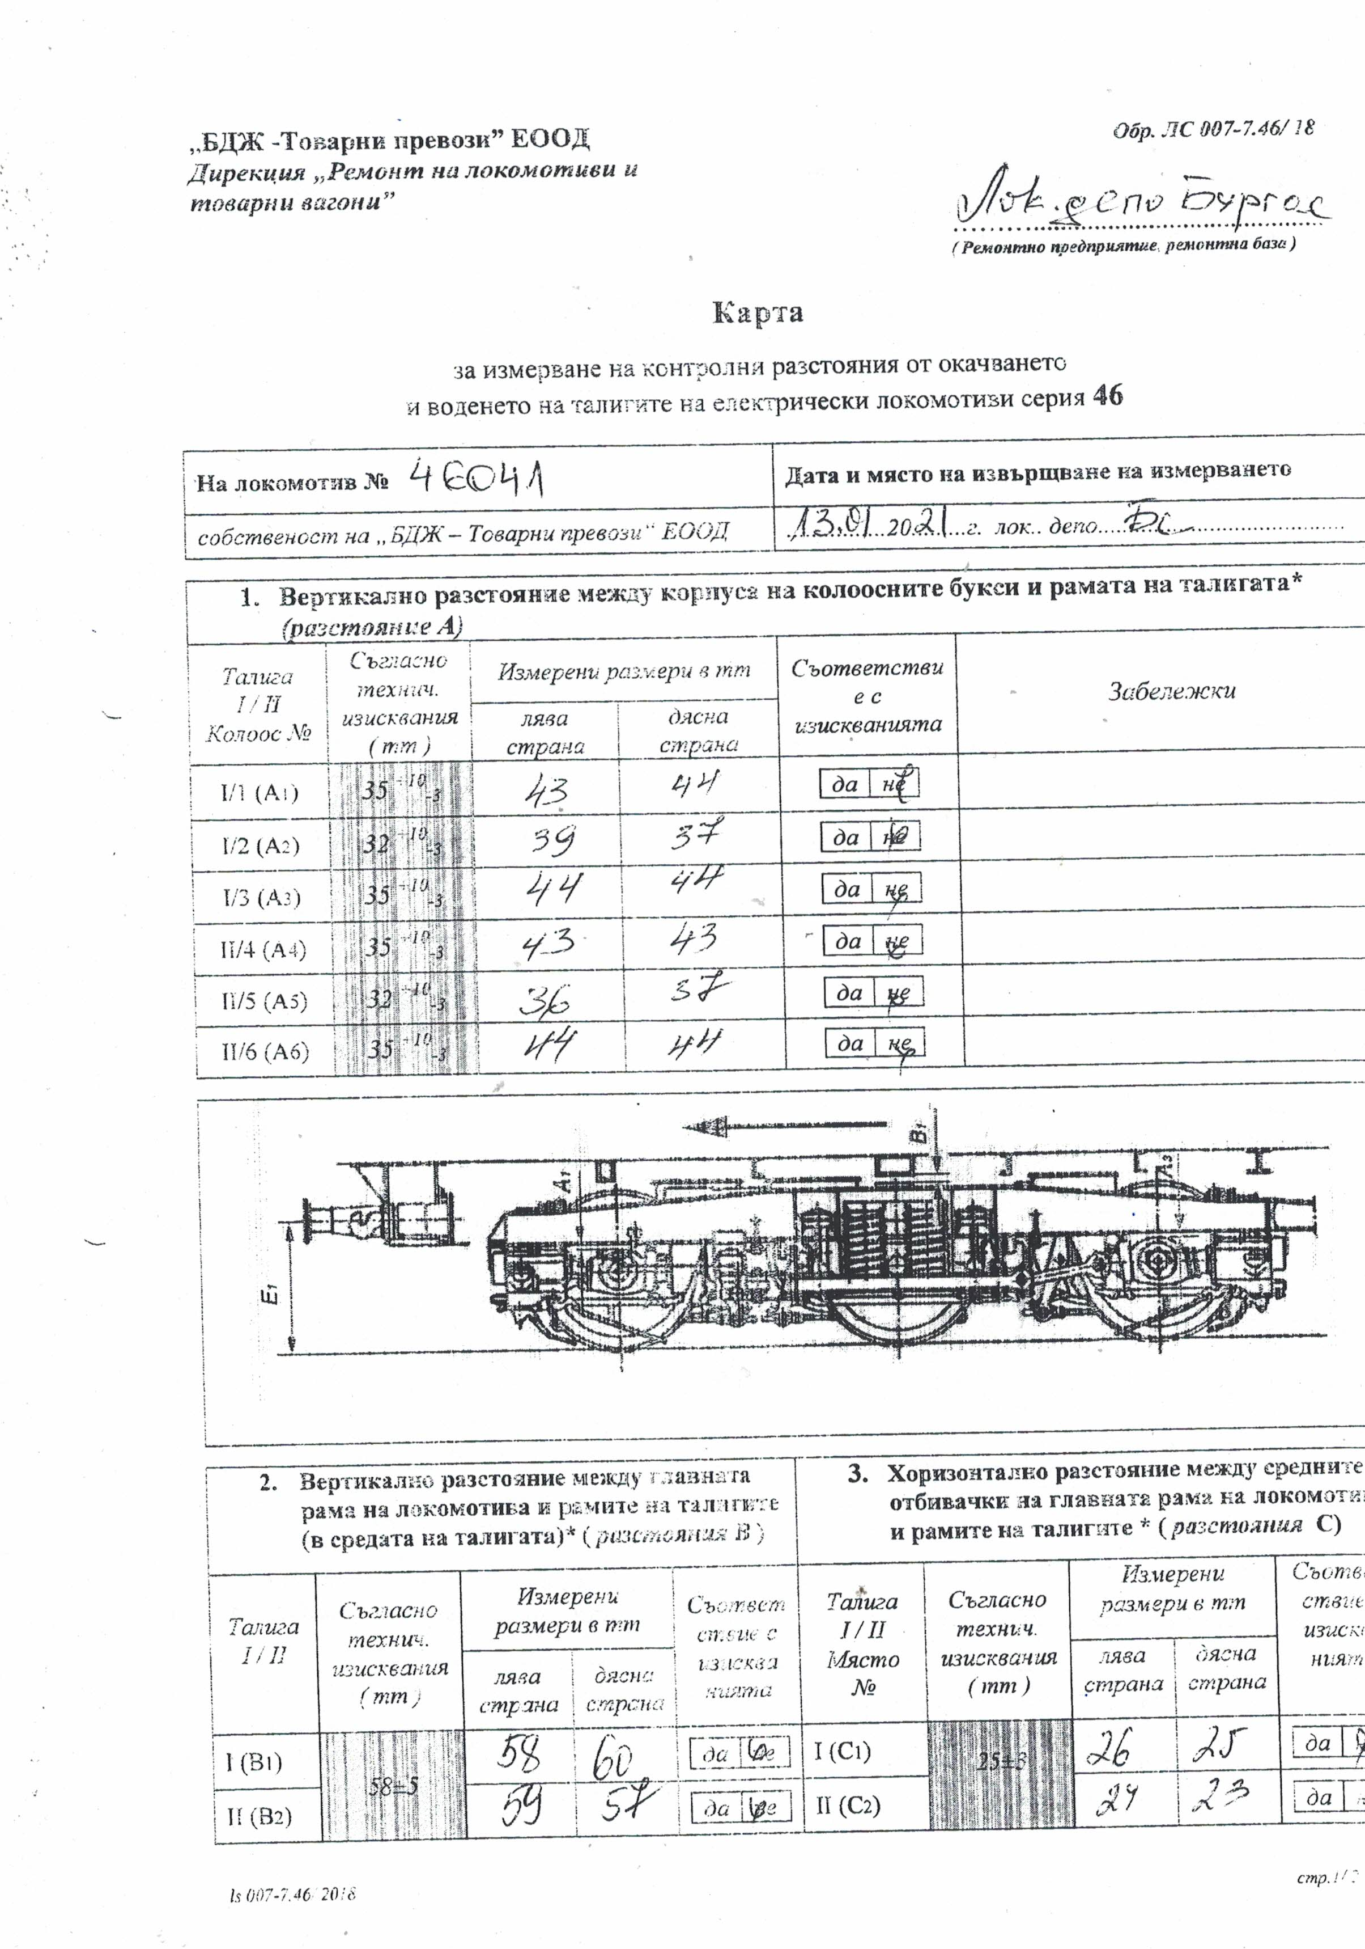
- the difference in the sum of the loads of all the left compared to the sum of the loads of all the right wheels (marked with an ellipse in purple colour) is 0.1 kN, or 0% (with a maximum allowable difference of 5%).
Fig. 4.19. Card of measurement of the controlled distances from the suspension and guidance of the bogies of locomotive № 46041 from 13.01.2021– sheet 1
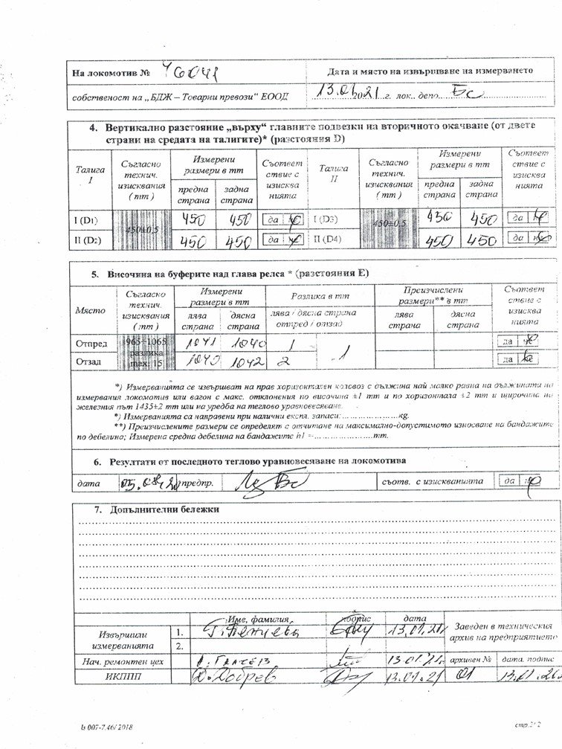
Fig. 4.20. Card of measurement of the controlled distances from the suspension and guidance of the bogies of locomotive № 46041 from 13.01.2021– sheet 2

The data displayed in the Card for measuring the static load in the wheels and adjusting the spring system (Fig. 4.12) and in the Card for measuring the control distances from the suspension and guidance of the bogies of electric locomotive № 46041 (Fig. 4.19 and Fig. 4.20), show that all the differences in loads and control distances are within the permissible regulatory limits and meet the requirements.
In summary, locomotive № 46041 before the accident was in good technical condition, i.e. it cannot be the cause for its derailment.
Railway infrastructure:
When the train passes on the diversion track of switch № 11 leading for the third track in the uphill with 3.53 ‰ in the direction of movement, the right guide wheel rises on the right diversion blade of the right stock rail at a distance of 0.53 m from the tip of the balde and 2.02 m from the beginning of the switch. The place of ascent is at km 31 + 872, and the beginning of the switch is at km 31 + 874 in the direction of mileage. After the right leading wheel rises on the head of the right stock rail, the inner left wheel is still on the left stock rail. With the distance of the right flange on the head of the stock rail with the total value of the thickness of the flange, the width of the head of the blade and part of the width of the stock rail, as well as the curvature of the left stock rail, follows the derailment of the left wheel about km 31 + 865 right from the left stock rail before the semi-coupling of the left right blade, where there are traces of slipping of the left wheel. The derailed left wheel and the right wheels of the second and third wheelset, which were moving normally on the right deflection blade, did not allow the right wheel to shift to the right of the stock rail. A distance between the two stock rails of about 1640 mm was found, which forced the right wheel to slip between the right stock rail and the right blade around the support wedges at km 31 + 863. In the area around the fourth blade support wedge there are clearly marked traces of the flanges and bandages of the right and left wheel of the derailed wheelset. There was a rise of the left wheel on the left check (counter) rail, and the traces of the right wheel are lost in the area at a distance of 2.60 m before the top of the frog and 2.40 m after it or a total distance of 5 m. There are clearly defined traces at the end of the frog on the clamping sets. The movement of the derailed right wheel near the inner rail follows this on its outer side and on the left wheel on the inner side of the outer rail in the right curve in the direction of train movement. The curve after switch № 11 has a radius R = 1200 m and an elevation = 80 mm.
The train stops 65 m after the end of switch № 11 at km 31 + 776.
The dimensions of the elements in the blade part where the accident occurs are the following:
- Right straight stock rail with length = 14 248 mm.
- Left arc stock rail with length = 14 212 mm.
- Right deflection and left straight blade with a length of 12,750 mm.
To make easier to turn the blades, 11 sliders are installed, which serve to support them. In the elastic blade part, on the stock rails, four blade supports are installed, the main purpose of which is to prevent an increase in the track gauge when passing the rolling stock.
The particularities of the longitudinal profile of the blades are the following:
Initially, the blades are thinned and lowered relatively to the stock rails in order to protect them from the impact of the flanges and from the load on the tires/bandages of the rolling stock. In this case, the height of the blade at the tip is 96.5 mm and gradually increases to 116 mm at a width of 50 mm, where the blades acquire the required load-bearing capacity.
Assessment of the rail track condition - tongue part of the switch № 11. In addition to the track gauge, the transverse level, the deviations along the axles, the vertical and lateral operation of the stock rails and blades, as well as the condition of the crossbeam, fasteners and ballast prism.
Analysis of the parameters from the Statement of findings of the Task Force for the state of the switch and the measured parameters.
Rail gauge
The rail gauge, coordinated with the transverse dimensions of the wheelsets of the rolling stock, play one of the most important roles for the safe movement. In this case, the accident occurs in the diversion track in a curve without transition and without cant. In the diversion track, the maximum track gauge for switches with radius R = 300 m and specifically for the case in the blade part is as follows:
- in the initial joint + 8 mm;
- at the tip of blades + 11 mm;
- in section of 30 mm + 11 mm;
- in the interim part + 18 mm.
From the Statement of findings of the TF can be seen that the track gauge of switch № 11 corresponds to the Instruction for current maintenance of the rail track and switches.
The inner bandage distance is 1358.5 mm and the thickness of the right and left flange is 31.6 mm and 27.2 mm, respectively. Their total distance is 1417.3 mm, which is the distance between the outer surfaces of the flanges. This distance must be at most 1426 mm and at least 1410 mm. Extremely rare is the occurrence of notches in the area from 330 mm to 730 mm from the tip of the blade, because here it "hides" in the bevelled part of the stock rail and it absorbs the vertical dynamic forces from the bandages.
Transverse level of the permanent way in the diversion track in the blade part of switch №11. The distance between the first and second wheelset is equal to 2.25 m.
Level p.0 = 10 m, p.2 = 10 mm; Hidden twist – left = 5 mm; right = 4 mm;
Level with hidden twist p.0 = 11 mm, p.2 = 10 mm;
Difference = 1 mm.

$К=\frac{L}{H}$ = $\frac{2250mm.}{1mm.}=2250$; transition 1:2250 before the rise point;

p.0 = 10 mm; p. -2 = 6 mm; hidden p.0 = left = 5 mm, right = 4 mm; level in point 0 = 11 mm; hidden in point -2 left = none; right = none. Difference = 11 – 6 mm. = 5 mm;

$К=\frac{L}{H}$ = $\frac{2250mm.}{5mm.}=450$; transition 1:450 after point of rise.

Based on the inter-bogie distance = 10 300 mm;
Level: p.0 = 10 mm; hidden left = 5 mm, right = 4 mm;
Level: p. -10 = 1 mm; hidden left = 3 mm, right = 2 mm;
The level in p.0 = 11 mm; p. -10 = 2 mm, difference = 9 mm;

$К=\frac{L}{H}$ = $\frac{10 300mm.}{9mm.}=1144$; transition 1:1144.

It is evident from the calculated transitions that there is no deviation from the technical requirements under Ordinance № 58 and the Instruction for construction and maintenance of the rail track and the switches.
Condition of the diversion track of the switch along the axle.
The condition of the same is assessed based on the measured alignments with a chord of 10 m and their differences. The basic rule here is that each size of a given alignment corresponds to a corresponding radius of a given curve and is determined by$f= \frac{a^{2}}{2R}=\frac{S^{2}}{8R}$;
where:
a = half of the chord length;
f = the measured alignment in a given curve;
S = used chord as per the radius;
R = curve radius;
In curve without transition curve and speed up to 40 km/h, the difference between the alignments is calculated by $Δf=0,5 x \frac{a^{2}}{2R}±5 mm. => Δf=0,5 x \frac{5^{2}}{2 x 300}=\frac{12,5 x 1000}{600}=20,83 mm;$
In the case the measured alignment in p.5 is 29 mm; and in p.0 = 41 mm; difference = 12 mm;
The alignment in p. -5 = 44 mm; in p. -10 = 40 mm, in point – 15 = 39 mm and they are respectively with differences 3 mm, 4 mm and 1 mm;
The alignment in the diversion track is with admissible values as per Table № 25 of the Instruction for planning and maintenance of rail track and switches.
The theoretical alignment for curve with R = 300 m is calculated by $ftheoretical= \frac{S^{2}}{8R}$ = $\frac{{10}^{2}}{8 x 300}= \frac{100 x 1000}{2400}=41,7 mm.$

Displayed diagram for measuring the values of switch № 11: level, track gauge and alignment differences.
There is no lateral or vertical operation on the blade and the right stock rail.
The condition of the switch sleeper gird and fasteners is good.
When observing the passing train rolling stock, oscillations are observed in the track, which are marked in the protocol of measurement, including hidden twists.
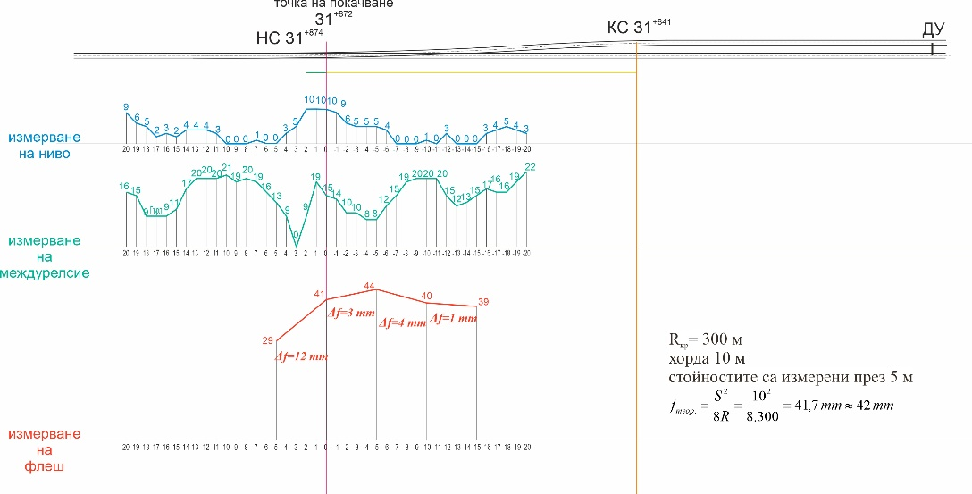
There is no hardened ballast prism.
Fig. 4.21. Scheme of the measured values of switch № 11
From the inspections made on the right deflection blade of switch № 11 it was found that from its top up to 150 mm horizontal distance from it, there is no contact with its side work surface. There are no traces of blows from the passing wheel on its top. This is an evidence that the blade has been very well sealed to the stock rail, which has no vertical operation. In this position, the blade is well protected in its thinned part from side impacts and vertical dynamic loading from the wheel tires. At a distance of 330 mm from its top to 730 mm with a length of 400 mm with a permissible 300 mm there is a notch with different depth, and in its middle part reaches 9 mm with a permissible 8 mm. This measurement was performed with a calliper on 02.02.2021. These data appear in violation of Art. 49, item 6 of Ordinance № 58 and of item 7.4 of the Instruction for current maintenance of the rail track and switches. It is clear that when the wheelset of the wheels of the rolling stock move in the straight sections of the rail track, they move in parallel to the rails. However, this is not the case when moving in the curves. In the present case, the leading first wheelset of the first three-axle bogie of the locomotive, after passing the 10 m line between switches № 7 and № 11, enters in the curve for the deviating 3rd track of switch № 11, which is without transition curve and without cant. A centrifugal force appears, as the vehicle tends to continue on its tangent. It forces the flange of the first right wheel to fit snugly against the working side surface of the blade. It is possible that the horizontal transverse force appeared is so large that multiplied by the coefficient of friction, it has overcome the pressure of the wheel. (H x f> Q);
where:
H = transverse horizontal force;
f = coefficient of friction;
Q = pressure of wheel.
The notching of the blade is caused by chipped metal in its upper thin part.
The reduced grip between the flanges of the right wheel of the first wheelset, due to the notching of the blade with length of 400 mm at a distance of 330 mm from its tip has caused the flange to rise on the right stock rail. The combination of all these conditions has led to the derailment of the leading wheelset of the locomotive. The sealed blade to the right stock rail in this area did not allow the flange to be inserted between the right stock rail and the right deflection blade adhering to it.
b). Undertaken measures after the event occurrence.
Railway undertaking:
In the Burgas Locomotive Depot after the accident, balancing was performed to normalize the static load on wheels and axles of locomotive № 46041.
Railway infrastructure:
After the accident on switch № 11 and on the 3rd track in Stolnik station in the area of derailment of locomotive № 46041, the track was repaired.
c). Additional findings.
After the derailment on 15.01.2021 on switch № 11, the operation of the damaged blade continued. It was replaced with a new one on 03.02.2021.
6. Safety recommendations
In order to improve the safety in rail transport, the Investigation Commission at NAMRAIB proposes to the Railway Administration Executive Agency the following safety recommendations adapted to SE NRIC and „BDZ-Cargo“ Ltd.
- Recommendation 1 proposes SE NRIC to strengthen the control of the commissions for carrying out the monthly and six-monthly audits of the railway switches in the stations.
- Recommendation 2 proposes SE NRIC to bring switch № 11 in Stolnik station in accordance with the Technical Requirements for Railway Infrastructure (NRIC TSI) and the Instruction for construction and maintenance of the rail track and the switches, without violating Art. 49, para. 6, item 2 of Ordinance № 58 / 2.08.2006.
- Recommendation 3 proposes that BDZ Cargo Ltd. periodically adjust (balance) the spring system of the locomotives, in order to equalize the vertical load in the wheels.

With reference to the requirements of art. 94, paragraph 3 of Ordinance No 59 of 5.12.2006. The NAMRAIB Investigation Commission proposes to RAEA and interested parties a final report, which contains information on the performed investigation with proposed safety recommendations.
The Report’s Addressees shall inform in written the Deputy presidentof the NAMRAIB Administrative Board (President of the Commission) on the undertaken measures under the presented recommendations.

The NAMRAIB Commission proposes a final report with safety recommendations dated 17.05.2021.

President:
Dr. Eng. Boycho Skrobanski
Deputy President of the NAMRAIB AB

