REPUBLIC OF BULGARIA
MINISTRY OF TRANSPORT,
INFORMATION TECHNOLOGIES AND COMMUNICATION

9, Diakon Ignatiy Street, 1000 Sofia bskrobanski@mtitc.government.bg
тел: +359 2 940 9317 mail@mtitc.government.bg
факс: +359 2 940 9350

SPECIALIZED UNIT FOR INVESTIGATIONS OF ACCIDENTS AND INCIDENTS IN RAILWAY TRANSPORT AT MTITC

FINAL REPORT

From

investigation of a railway accident – fire occurred
in electric locomotive № 46221.8 while in motion, during servicing fast train № 8602 between Svoboda station and Chirpan station on April 09, 2019

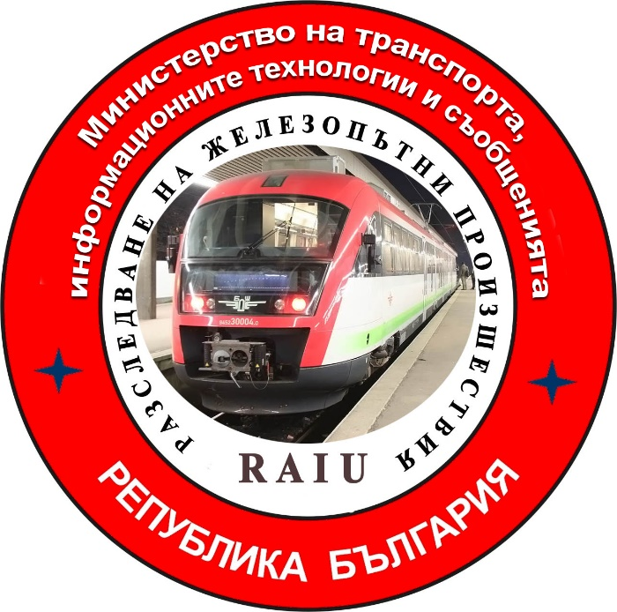

2019

FINAL REPORT

Purpose of the investigation and degree of responsibility

The Investigation of serious accidents, accidents and incidents is carried out by an independent investigation authority of the Republic of Bulgaria - "Specialized Unit for Investigation of Accidents and Incidents in Railway Transport" in the "Ministry of Transport, Information Technologies and Communications" (MTITC) and it aims:
To identify the circumstances and the reasons that led to their implementation with a view to improve safety and prevent from others without seeking personal responsibility and guilty.
The investigation is carried out in accordance with the requirements of Directive 2004/49 / EC of the European Parliament and of the Council upon safety of the Community's railways transpositioned in the Law for Railways ( LR ), Ordinance № 59 from December 5, 2006 about the management of safety in railway transport, Ordinance № H-32 from September 19, 2007 about the coordination of the actions and the exchange of information during investigations of railway accidents and incidents and the Agreement for interaction during investigations of accidents and incidents in the air, waterway and railway transport between the Prosecutor's Office of the Republic of Bulgaria, Ministry of Interior and MTITC from April 17, 2018.

CONTENTS

1. Резюме…………………………………………………………………………...…..………4
2. Direct facts and circumstances ……………..……………………….…………..…..……..5
3. General data established during the investigation process …….……………..…...……..7
4. Deaths, injuries and material damages ……………………………………………….........9
5. External circumstances - weather and geographic conditions ……….………….…..…....9
6. Data for railway infrastructure and railway carrier staff related to the accident….........9
7. Summary of testimony ………………………………………………………………..…….11
8. System of Safety Management (SSM) of RINC and BDZ PT Ltd ……………..………..11
9. Rules and norms ………………………………..………………………….…..…………...12
10. Functional condition of rolling stock and technical facilities of the railway
infrastructure ………………………..………….......…………………..……..……...12
11. Operational System Documentation …………………………………..…………………13
12. Health and Safety work conditions …………………………..…………………….…….14
13. Accidents of similar nature previously registered …………………………………........14
14. Analysis and conclusions ……………………………………………..……….…..………15
15. Description of already taken measures as a result of the accident…………….……..…20
16. Recommendations issued in order to avoid accidents upon the same reasons ……..….20

1. Summary.
1.1. Brief description of the event.
On April 09, 2019 at 16:33 hours a fast train (FT) № 8602 has left Burgas station to Sofia station, consisting of 5 wagons, 20 axles, 237 tons, serviced by electric locomotive № 46221.8. The fast train runs along Burgas - Stara Zagora - Plovdiv - Sofia. The locomotive and transport brigades who served the train haven't noticed anything unusual during the train movement. The Duty Staff at train stations along the route has not also noticed anything unusual in train's movement.
The train has arrived at Stara Zagora Station by schedule at 18:31hours and after a two-minute stay, at 18:33 hours, it has departed. During the movement, the train has kept the section speed and the limitations along the railway. Upon entering Svoboda station, the locomotive brigade hears a strange noise coming from the locomotive's truck. The motorman undertakes a quick stop with the automatic train brake and the train stops at 18:56 hours at the station. After the inspection of the locomotive, the locomotive brigade doesn't find anything unusual and the train leaves Svoboda station at 19:02 hours. When the train leaves the station, the locomotive brigade senses a burned insulation smell and sees that the machine room is filled with smoke. The motorman undertakes a stop with the train brake and the train stops at 19:05 hours at km 69 + 480 in Svoboda - Chirpan stage.
The motorman enters the locomotive engine room and finds out that flames and smoke come out of the compressor. He takes off the pantograph and, together with the assistant motorman, they start extinguishing the fire with the fire extinguishers in the locomotive. This is what the locomotive looks like after the fire, without external damage (Fig. 1).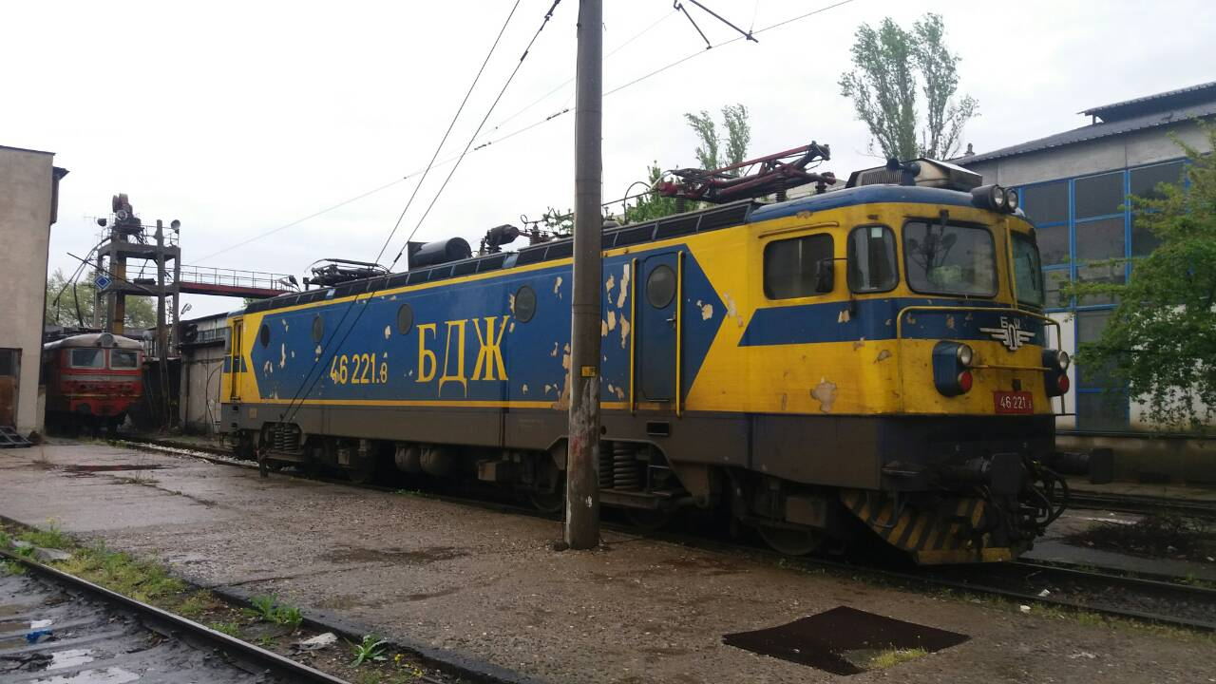
Fig. 1
1.2. Main cause of the accident:
The Investigation Commission came to the conclusion that the cause of fire in the locomotive was due to a loosening and displacement of the cooling turbine from the shaft of the main compressor engine which has led to a friction of its rear part into the wall of the air outlet camera. The friction between the two surfaces (steel in steel) has created sparks, resulting in a flame and the temperature in the cameras has risen. This has led to the ignition of the greased dust layered on the noise insulation of the inside walls of the compressor's cameras. The ignited insulation has further increased the temperature which has led to the ignition of the power cable insulation supplying the compressor unit that passes through the base of the duct cameras.

1.3. Summary of the main recommendations.
Recommendations issued by MTITC Commission for investigation are methodological and technical in order to prevent other similar incidents for this locomotive series.
The recommendations are addressed to the national safety authority Executive Agency "Railway Administration"(EARA), directed to the railway carrier BDZ ,, Passenger Transport "Ltd.
- Recommendation № 1 proposes to familiarize the staff in service (locomotive and transport
brigades with the contents of the report;
- Recommendation № 2 proposes for the renovated locomotives in "BDZ Konchar" JSC, when
performing a large periodic repair (LPR) of the compressor unit to replace oil separator, oil filter, air filter and straps;
- Recommendation № 3 proposes to replace the available flammable noise insulation installed
on the inside of the compressor aggregate walls with such of a non-combustible material in the renovated locomotives in "BDZ Konchar" JSC;
- Recommendation № 4 proposes to install a thermal sensor in the compressor cooling camera
and to be connected to the locomotive's fire alarm system.
2. Direct facts and circumstances.
2.1. Date and time of the event.
On April 09, 2019 at 18:51 hours, the head of traffic at Svoboda Station received a departure of FT № 8602 from the head of traffic at Mihaylovo Station. Through the stationary routing-relay centralization (RRC-H-68), he has prepared the route for accepting the train on the second main track according to "Plan II-24". In view of the Train Traffic Schedule (TTS), the train doesn't stop at the station. The train stops extraordinarily at Svoboda Station at 18:56 hours. Upon stopping the train at the station, the head of traffic had a conversation with the motorman about the reason for the suspension for which he had informed the train dispatcher. With the inspection of the locomotive, the locomotive brigade has not found anything unusual and the train has departed at 19:02 hours (Fig. 2).

SCHEME of SVOBODA station
Direction of FT №8602 movement
Chirpan
Mihaylovo

Fig.2.
After the train leaves the station, the locomotive brigade senses the smell of a burning insulation, they see that there is a smoke in the engine room and they undertake a quick stop. The train stops at 19:05 hours at kilometer 69 + 480 in the Svoboda - Chirpan stage. The motorman enters the engine room of the locomotive and finds that flames and smoke come out of the compressor. He takes off the pantograph and start extinguishing the fire with the available extinguishers of the locomotive loaded with carbon dioxide. After using the fire extinguishers they fail to extinguish the fire and the motorman calls the common emergency number 112 by his mobile phone, informing of the fire and the location of the train. The locomotive brigade manages to dismantle the locomotive from the wagons and pulls it to a safe distance, secured against self-propulsion. The motorman notifies the services concerned in accordance with the established order and takes measures to switch off the voltage in the contact network (CN).
At 19:16 hours by an order of the Power Dispatcher the voltage in the Svoboda - Chirpan stage is switched off.
At 19:25 hours the motorman has grounded two-sided CN for extinguishing the fire.
At 19:30 hours a RS FS&PP - Chirpan fire car arrives and they start extinguishing the fire.
By an order of the train dispatcher at 19:51 hours, the Svoboda - Chirpan stage is closed for train traffic.
At 20:30 hours the authorities of RS FS&PP - Chirpan have informed the motorman that the fire in the locomotive have been suppressed and it could be carted away.

2.2. Event’s location.

The fire in the electric locomotive № 46221.8 has occurred in the Svoboda - Chirpan stage between km 69 + 480 in a one-way section with a permissible speed of 50 km / h. The stations are located on the eighth main railway line in the geographical direction Plovdiv - StaraZagora - Karnobat - Burgas (Fig. 3).
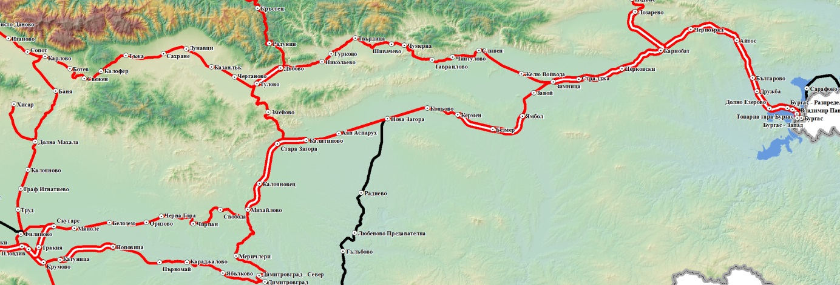

Svoboda
Place of ignition
Chirpan
Plovdiv
Burgas

Fig. 3

2.3. Event’s classification.
At 19:35 hours on April 09, 2019 the head of the "Specialized Unit for investigation of railway accidents and incidents "(SUIRAI) in the Ministry of Transport, Information Technologies and Communications" (MTITC) is notified via SMS on the phone, for arisen fire in the electric locomotive № 46221.8, which has served FT № 8602 during the movement along the Svoboda - Chirpan stage.
The information is submitted in relation to the requirements of "Safety Procedure SP 2.03." from September 01, 2018 of RINC.
The head of SUIRAI, after clarifying gathered operational information, classifies the event as a railway accident, in accordance with the requirements of Art. 19 para. 2 of Directive 2004/49 / EC and Art. 68, para. 1, item 2 and para. 2 of Ordinance No 59, for which he informs the interested parties.
2.4. Consequences of the Event:
- no injured passengers;
- no injured personnel;
- no damages to the railway infrastructure;
- no damages to the environment;
- a part of the compressor unit of electric locomotive № 46221.8 is burnt down;
2.5. Decision to initiate an investigation:
The decision to initiate an investigation is taken by the head of SUIRAI basing on the above mentioned norms in item 2.3.
Composition of the commission:
In MTITC an independent investigation commission is appointed. The head of SUIRAI is the Chairman of the commission. The commission consists of external experts with appropriate qualifications and professional relevance to the accident.
.
Investigation:
At 21:30 hours a RD of MoI - Chirpan operational investigation group arrives at the scene of the accident , which inspects the fire-damaged locomotive № 46221.8. At 21:55 hours after the completion of the operational investigation, the locomotive is released from the supervision of the MoI authorities for carting away from the stage.
At 22:15 hours from Chirpan station a locomotive № 44060.2 is sent for assistance and retraction of locomotive № 46221.8 from the stage.
About 22:30 hours after a coordination between the BDZ "Passenger Transport" Ltd Manager and the Head of SUIRAI in MTITC, the fired locomotive is moved to Plovdiv Locomotive Depot for an inspection by the Investigation Commission.
On 10 April 2019, the Investigation Commission of MTITC went to Plovdiv Locomotive Depot, where it carried out the first inspection of the burnt locomotive. The locomotive brigade's written explanations and the locomotive speed belt transcription were provided at Plovdiv Locomotive Depot.
After a coordination with the investigation commission on April 11, 2019, locomotive № 46221.8 was moved from Plovdiv to Sofia Locomotive depot .
On April 19, 2019 at Sofia Locomotive Depot in the presence of the Commission the locomotive compressor unit was removed and dismantled. After the inspections of the compressor, the Commission decided to carry out multiple tests over the particular nodes.
At Sofia Locomotive Depot , the Commission was able to compare the burned compressor of locomotive № 46221 with the strong compressor of electric locomotive № 46205, which was also a renovated locomotive in "BDZ Koncar" JSC. At locomotive № 46205, a large plan overhaul is to be carried out which enables the Commission to inspect and compare the fired with the non-fired elements between the two locomotives.
In the course of the investigation, the report submitted by the Operational Group and documents collected to it, as well as further requested materials and documents submitted by BDZ "Passenger Transport" Ltd related to the investigation, were analyzed.
The Chairman of the Commission has adopted the written observations of the external experts in fulfillment of the investigative tasks assigned to them under the investigation.
2.6. Conducting of rescue and emergency-restoration actions:
For the safety of the passengers in the train, the locomotive brigade unhooks the locomotive
from the wagons and moves it to a safe distance;
At the request of the motorman at 19:16 hours the voltage in the contact network (CN) is
switched off;
At 19:25 hours the motorman was ordered to ground two-sided CN to start extinguishing the
locomotive;
At 19:30 hours a specialized RS FS&PP - Chirpan fire car arrives and they start immediately
extinguishing the locomotive;
At 20:30 hours the fire in the locomotive was suppressed.
At 21:55 hours MoI investigating authorities release the locomotive from supervision to be
carted away.
3. General data established during the investigation process.
3.1. Participating officers:
RINC personnel on a shift:
- duty head of traffic at Svoboda station;
- duty head of traffic at Chirpan station;
BDZ" Passenger transport " Ltd personnel:
- Locomotive motorman of an electric locomotive № 46221.8;
- Locomotive motorman assistant of an electric locomotive № 46221.8;
- FT № 8602 Trainmaster and passenger movement;
- FT № 8602 Conductor.
3.2. Data on rolling stock:
- FT № 8602 /8601 operates daily according to the Train Traffic Schedule (TTS) along the route Sofia – Plovdiv – Stara Zagora – Karnobat – Burgas and back;
- according to the approved Train Composing Plan(TCP) for 2019 of BDZ " Passenger transport " Ltd, FT № 8602/8601 is comprised of - an electric locomotive, a first class, three second class passenger coaches and a bistro wagon.
3.3. Data on the carrier:
- BDZ " Passenger transport " Ltd is a national railway carrier licenced for passenger transport in the Republic of Bulgaria;
- It possesses national licence for passenger transport № 151/October 21,2013.;
- It possesses Safety certificate part ,,А“ BG 11 2017 0009 valid from December 31,2017 tilll December 30, 2022;
- It possesses Safety certificate part ,,В“ BG 12 2017 0009 valid from December 31,2017 tilll December 30, 2022;
- It possesses certificate of an authority, responsible for the maintenance of railway vehicles BGRA/2017/0004 valid from December 31, 2017 till December 30, 2022;
3.4. Train type, number and category:
- passenger train, № 8602, fast;

3.5. Train tractive rolling stock type and number:
- Electric locomotive № 46221.8 - with regular registration in Vehicles’ register;

3.6. Train non-tractive rolling stock (coaches) type and number:
- № 5052229709-5 В4, № 51522297008-7 В4, № 51521050052-3 А4, № 61528597004-7 Аrk, № 50522297010-3 В4 – with regular registrations in Vehicles’ register;

3.7. Railway infrastructure description:
- railway:
Svoboda Station has four tracks with a longitudinal slope of 0 ^{о}/_{оо}. The tracks are located in a curve with a radius R = 500 m;
in Svoboda - Chirpan stage, the railroad is with rail joints, rails type S 49, ST-4 sleepers, straight, with a profile of 10,5 ^{о}/_{оо} in a climbing to Chirpan station;
- contact network – chain, compensated;
3.8. Signalization, station safety installations and between-station block system:
- Svoboda Station is equipped with a Route-Relay Centralization (RRC H-68) with a control panel, with warningcombined enter and exit lights of the regular signaling, which are indicated on the panel with the corresponding initials.
- Svoboda - Chirpan stage is equipped with an automatic blocking and axis counters without duct capacitor signals. Centralization does not allow the sending of a train when the stage is occupied by another vehicle. Permissible speed - 50 km / h;

3.10. Train protection:
- electric locomotive № 46221.8 is equipped with a regular alertness device;
- The automatic locomotive signaling type "Altrax" is installed on the electric locomotive № 46221.8;
- Electric locomotive № 46221.8 is equipped with a fault registration system (PC-display);
- The electric locomotive № 46221.8 compressor is equipped with
high oil temperature protections and voltage changes (at the time of the accident the protections have not been activated);
- the railway infrastructure in the Stara Zagora - Orizovo stage is equipped with a operational JZG-703 "Erricson" automatic locomotive signaling (ALS);
3.11. Communication system:
- гарите Свобода и Чирпан са equipped with a universal telephone connection commutator UCС-8. Due to UCC-8 duty head of traffic performs a telephone connection with the two points posts, between-station connection with the two adjacent stations, connections with train and power dispatchers, a stationary mobile phone is also provided at the station;
- the locomotive and transport brigades have mobile phones;

3.12. Implementation of a plan for railway accidents and events.
- in implementation of the "Instruction on fire safety rules and requirements for rolling stock in operation, buildings, areas and sites of BDZ" Passenger Transport "Ltd and actions in events of fire", the personnel (locomotive and transport brigades serving FT № 8602) undertake the execution of their official duties concerning the occurrence of fire in traction rolling stock in a stage (as can be seen from the explanations of staff);
- the transport brigade informed the train passengers in advance of the unregulated train stop at Svoboda station and of the fire in the locomotive at Svoboda - Chirpan stage . Subsequently, they have cooperated in the passengers trans-shipment from the train on a bus.
- after the stop of FT № 8602 in Svoboda - Chirpan stage, the duty heads of traffic have organized, in coordination with the locomotive brigade and with train and power dispatchers, the shutdown and subsequently switching on the voltage into the contact network in the stage and ensuring the movement;
4. Deaths, injuries and material damages.
4.1. No deaths;
4.2. No injured passengers;
4.3. No injured personnel;
4.4. Material damages:
For BDZ " Passenger transport " Ltd:
The book value of electric locomotive № 46221.8 as of April 09, 2019 – 4 566 016,25 BGN.;
- damages of electric locomotive № 46221.8 – amount to 1047,44 BGN;
- coaches – no damages;

For "RINC":
- expenses for railway – none;
- contact network - no damages, switching on and off voltage, regulation with specialized equipment РССМ – 676,13 BGN;

For the environment – none;
Total damage from the accident amount to: 1723, 57 лв.

5. External circumstances - weather and geographic conditions.

- in the light part of the day;
- air temperature +11º С;
- clouds - clear.

6. Data for railway infrastructure and railway carrier staff related to the accident.
6.1. Position, place of work, sex and age.
Personnel of RINC:
-head of traffic – Svoboda station – RTMSA -Plovdiv, RINC, man at 63;
-head of traffic – Chirpan station – RTMSA -Plovdiv, RINC, man at 34;
Personnel of BDZ " Passenger transport " Ltd:
- motorman– Locomotive depot Sofia, BDZ " Passenger transport " Ltd, man at 32;
- motorman assistant,– Locomotive depot Sofia, BDZ " Passenger transport " Ltd, man at 27;
- trainmaster, passenger traffic – PTD -SF, BDZ " Passenger transport " Ltd, woman at 52;
- conductor – PTD -SF, BDZ " Passenger transport " Ltd woman at 64;
6.2. Position certificate and certificate data.
- Certificate № III-241/February 28, 2014 for occupying position – motorman, train work;
- Certificate № III-672/June21,2017 for occupying position motorman assistant,;
Acquired professional qualification:
Motorman:
- Certificate for vocational training № 5262-1123/August 04, 2008, acquired qualification for electric locomotive series 43, 44, 45000, teaching structure VТC-BDZ;
- Certificate for vocational training № 5704-108/March 24, 2009, acquired qualification for electric locomotive series 46200, teaching structure VТC-BDZ;
- Certificate for vocational training № 6468-261/April 09, 2010, acquired qualification for electric locomotive series 44001 - 44002, teaching structure VТC-BDZ;
- Certificate for vocational training № 1307-182/March 25, 2013, acquired qualification for electric locomotive series 61000, teaching structure VТC-BDZ;
- Certificate for vocational training № 367-367/June 13, 2017, acquired qualification for electric railcar series 30000, 31000, teaching structure VТC-BDZ ;
Motorman assistant:
- Certificate for vocational training № 360-360/May 30, 2017, acquired qualification for ,, Motorman assistant on electric locomotives, able to fullfil ABC checks“, teaching structure VТC-BDZ;
6.3. Qualification certificate and certificate data.
- Qualification certificate № 9100, acquired qualification: motorman of electric locomotive, study period: May 12. – July 11, 2008, teaching structure VТC-BDZ, Protocol № 3052-470-453 from July 28, 2008.
- Qualification certificate № 19457, acquired qualification : motorman assistant of electric locomotive, study period September 07, 2016 –March 06, 2017, teaching structure VТC-BDZ, Protocol № 17-48-46 from April 18, 2017.
6.4. Document for professional qualification.
- motorman – a diploma for completed secondary education № 014817/June 16, 2005, profession: Motorman assistant, teaching structure Railway Transport Professional secondary school ,,Nikola Korchev“ – Sofia;
- Certificate for locomotive driving BG 71 2016 0280 – EA RA
- motorman assistant – a diploma for completed high education № 081609/July 14, 2015 (Bachelor), Economic Academy "Dimitar A. Tsenov" - Svishtov;
6.5. Certificate for passing an examination as per Ordinance № 56 from 2003
- motorman – pr. № X-38-7 / April 20, 2018;
- motorman assistant – pr. № 17-48-46/ April 18,2017;
6.6. Personnel break duration before staff time:
In accordance with the requirements of the normative acts - Labour Code and Ordinance № 50 / December 28, 2001 – the personnel are provided with the required rest period before their work:
Personnel of BDZ " Passenger transport " Ltd:
- motorman – has rested from 07:15 hours till 15:10 hours on April 09, 2019 ;
- motorman assistant – has rested from 07:15 hours till 15:10 hours on April 09, 2019 ;
- trainmaster – has rested from 05:43 hours till 15:50 hours on April 09, 2019 ;
- conductor – has rested from 05:43 hours till 15:50 hours on April 09, 2019
6.7. Work experience of the staff.
Personnel of RINC:
-head of traffic at Svoboda station – 42 years work experience;
- pointsman/ rail crossing guard st Chirpan station – 4 years work experience;
Personnel of BDZ " Passenger transport " Ltd:
- motorman – 14 years work experience;
- motorman assistant – 2 years work experience;
- trainmaster – 8 years work experience;
- conductor – 9 months work experience;
6.8. Shift (travel) briefing.

Personnel of RINC:
- Personnel at Svoboda and Chirpan stations is briefed for duty on April 09/10, 2019 and they sign in the instruction book stating that they were cheerful, rested and haven’t used an alcohol and other narcotics.
Personnel of BDZ " Passenger transport " Ltd:
- the locomotive brigade is briefed before travel by the duty depot master at Burgas
locomotive depot and they sign in the instruction book stating that they were cheerful, rested and haven’t used an alcohol and other narcotics.
- the transport brigade has been briefed by the duty train crew instructor, trainmaster at Transport post in Burgas and they sign in the instruction book stating that they were cheerful, rested and haven’t used an alcohol and other narcotics.
7. Summary of testimony.
The investigation commission doesn’t have testimony.
8. System of Safety Management (SSM) .

8.1. Observing the procedures set out in SSM of RINC:
The Investigation Commission requested and took note of the provided procedures written in SSM of RINC and found that they had been met by the staff of the Railway Traffic Management and Station Activities (RTMSA) - Plovdiv. This is evident by the report of the operational group, further requested materials and station personnel statements.

8.2. Compliance with the procedures in SSM of BDZ "Passenger Transport" Ltd;

The Investigation Commission requested the procedures written in SSM and PRM and information for last locomotive repair works and after having become acquainted with them, established the following:
8.2.1. On the electric locomotive № 46221.8, a renovation has taken place in the Bulgarian-Croatian enterprise "BDZ Konchar"JSC in 2006, in Sofia.
8.2.2. Through the compressor unit ventilation cameras passes the 380 V power supply cable. The particular cameras are closed with mobile metal covers, which are sticked from the inside with an acoustic insulation (foam) soaked with oil due to leakages. As a result, a non-compliance with the requirements of the "Instruction on fire safety rules and requirements for rolling stock in operation, buildings, areas and sites of BDZ" Passenger Transport "Ltd and actions in events of fire", which is a part of the SSM, has been established.
8.2.3. In connection with the implementation of the repair activity of the locomotive 46221:
- in the period August 13, 2018 -November 06, 2018 a planned major periodic repair (MPR) is carried out at Sofia Locomotive Depot , (Poduene region) presented with a reference to BDZ "Passenger transport" Ltd;
- in the period March 29, 2019 t- March 29, 2019, a Technical Inspection (TI-1), presented with a reference to BDZ "Passenger transport" Ltd, is carried out at Sofia Locomotive Depot(Poduene region);
- On April 8, 2019 at Sofia Locomotive Depot (Poduene region) an Operational Review (OR) is carried out.
The Commission finds out that when locomotives undergo a minor periodic repair (MPR), the following consumables are not regularly replaced: oil separator, oil filter air filter and straps.

9. Rules and norms.
9.1. RINC staff before and during the accident, acts in a compliance with the approved regulations and internal rules regulating the safety of the transport on the railway infrastructure -,,Rules for the movement of trains and shunting work in rail transport“, "Plan for disaster protection of RINC" and" Firefighting file regulating fire safety at a RINC site - RTMSA – Plovdiv, Svoboda station nad the stage to Chirpan station;
9.2. The locomotive brigade serving the train, before the accident, acts in accordance with the approved regulations concerning the railway transport safety - "Ordinance No 58 from August 02, 2006 on the rules for the technical operation, trains movement and signaling in the railway transport" "Rules for trains movement and shunting work in rail transport". After the train stops in Svoboda- Chirpan stage during the accident, they immediately undertake actions to fulfil the requirements of the Fire Safety Instruction and the Crisis Action Plan, and in addition:
- unhooking and removing the locomotive from the wagons at a safe distance;
- securing the locomotive against a self-propulsion;
- taking down the pantograph from the contact network and switching off the battery;
- undertaking fire extinguishing with the available locomotive fire extinguishers ;
- undertaking action on earthing and securing the contact network, enabling the locomotive to be extinguished by the specialized bodies of FS&PP.
9.3 The Transport Brigade has undertaken actions against self-propulsion of the wagons (actuation of the parking brakes) after the locomotive has been detached from the wagons.
At 21:32 hours, a diesel locomotive № 55-124 is sent from Svoboda Station to return FT № 8602 stock back to Svoboda Station;
The transport brigade has provided assistance to the passengers for their trans-shipment from the train to a bus to Chirpan station.

10. Functional condition of rolling stock and technical facilities of the railway infrastructure.

10.1. Functional condition of the railway infrastructure:
Railway in the stage, after the accident – troublefree;
Safety equipment, communications, radio and power supply– troublefree;
Contact network– troublefree;
In Stara Zagora – Orizovo stage an ALS is mounted and activated.

10.2. Functional condition of rolling stock.
- locomotive № 46221.8 functional condition– unusable;
- coaches functional condition – fitted to operate;
- Both cabins of electric locomotive № 46221.8 are equipped with an automatic data logger and a speedometer-device for recording the driving speed in the range of 0 to 150 km / h. In 1st cabin of the locomotive is installed a wall-mounted tape tachograph type RT9 (registering) and in 2nd cabin - tachometer A16 (non-registering) type "Hasler". The speedometer installation registers graphically, using nibs on a paraffined paper band with perforations at the top and bottom along the strip, the following parameters:
- astronomical time - in a 24-hour digital scale;
- movement and stop time in minutes;
- speed - in km / h;
- Distance;
- air pressure in the main air tube of the pneumatic automatic brake at the value of which is judged to be triggered.

On April 10, 2019 a decodification of speedometer strip of electric locomotive № 46221.8 was done at Sofia Locomotive depot for the movement of FT № 8602 on April 09, 2019 in Stara Zagora – Svoboda stage:
- "FT 8602 departs from Stara Zagora station at 18:33 hours, develops speeds up to 80 km/h, traverses 400 m and accelerates to 125 km/h, travels 10,200 m and accelerates to 150 km/h, traverses 8,000 m and the speed drops to 60 km/h, it passes 800 m and the speed goes down smoothly and at 18:46 hours , passes through Mihaylovo station at a speed of 40 km/h, accelerates to 55 km/h, passes 8400 m and at 18: 56 hours stops, moves off, develops speeds up to 15 km/h and stops at 19:35 hours, stays 7 minutes. The control strip is removed from the locomotive at 19:41 hours. "
11. Operational System Documentation.

11.1. Measures taken by staff to regulate train movements.
The Operational Control Unit (OCU) and RTMSA ​​- Plovdiv together with BDZ PT Ltd., coordinated by Central Dispatch Management (CDM) of RINC, take timely operational actions regarding changes in the train traffic schedule in Stara Zagora- Chirpan stage till the liquidation of the accident. A change of route is applied to some Passenger Trains. FT № 8602 passengers are trans-shipped by busses from Svoboda station to Chirpan station at the expense of the railway carrier.
11.2. Exchange of Oral Orders and Written Messages.
With the order of the train dispatcher in OCU - Plovdiv from 19:16 hours in Svoboda-Chirpan stage, the CN voltage is switched off and TTS is stopped.
At 19:25 hours the motorman was ordered to earth two-sided CN for extinguishing the locomotive fire with a specialized RS FS & PP - Chirpan car.
A fire car arrives at 19:30 hours and RS FS & PP employees start extinguishing the fire.By an order of the train dispatcher at 19:51 hours Svoboda - Chirpan stage is closed for train movement .
At 20:30 hours, RS FS & PP employees inform the motorman that the fire has been suppressed, and with the order of the train dispatcher the earthing devices are removed and the voltage in Svoboda - Chirpan stage CN is switched on.
At 21:32 hours, a diesel locomotive № 55124.2 is sent from Svoboda station, to return the FT 8602 rolling stock to Svoboda Station at 21:53 hours.
At 21:55 hours after the investigation operations on the fired locomotive have completed, it's been released from surveillance by MoI authorities.
At 22:15 hours, an electric locomotive № 44060.2 is sent from Chirpan station to return the burned locomotive № 46221.8 from the stage. At 23:05 hours the locomotives arrive at Chirpan station and the stage Svoboda - Chirpan is released.
After the departure of the locomotives, an inspection is carried out to the railway by an employee of the Railway Section - Plovdiv and to the contact network - from a member of the Energy Agency - Plovdiv who have not find any damages.
At 23:18 hours by an order of the train dispatcher the movement in Svoboda - Chirpan stage is restored according to book schedule
11.3. Measures taken to protect and guard the scene of accident.
From 21:00 to 22:00 hours on April 09, 2019, the Svoboda - Chirpan stage region is split off by the MoI authorities with restricted access to outside persons, except for RS FS&PP -Chirpan Fire-fighting teams and the Investigation Authorities of MoI RD - Chirpan.
12. Health and Safety work conditions.
- With reference to the requirements of Art. 13, para. 1 and Art. 14, para. 1 of Ordinance №50 / December 28, 2001 no violations are observed in the reporting of personnel working hours at RINC and BDZ, "Passenger Transport" Ltd.
- With reference to the requirements of Art. 28, para. 1 of Ordinance № 54 / June 02, 2003 for medical examinations of the personnel related to the accident, at RINC and BDZ "Passenger Transport" Ltd., no violations are found.
- With reference to the requirements of Art. 20, para. 2 of Ordinance № 54 / June 02, 2003 the officials of RINC and BDZ "PT" Ltd., related to the accident, have valid certificates for psychological examination.
13. Accidents of similar nature previously registered.
The accidents quoted in previous periods of such a character have been investigated by SUIRAI and concern electric locomotives of the railway carrier BDZ " Passenger transport " Ltd, during servicing fast and passenger trains.
- on November 30, 2009 while in motion a fire occurs in electric locomotive № 45167, servicing FT № 3601 between stations Stamboliiski and Todor Kableshkov;
- on July 20, 2011 while in motion a fire occurs in electric locomotive № 44089, servicing FT № 2615 between stations SP Lesicheri and Resen;
- on December 19, 2012, in the course of manoeuvring a fire occurs in electric locomotive № 42081, servicing PT № 90101 at Shumen station;
- On June 26, 2013, while starting, a fire occurs in electric locomotive № 44074, servicing PT № 70200 between railway stations Rakevo and Boychinovtsi,
- on August 07, 2014 while in motion a fire occurs in electric locomotive № 44117, servicing FT № 8613 between stations Kaloyanovets and Stara Zagora;
- on July 06, 2015 while in motion a fire occurs in electric locomotive № 44174, servicing FT № 460 between Pordim and Levski stations;
- on October 13, 2015, while in motion a fire occurs in electric locomotive № 44169, servicing FT № 1621 between Elin Pelin stations;
- on April 13, 2016, while in motion a fire occurs in electric locomotive № 44081, servicing FT № 8626 between stations Aytos and Chernograd;
- on June 16, 2016 while in motion a fire occurs in electric locomotive № 44085, servicing FT № 3622 between Dunavtsi and Sahrane stations;
- on July 08, 2016 while in motion a fire occurs in electric locomotive № 44141, servicing FT № 4681 between station Mihaylovo and Svoboda;
- on September 14, 2016 while in motion a fire occurs in electric locomotive № 44096, servicing the Ver. № 80290 between the stations Chernograd and Karnobat;
- on October 12, 2017, in the course of manoeuvring a fire occurs in electric locomotive № 44134, servicing PT № BG 8693 at Dimitrovgrad station.
- on May 04, 2018 while in motion a fire occurs in electric locomotive № 44121, servicing FT № 8613 at Dolno Ezerovo station;

14. Analysis and conclusions.

14.1. Description of the chain of events based on established facts.
The Commission for Investigation in MTITC collected the necessary documentation and materials. It analyzed the possible circumstances, facts and evidence that could lead to an identification of the cause of the railway accident.
Carried out several detailed inspections of the burnt locomotive, as well as an analysis of the materials and documents provided by the Operational Group, discussed the views of the experts participating in the Commission.
Held interviews and required for the explanations of the staff involved in the accident. The Investigation Commission informed the manager of BDZ "Passenger transport" Ltd about the fire occurred in the locomotive, as well as about the cause of the fire. The recommendations that the Investigation Commission proposed were discussed too.

14.2. Analysis of the facts and conclusions on the causes of the accident.

Analysis of № 46221.8 electric locomotive recorder recording made in Stara Zagora – Svoboda stage during the service of FT № 8602.

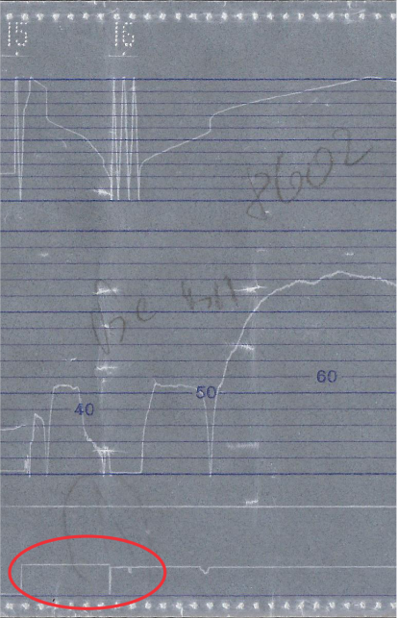
From the record of the speed tape and the data from locomotive № 46221.8 electrometer the following is found:
Fig. 4

The analysis of train № 8602 movement was made for the stage from Stara Zagora to Svoboda - Chirpan stage at km 69 + 480. It should be noted that the pressure marker on MAC doesn't always take the same position, which may in some cases lead to an ambiguous interpretation of the recorded information, so it is imperative to check the speedometer and the "Knorr D3" automatic, mounted on locomotive 46221 (Fig. 4).
The train moves at a speed of 140 km/h when 3100 m before Stara Zagora at 18:28 hours begins to decrease without using ABC, i.e. due to the natural resistance in movement (Fig. 5). Speed decreases to 135 km/h. In this way, it traverses 500 meters and in less than a minute the motorman triggers the brake by dropping 0.7 bar from the main air duct. The speed decreases to 110 km/h, as in this time the train travels 1300 m for about a minute. In this moment the motorman performs a second hold and releases another 1 bar and the pressure in MAC is set at 3.7 bars. The speed starts to decrease at a faster pace, and it is just 80 km/h 450 meters farther.
Apparently by motorman's discration this has been more than necessary, and after a very short extra hold of down to 3.4 bars, he makes a partial loosening of up to 4.0 bars, and about another 70m farther he makes a full loosening using an impact filling. The brakes loosen for about 250 meters and the rate of deceleration decreases again. Subsequent new partial holdings up to 4.6, to 4.15, to 3.7, followed by complete retention to 3.4 bars in the main air duct and immediately afterwards partial loosening to 4.3 bar, followed by full loosening with an impact filling at setting the train at the station. These actions of the motorman show that either the motorman felt insecure in the braking performance of the train, or the train showed unsustainable behavior in braking mode.
After a 1.5 minutes stay at Stara Zagora station, the train departs at 18:32 hours, for 500 m it accelerates to 80 km/h , then the motorman triggers the ABC, reducing the pressure in MAC at once to 3.7 bars and almost immediately afterwards it performs a full loosening with an impact filling. Due to these actions, the speed drops to 50 km / h and immediately begins to accelerate again, reaching a speed of 125 km/h 2400 m after the last retention. With this speed, the train traverses 10,000 m. At 18:39 hours the train starts to accelerate, passing through Kaloyanovets station and 3600 m farther, at 18:41 hours the speed reaches 145 km / h. At this speed, the train traverses 3800 meters and at 18:43 hours performs ABC official retention by initially reducing the pressure in MAC to 4.0 bar, and 1000 m farther with another 0.6 bar to 3.4 bars. The speed drops to 80 km/h and then the motorman makes a full loosening, reducing it to 60 km/h. 100 m farther the motorman again makes a retention by releasing 0.2 bar from MAC, resulting in a speed decreasing to 42 km/h at 18:46 hours when the train passes through Mihaylovo station. The train accelerates to 48 km/h and after a few fluctuations between 45 ÷ 55 km/h the speed is quiet at 55 km/h, and in this way the train moves till Svoboda station, where extreme detention takes place and at 18:56 hours the train is settled down the station. Undoubtedly this is the moment when the motorman has heard the noise from the truck and has decided to stop and check its condition. After an 8-minute stay, the train moves off at 19:03 hours, develops 47 km/h, then speeds down slowly without using the train brake. When the speed reaches 20 km/h, the brake is activated and at 19:05 the train stops. The tape is down at 19:41 hours.
Fig. 5

14.3. Conclusions - direct and main causes of the accident additional factors related to the technical condition of the rolling stock.
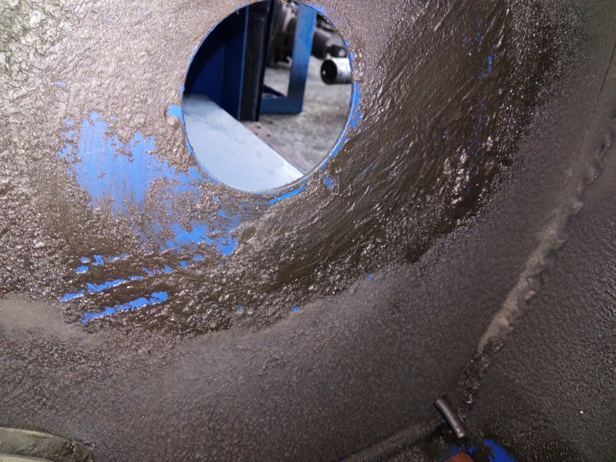
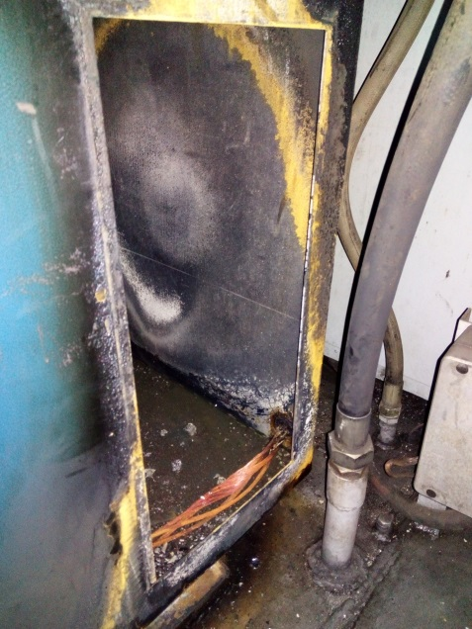
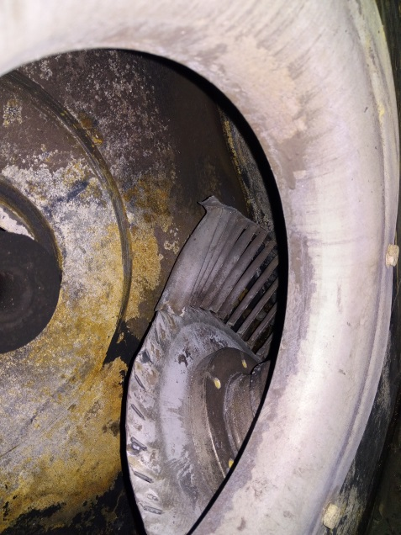
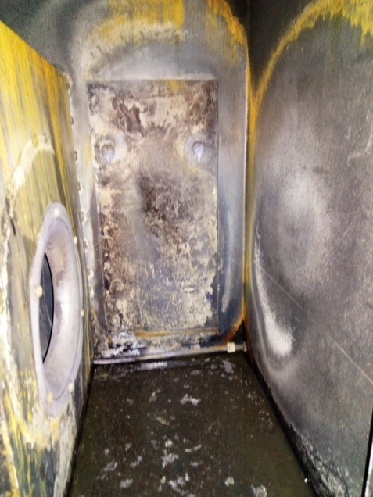
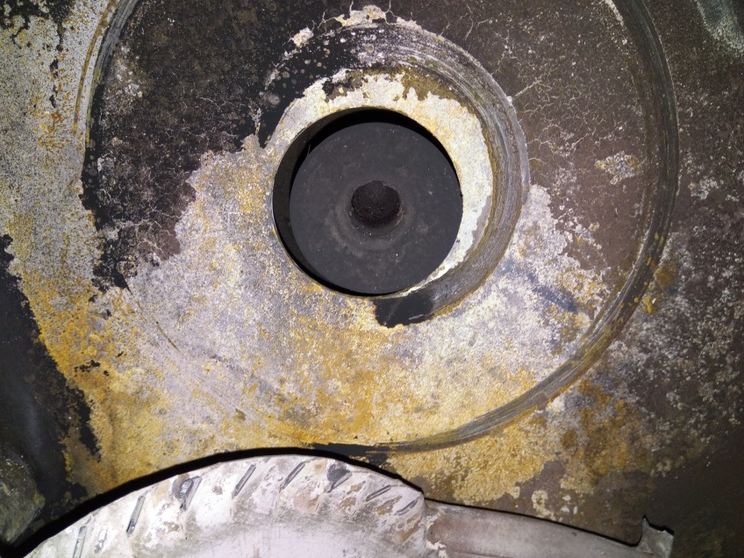
The Investigation Commission took note of the factual situation and the consequences of the ignition, and after several inspections at Plovdiv Locomotive Depot and at Sofia Locomotive Depot , it was found that the main cause of the ignition has been the incoherence of the cooling turbine towards the main compressor's shaft as a result of which a front impact rotation has occurred during, which has led to its rear part being rubbed into the wall of the air outlet camera (Fig. 6). The friction between the two surfaces (steel in steel) has created sparks which have ignited the greased dust layered on the noise insulation of the inside walls of the compressor's cameras (Fig. 7). As a result, a flame has occurred and the temperature in the camera has risen. As a consequence of the flames and the high temperature, the sound insulation mounted on the inner side of the compressor unit cameras' covers (Fig. 8) is ignited. The ignited insulation has further increased the temperature which has led to the ignition of the power cable insulation supplying the compressor unit which passes through the same cameras (Fig. 9).
Fig. 7
Fig. 9
Fig. 10
Fig. 8
Fig. 6

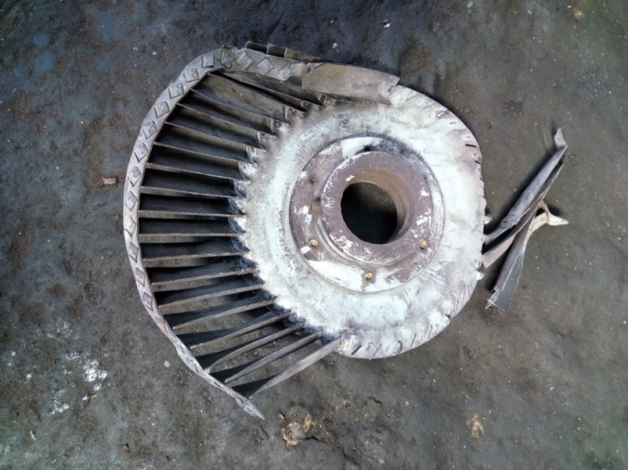
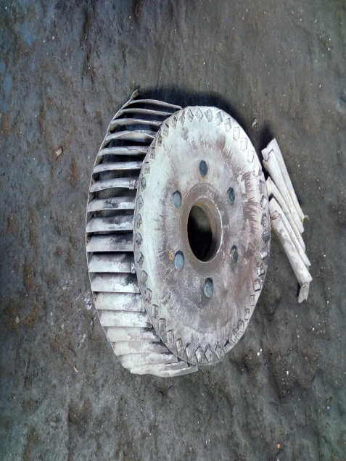
Initially, the turbine exacerbates the flames and helps to feed and expand them. Subsequently, touching the walls of the compressor cameras has led to its deformation and at a moment it has ceased to perform its purpose due to falling off from the drive shaft of the main compressor electrical motor and has fallen to the bottom of the camera (Fig. 10).
Fig. 12
Fig. 11

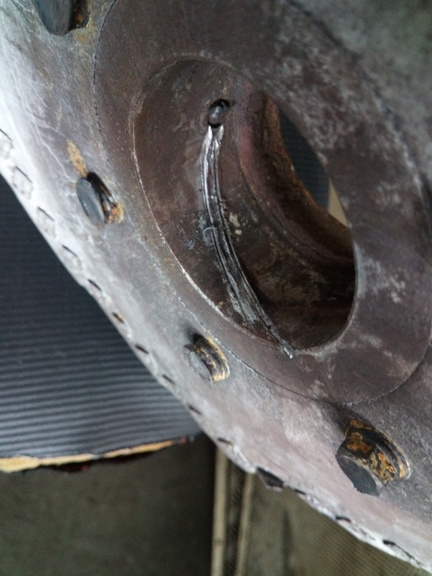
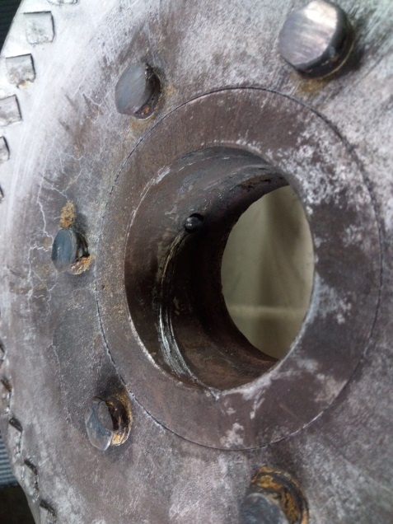
The Investigation Commission took a comprehensive view of the compressor unit cooling turbine and found out blockage trace marks on the holdfast hub on the drive shaft of the compressor elctrical motor. There were no missing blades, or such as dislodged by the turbine casing due to centrifugal forces (Figures 11 and 12). Deformations of the turbine blades have occured due to the contact with the walls of the camera and there are no traces of malfunctions occurring before the accident. The fastening screw on the turbine bush is in working condition, showing signs of deformation and contact with the shaft of the electric motor (Fig. 16). Two traces were found on the locking screw of the engine shaft, one of which is a tapered depression and is assumed to be done during a previous mounting (Fig. 13). The second trace is a recess in the form of a path along the shaft. At the same time, the inside of the turbine hub shows a double trace of blockage in the form of a screw obtained from the cooling turbine falling off from the motor shaft as a result of a contact with the injured surface of the shaft itself by the locking screw (Fig. 14). The screw also has traces of contact with the motor shaft , which is expressed in a dull tip (Figures 15 and 16).)
Fig. 16
Fig. 13
Fig. 14
Fig. 15
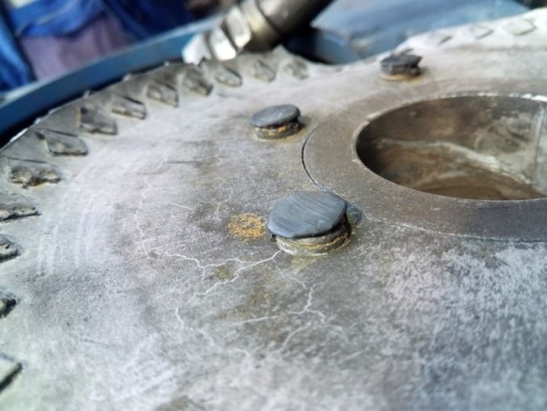
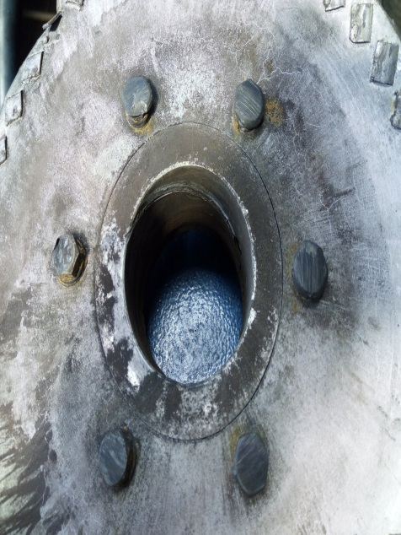
The bolt heads from the disc on the back of the turbine show traces of the friction with the wall of the turbine camera (Figures 17 and 18). They have been the first elements to come in contact with the wall, which is evident both from their condition and the traces on the wall of the camera. Besides the traces left by the bolt heads, there are traces of the peripheral part of the turbine disc on the wall of the camera, which have appeared when the front impact rotation has increased (Fig. 6).
Fig. 18
Fig. 17
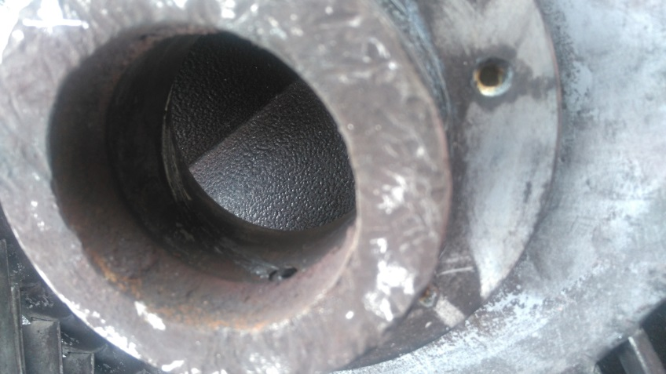
During the views of the drive shaft of the electric motor, it was found that there was a hole in it with a cut thread, with no bolt in the hole. At the same time it was found that the hub is so placed on the shaft that it does not cover it with its entire length, i. e. a part of it (about a quarter to a third) remains out (Fig. 19). This further has contributed to the destabilization of the hub and the occurrence of a front impact rotation which has led to the dislocation of the joint between the hub of the turbine wheel and the shaft of the electric motor.
Fig. 19

14.4. Other conclusions and observations related to the causes of the fire during the investigation.
On May 17, 2019 at Sofia Locomotive Depot(Poduene Region), the Investigation Commission carried out a review of the compressor unit after its recovery. The installation of the turbine to the shaft of the electric motor was checked. Connections of the electrical and pneumatic compressor parts to a locomotive of the same series were made. After its launch, the following parameters were observed:
- Compressor flow rate
- Compressor on/off pressure;
- purge and idling systems;
- simulating high temperature oil protection (overheating of the compressor);
- presence of vibration when the cooling turbine operates ;
From the parameter check, it was found out that all compressor systems worked normally after it was restored.

15. Description of already taken measures as a result of the accident.
In the course of the investigation of BDZ "Passenger transport" Ltd, the following
recommendations were given, starting their implementation:
Removing the available noise insulation of the fired locomotive mounted on the
compressor unit walls and replacing it with non-combustible material;материя;

16. Recommendations issued in order to avoid accidents upon the same reasons.
In accordance with the requirements of Art. 94 para. 1 and para. 3 of Ordinance № 59 from December 5, 2006 in order to improve safety in railway transport, EA "Railway Administration" orders BDZ "Passenger Transport" Ltd to implement the given safety recommendations:
- Recommendation № 1 proposes to familiarize the staff in service (locomotive and transport
brigades with the contents of the report;
- Recommendation № 2 proposes for the renovated locomotives in "BDZ Konchar" JSC, when
performing a large periodic repair (LPR) of the compressor unit to replace oil separator, oil filter, air filter and straps;
- Recommendation № 3 proposes to replace the available flammable noise insulation installed
on the inside of the compressor aggregate walls with such of a non-combustible material in the renovated locomotives in "BDZ Konchar" JSC;
- Recommendation № 4 proposes to install a thermal sensor in the compressor cooling camera
and to be connected to the locomotive's fire alarm system.
With reference to the implementation of Art. 94 para. 4 of Ordinance № 59 from December 5, 2006 for Railway Safety Management EA "Railway Administration" to notify in writing the head of SUIRAI in MTITC for the implementation of the given recommendations.

Sofia July 05, 2019 г.

Chairman:
Dr. eng. Boycho Skrobanski
Head of NIB in MTITC

